Outputs of the project:

1. Uploading of the file

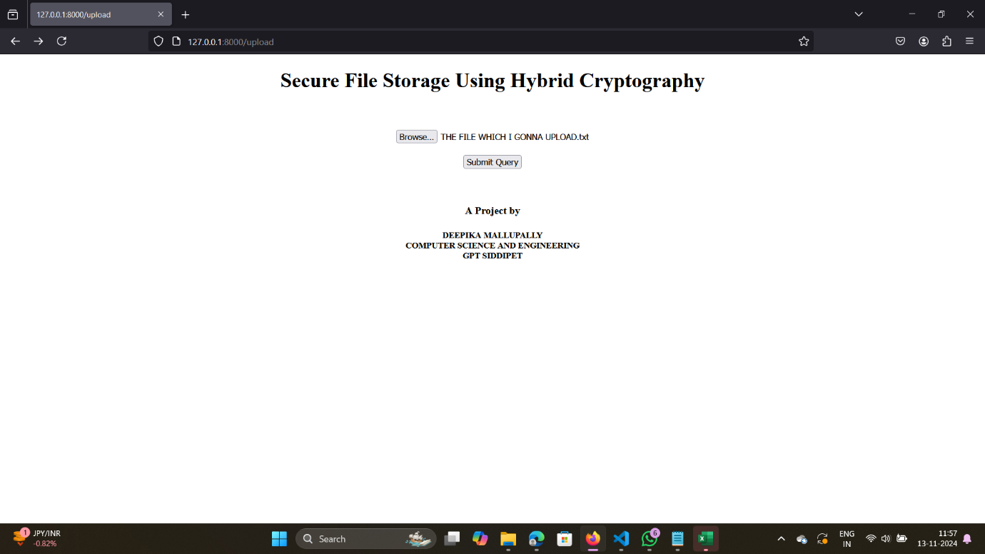

1. After uploading the file. We will get the success with 2 options as below screenshot. Here, I am downloading the key. Which is used for the restoring purpose.

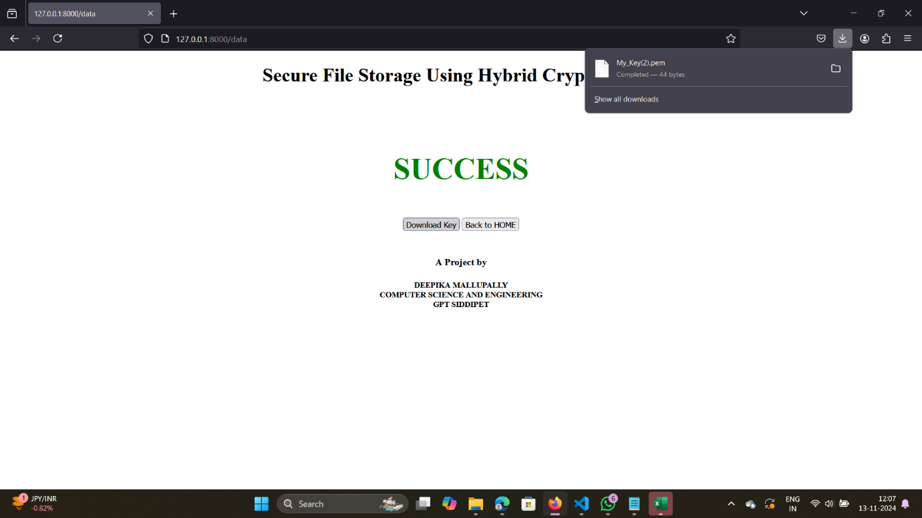

1. Restore/ Decryption : by clicking on restore button upload the downloaded key after encryption.

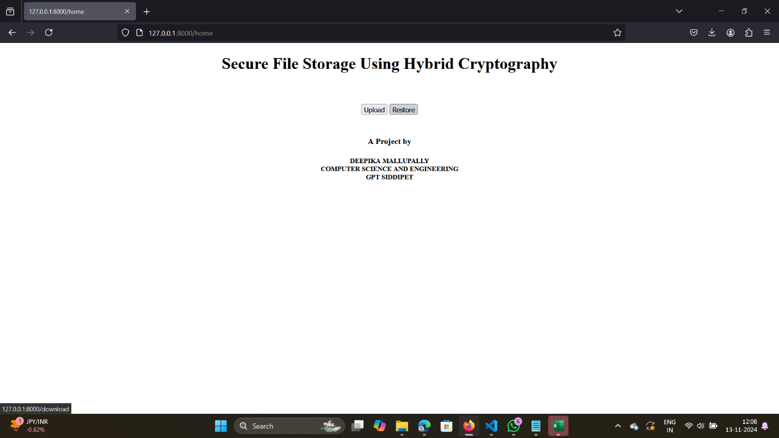

1. After uploading the key u will get the decrypted file.

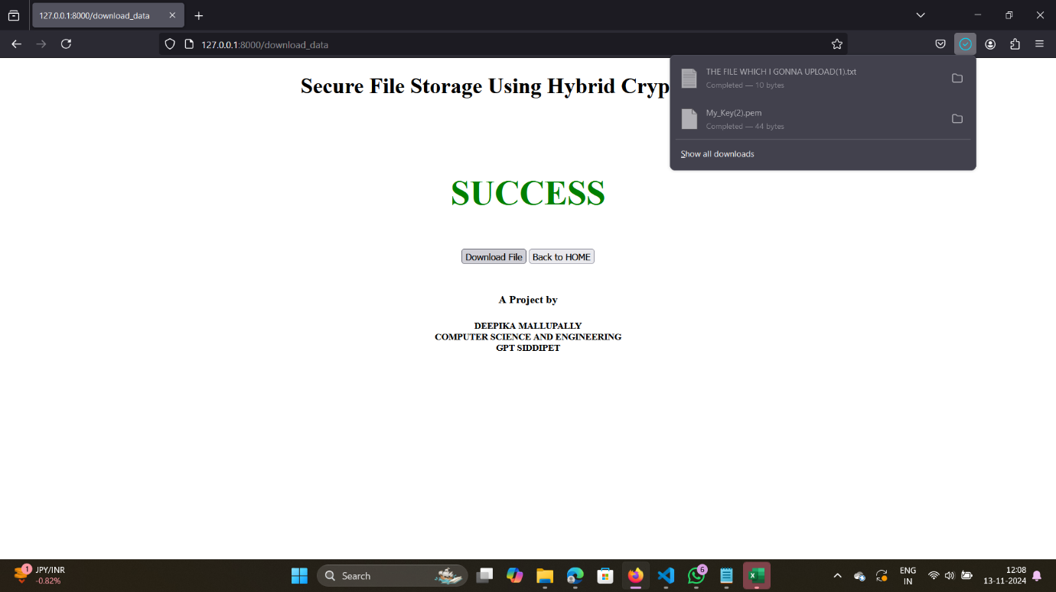

I hope these screenshots give a thought of the project. I had missed some of the screenshots. But you guys look at readme to get clear understanding. THANK YOU!!