SUPERMARKET SALES ANALYSIS
Data Analytics Project Report
IBM SkillsBuild – Data Analytics with AI
Academic Internship Program
Conducted by BharatCares in association with AICTE
Submitted by: pp
M.Tech in Computer Science

Table of Contents
1. Introduction
2. Problem Statement
3. Objectives
4. Dataset Description
5. Tools and Technologies
6. Methodology
7. Key Performance Indicators
8. Analysis and Findings
9. Summary of Insights
10. Business Recommendations
11. Limitations
12. Conclusion
13. Project Files

1. Introduction
Supermarkets generate a large number of sales records every day. When these records are organised and analysed, they show which products customers prefer, which stores perform best and where service can be improved. This project analyses a supermarket sales dataset using Python and converts the results into practical business decisions.

2. Problem Statement
The aim of this project is to analyse supermarket sales data and find useful information about products, branches, categories, customers, payments and ratings. The analysis answers six business questions:
- Which product generates the highest sales?
- Which branch performs best?
- Which category sells the most?
- What is the most popular payment method?
- Do Members spend more than Normal customers?
- What is the average customer rating?

3. Objectives
- Load, clean and validate the sales dataset.
- Calculate key performance indicators (KPIs) such as total sales, average transaction value and average rating.
- Compare sales across products, categories, branches, customer types and payment methods.
- Present the results through clear charts.
- Recommend actions that the supermarket can apply to improve sales and customer satisfaction.

4. Dataset Description
The dataset (supermarket_sales.csv) contains 500 sales transactions recorded between 1 January 2026 and 1 July 2026 across four branches in four cities. Each row is one invoice.
Column | Description
Invoice ID | Unique transaction ID (INV0001 – INV0500)
Date | Date of the transaction
Branch / City | Store branch (A–D) and its city: A–Jaipur, B–Delhi, C–Mumbai, D–Bengaluru
Customer Type | Member or Normal
Gender | Male or Female
Product / Category | Item sold (20 products) and its category (8 categories)
Quantity | Units purchased (1–10)
Unit Price | Price per unit in ₹
Payment | UPI, Net Banking, Card or Cash
Rating | Customer rating, 3.0 – 5.0
Sales | Transaction value in ₹ (Quantity × Unit Price)

Categories and products: Beverages (Cold Drink, Coffee, Tea), Personal Care (Face Wash, Shampoo, Soap), Dairy (Cheese, Eggs, Milk), Grocery (Cooking Oil, Noodles, Rice), Fruits (Apples, Bananas), Snacks (Biscuits, Chips, Chocolate), Vegetables (Potato, Tomato) and Bakery (Bread).

5. Tools and Technologies
Tool | Purpose
Python 3 | Programming language
Pandas, NumPy | Data loading, cleaning, grouping and calculations
Matplotlib, Seaborn | Data visualisation
SciPy | Statistical test (Welch t-test)
Jupyter Notebook | Interactive coding and documentation

6. Methodology
- Collect and load: the CSV file was loaded into a Pandas DataFrame.
- Check data quality: missing values, duplicates, data types, valid ranges and the Sales formula were verified.
- Feature engineering: the Date column was converted to datetime and Month and Weekday columns were created.
- Summarise: data was grouped by product, branch, category, payment method and customer type using totals, counts and averages.
- Visualise: bar charts, pie chart, heatmap, box plot, histogram and line chart were created.
- Interpret: results were converted into insights and business recommendations.

6.1 Data Quality Results
Check | Result
Missing values | None in any column
Duplicate rows / Invoice IDs | None (500 unique invoices)
Sales = Quantity × Unit Price | Correct in all 500 rows
Rating range | 3.0 – 5.0 (valid)
Quantity range | 1 – 10 (valid)
Branch–City mapping | One city per branch

The dataset was already clean, so no records were removed or imputed.

7. Key Performance Indicators
KPI | Value
Total transactions | 500
Total sales | ₹2,44,411.08
Average transaction value | ₹488.82
Total units sold | 2,768
Average customer rating | 3.99 / 5

8. Analysis and Findings

8.1 Which product generates the highest sales?
Cheese generated the highest sales: ₹27,906.30. Coffee (₹27,694.87) and Shampoo (₹27,497.48) are almost equal, with less than 2% between first and third place. All three have a high unit price (₹115–₹235).
Rank | Product | Sales (₹) | Units sold
1 | Cheese | 27,906.30 | 126
2 | Coffee | 27,694.87 | 153
3 | Shampoo | 27,497.48 | 152
4 | Cooking Oil | 21,525.06 | 142
5 | Tea | 17,681.59 | 146
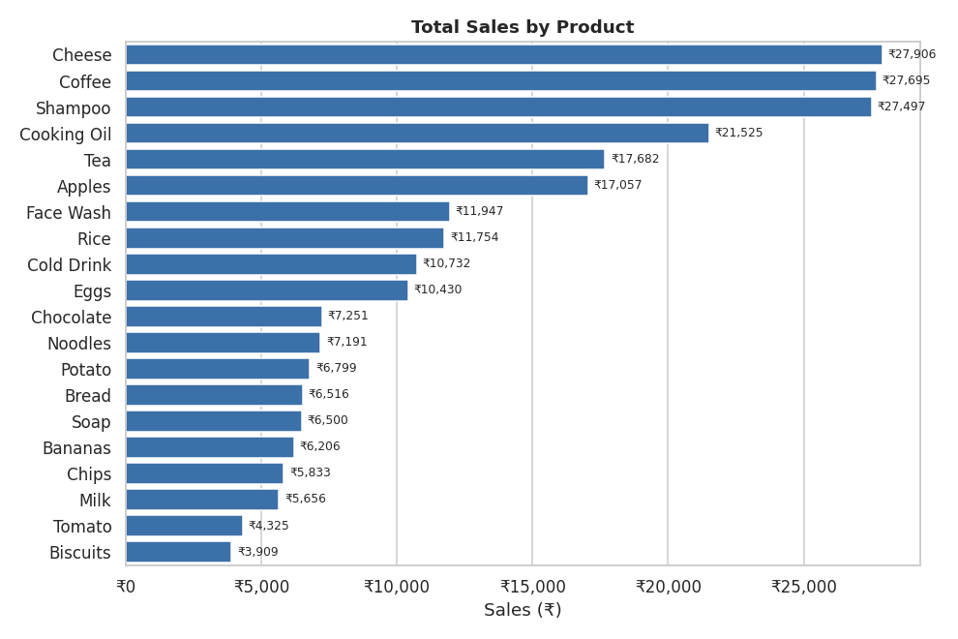
Figure 1: Total sales by product

8.2 Which branch performs best?
Branch C (Mumbai) performed best with sales of ₹72,469.45, which is 29.7% of total sales. Branch A (Jaipur) is the lowest at ₹52,357.08.
Branch | City | Sales (₹) | Share | Transactions | Avg. sale (₹) | Avg. rating
C | Mumbai | 72,469.45 | 29.7% | 143 | 506.78 | 4.05
B | Delhi | 64,116.26 | 26.2% | 133 | 482.08 | 3.98
D | Bengaluru | 55,468.29 | 22.7% | 119 | 466.12 | 4.09
A | Jaipur | 52,357.08 | 21.4% | 105 | 498.64 | 3.84

Branch C's lead comes mainly from more transactions (143, against 105 in Branch A) and not from a bigger bill: its average sale is close to Jaipur's. Branch A has both the lowest sales and the lowest rating.
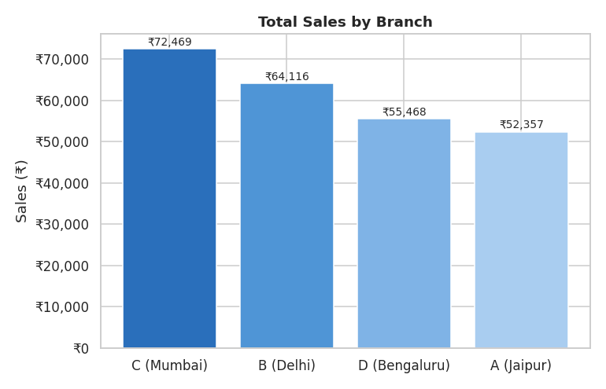
Figure 2: Total sales by branch
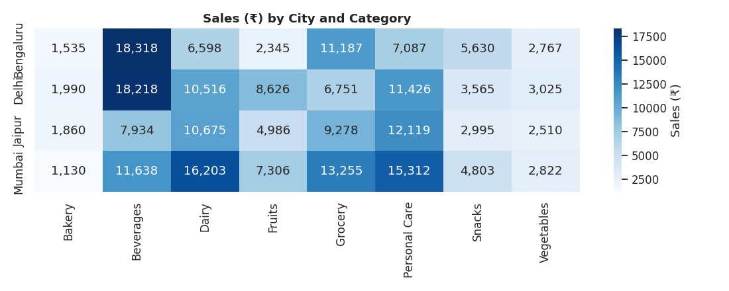
Figure 3: Sales by city and category (₹)

8.3 Which category sells the most?
Beverages had the highest sales with ₹56,108.24 (23.0% of total). Personal Care and Dairy follow. The top three categories together bring about 60% of all revenue.
Category | Sales (₹) | Share | Units | Avg. unit price (₹)
Beverages | 56,108.24 | 23.0% | 465 | 118.38
Personal Care | 45,943.96 | 18.8% | 399 | 113.86
Dairy | 43,992.00 | 18.0% | 345 | 128.85
Grocery | 40,470.47 | 16.6% | 439 | 90.74
Fruits | 23,263.17 | 9.5% | 223 | 97.12
Snacks | 16,992.97 | 7.0% | 443 | 37.66
Vegetables | 11,124.17 | 4.6% | 290 | 39.45
Bakery | 6,516.10 | 2.7% | 164 | 39.90
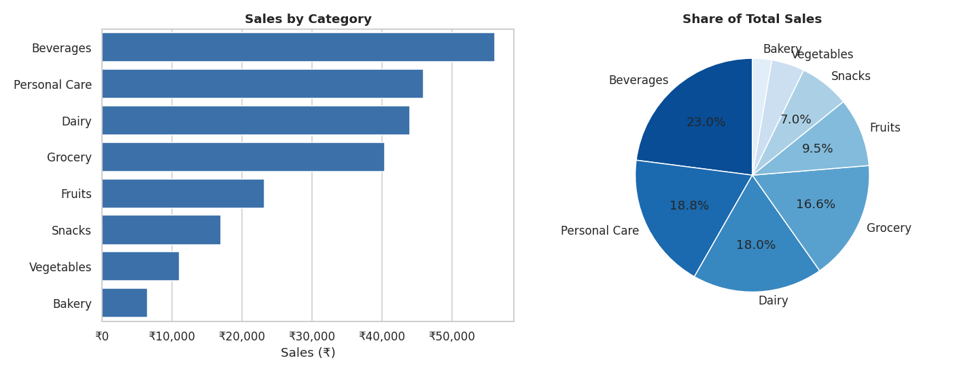
Figure 4: Sales by category and share of total
Sales depend more on price than on volume: Snacks sell about as many units as Grocery (443 vs 439) but earn less than half, because the average unit price is ₹38 against ₹91.

8.4 What is the most popular payment method?
UPI was the most used payment method with 127 transactions. However, the difference between methods is very small, so customers use all four almost equally.
Payment method | Transactions | Share | Sales (₹)
UPI | 127 | 25.4% | 67,910.33
Net Banking | 126 | 25.2% | 65,194.93
Card | 125 | 25.0% | 57,265.64
Cash | 122 | 24.4% | 54,040.18
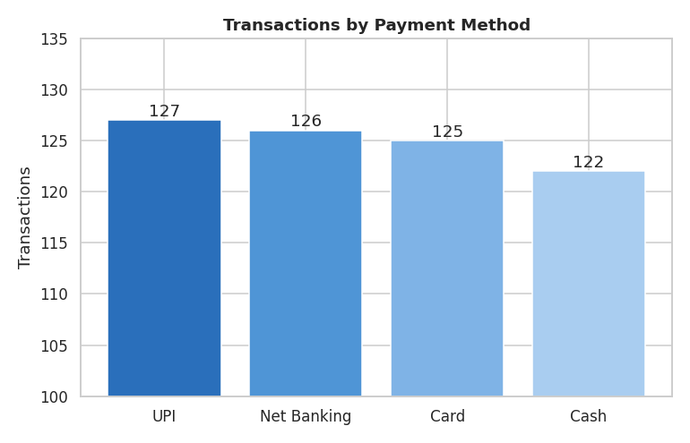
Figure 5: Transactions by payment method (y-axis starts at 100)

8.5 Do Members spend more than Normal customers?
No. The average Member transaction was ₹483.14, while Normal customers averaged ₹497.07. A Welch t-test gives p = 0.73, so the difference is not statistically significant: Members and Normal customers spend about the same per visit. Members account for 296 of 500 transactions (59%), so the membership brings more visits rather than bigger bills.
Customer type | Transactions | Avg. transaction (₹) | Median (₹) | Total sales (₹)
Member | 296 | 483.14 | 314.46 | 1,43,009.30
Normal | 204 | 497.07 | 352.56 | 1,01,401.78
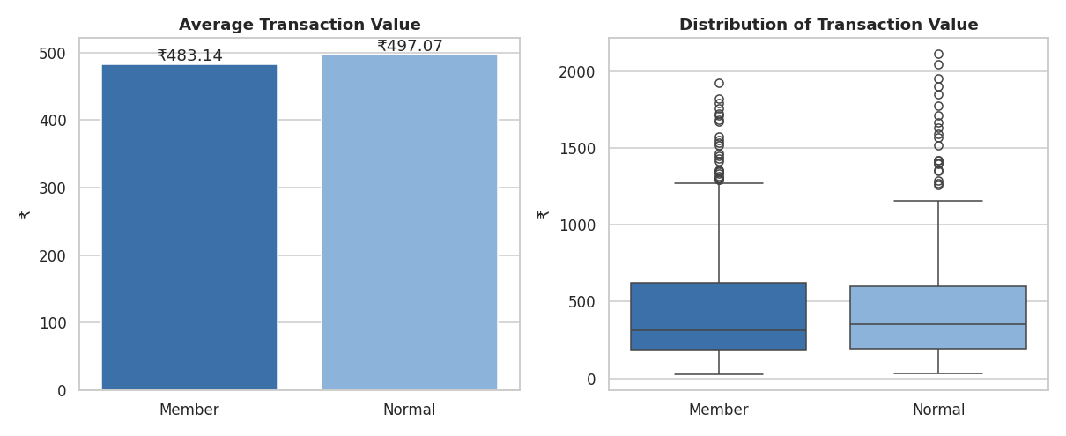
Figure 6: Member vs Normal customers

8.6 What is the average customer rating?
The average customer rating was 3.99 out of 5. Ratings are spread between 3.0 and 5.0 and have almost no relationship with the bill amount (correlation −0.05). Bengaluru has the highest average rating (4.09) and Jaipur the lowest (3.84). About 23% of transactions are rated below 3.5.
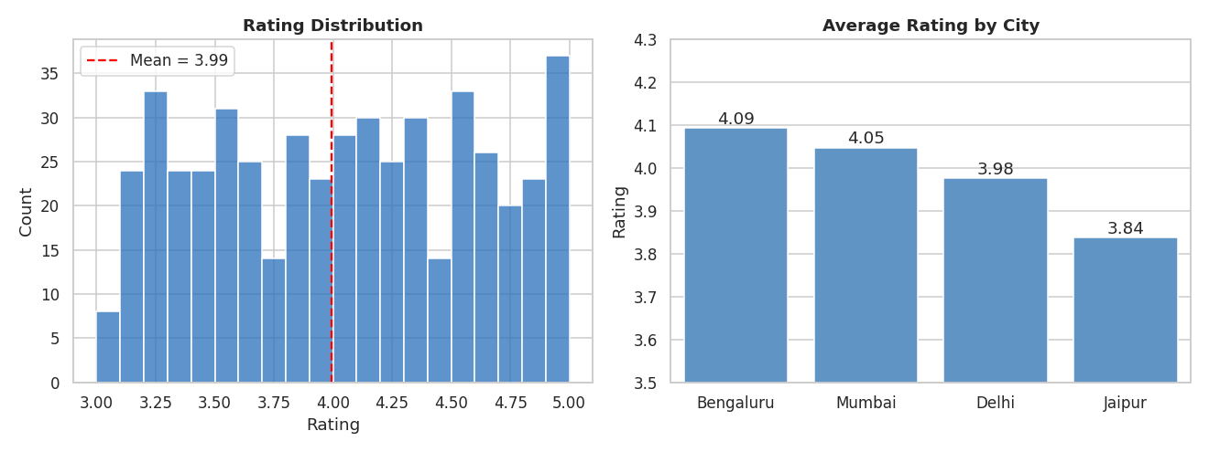
Figure 7: Rating distribution and average rating by city

8.7 Additional findings
- Monthly trend: April is the strongest month (₹52,569.77) and February the weakest full month (₹30,068.15). July has only one day of data (1 July) and should not be compared with other months.
- Gender: female customers contributed ₹1,23,954.12 and male customers ₹1,20,456.96, with similar average bills (₹486 vs ₹492). Gender is not a useful basis for targeting.
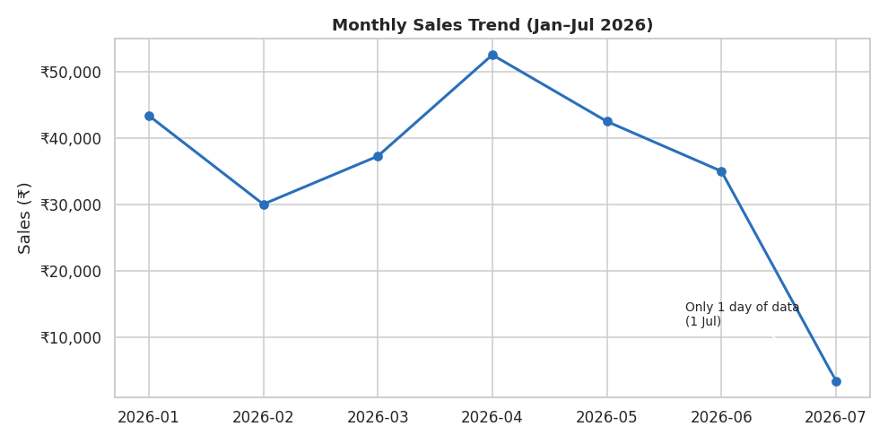
Figure 8: Monthly sales trend
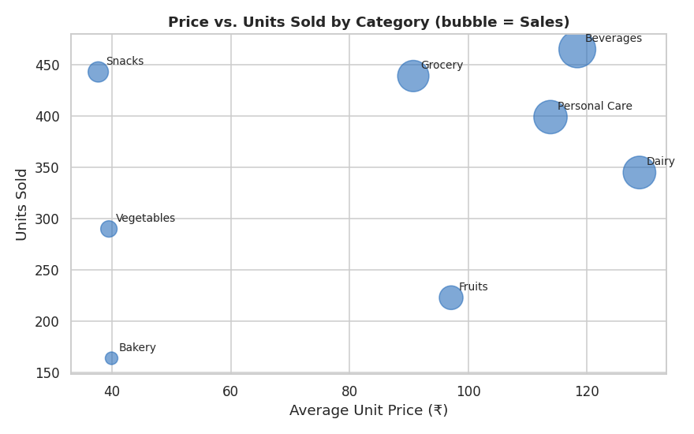
Figure 9: Price vs units sold by category

9. Summary of Insights
Question | Answer
Highest-selling product | Cheese – ₹27,906.30
Best branch | Branch C (Mumbai) – ₹72,469.45
Top category | Beverages – ₹56,108.24
Most popular payment method | UPI – 127 transactions (all methods nearly equal)
Members vs Normal | Members ₹483.14 vs Normal ₹497.07 – Members do not spend more
Average rating | 3.99 out of 5

10. Business Recommendations
- Stock management: keep deep stock of Cheese, Coffee, Shampoo and the Beverages, Personal Care and Dairy categories, which bring about 60% of revenue.
- Branch strategy: study why Branch C attracts more transactions (location, timing, offers) and test the same practices in Branch A (Jaipur).
- Payments: continue supporting UPI, but keep Net Banking, Card and Cash active because usage is almost equal.
- Membership: since Members visit more often but do not spend more per visit, introduce minimum-spend or bundle offers to raise basket value.
- Customer service: start with Branch A (rating 3.84) and the 23% of transactions rated below 3.5, using feedback follow-up and staff training.
- Promotions: pair low-price, high-volume items (Vegetables, Snacks, Bakery) with high-value items as add-on offers.

11. Limitations
- The dataset has only 500 transactions covering 1 January – 1 July 2026.
- July has only one day of data, so month comparisons exclude it.
- There is no customer ID, so repeat-purchase behaviour cannot be measured.
- The data contains no cost or profit information, so the analysis is based on sales (revenue) and not on profit.

12. Conclusion
This project shows how raw sales data can be converted into simple, useful insights. Revenue is concentrated in a few high-priced categories and in Branch C, customer spending is the same across Member and Normal customers, payment preferences are evenly spread, and the average rating of 3.99/5 shows good customer satisfaction with room for improvement. These findings help a supermarket plan stock, focus on weaker branches, design better membership offers and improve service.

13. Project Files
File | Description
pp_Supermarket_Sales_Analysis.ipynb | Complete analysis code with outputs and charts
requirements.txt | Python libraries needed to run the project
pp_ProjectReport.docx | This report
README.md | Project overview and run instructions
supermarket_sales.csv | Dataset (500 transactions)

