F Ratio - OLS regression

Sri Seshadri

1/20/2018

# Question

Page 76 of ISLR states that “…When there is no relationship between the response and predictors, one would expect the F-Statistic to take on a value close to 1. On the other hand, If $H_{a}$ is true then E{(TSS - RSS)/p} > $σ^{2}$, so we expect F to be greater than 1”

**If there was no relationship between the predictor and the response variable shouldn’t the F statistic be very less than on equal to 1? instead of close to 1?**

# Experiment

Generate random numbers and randomly assign the levels of the predictor variable to the random numbers. Fit a OLS regression and inspect the ANOVA table for F ratio. Repeat the experiemt for 1000 iterations.

getFStats <- function() {  
 # Generate random numbers from a standard normal distribution  
   
 y <- rnorm(1000)  
   
 # generate predictor variable with levels 1 through 10   
   
 x <- rep(1:10,100)  
   
 # plot y vv x  
   
 #plot(y~x)  
   
 # Simple linear regression  
   
 model.lm <- lm(formula = y ~ x)  
   
 #summary(model.lm)  
   
 Fstats <- anova(model.lm)$`F value`[1]  
 return(Fstats)  
}  
  
result <- replicate(1000,getFStats())  
  
hist(result,breaks = 20,col = "blue",xlab = "F statistic",main = "Histogram of F Ratios")  
abline(v=1,col = "red",lty = 5)

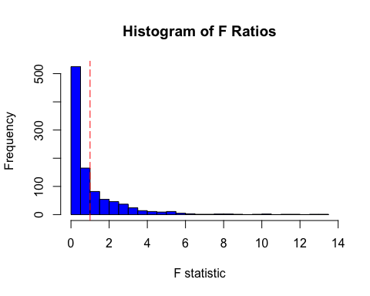

# Conclusion

The quote in ISLR is misleading and should read “F statistic should take on values less than on equal to 1”. I am open to criticism, please point me in a direction should you feel the experimentation is not set up correctly.