**GitHub Username**: deepikanathan

Track Your Health

Description

Track Your Health helps you take control of your health and lead a healthy lifestyle. Monitor your health by recording key health indicators and view a complete history of your health data, including your weight, A1C, Blood sugar, and Cholesterol, track progress, and improve your health over time. It also helps make a note of current medications you take.

Intended User

App can be used by anyone that wants to maintain good health.

Features

* Shows list of current medications.
* Shows history/journal of health indicators.
* Shows statistics of health indicators.

User Interface Mocks

**Screen 1 – Welcome Screen**

Welcome screen that has a link to Sign Up. This is the first page that is shown after initial installation of the app.

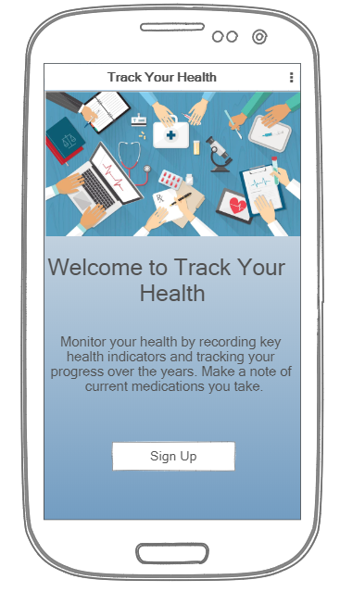

**Screen 2 – Sign Up / Create Account**

Create Account page will gather information about the user. All the fields in the Sign Up page are required. Clicking the Add Account button will take the user to the Main Screen.

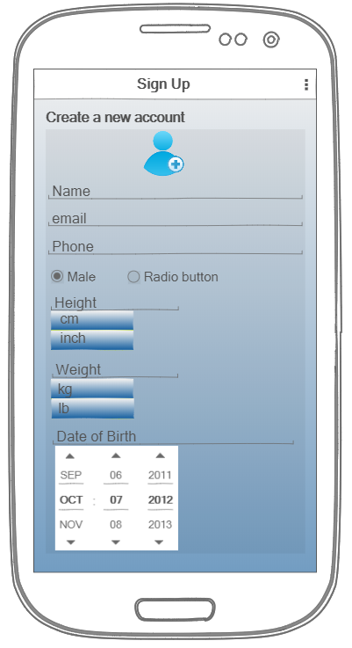 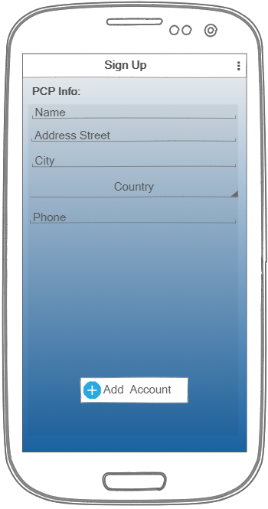

**Screen 3 – Main Screen**

Main screen provides buttons to navigate to activities such as My Profile, Journal, Log doctor visit, and Medications.

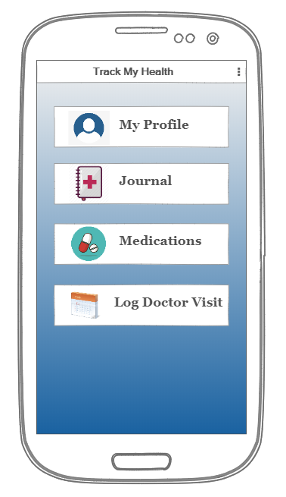

**Screen 4 – Profile**

Profile screen to show user’s information. Some of the information include Name, Email, Phone, Birthday, Emergency Contact, and PCP information. Clicking the Back button on top will take the user to the Main Screen.

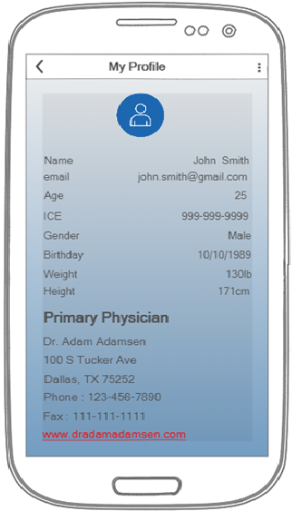

**Screen 5 – Current Medications**

This screen shows a list of all the drugs that the user takes, along with the dosage information. The Add button at the bottom opens the Add Medication screen and lets the user add new medications. The Edit button opens a page similar to the Add Medication page except that the fields are already populated. The Delete button removes a medication from the list. The Back button on top takes the user to the Main Screen.

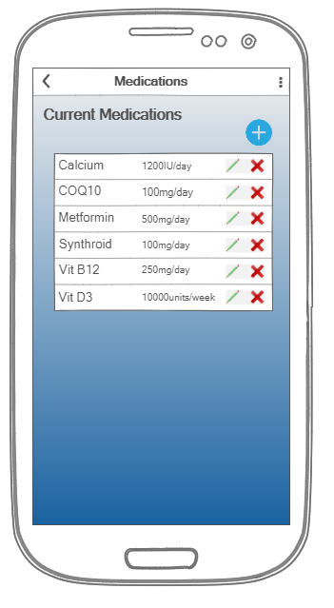

**Screen 6 – Add Medication**

The Add Medication screen lets the user add a new medication. If the newly entered drug matches an already existing medicine, then an error message is shown. The user can type the first 5 characters of the medication and hit the Search button. The app connects to RxNorm RESTful API’s approximateTerm method (<https://rxnav.nlm.nih.gov/REST/approximateTerm?term>) to retrieve all possible matches.

For example, if the user types “Cital” (<https://rxnav.nlm.nih.gov/REST/approximateTerm?term=cital%2010%20mg&maxEntries=4>), the API returns “citalopram”.

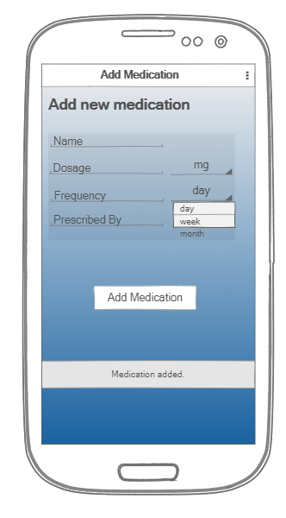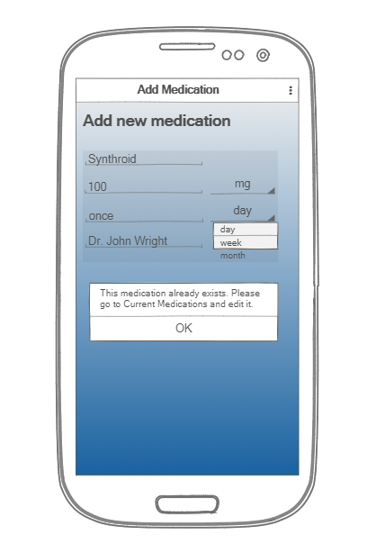

**Screen 7 – Journal**

The Journal page shows a history of key health indicators such as A1C, Blood Sugar, and Cholesterol etc. The user can compare values and make lifestyle changes accordingly. Clicking on each indicator takes the user to the Statistics page where a graphical representation of the health indicator values is shown. The Back button on top takes the user to the Main Screen.

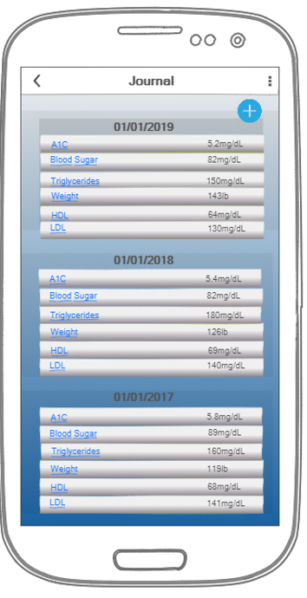

**Screen 8 – Statistics**

Statistics page shows a graphical representation of the health indicator values. It helps the user visualize the progress and make any lifestyle changes to improve health data. The Back button on top takes the user to the Journal page.

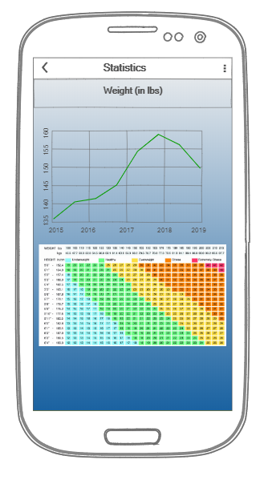 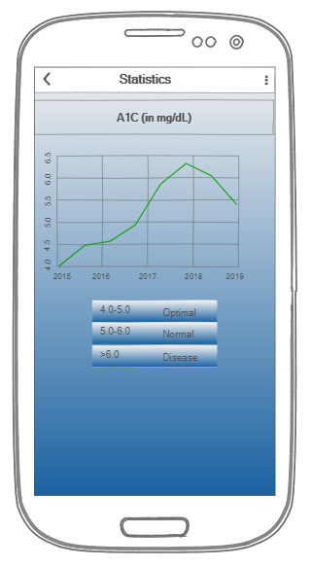

**Screen 9 – Log Health Data**

Screen captures key health indicators. The options are shown as a dropdown. The user can change the units (mg/dL to mmg/dL) in the Settings screen.

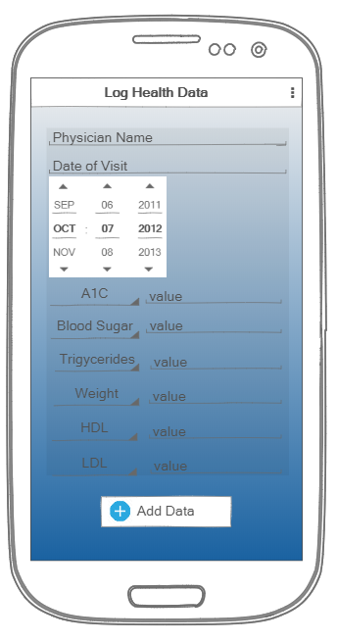

**Screen 10 – Settings**

The Settings screen lets the user change the units in which the data such as height, weight, and drug dosage are measured.

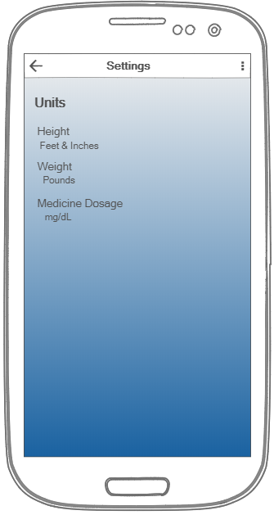 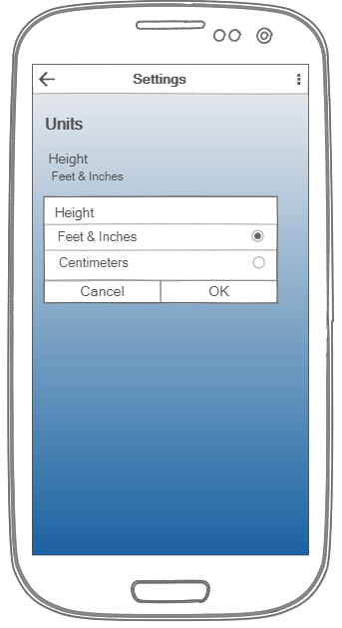

Key Considerations

**How will your app handle data persistence?**

App will use Content Provider and Shared Preferences to store data.

**Describe any edge or corner cases in the UX.**

* After initial install or when there is no data to display, the Journal and Current Medications screens show an empty screen with just the Add button on top.
* The layouts will adapt to changes in screen orientation and resolution.
* A Network Failure message will be shown when there is no internet.

**Describe any libraries you’ll be using and share your reasoning for including them.**

* Picasso to handle the loading and caching of images.
* Retrofit to handle network API requests.
* ButterKnife for field and method binding.
* Firebase for analytics and reporting crash.

**Describe how you will implement Google Play Services or other external services.**

* [com.google.android.gms.analytics](https://developers.google.com/android/reference/com/google/android/gms/analytics/package-summary.html) – Google Analytics
* [com.google.android.gms.maps](https://developers.google.com/android/reference/com/google/android/gms/maps/package-summary.html) – Google Maps
* io.fabric.tools:gradle:1.31.2 – Firebase Crashlytics

Required Tasks

**Task 1: Project Setup**

* Create a new project in Android Studio and add it to Github.
* Add necessary dependencies for libraries.
* Create debug and build variants.

**Task 2: Data model classes**

* Create data classes for
  + User
  + Medications
  + Health Data

**Task 3: Data Persistence**

* Add a Content Provider and Shared Preferences class to handle locally stored data.
  + Create a database helper
  + Create a Content Provider
  + Create a Shared Preferences helper
  + Implement database access functions using Loaders

**Task 4: Networking**

* Add classes to communicate with [*https://rxnav.nlm.nih.gov/REST/approximateTerm?term*](https://rxnav.nlm.nih.gov/REST/approximateTerm?term%20)to retrieve matching medications.

**Task 5: User Interface**

* Create layouts and activities for all screens.
* Handle changes in orientation and resolution.

**Task 6: Implement Google Play Services**

* Implement Firebase Crashlytics and Analytics

**Task 7: Make app production ready**

* Implement Material Design principles.
* Provide content descriptions for meaningful UI elements.
* Provide accessibility support.

**Task 8: Test**

* Test on multiple devices

**Task 9: Deploy to Play Store**

* Generate app flavor keys.
* Create APK.
* Push the APK to the play store.