**Assignment 8.2**

**TASK :**

**Write a hive UDF that implements functionality of string concat_ws(string SEP, array<string>). This UDF will accept two arguments, one string and one array of string. It will return a single string where all the elements of the array are separated by the SEP.**

**To complete this task below steps are followed:**

**Step 1: Started all hadoop daemons using start-all.sh command inside /$HADOOP_HOME/sbin. Started mysqld service using sudo service mysqld start.**

**Step 2: Launched hive using hive command.**

**Step 3: Created emp_array.txt file inside /home/acadgild/Documents/mydata/Hive/Practice with following contents:**

**Joe Analyst,Data Engineer,Data Consultant**

**Dan Analyst,Software Engineer,Software Consultant**

**Alex Director,Project Manager,Project Consultant**

**John Analyst,Test Engineer,Software Consultant**

**Step 4: Created emp_array table inside emp database as follows:**

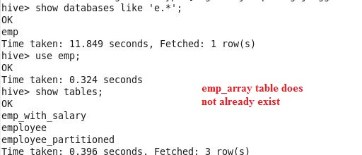

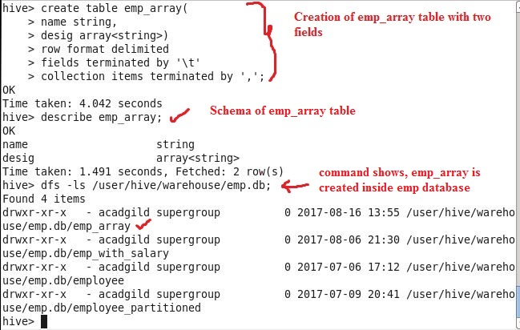

**Step 5: Loaded emp_array table with data inside emp_array.txt file as follows:**

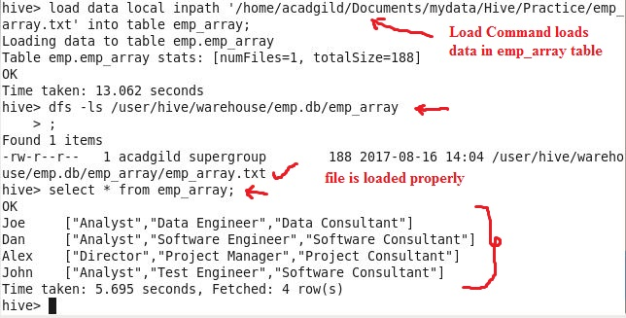

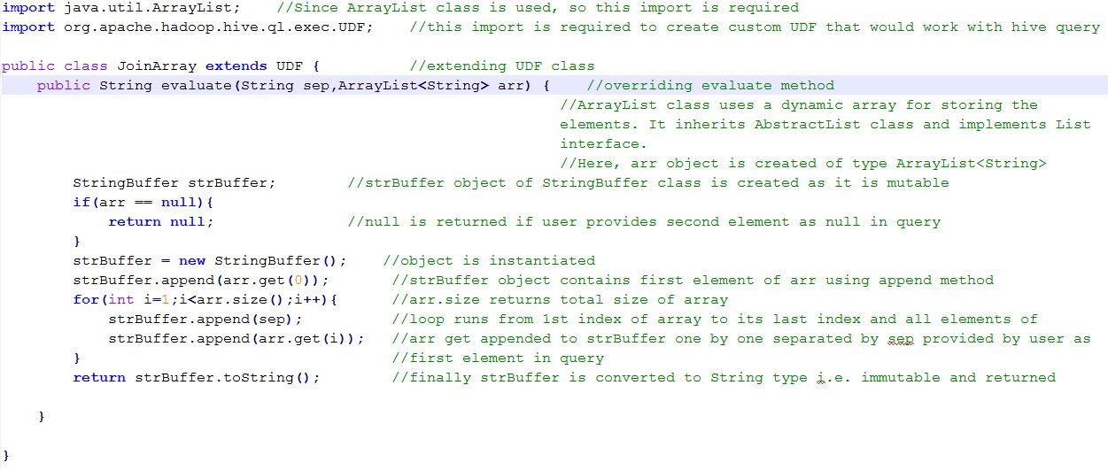**Step 6: Created JoinArray class extending UDF class inside JoinArray.java file using eclipse, and code for UDF is as follows:**

**Step 7: Created JoinEmpDesigArray.jar for file JoinArray.java.**

**Step 8: At hive prompt, added this jar i.e. JoinEmpDesigArray.jar, after successful addition of jar, created temporary function arraySep(param1,param2).**

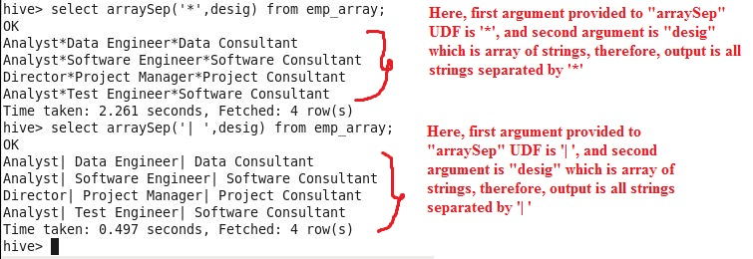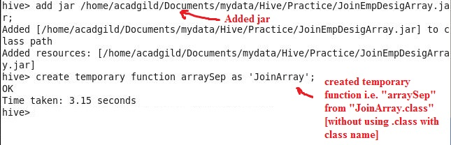

**Step 9: At hive prompt, executed query with UDF i.e. arraySep(), as follows:**

