**ShopEZ: e-commerce Application**

**1. Introduction**

**An e-commerce shopping website provides a digital platform where customers can browse, select, and purchase products online. Typically, it features a user-friendly interface with categories, product pages, a shopping cart, and a secure checkout process. Users can explore various products, filter by category, price, and brand, and view detailed descriptions, images, and reviews to help inform purchasing decisions. Payment options often include credit cards, digital wallets, and other secure methods. Backend services manage inventory, customer data, and transaction security, while front-end design ensures a seamless shopping experience on both desktop and mobile devices**.

**2. Project Overview**

**An e-commerce shopping website project involves creating an online platform where customers can conveniently browse products, add items to a shopping cart, and make secure purchases. Key components include a product catalog, user-friendly navigation, filtering options, and a checkout system with multiple payment options. The backend handles inventory management, customer accounts, and data security, while the frontend ensures an engaging and responsive user experience across devices. This project aims to streamline online shopping, providing users with an accessible, reliable, and enjoyable way to shop from anywhere.**

**3. Architecture**

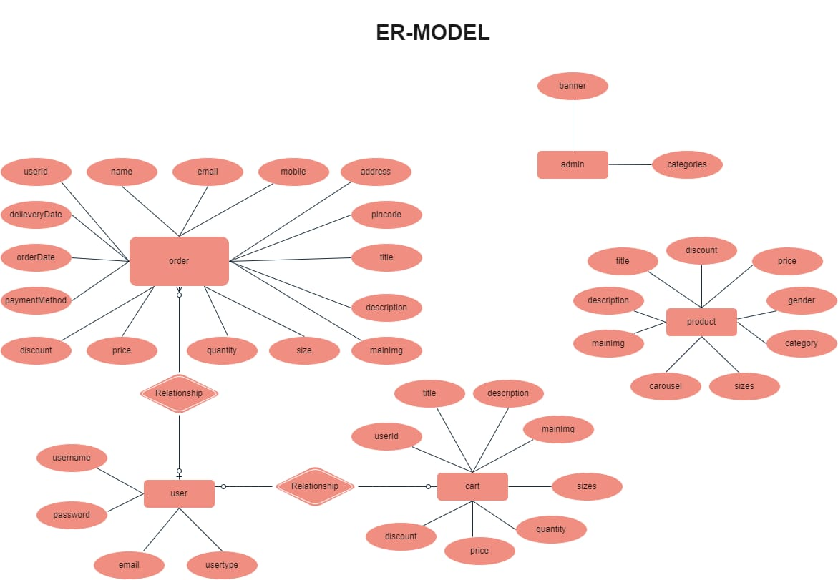

**he ShopEZ ER-diagram represents the entities and relationships involved in an e-commerce system. It illustrates how users, products, cart, and orders are interconnected. Here is a breakdown of the entities and their relationships:**

**USER: Represents the individuals or entities who are registered in the platform.**

**Admin: Represents a collection with important details such as Banner image and Categories.**

**Products: Represents a collection of all the products available in the platform.**

**Cart: This collection stores all the products that are added to the cart by users. Here, the elements in the cart are differentiated by the user Id.**

**Orders: This collection stores all the orders that are made by the users in the platform.**

**Features:**

**1. Comprehensive Product Catalog: ShopEZ boasts an extensive catalog of products, offering a diverse range of items and options for shoppers. You can effortlessly explore and discover various products, complete with detailed descriptions, customer reviews, pricing, and available discounts, to find the perfect items for your needs.**

**2. Shop Now Button: Each product listing features a convenient "Shop Now" button. When you find a product that aligns with your preferences, simply click on the button to initiate the purchasing process.**

**3. Order Details Page: Upon clicking the "Shop Now" button, you will be directed to an order details page. Here, you can provide relevant information such as your shipping address, preferred payment method, and any specific product requirements.**

**4. Secure and Efficient Checkout Process: ShopEZ guarantees a secure and efficient checkout process. Your personal information will be handled with the utmost security, and we strive to make the purchasing process as swift and trouble-free as possible.**

**5. Order Confirmation and Details: After successfully placing an order, you will receive a confirmation notification. Subsequently, you will be directed to an order details page, where you can review all pertinent information about your order, including shipping details, payment method, and any specific product requests you specified.**

**In addition to these user-centric features, ShopEZ provides a robust seller dashboard, offering sellers an array of functionalities to efficiently manage their products and sales. With the seller dashboard, sellers can add and oversee multiple product listings, view order history, monitor customer activity, and access order details for all purchases.**

**ShopEZ is designed to elevate your online shopping experience by providing a seamless and user-friendly way to discover and purchase products. With our efficient checkout process, comprehensive product catalog, and robust seller dashboard, we ensure a convenient and enjoyable online shopping experience for both shoppers and sellers alike.**

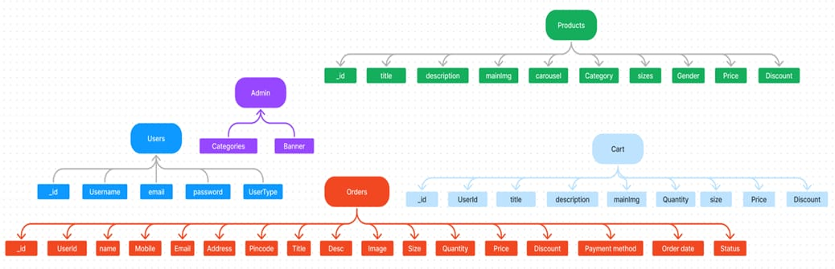

**4. Setup Instructions**

**Here’s a concise step-by-step guide for building an e-commerce website:**

**1. **Plan and Define**: Identify target audience, product categories, and essential features (product catalog, cart, checkout).**

**2. **Select Tech Stack**: Choose frontend (React/Vue), backend (Node.js/Django), and database (MySQL/MongoDB).**

**3. **Set Up Structure**: Organize files and install necessary packages.**

**4. **Frontend Design**: Build pages for products, cart, and user accounts with responsive design.**

**5. **Backend Development**: Set up database and create APIs for product management, authentication, and checkout.**

**6. **Security**: Implement HTTPS, secure authentication, and payment integrations (Stripe/PayPal).**

**7. **Testing**: Test all features, including product listing, cart, and payments.**

**8. **Deploy**: Host on a cloud provider and configure domain and SSL.**

**9. **Optimize**: Improve load speed and set up analytics.**

**10. **Maintenance**: Update products, features, and security regularly.**

**This approach ensures a smooth and secure shopping experience for users.**

**5. Folder Structure**

**Client:**

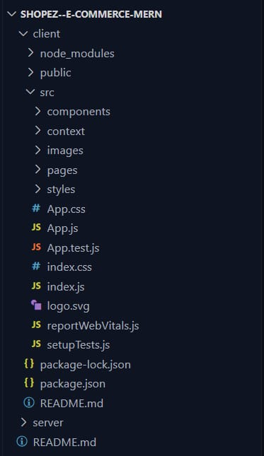

**Server:**

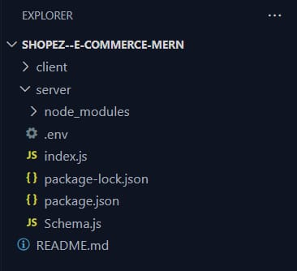

The folder structure is organized to maintain a clean and modular architecture.

This structure assumes a React app and follows a modular approach. Here's a brief explanation of the main directories and files:

* src/components: Contains components related to the application such as, register, login, home, etc.,

* src/pages has the files for all the pages in the application.

**6. Running the Application**

To run the e-commerce application:

1. **Install Dependencies**: In the project root, run `npm install` (for Node.js) or use the package manager required for your stack.

2. **Set Up Environment Variables**: Configure `.env` file with keys (e.g., database URL, API keys).

3. **Database Setup**: Initialize the database with `npm run db:setup` or the equivalent command.

4. **Start Backend Server**: Run `npm start` or `node server.js` to start the backend.

5. **Start Frontend**: Run `npm start` or `yarn start` in the frontend folder.

6. **Access Application**: Open `http://localhost:3000` in your browser to view the application.

7. **Testing**: Verify key features like product display, cart, and checkout.

This process should have the application up and running locally.

**7. API Documentation**

**8. Authentication**

This project uses JWT (JSON Web Tokens) to manage authentication and authorization. Upon login, the backend generates a token that is stored on the client-side and used in subsequent requests to verify the user’s identity. Role-based access is implemented, granting or restricting permissions based on the user’s role (e.g., admin, seller), thereby enhancing data security.

**9. User Interface**

The user interface is built with a focus on accessibility and ease of navigation. Screenshots or GIFs of the homepage, product listing page, product details page, cart, and checkout pages provide a clear representation of the user journey from browsing to purchasing, showcasing a consistent and streamlined experience.

**10. Testing**

The app follows a well-defined testing strategy:

- Unit Testing is performed with Jest to validate individual components and functions, ensuring each element works as expected.

- Integration Testing leverages Supertest to verify that API endpoints interact correctly with the database and business logic.

- End-to-End Testing uses Cypress to simulate real user interactions and verify the overall functionality of the application.

**11. Screenshots**

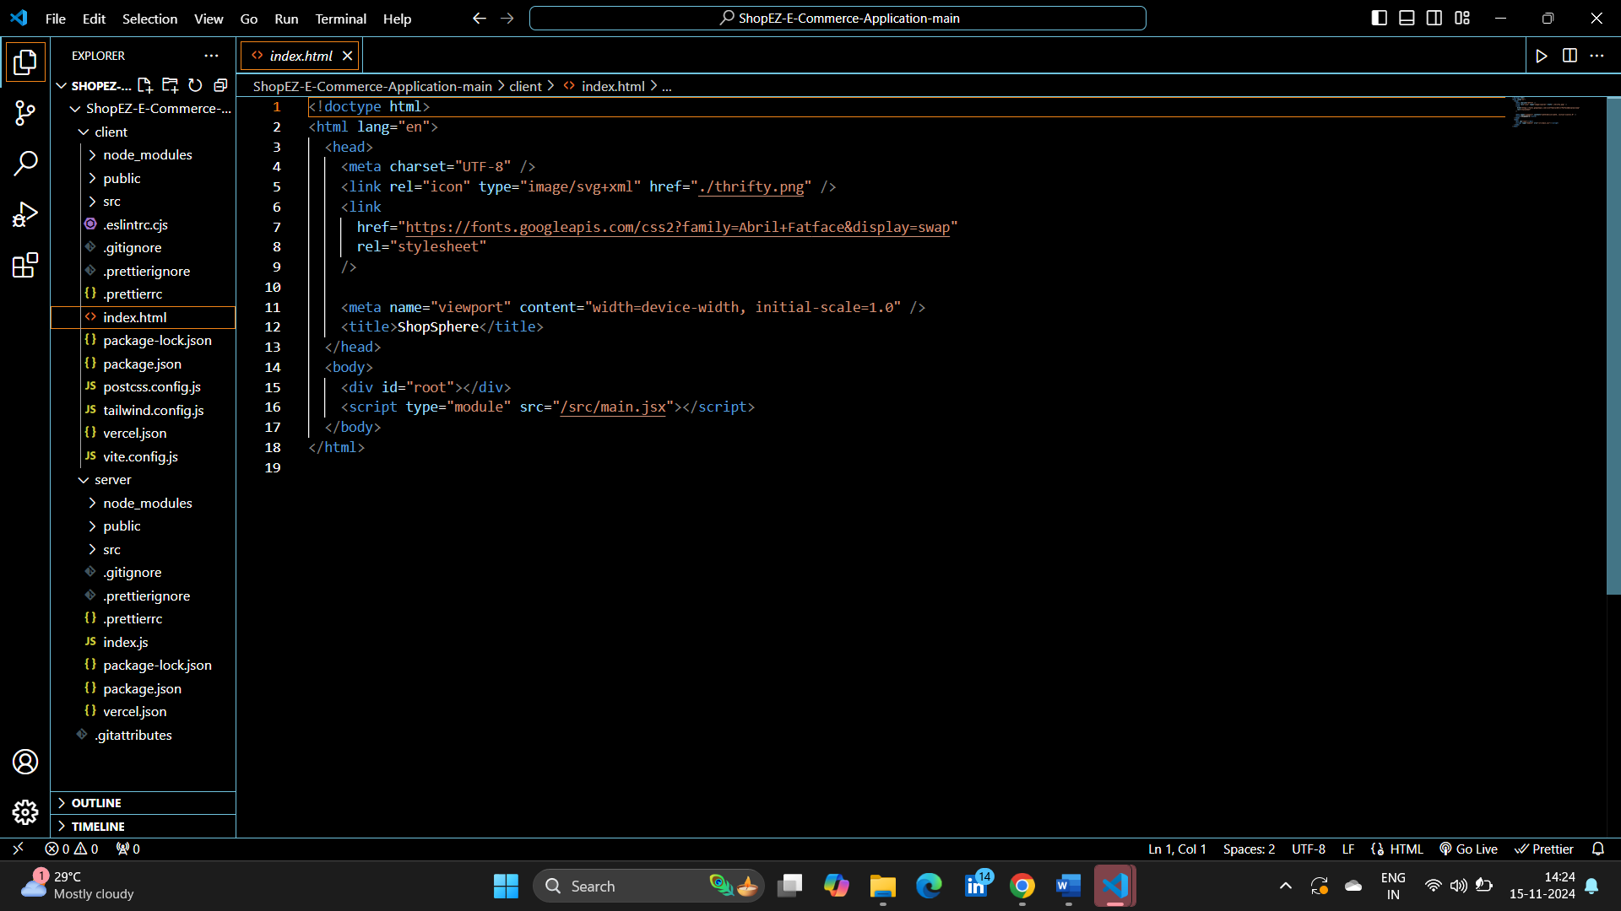

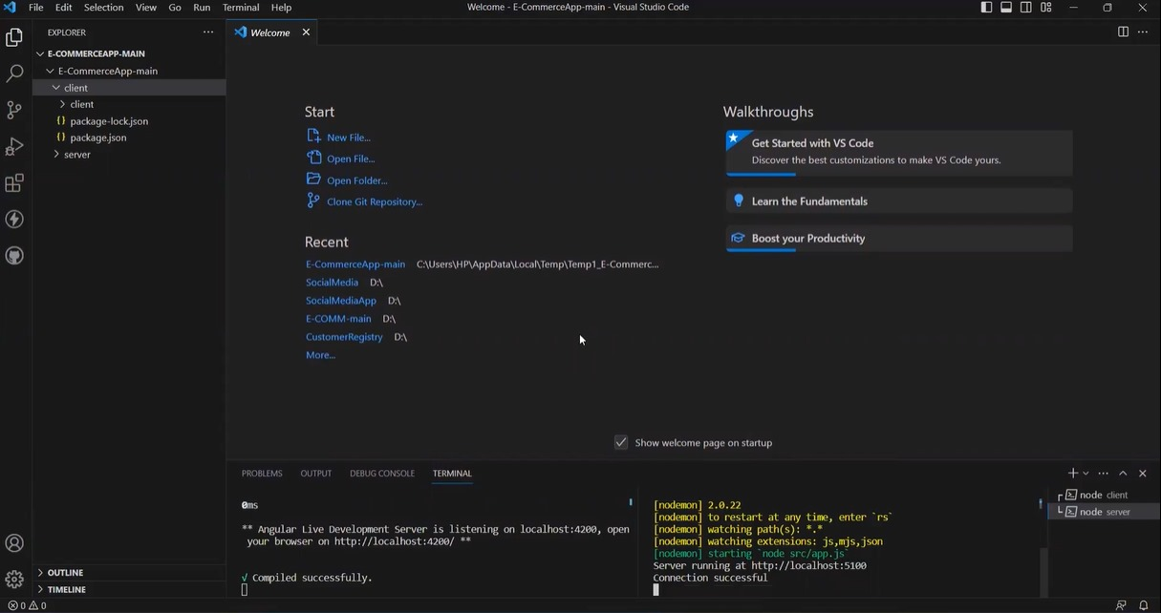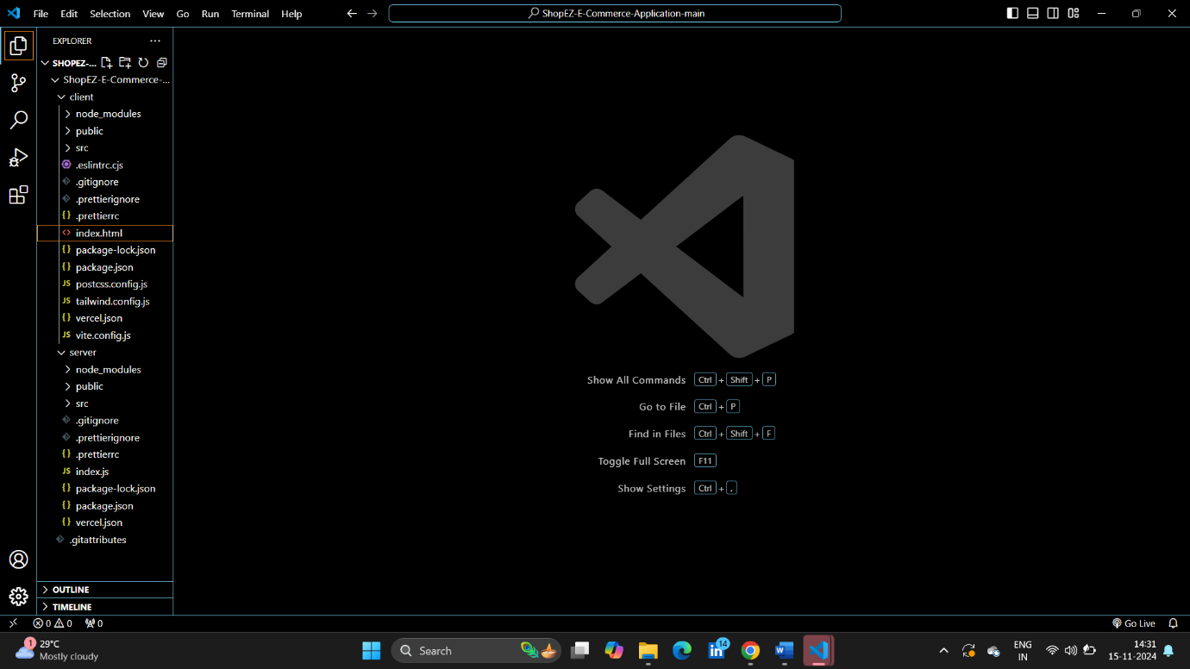

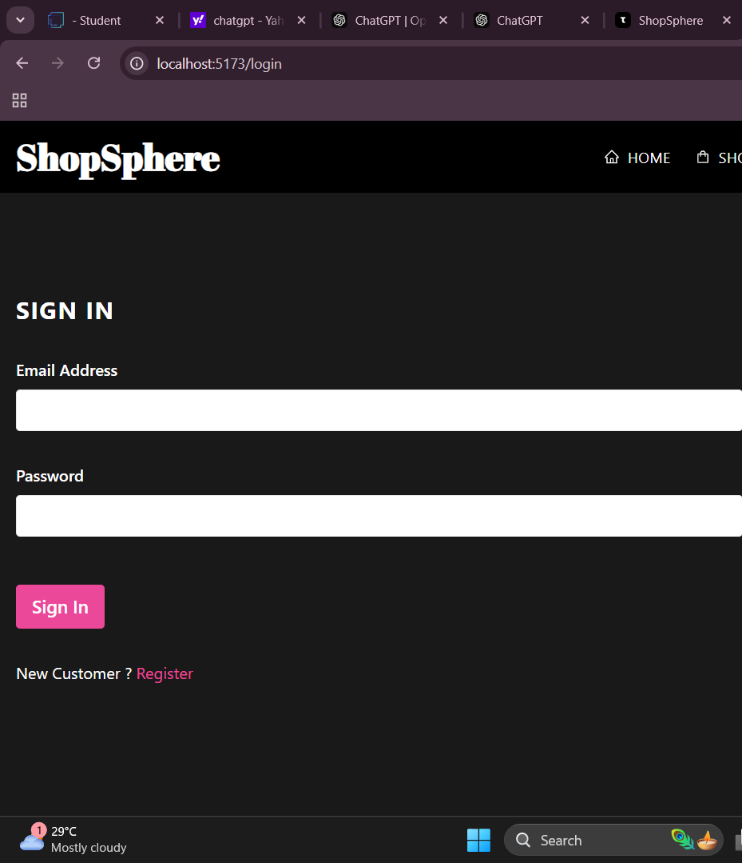

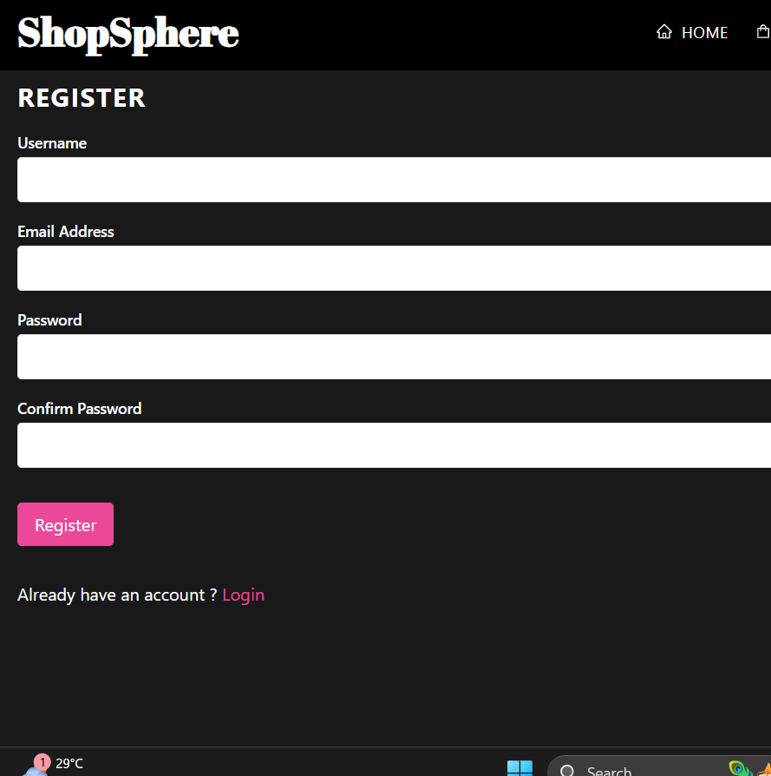

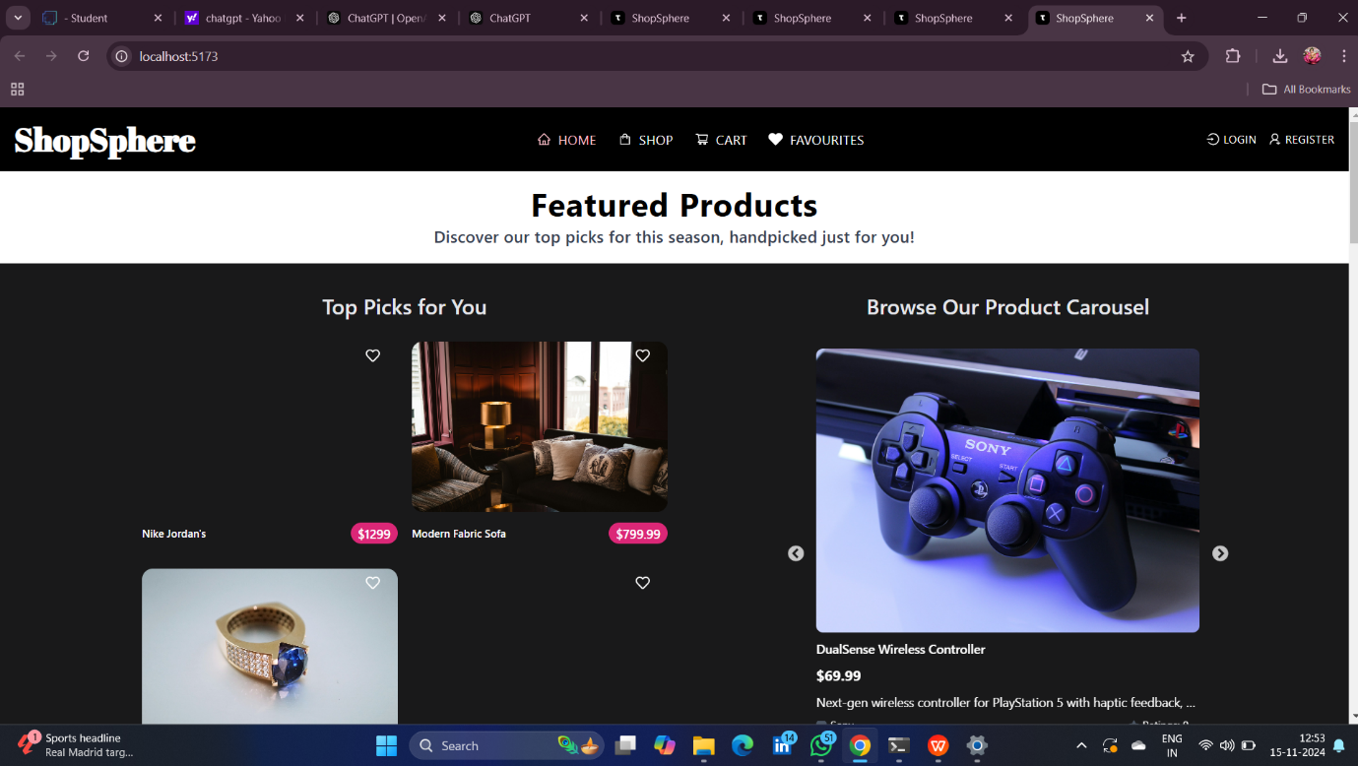

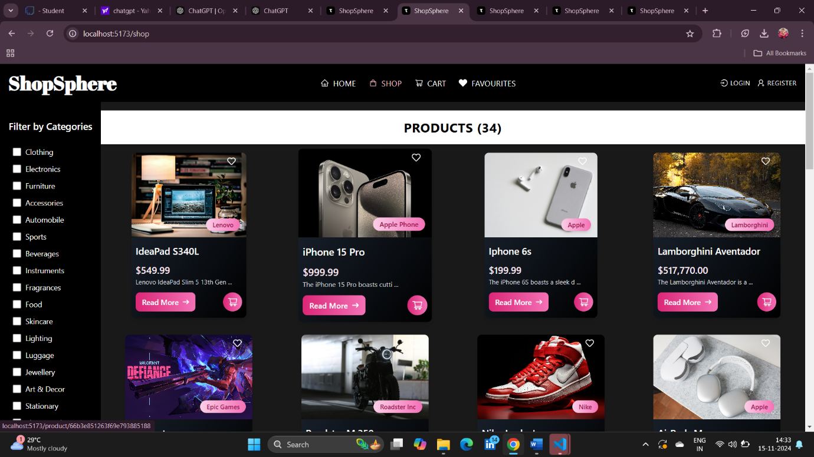

Visual assets such as screenshots of the homepage, product pages, and checkout provide users and developers with an illustrative overview of the application’s interface. For a more interactive experience, a live demo link or video walkthrough can further demonstrate the app’s features.

**12. Known Issues**

The app currently has a few known issues that are being addressed:

- There are minor UI inconsistencies on specific mobile screen sizes.

- Occasional delays in order confirmation can occur during peak server load.

**13. Future Enhancements**

To continuously improve the app, several future enhancements are planned, including:

- Adding multi-language support to expand accessibility for users of different languages.

- Implementing a recommendation engine to offer personalized product suggestions based on user purchase history.

- Enhancing seller analytics with detailed insights into sales trends and inventory forecasts, empowering sellers with data-driven tools.

This detailed report captures the project’s key features, technical setup, and functionality, providing a comprehensive reference for users and developers alike to understand, set up, and contribute to the grocery web app.