Development of System Electronics of 1 KW High Power Fiber Laser
Deepika Porwal^1, Abhishek Parmar^2
1 Defense Research Development Organization (DRDO) HQ, New Delhi, India– 110011
2 Instrument R&D Establishment (IRDE), Dehradun, India- 248008
deepikaporwal.irde@gov.in

Abstract: This paper presents the design and development of the system electronics for a 1 kW high-power fiber laser, implemented and successfully tested in a controlled laboratory environment. The developed system achieves a continuous-wave laser output of 1 kW at a wavelength of 1070 nm, with excellent beam quality characterized by an M² value of 1.2. To achieve this high optical output, the system integrates 36 high-power pump diodes, the performance of which is continuously monitored through a comprehensive electronic control and protection mechanism. Additionally, precise thermal management of the optical components—including the pump combiner, collimator, and mounting plates—is ensured through a closed-loop chiller and water flow system, maintaining operational stability and preventing thermal-induced degradation. The developed electronic control system incorporates real-time monitoring, feedback control, and protection circuits for efficient power management and safe laser operation. This paper contributes toward the indigenization and laboratory-scale realization of kilowatt-class fiber laser systems.
Keywords: - Laser technology, High Power Fiber Laser (HPFL), Solid state relay (SSR).

I. Introduction: -
In recent years, laser technology has advanced rapidly, particularly in the defense sector, where it has created both new opportunities and emerging challenges in directed-energy systems [1], [2]. Among the various laser architectures, high-power fiber lasers (HPFLs) have become a major milestone in modern photonics due to their high efficiency, superior beam quality, compact configuration, and effective thermal management [3]- [5].
In contrast to traditional solid-state or gas-based lasers, a fiber laser employs an optical fiber doped with rare-earth elements—such as ytterbium (Yb), erbium (Er), or thulium (Tm)—as the gain medium. The extended interaction length within the fiber and its large surface-to-volume ratio enable efficient removal of generated heat, allowing the laser to operate at elevated power levels with minimal thermal effects [6], [7]. These characteristics contribute to its stable and continuous-wave performance even under demanding power conditions.
Over the past two decades, fiber laser technology has evolved from a laboratory innovation into a mature and reliable platform for industrial and defense applications. Today, HPFLs are widely employed in precision machining, additive manufacturing, remote sensing, and medical procedures, as well as in directed-energy weapon systems [8]–[10]. Their capability to deliver kilowatt-class continuous-wave output with near-diffraction-limited beam quality makes them the preferred solution wherever high optical power and precision are essential [11], [12].
In Development of System Electronics of 1 KW High Power Fiber Laser (HPFL) as depicted in figure 1, 36 diodes having wavelength of 976nm and power of 44W were pumped combined to have total input power of approximate 1500W. Lasing occurred in this active fiber. continuous wave output is achieved having 1kw laser output power at 1070nm wavelength with good beam quality having m^2 of 1.2.

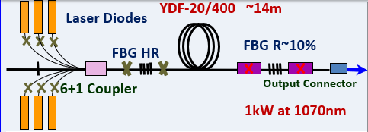
Fig.1. Schematic of Fiber Laser
II. Literature Survey:-
The first demonstration of a fiber laser was reported in the early 1960s by E. Snitzer and colleagues, who achieved an output power of approximately 500 mW at a wavelength near 1 µm, with a conversion efficiency of about 80% relative to the input pump power [13]. This pioneering work laid the foundation for modern fiber-laser technology. By the late 1990s, advancements in fiber design and pumping techniques enabled the realization of the first 100 W-level fiber laser, soon followed by the first kilowatt-class laser based on a large-core, double-clad ytterbium-doped fiber (Yb-DF) [14]. The output power of such systems was primarily constrained by the available pump-diode power rather than by intrinsic material limitations.
In 2009, IPG Photonics Inc. successfully developed and commercialized a single-mode fiber-laser system delivering 10 kW of continuous-wave output [15]. Subsequently, in 2012, a 100 kW multimode fiber-laser system operating near 1 µm was reported, representing the highest output power ever achieved from a solid-state laser source at that time [16]. The inherent advantages of fiber lasers—including compactness, high electrical-to-optical efficiency, superior beam quality, long operational lifetime, mechanical robustness, ease of integration, and low maintenance requirements—have made them a dominant alternative to traditional solid-state laser systems [17]. The 1 kW fiber-laser system developed in the laboratory serves as a critical step toward the development of higher-power fiber-laser platforms for future applications in scientific and defense domains.
III. Hardware Implementation Approach: -
To achieve a continuous laser output of 1 kW, as illustrated in Figure 2, it was necessary to precisely monitor and regulate multiple subsystems, including the output power of 36 pump diodes, and the temperature of different heat-dissipation plates, the pump combiner, and the collimator assembly. Stable operation at this power level demanded a highly efficient chiller and water-flow mechanism, providing continuous cooling and ensuring all components remained within their specified thermal limits. So, a data acquisition system (DAS) has been developed in the laboratory that can control temperature of different plates, power of diodes, flow pressure and analog temperature inside the chiller and control of fiber breakage for safe operation. So, a data acquisition system, consisting of 24 temperature sensors, 36 SSR, one flow meter sensor, one pressure sensor, one analog temperature sensor, one power fluctuation sensor and one fiber breakage sensor has been designed and developed in the laboratory.This DAS is interfaced to a microcontroller-based control unit, which performs signal conditioning, analog-to-digital conversion, and logic processing and microcontroller interfaced with system manager using RS232 interface. The microcontroller monitors the temperature of plates using 24 temperature sensors, 36 SSR for controlling diodes and 5 analog sensors. If any sensors go out of the range it sends commands to the system manager to stop operation of the laser.
Flow chart in figure 3 shows how the micro controller was interfaced with the system manager and HPFL system. The mode of operation of the system manager was standby, ready and fire. The first system manager sends commands to the microcontroller to establish a link between them. When the temperature of all plates was found within range and it is in ready state. The micro controller sent data from sensors to the system manager. When the laser is fired and any sensors found out of the range, the microcontroller generates an interlock and sends the command back to the system manager to stop operation of the laser.
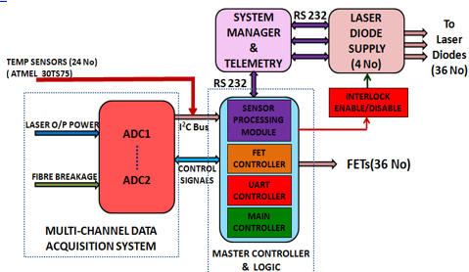
Fig. 2. Block diagram of system electronics of 1 KW FL

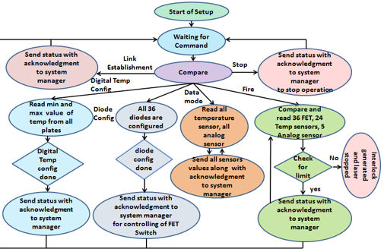

Fig. 3. Flow chart of Master Controller Communicating with different sensors
IV. Results: -

Figure 4 presents the experimental laboratory setup of the prototype 1 kW High-Power Fiber Laser (HPFL) system developed in-house. The entire setup was assembled on a vibration-isolated optical table to minimize alignment drift and thermal stress during continuous operation. The HPFL employs 36 high-power laser diodes as the primary optical pump sources. These diodes are organized into three modular diode plates—Diode Plate 1, Diode Plate 2, and Diode Plate 3—each accommodating 12 diodes. The diode modules are mounted on precision-machined aluminum heat-sink plates to facilitate efficient heat dissipation. Each diode plate is equipped with individual solid-state relays for power control and protection. Electronics plate consists of Data acquisition system, 24 temperature sensors positioned across the diode plates, pump combiners, and mechanical mounts, 36 SSRs for diode current control, one flow-meter sensor for chiller water circulation monitoring, one pressure sensor to verify adequate coolant pressure, one analog temperature sensor inside the chiller, one power-fluctuation sensor to detect diode instability and system instability, one fiber-breakage sensor to protect against catastrophic optical-fiber damage. The experimental results demonstrated the reliability, scalability, and safety of the developed DAS-controlled HPFL system. This prototype serves as a proof-of-concept for further scaling to multi-kilowatt fiber-laser systems.
Figure 5 shows a prototype of 1KW High fiber laser system developed at laboratory.

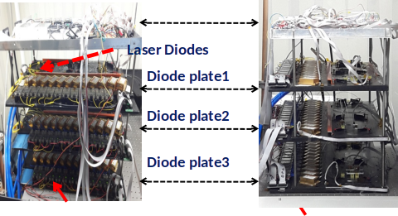

Fig. 4. Experimental Setup in Laboratory

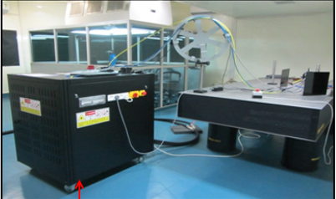

Fig. 5. Prototype of 1KW HPFL developed at Laboratory
V. Conclusion: -
Laser technology continues to evolve, contributing significantly to various fields such as manufacturing, medicine, communication, defense, and scientific research. In this present work, extensive research and development have been carried out in the laboratory to design and implement a 1 kW High-Power Fiber Laser (HPFL) system. A microcontroller-based Data Acquisition System (DAS) was developed to monitor and control the temperature of multiple diodes and other critical parameters using various sensors. This system ensures precise control, real-time monitoring, and automatic interlocking for safe and stable operation of the HPFL. The successful realization of the 1 kW HPFL prototype serves as a proof-of-concept for further advancements toward multi-kilowatt fiber-laser systems.
References: -
[1] J. D. Walker, “Directed Energy Weapons: Physics of High Energy Lasers,” SPIE Defense, Security, and Sensing, 2012.
[2] A. M. Rubenchik, M. P. Fedoruk, and I. M. Belousov, “Laser technologies for defense applications,” Applied Optics, vol. 58, no. 34, pp. 9415–9425, 2019.
[3] J. Limpert, T. Schreiber, and A. Tünnermann, “High-power ultrafast fiber laser systems,” IEEE Journal of Selected Topics in Quantum Electronics, vol. 12, no. 2, pp. 233–244, 2006.
[4] C. Jauregui, J. Limpert, and A. Tünnermann, “High-power fiber lasers,” Nature Photonics, vol. 7, pp. 861–867, 2013.
[5] W. A. Clarkson, “Thermal effects and their mitigation in end-pumped solid-state lasers,” Journal of Physics D: Applied Physics, vol. 34, no. 16, pp. 2381–2395, 2001.
[6] A. E. Siegman, Lasers, University Science Books, 1986.
[7] T. Richardson, “Fiber laser design fundamentals,” Optics and Photonics News, vol. 26, no. 10, pp. 34–41, 2015.
[8] H. Liu, Y. Zhao, and Z. Zhang, “Advances in high power fiber lasers and their applications,” Frontiers of Optoelectronics, vol. 15, pp. 1–15, 2022.
[9] B. Samson et al., “Industrial applications of high power fiber lasers,” Physics Procedia, vol. 56, pp. 1074–1083, 2014.
[10] D. M. Filgas, “High-energy laser weapon systems,” IEEE Transactions on Plasma Science, vol. 43, no. 5, pp. 1412–1418, 2015.
[11] Y. Jeong et al., “High-power single-mode ytterbium-doped fiber laser,” Optics Express, vol. 12, no. 25, pp. 6088–6092, 2004.
[12] D. J. Richardson, J. Nilsson, and W. A. Clarkson, “High power fiber lasers: current status and future perspectives,” Journal of the Optical Society of America B, vol. 27, no. 11, pp. B63–B92, 2010.
[13] E. Snitzer, “Optical maser action of Nd³⁺ in a barium crown glass,” Physical Review Letters, vol. 7, no. 12, pp. 444–446, 1961.
[14] J. Limpert, T. Schreiber, and A. Tünnermann, “High-power ultrafast fiber laser systems,” IEEE Journal of Selected Topics in Quantum Electronics, vol. 12, no. 2, pp. 233–244, 2006.
[15] V. Gapontsev and V. Fomin, “Ten-kilowatt single-mode fiber laser: new horizons for industrial applications,” Laser Technik Journal, vol. 6, no. 4, pp. 45–48, 2009.
[16] IPG Photonics, “100 kW fiber laser sets world record,” Press Release, Oxford, MA, 2012.
[17] C. Jauregui, J. Limpert, and A. Tünnermann, “High-power fibre lasers,” Nature Photonics, vol. 7, pp. 861–867, 2013.

