# Insight Stream

# 1. Introduction

• Project Title: Insight Stream Navigate the landscape   
• Team ID: 709  
• Team Leader:Deepika.R & @deepikaravichandran788@gmail.com  
• Team Members:

Abirami.B & @abirami182007@gmail.com

Bhavithra.S & @sbhavithra844@gmail.com

Akshaya.T & @priyatamilt615@gmail.com

# 2. Project Overview

• Purpose: This project is a news portal frontend built with React. It allows users to browse top stories, categories, newsletters, and detailed news articles.  
  
• Features:  
 – Home page with top stories and highlights  
 – Category-based news browsing  
 – Newsletter subscription  
 – Responsive UI with reusable components

# 3. Architecture

• Frontend: React.js with Context API and modular components  
• Backend: [To be connected, e.g., Node.js/Express or external API]  
• Database: [Not in this repo; expected external API or backend storage]

# 4. Setup Instructions

• Prerequisites:  
 – Node.js  
 – npm (Node Package Manager)  
 – Git  
 – Visual Studio Code  
  
• Installation Steps:  
 # Clone the repository  
 git clone <repo_url>  
  
 # Navigate to project folder  
 cd code  
  
 # Install dependencies  
 npm install  
  
 # Start development server  
 npm start

# 5. Folder Structure

code/  
├── public/ # Static assets  
├── src/  
│ ├── components/ # Reusable components (Hero, Navbar, Footer, etc.)  
│ ├── context/ # Global state management  
│ ├── pages/ # Page components (Home, NewsPage, CategoryPage)  
│ ├── styles/ # CSS stylesheets  
│ └── App.js # Main React app entry  
└── package.json # Project metadata & dependencies

# 6. Running the Application

• Development:  
 cd code  
 npm start  
  
• Access: Visit http://localhost:3000

# 7. API Documentation

• This frontend project consumes APIs (not included in this repo).  
 Expected API endpoints may include:  
 – /api/news/top  
 – /api/news/category/:id  
 – /api/news/:id  
 – /api/newsletter/subscribe

# 8. Authentication

• Authentication is not implemented in this frontend-only repo.  
• Expected future integration with JWT or OAuth backend.

# 9. User Interface

• Landing Page (Top stories, highlights)  
• Category Page (Filtered news)  
• News Detail Page  
• Newsletter Subscription  
• Responsive Navbar and Footer

# 10. Testing

• Unit tests with Jest and React Testing Library (setupTests.js)  
• Manual testing during development using Chrome DevTools

# 11. Screenshots or Demo

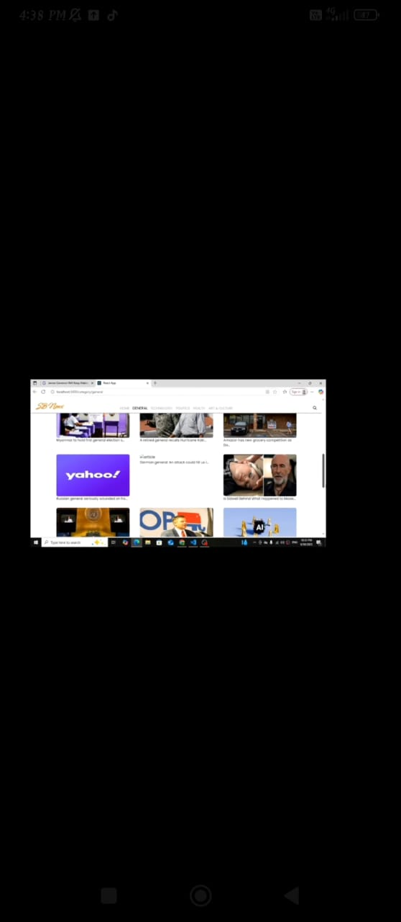

# 12. Known Issues

• Backend APIs not connected in this repo  
• Placeholder data may be used in components

# 13. Future Enhancements

• Full integration with live backend APIs  
• User authentication and personalized dashboard  
• Admin panel for managing news content  
• Improved mobile responsiveness