OptiCrop – AI-Based Smart Crop Recommendation System

Project Title
OptiCrop – AI-Based Smart Crop Recommendation System Using Machine Learning

Abstract
OptiCrop is a Flask-based machine learning web application that recommends suitable crops based on soil nutrients (N, P, K) and environmental parameters such as temperature, humidity, pH, and rainfall. It helps farmers make informed decisions to improve productivity and reduce crop selection risks.

Problem Statement
Farmers often rely on traditional knowledge to choose crops, which can lead to poor yields due to changing soil and climate conditions. OptiCrop provides data-driven crop recommendations.

Features
- Machine learning crop prediction
- Simple Flask web interface
- Fast recommendations
- Responsive design
- Easy deployment

Tech Stack
- Frontend: HTML, CSS, JavaScript, Bootstrap
- Backend: Python, Flask
- ML: Scikit-learn, NumPy, Pandas
- Visualization: Matplotlib, Seaborn
- Tools: VS Code, Git, GitHub

Installation Steps
- Clone the repository: git clone https://github.com/deepikareddy0425/OptiCrop.git
- Navigate to the project folder.
- Create and activate a virtual environment.
- Install dependencies using: pip install -r requirements.txt
- Run the application using: python app.py
- Open http://127.0.0.1:5000 in a web browser.

Usage Instructions
- Launch the application.
- Enter N, P, K, temperature, humidity, pH, and rainfall.
- Click Predict.
- View the recommended crop.

Screenshots
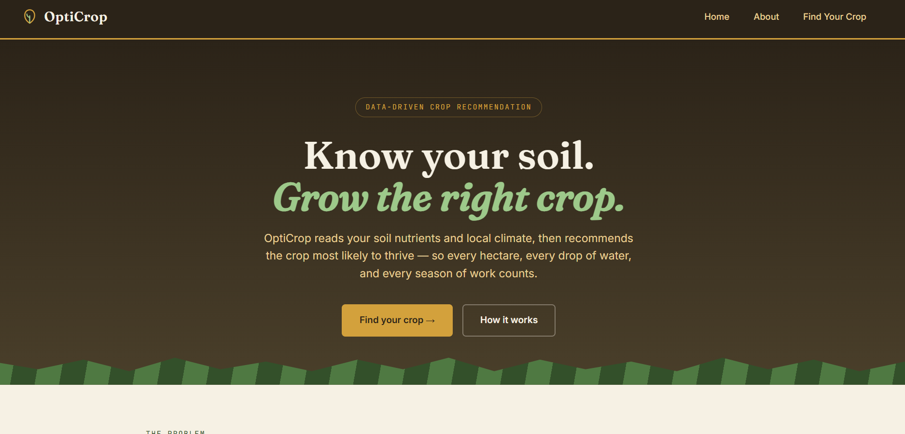
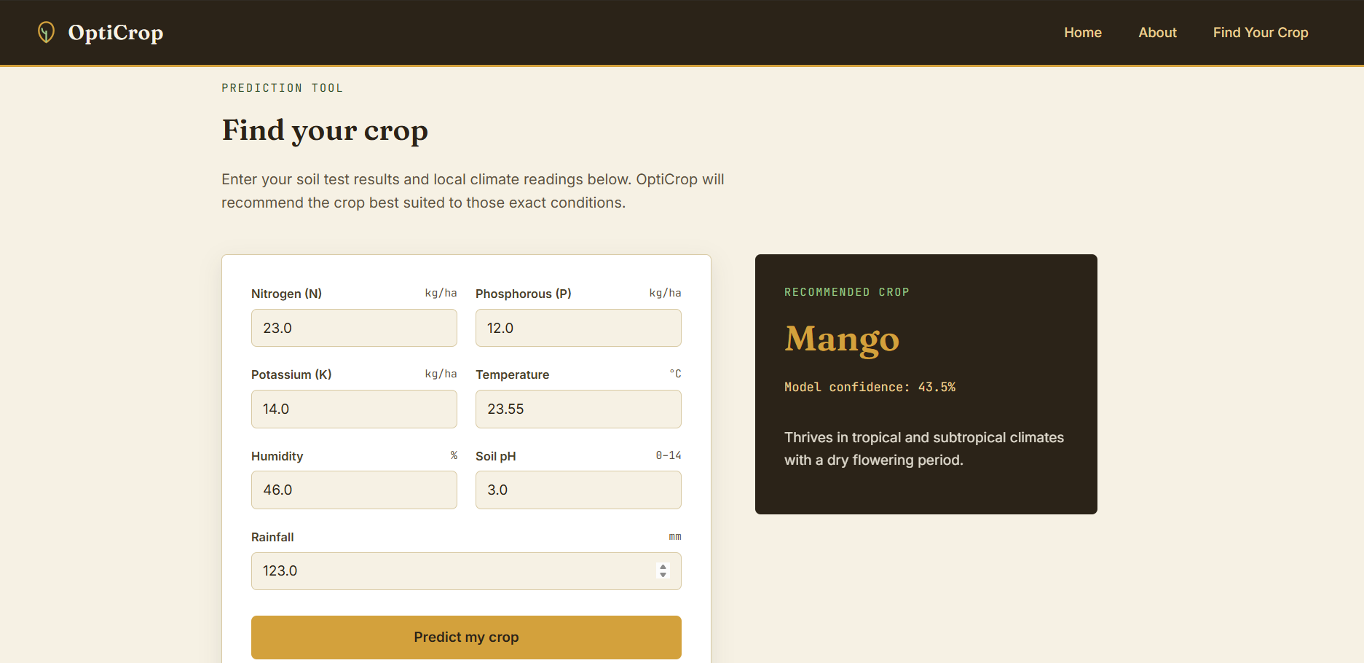
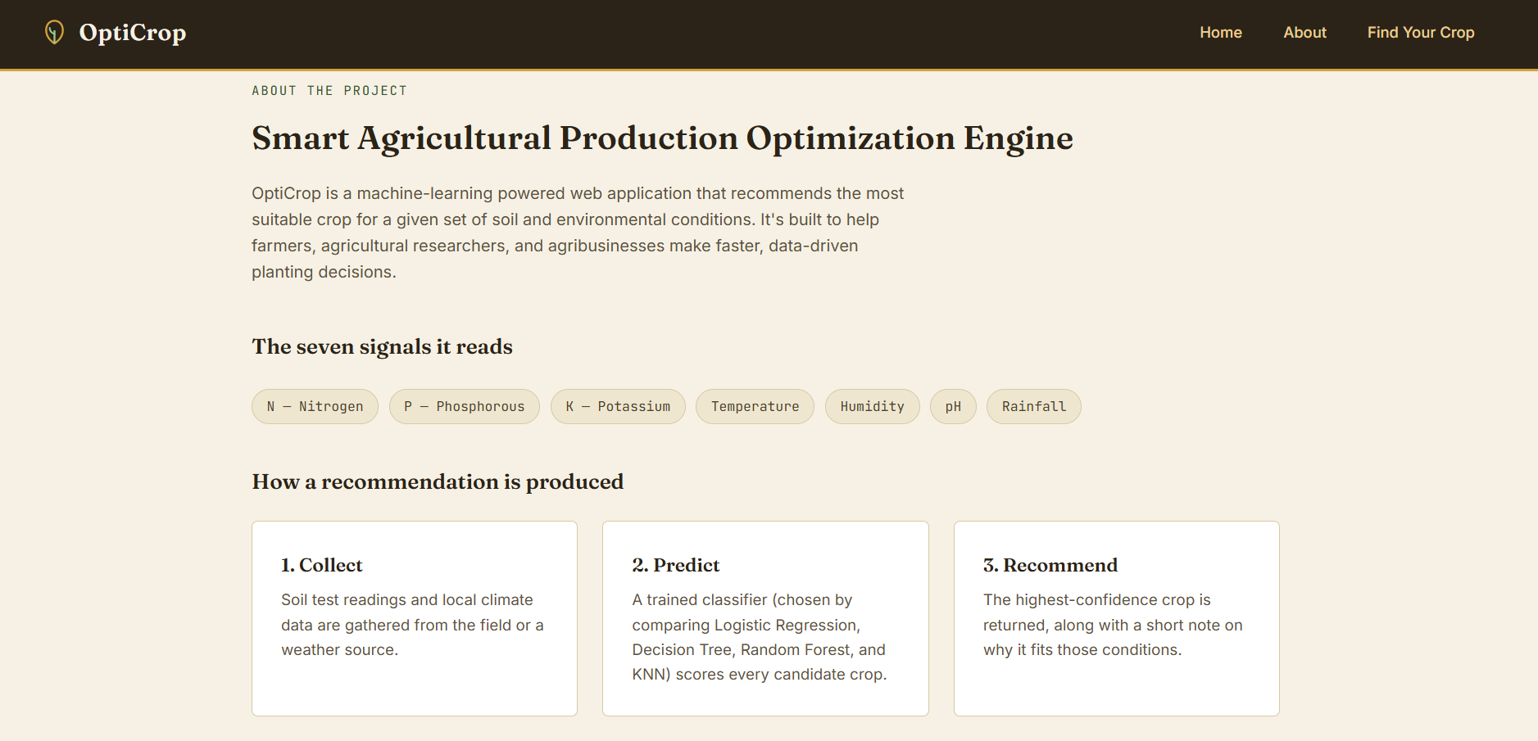

Future Scope
- Weather API integration
- Fertilizer recommendation
- Crop disease detection
- IoT sensor integration
- Mobile application
- Multilingual support
- Yield and market price prediction

