Figure 3: GERBER FILE Top Layer VIEW OF 5V DC REGULATED POWER SUPPLY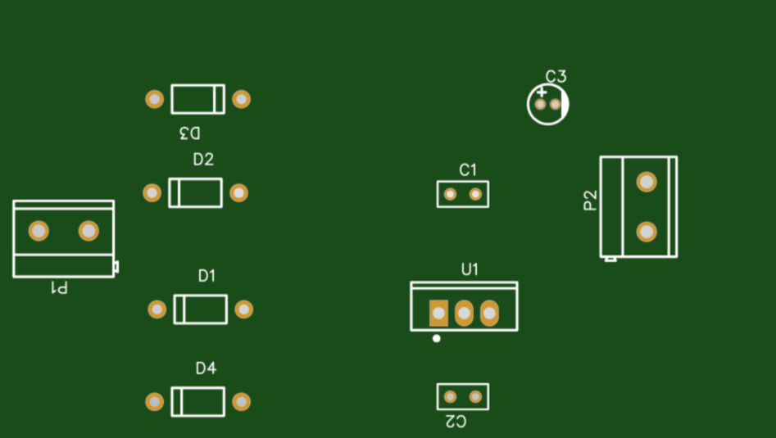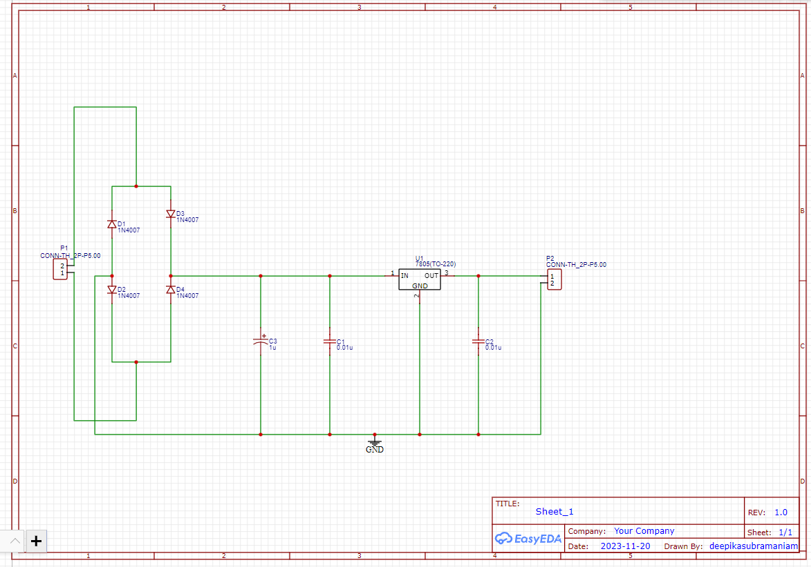

Figure 1: Design of 5V DC REGULATED POWER SUPPLY using EASYEDA



Figure 4: GERBER FILE Bottom Layer VIEW OF 5V DC REGULATED POWER SUPPLY

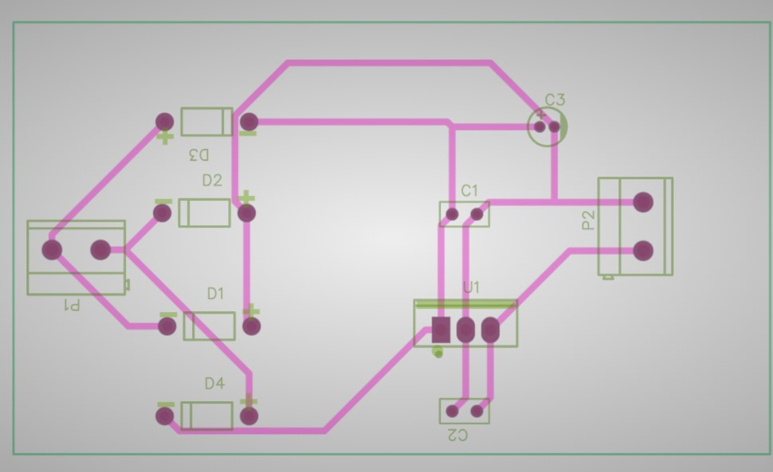

Figure 2: GERBER FILE Layered VIEW OF 5V DC REGULATED POWER SUPPLY