**KONGU ENGINEERING COLLEGE (AUTONOMOUS)**

**PERUNDURAI, ERODE – 638060**



**DEPARTMENT OF ELECTRONICS AND INSTRUMENTATION ENGINEERING**

**SENSORS AND TRANSDUCERS- 22EIT36**

**MICRO PROJECT**

**Real-Time Error Detection: Statical Analysis Of Temperature Measurement**

**Using Thermocouple**

**TEAM MEMBERS:**

S. DEEPIKA (23EIR016)

A. V. DEEPTHI (23EIR017)

M. DEVAKI (23EIR018)

**MICRO PROJECT REPORT**

Real-Time Error Detection: Statical Analysis Of Temperature Measurement

Using Thermocouple

**OBJECTIVE:**

The primary objective of this project is to develop a real-time error detection system for temperature measurements obtained from thermocouples by applying statistical analysis techniques. This system aims to identify and mitigate errors in the temperature data caused by noise, calibration issues, or other anomalies inherent in thermocouple- based measurement systems.

**PRINCIPLE**

A thermocouple is a device for measuring temperature. It comprises two dissimilar metallic wires joined together to form a junction. When the junction is heated or cooled, a small voltage is generated in the electrical circuit of the thermocouple which can be measured, and this corresponds to temperature.

**1. Thermocouple**

The thermocouple will be used to measure temperature by generating a voltage that corresponds to the temperature difference between the measurement point and a reference junction.

**2.Signal Conditioning Circuit**

**Amplifier:** To amplify the small voltage signal generated by the thermocouple.

**3.User Interface (Optional, for Visualization)**

**Display**: An LCD or OLED display to show real-time temperature data and any error messages or alerts.

**4.Power Supply**

**Power Supply Unit:** A suitable power source for the entire system

**COMPONENT SETUP:**

**1. Thermocouple**

**Connection:**

• The thermocouple has two wires: one for the positive lead and one for the negative lead (reference).

**•** Connect the positive lead of the thermocouple to the input of the signal conditioning circuit (e.g., an amplifier or thermocouple-to-digital converter).

**•** The negative lead should typically be connected to the ground or reference point of the system.

**2.Display:**

An LCD/OLED display can show real-time temperature readings and status, including any detected errors or alerts.

Connect the data output from the microcontroller (temperature and error status) to the display.

**METHODOLOGY:**

The methodology for real-time error detection in temperature measurements using a thermocouple involves:

1. **System Setup and Instrumentation**

**Thermocouple Selection**: Choose a suitable thermocouple type (e.g., Type K, J, or T) based on the temperature range, sensitivity, and accuracy requirements for the application.

**Measurement Kit Setup**: Use a standard temperature measurement kit, which typically includes the thermocouple, an analog-to-digital converter (ADC)

**Calibration**: Calibrate the thermocouple using known reference temperature standards (e.g., a calibration bath or fixed point temperature references) to ensure accurate temperature readings.

**2. Real-Time Data Collection**

**Temperature Measurement**: Continuously record the temperature from the thermocouple in real-time. This data is acquired by the ADC and sent to a processing unit.

|  |  |  |
| --- | --- | --- |
| **S.NO** | **TEMPERATURE** | **VOLTAGE(mV)** |
| **1** | **32-50** | **152.3** |
| **2** | **60-50** | **149-8** |
| **3** | **30-50** | **148.8** |
| **4** | **70-50** | **148.2** |
| **5** | **35-50** | **147.4** |
| **6** | **61-50** | **146.9** |
| **7** | **36-50** | **146.2** |
| **8** | **62-50** | **145.3** |
| **9** | **37-50** | **144.4** |
| **10** | **65-50** | **143.6** |

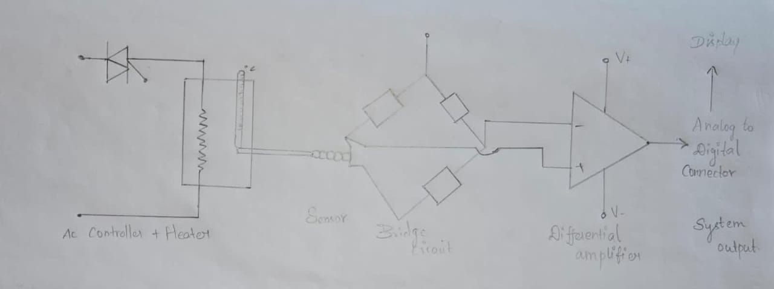

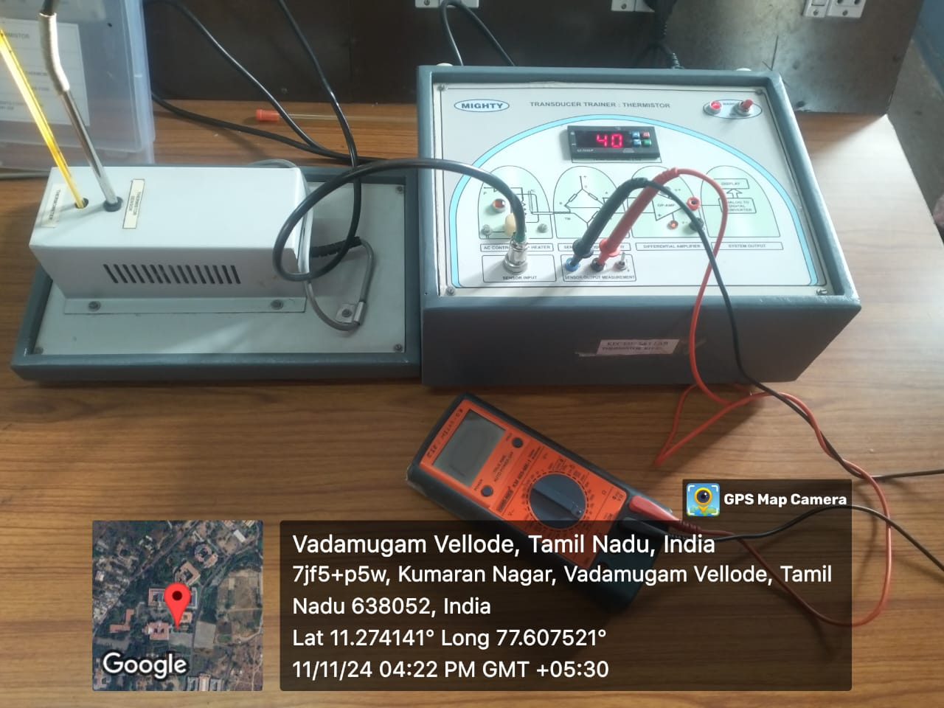

**CONCULSION**

Thermocouples are effective, versatile tools for temperature measurement, especially in high-temperature and dynamic environments. Their simplicity, wide range, and rapid response time make them ideal for industrial applications, though they do require regular calibration to maintain accuracy. Despite their susceptibility to issues like drift, noise, and interference, the use of statistical analysis and real-time monitoring can help mitigate errors and enhance measurement reliability. Overall, thermocouples provide accurate and dependable temperature data when properly managed, making them a cornerstone in many temperature-sensitive applications.