- Create item with content of CSV file.

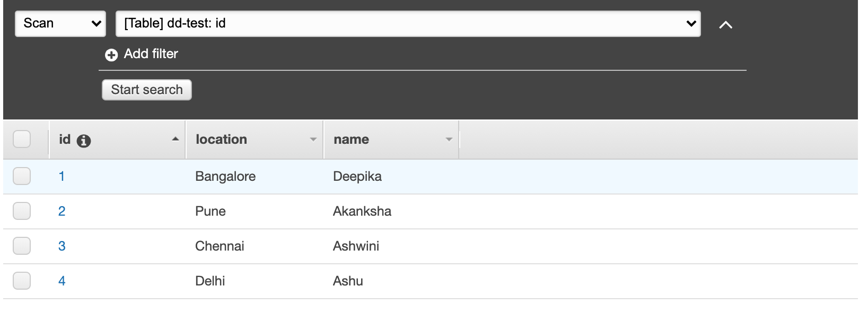

- Read item based on ID.

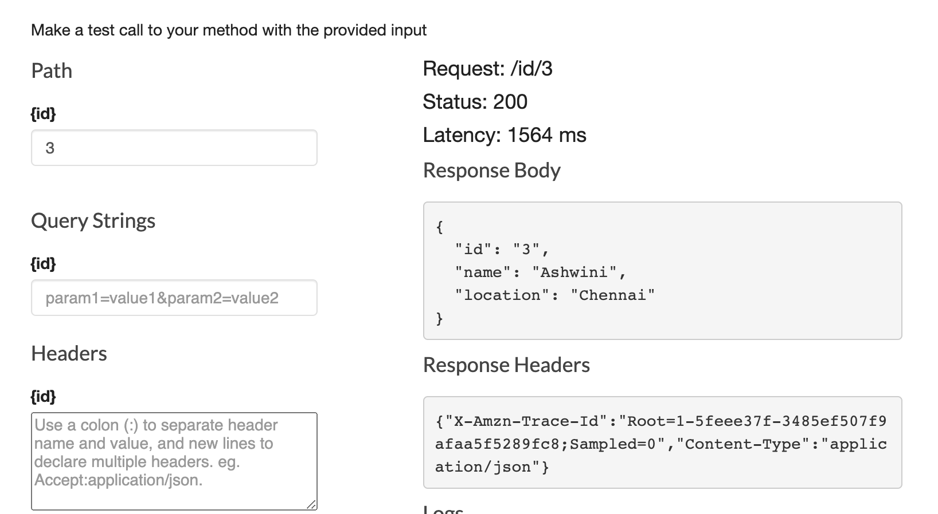

- Delete item based on ID.
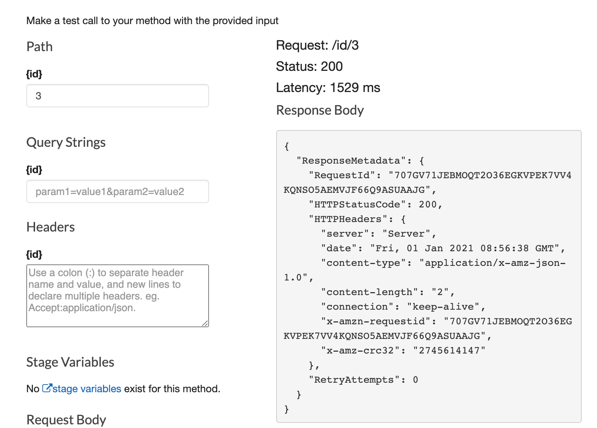

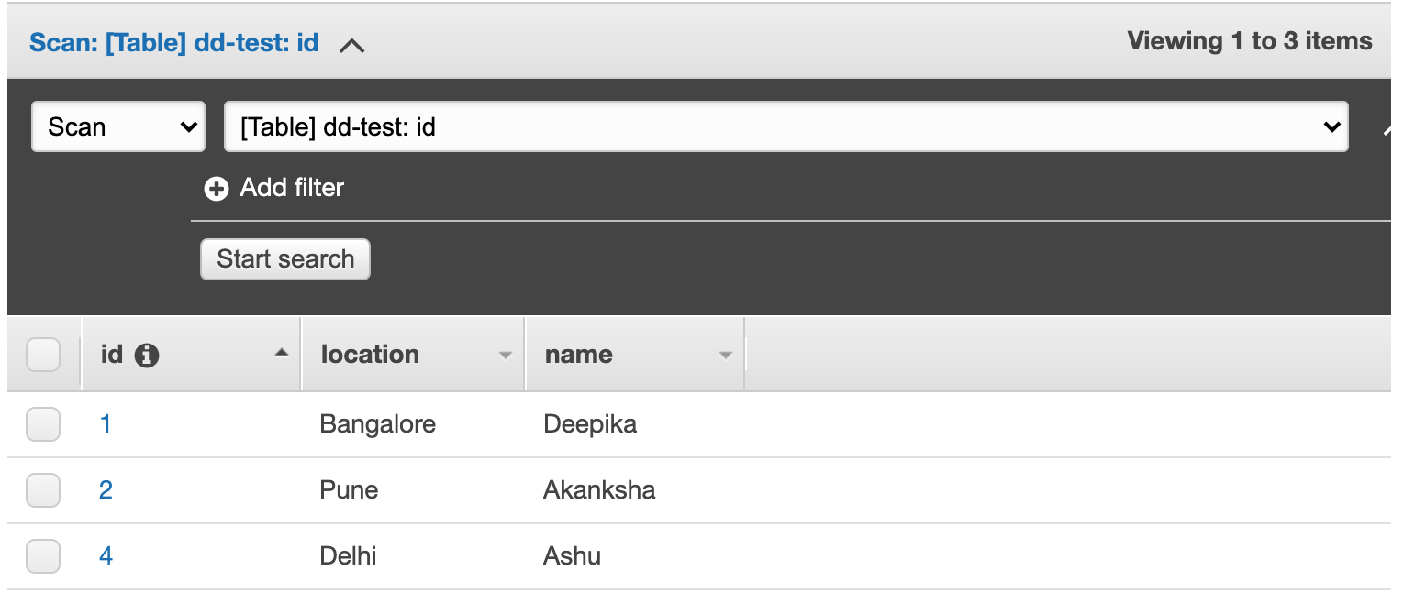

- Update item based on ID and request body content which include what needs to be changed.
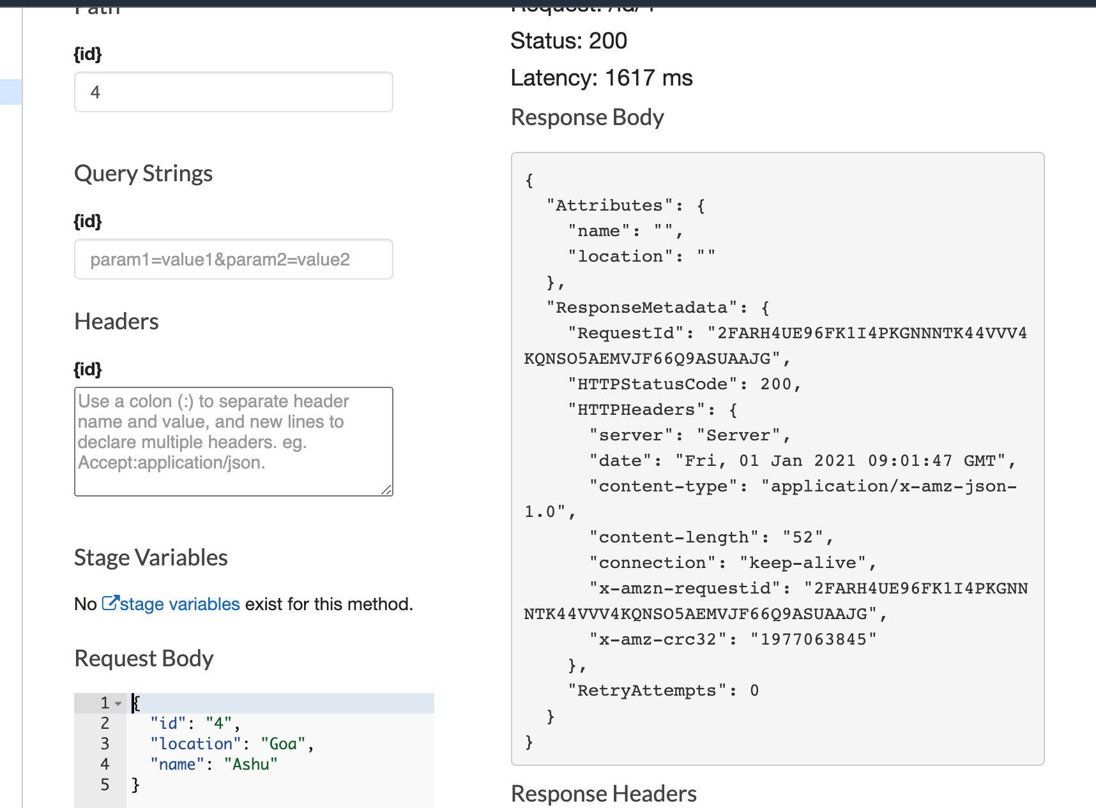

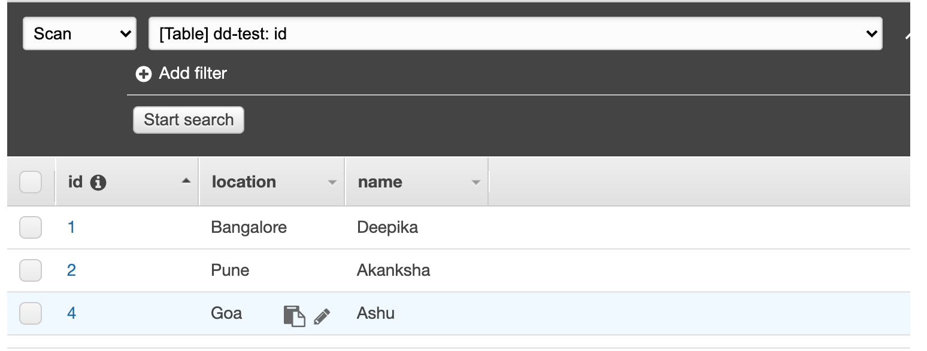

After making any small changes to the API method or resource, re-deploy API into staging and test it with invoke URL.
Use POSTMAN for any request which asks for update or new creation of the item.

