**SOFTWARE ENGINEERING**

**PROJECT: NOTE TAKING APP**

* **USE CASE DIAGRAM**

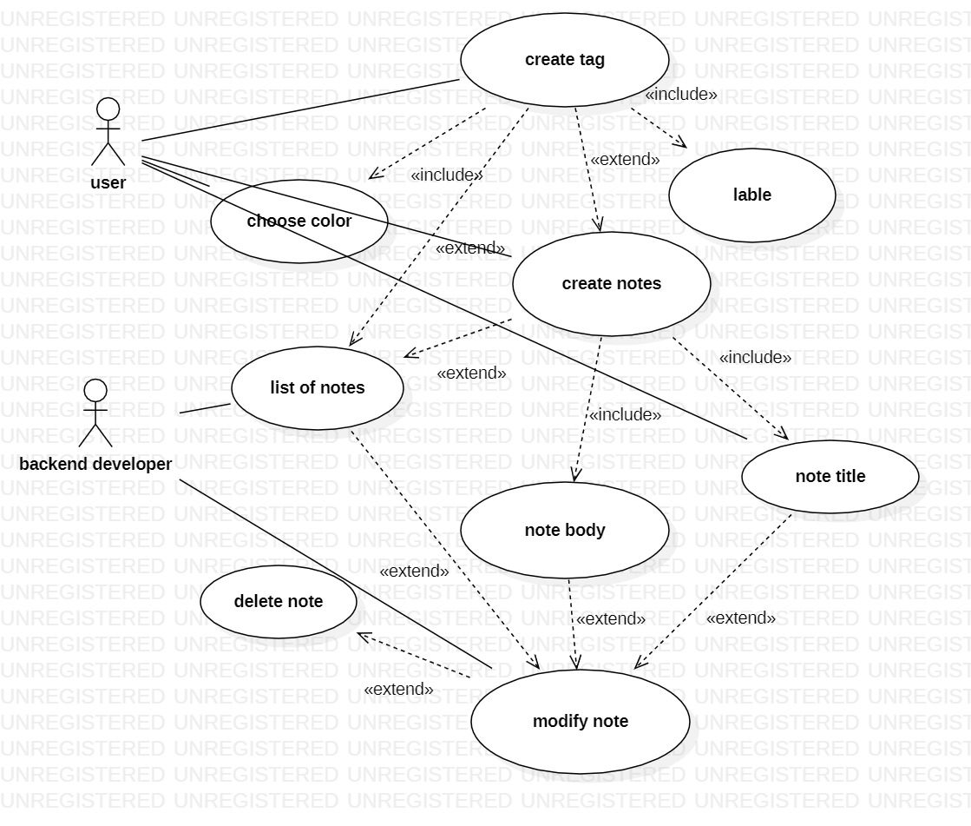

* **CLASS DIAGRAM**

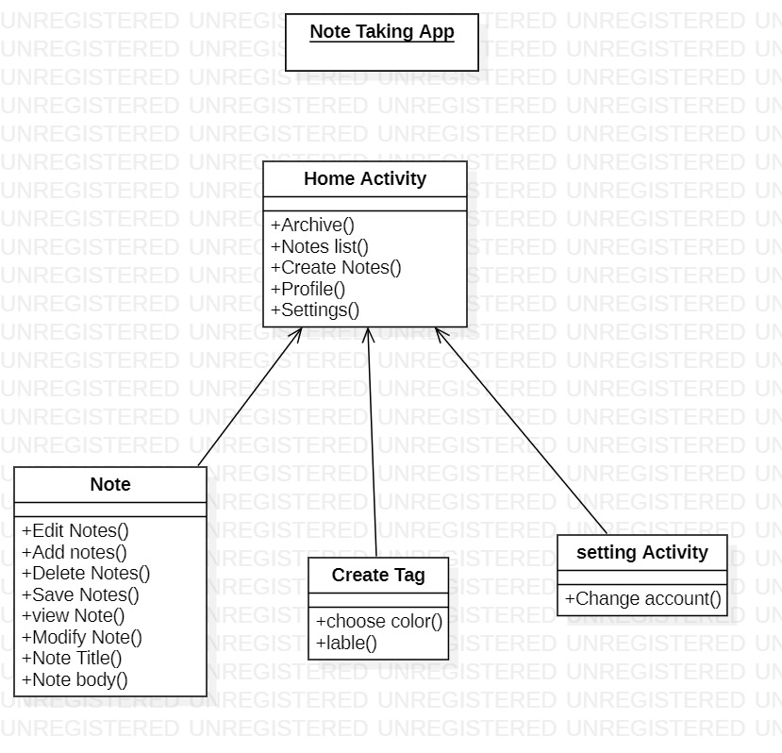

* **SEQUENCE DIAGRAM**

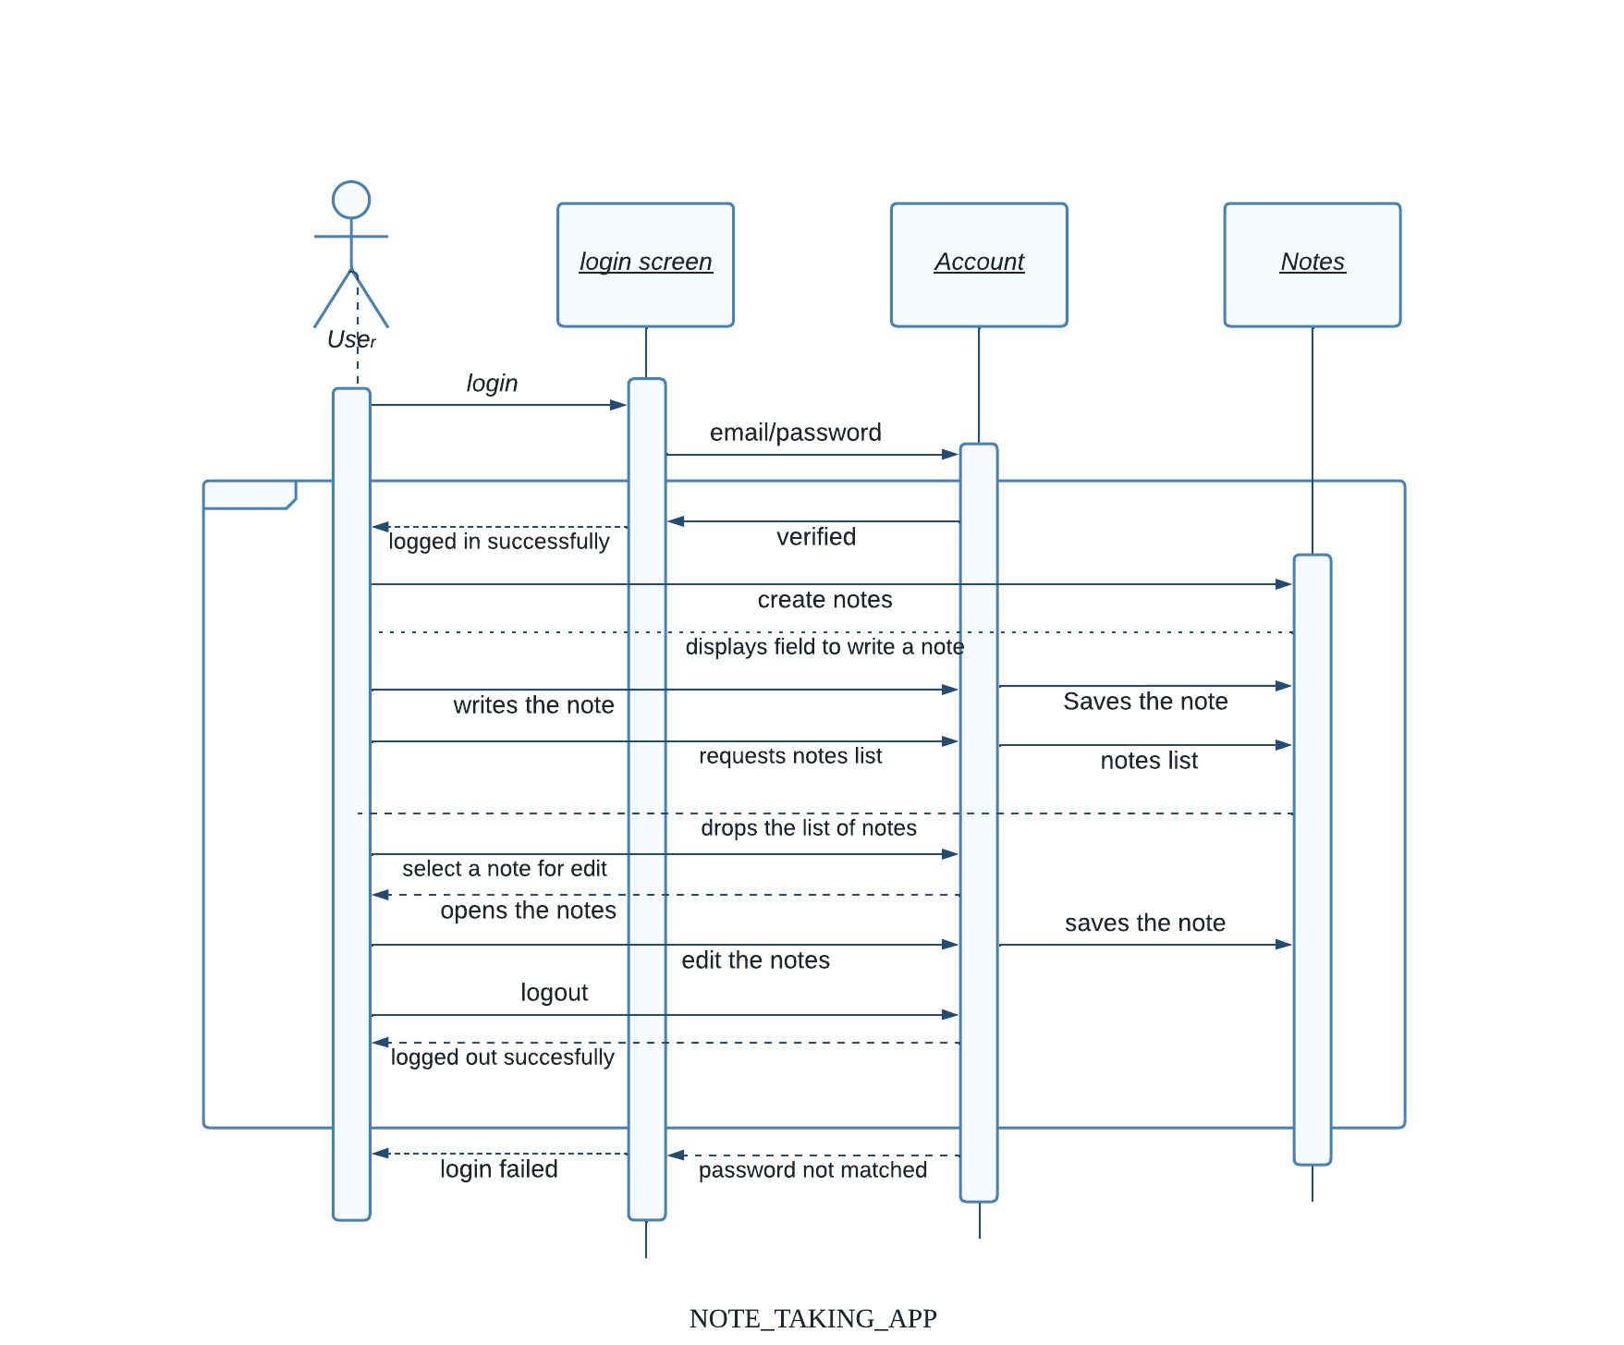

**Student Name & Reg Numbers:**

1)  ABHISHEK A (21BCS002)

2) RAVIKUMAR V.P (21BCS092)

3) MANJUNATH BISAGUPPI (21BCS065)

4) DEEPIKA MAHESH TALAWAR (21BCS030)

5) C B NAGARATHNA (21BCS023)