|  |
| --- |
| **Recommendation by Method 1:**  [(862, 0.6908911995020903), (698, 0.6863519630887088), (3437, 0.3557297126038576), (865, 0.30637254901960786), (868, 0.30637254901960786), (3495, 0.199994840958673), (3684, 0.19824414067856097), (3797, 0.1945961698623275), (3721, 0.17551686795128824), (3592, 0.16849482023156612)]  **Recommendation by Method 2:**  [(3501, 6), (3577, 6), (3633, 6), (3684, 6), (3948, 6), (1085, 5), (3609, 5), (3677, 5), (3721, 5), (3692, 5)]  **Average Rank of Method 1:**  6.5  **Average rank of Method 2:**  3.5  **Number of Same recommendations from both methods:**  99  **Number of different recommendations from both methods:**  3940  **Lonely Nodes:**  {1431: 0.43345786633457867, 2123: 0.7307711066673169, 1352: 0.4081469358065103} |

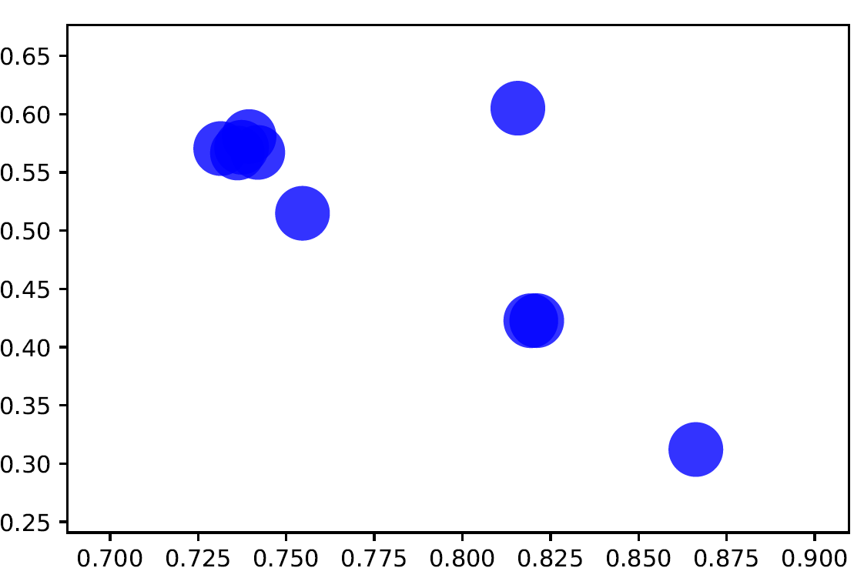

|  |
| --- |
| **Recommendation by Method 1:**  [(862, 0.6908911995020903), (698, 0.6863519630887088), (3437, 0.3557297126038576), (865, 0.30637254901960786), (868, 0.30637254901960786), (3495, 0.199994840958673), (3684, 0.19824414067856097), (3797, 0.1945961698623275), (3721, 0.17551686795128824), (3592, 0.16849482023156612)]  **Recommendation by Method 2:**  [(3501, 6), (3577, 6), (3633, 6), (3684, 6), (3948, 6), (1085, 5), (3609, 5), (3677, 5), (3721, 5), (3692, 5)]  **Average Rank of Method 1:**  3.5  **Average rank of Method 2:**  2.5  **Number of Same recommendations from both methods:**  100  **Number of different recommendations from both methods:**  3939  **Lonely Nodes:**  [483, 483, 483, 483, 483, 2464, 483, 1431, 2123, 2464] |

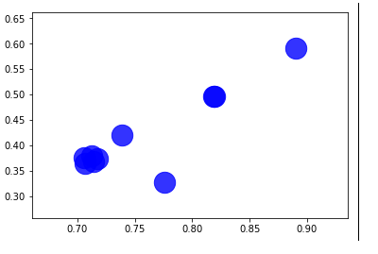

|  |
| --- |
| ***Recommendations by Method 1:***  [(1376, 97), (1833, 91), (1746, 88), (993, 86), (1390, 86), (1391, 83), (1714, 83), (1059, 81), (1516, 81), (1612, 81)]  ***Recommendation by Method 2:***  [(107, 1.5041943556371893), (1888, 1.0776933333350602), (1352, 1.0612043383752092), (1377, 1.0363770157940952), (1730, 1.0127165834130822), (1663, 1.0070598176447842), (1551, 0.9766386140683305), (1813, 0.9717048924955747), (1768, 0.9555284637663646), (1199, 0.9479967116267918)]  ***Average Rank of Method 1:***  4.0  ***Average rank of Method 2***:  0  ***Number of Same recommendations from both methods:***  104  ***Number of different recommendations from both methods:***  3935  ***Lonely Node:***  9 |

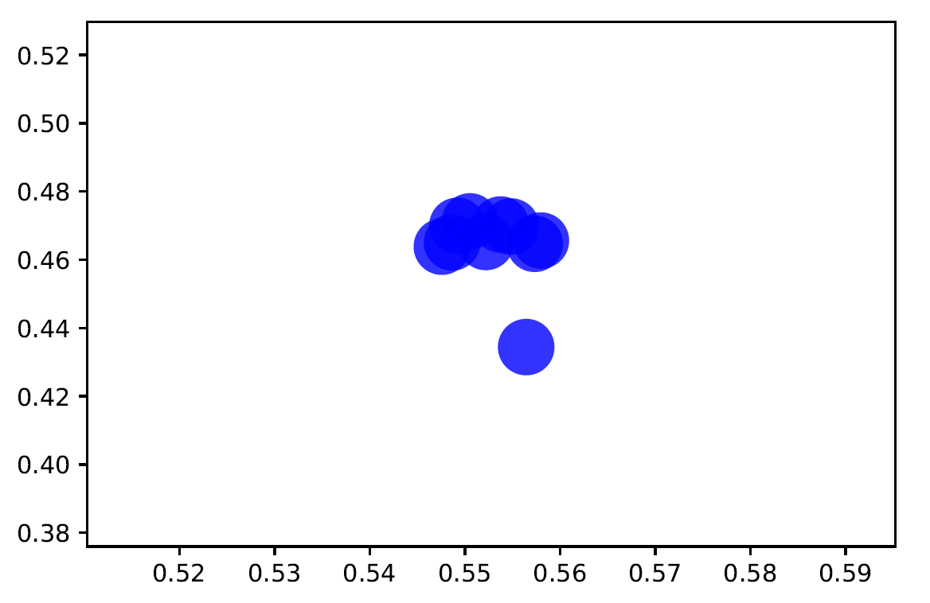

**Dataset Analysis Report**

*Type*: Graph

*Number of nodes*: 4039

*Number of edges*: 88234

*Average degree*: 43.6910

The Graph is connected

The graph is not directed

*Average clustering coefficient is*: 0.6055467186200876

