**____________________________________________**

**BME 590L: Machine Learning in Imaging Final Project**

**Segmentation of packed particles**

____________________________________________

**Lindsay Riley**

Department of Biomedical Engineering

Duke University

Durham, NC 27708

lindsay.riley@duke.edu

**Abstract**

Granular hydrogels are emerging as a versatile and effective platform for tissue engineered constructs in regenerative medicine. These biomaterials are often studied and utilized in the jammed state where packed particles form a scaffold structure through which cells may migrate. The microscopic granular scaffolds are frequently imaged not only to assess bulk material properties, but also to analyze individual particle size, cell-scaffold dynamics, and void space geometries. In order to accurately analyze scaffold data gathered from imaging techniques, it is essential to effectively delineate individual particles in images. Here, we implement machine learning techniques applied to simulated confocal microscope z-stack images of granular hydrogel scaffolds in order to segment the images into particles and void space. **Methods:** Training data was generated in MATLAB and processed prior to entering our network. Our model trains on the aperture phase within our physical layer and uses a U-Net for our segmentation method. **Results:** Our evaluation metric of intersection over union (iou) was greater than 97% for 5 out of 5 runs, and we report the average aperture phase returned by our network. **Conclusion:** Our model was able to accurately segment particles on our preliminary training datasets. Further studies will expand to larger simulated datasets, as well as real microscope images.

1. **Background**

Granular hydrogels comprise a collection of hydrogel microparticles (HMPs) that frequently exist in the jammed state, where HMPs pack together and form a scaffold of touching particles. The micron-size of the particles results in pockets of micron-sized void spaces within the interstitial space of the scaffold. As a result, cells on this length-scale are able to infiltrate and traverse the granular scaffold without the need to degrade hydrogel, as is classically seen in non-granular hydrogels [1]. This phenomenon has led to promising results in terms of utilizing granular hydrogels for improved wound healing [2, 3]. For this reason, biomaterial scientists are becoming increasingly interested in optimizing HMPs for targeted goals. Imaging microparticles using florescence microscopy is a common technique for studying features of individual particles, as well as the void space surrounding particles. Essential to the accuracy of scope image analysis is accurate segmentation of individual particles. In dilute samples, particle isolation using image analysis tools can be a straightforward process [4]; however, particles in a jammed state pose a more difficult situation, as individual particle resolution may be challenging due to the inherent resolution of the microscope.

We aim to address this issue by utilizing techniques in machine learning to aid in image segmentation. Our training dataset is generated from simulated confocal microscopy data of packed particles and taking slices along the z-axis, i.e., z-slices that make up a z-stack, much the way a microscope outputs 2-D slice images. We include a physical layer in our model to capture and train additional microscope effects. Our goal is to create an image segmentation software that can accurately and efficiently segment real microscope images of granular hydrogel scaffolds for the purpose of further material optimization and cell studies.

1. **Methods**

Our methods are broken down into three phases: 1) image generation, 2) physical layer, and 3) convolutional network. In Phase 1, we generate our dataset for training and testing. Our images will reflect real florescent confocal microscope images taken of spherical granular hydrogel scaffolds, i.e., packed particles. To begin, we use a particle packing algorithm that resolves collisions to get random loose packing of spheres, as seen in [5]. From this, we obtain a 3-D discretized matrix of labeled grid points corresponding to bead voxel locations. We chose to work with 20 particles to start, which were all cropped to 100 x 100 x 100 units. We intentionally chose a large grid mesh-size for easier training. Observation of real microscope images shows substantial pixel noise, so we aim to mimic this by imposing noise between the range of 5 to 100 grayscale pixel intensity on the interior of each bead. We then apply a Gaussian filter with σ = 0.5 to include a baseline blur that is representative of all z-stack images. To capture z-axis resolution of all microscopes, we collapse z-axis rows in our matrix by a specified thickness; in our case, we assume spheres represent particles that are ~100 μm in diameter and assume a z-axis resolution of ~5 μm. This then produces a realistic z-stack for input into our model. This section of our code is written in MATLAB.

For Phase 2, we aim to model physical effects of the microscope on our sample of interest. We assume a sample thickness equal to 1 wavelength of light. We include both light propagating through a lens that filters higher frequencies, as well as light propagating through an aperture device that can manipulate phase (not magnitude). We allow aperture phase to be a trainable variable in our graph. This aperture plane requires a Fourier transform of the incoming field and an inverse Fourier transform of the exiting field. The aperture itself is modeled as a standard circular aperture. We finally take the magnitude squared of the field hitting the detector (or image plane) since only intensity can be measured. Our images are then ready to enter our convolutional network. This section of our code is written in tensorflow.

In Phase 3, we pass our images through a 3-layer U-Net, which was adapted from [6]. This network contains approximately ~27,000 parameters to train. Some features of our model include the use of: a sigmoid activation function as the final step in our U-Net; a binary cross-entropy loss function; and an Adam Optimizer for our optimization algorithm. Our training dataset is obtained from taking z-stacks of 9 different particles domains (34 z-slices per domain) for a total of 306 images. Our testing dataset is obtained from 2 different particle domains for a total of 68 images. Although our physical layer is coded in tensorflow, our U-Net is written using Keras; therefore, we must merge the two during session runs so that they can ‘talk.’ We batch our inputs using a batch size of 6 and threshold our output matrices above and below 0.5 to give comparable binary images. We look at Intersection over Union as our evaluation metric. We also visually assess of our segmentation method and output the mean and variance of trained aperture phase over 5 separate runs (500 iterations per run).

1. **Results**

The results of our model show a significant decrease in loss over most runs, where all runs begin with a loss of around 8 after the first 100 iterations. Most impressively, our Intersection over Union results show > 97%, indicating a good match between model prediction and labeled images in terms of image-pixel overlap.

|  |  |
| --- | --- |
| Runs | Intersection over Union |
| 1 | 0.98127834 |
| 2 | 0.97514591 |
| 3 | 0.97474363 |
| 4 | 0.97326654 |
| 5 | 0.97498274 |

Visually, our model does a good job segmenting our blurry, noisy images to match the true segmentation label (Fig. 1).

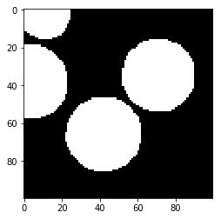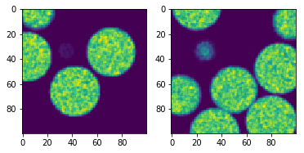

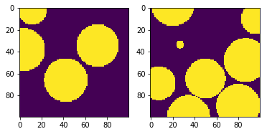

Figure 1. Left: Input image (blurred and noisy). Middle: Labeled image. Right: Model segmentation prediction

Aperture phase over 5 runs was also plotted, and mean and variance of the 5 runs was visualized.

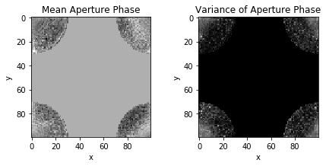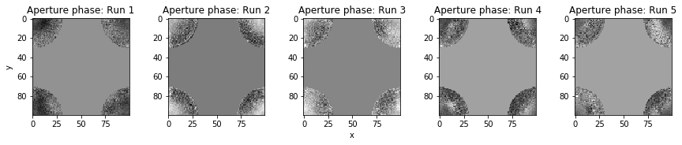

Figure 2. Top: Trained aperture phase plots from 5 runs. Bottom: Mean and variance aperture phase over 5 runs.

1. **Conclusion**

By our evaluation metrics, our model did a decent job at accurately segmenting our sample images. With this software, we can then gather z-slices corresponding to unique particle domains to reconstruct a 3-D matrix. This will likely require interpolation along the z-axis. The next step will be to scale-up our bead domains and decrease mesh size of our grid. Moving forward, we will be interested in adding RGB channels to accommodate multi-fluorescent imaging as well as testing real microscope images of granular hydrogel scaffolds. Overall, our results are promising.

1. **References**

[1] Riley L, Schirmer L, Segura T. Granular hydrogels: emergent properties of jammed hydrogel microparticles and their applications in tissue repair and regeneration. *Current Opinions in Biotechnology.* 2019. 60:1-8.

[2] Griffin DR, Weaver WM, Scumpia PO, Di Carlo D, Segura T: Accelerated wound healing by injectable microporous gel scaffolds assembled from annealed building blocks. *Nature Mater*ials. 2015, 14:737-744.

[3] Nih LR, Sideris E, Carmichael ST, Segura T: Injection of  
microporous annealing particle (MAP) hydrogels in the stroke cavity reduces gliosis and inflammation and promotes NPC migration to the lesion. *Adv Mater.* 2017, 29 1606471.

[4] Truong N, Tahmizyan N, Lesher-Perez SC, Chen M, Darling N, Xi W, Segura T: Physical and cell adhesion properties of microporous annealed particle (MAP) hydrogels control fibroblast spreading, proliferation, and gene transfer. *Submitted.* 2019.

[5] Roozbahani M, Borela R, Frost J: Pore Size Distribution in Granular Material Microstructure. *Materials (Basel)*. 2017, 10:1237.

[6] Hao, Zhixu. U-Net. https://github.com/zhixuhao/unet/. 2019.