WEEK 3 TASK
Advanced Data Analysis and Visualization in Logistics

Submitted by: M. Deepika
Department: Computer Science and Engineering
College: Arasu Engineering College, Kumbakonam
Project Area: Logistics Data Analysis using Python

1. Introduction
This Week 3 task extends the logistics project from Week 1 and Week 2 by focusing on exploratory data analysis (EDA), statistical summaries, visualization, and interpretation. A hypothetical logistics dataset is created to represent shipment distance, shipment volume, delivery time, transportation cost, vehicle type, and delivery status. The purpose is to identify operational patterns, cost drivers, and possible bottlenecks using Python.
The analysis demonstrates how visual analytics can convert raw logistics records into information that can support data-driven decisions. The dataset is simulated for academic purposes and does not represent a real company.

2. Hypothetical Dataset Structure
A dataset containing 120 simulated shipment records was created. The main variables are:
Variable | Type | Meaning
Order_ID | Categorical | Unique shipment identifier
Order_Date | Date | Shipment order date
Distance_km | Numeric | Delivery distance in kilometres
Shipment_Volume | Numeric | Shipment volume/quantity measure
Delivery_Time_hr | Numeric | Delivery time in hours
Transportation_Cost | Numeric | Estimated transportation cost
Vehicle_Type | Categorical | Van, Truck, or Mini Truck
Delivery_Status | Categorical | On-Time or Late

3. Data Preparation for EDA
The simulated data was generated with realistic relationships. Delivery time was influenced partly by distance, while transportation cost was influenced by distance and shipment volume. The data was checked for missing values and basic descriptive statistics before visualization.
The dataset contains 120 shipment records. Average delivery distance is 30.0 km, average shipment volume is 50.6 units, average delivery time is 5.45 hours, and average transportation cost is ₹1,093.96.

4. Exploratory Data Analysis

4.1 Central Tendency and Summary Statistics
Metric | Mean | Median
Delivery Time (hours) | 5.45 | 5.15
Transportation Cost (₹) | 1093.96 | 1049.51
Distance (km) | 30.02 | 27.75
Shipment Volume | 50.57 | 46.50
The simulated on-time delivery rate is 80.0%. This provides a simple operational KPI for assessing delivery reliability.

4.2 Distribution of Delivery Time
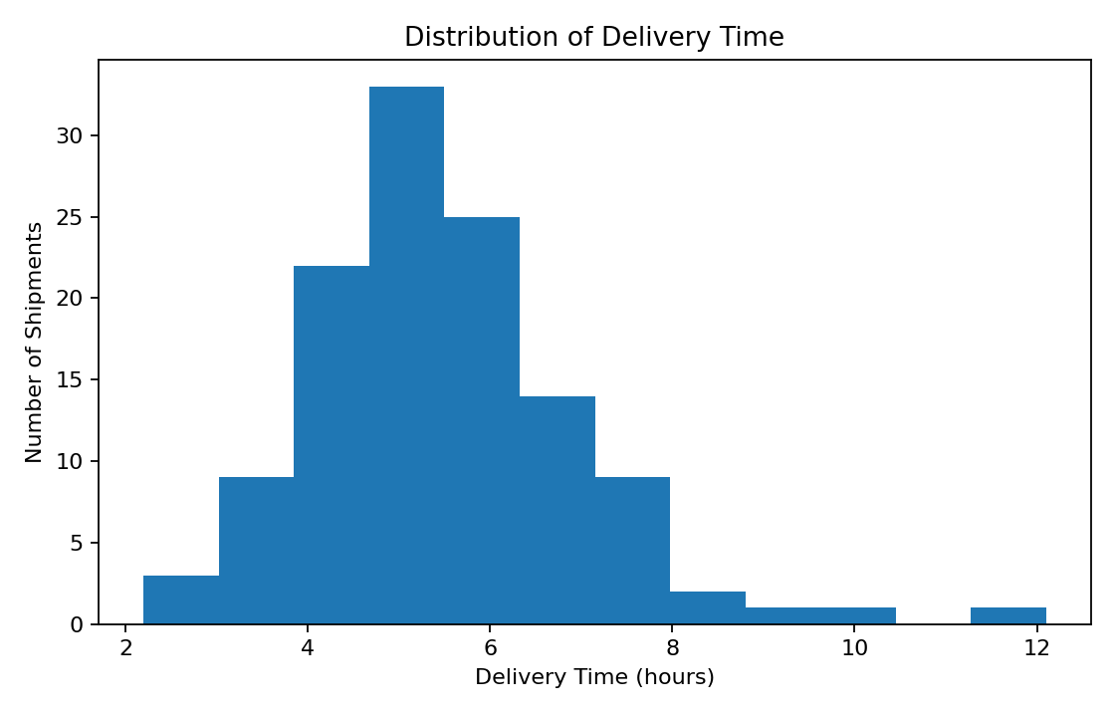
A histogram is appropriate for showing the distribution of delivery times. It helps identify the most common delivery-time range and whether unusually long deliveries are present. In this simulation, delivery times are concentrated around the middle range, with some variation between shipments.

4.3 Distance and Delivery Time Relationship
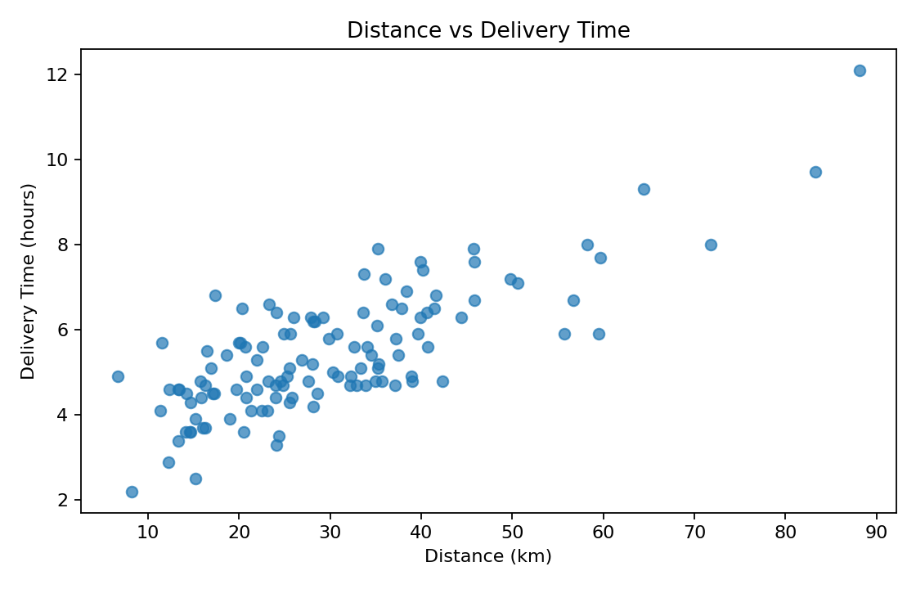
A scatter plot is used to study the relationship between distance and delivery time. The simulated Pearson correlation is 0.78, indicating a positive relationship in this dataset: longer delivery distances generally require more delivery time. This relationship can help identify shipments where delivery time is unusually high compared with distance.

4.4 Monthly Transportation Cost Trend
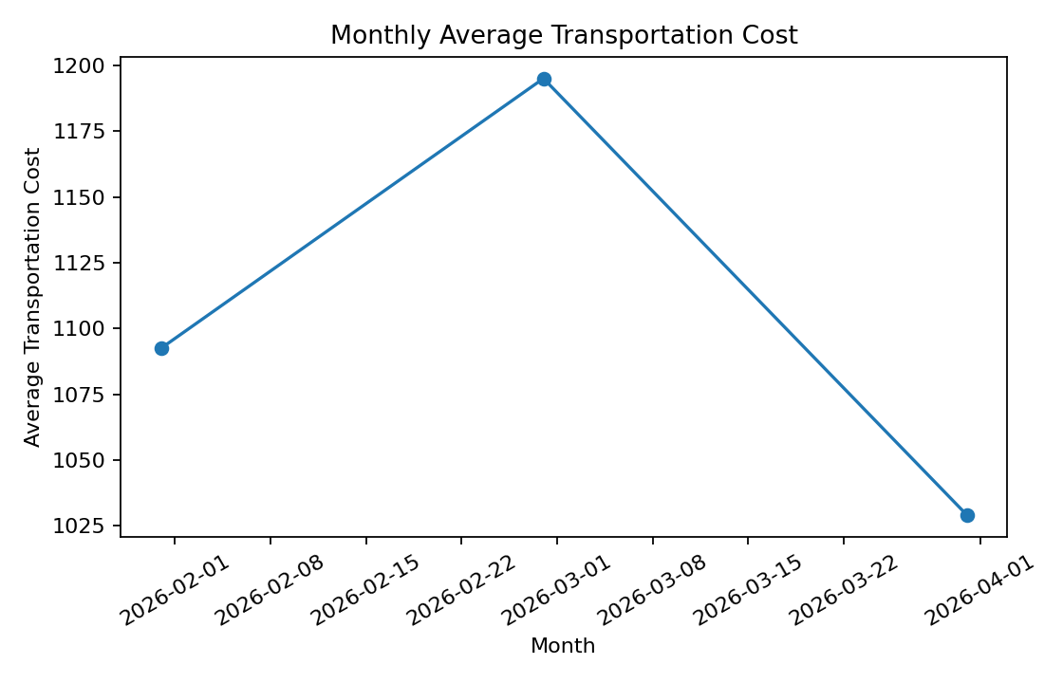
A line chart is suitable for time-based trends. It shows how average transportation cost changes across the simulated months. Managers can use such a trend to investigate periods of increased cost and compare them with shipment volume, distance, fuel prices, or operational changes.

4.5 Delivery Status
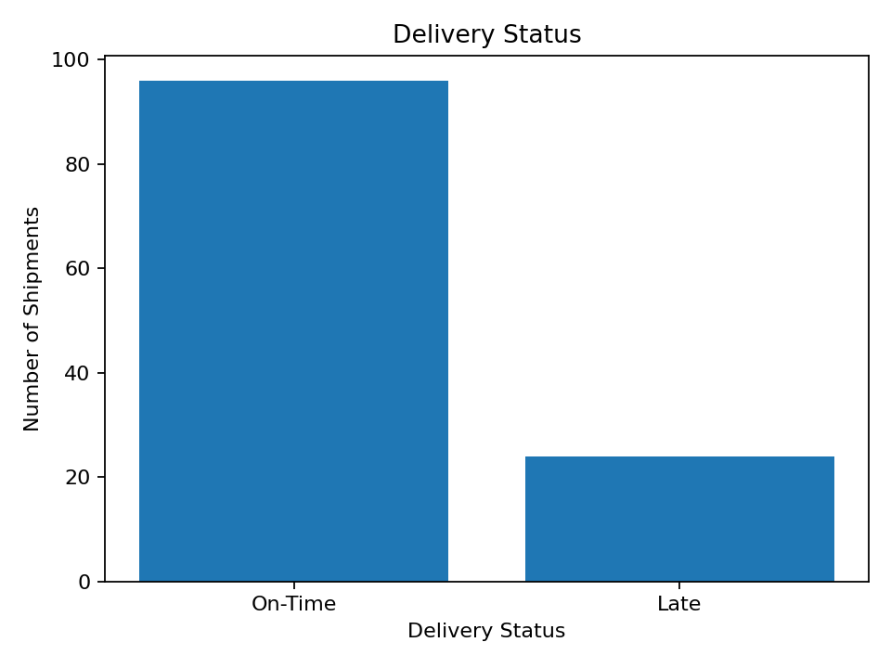
A bar chart clearly compares the number of on-time and late shipments. It is useful for monitoring service reliability and quickly communicating the delivery-status distribution to managers.

4.6 Correlation Analysis
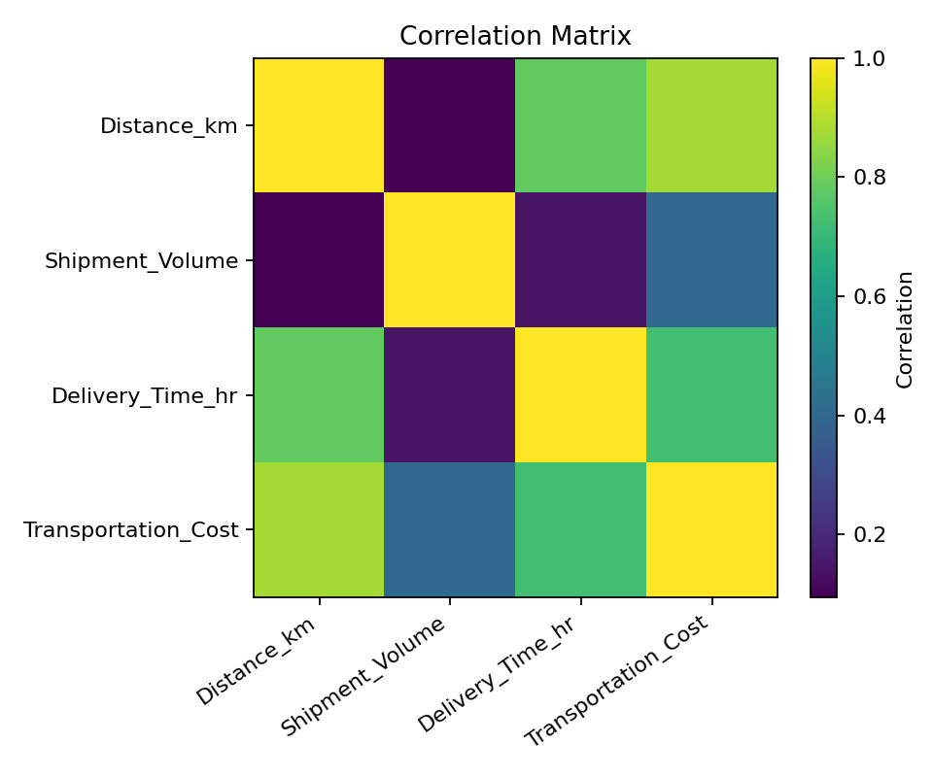
The correlation matrix summarizes relationships between major numerical variables. In this simulation, distance and delivery time have a correlation of 0.78, while shipment volume and transportation cost have a correlation of 0.41. Correlation does not prove causation, but it helps identify variables that deserve further investigation.

5. Python Code Used
import pandas as pd
import matplotlib.pyplot as plt
data = pd.read_csv("logistics_data.csv")
print(data.describe())
print(data.isnull().sum())
# Delivery time distribution
plt.hist(data["Delivery_Time_hr"], bins=12)
plt.xlabel("Delivery Time (hours)")
plt.ylabel("Number of Shipments")
plt.title("Distribution of Delivery Time")
plt.show()
# Relationship between distance and delivery time
plt.scatter(data["Distance_km"], data["Delivery_Time_hr"])
plt.xlabel("Distance (km)")
plt.ylabel("Delivery Time (hours)")
plt.title("Distance vs Delivery Time")
plt.show()
# Correlation
print(data[["Distance_km", "Shipment_Volume",
"Delivery_Time_hr", "Transportation_Cost"]].corr())

6. Analytical Insights
- Delivery performance: The simulated on-time rate is 80.0%, so late shipments should be examined to identify operational causes.
- Distance effect: Distance and delivery time show a positive correlation of 0.78, suggesting that route length is an important factor in delivery duration.
- Cost drivers: Shipment volume and transportation cost have a correlation of 0.41, indicating that higher shipment volumes are associated with higher simulated transportation costs.
- Potential bottlenecks: Shipments with high delivery time relative to their distance may indicate traffic, loading delays, inefficient routes, or other operational issues.
- Decision support: Combining KPI trends with visualizations can help managers investigate costly routes, late deliveries, and unusual shipment records.

7. Recommendations
- Monitor late shipments separately by distance, vehicle type, and delivery period.
- Investigate unusually high delivery times rather than assuming every long delivery is caused by distance.
- Review high-cost shipments and compare their distance and shipment volume with normal shipments.
- Use route-level analysis in later stages to identify opportunities for reducing travel distance and delivery time.
- Continue collecting clean operational data so that future predictive models can estimate delivery time and transportation cost.

8. Conclusion
The Week 3 analysis demonstrates how exploratory data analysis and visualization can support logistics decision-making. Statistical measures describe the central behavior of the data, while histograms, scatter plots, line charts, bar charts, and correlation analysis reveal patterns and relationships that are difficult to identify from raw records alone. The simulated results show that delivery distance, shipment volume, and delivery status can provide useful information about operational performance and cost. These insights provide a foundation for future predictive modeling and route optimization.

9. References / Tools
- Python – General-purpose programming language used for analysis.
- pandas – Data loading, manipulation, descriptive statistics, and preprocessing.
- Matplotlib – Visualization library used to create charts.
- scikit-learn – Python library that can be used for future preprocessing and machine learning.

