Scrabble Program
User Guide

WRITERS:

MEMBERS OF CSE-t47

OF CSE116

UNDER DR. ALPHONCE

SCRABBLE PROGRAM USER MANUAL | 1

TABLE OF CONTENTS

INTRODUCTION

- BEGINNING THE GAME . . . . . 4

  - SETTING NUMBER OF PLAYERS
  - SETTING PLAYERS’ NAME
- HOW TO PLAY THE GAME . . . . 5

  - PLACEING A TILE
  - PASSING A TURN

- HOW TO SAVE AND LOAD THE GAME . . . . . 6

  - SAVING THE GAME

  - LOADING THE GAME

SCRABBLE PROGRAM USER MANUAL 2

INTRODUCTION

Scrabble is a word game, which players get points by placing tiles of characters onto a game board that is divided in rectangular shapes of 20 by 20 and forming a word out of those tiles. When you start a game, each player gets some tiles out of 56 tiles in an inventory. Some tiles have more point value. A distribution and point value of tiles are explained in the table below.

LETTERS | NUMBER OF TILES | POINT VALUE FOR
 | FOR EACH LETTER | EACH LETTER
A,E,I,O,U | 29 | 1
Y | 15 | 2
B,C,D,F,G,H,J,K,L,M,N,P,Q,R,S,T,V,W,X,Y,Z | 12 | 5

Players alternate each turn. A player can use every tile on his tile rack. The tile rack will be refilled after each turn from the inventory. When the inventory becomes empty, the tile rack doesn’t get refilled.

The player can get points when he assembles an English word by placing tiles on squares in a vertical or horizontal position.

The player with the greatest score at the end of the game wins.

SCRABBLE PROGRAM USER MANUAL | 3

BEGINNING THE GAME

Setting the number of players

When you start the SCRABBLE PROGRAM 9000, your computer prompt will show something like below:


When you see this prompt, you need to enter number of people who are going to play the game. Remember that only four people can play the game at the same time.

Setting player’s name
After entering in the number of players, you will see something like below:
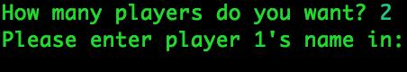

When you see this prompt, you need to enter each player’s name.

SCRABBLE PROGRAM USER MANUAL 4

HOW TO PLAY THE GAME

SCRABBLE PROGRAM 9000 uses an innovative UI by using a tool called a mouse. You control a pointer on your screen by moving the mouse. You can choose an element by clicking a button that resides on the mouse.
Please be reminded that the UI shown at examples may look different from yours.

PLACING A TILE

When you start the game, you will see several windows: a main window, players’ tile racks, and an option window.

Before placing a tile, you may need to check whether it is your turn or not.
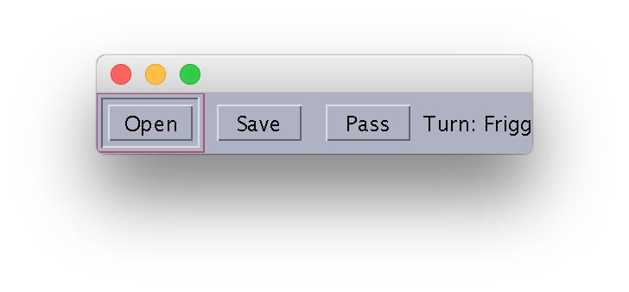

You can check the turn by referencing the option window

In order to place a tile, you need to click a tile you want to place on your tile rack.
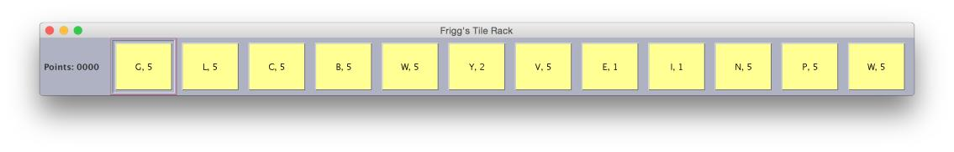

The points label on the left shows how much points you have right now.

After clicking the tile, you need to click a blank rectangular shape. The program will place the tile you choose on the main window. After the first turn, you may only place tiles adjacent to other tiles already present in the main window.

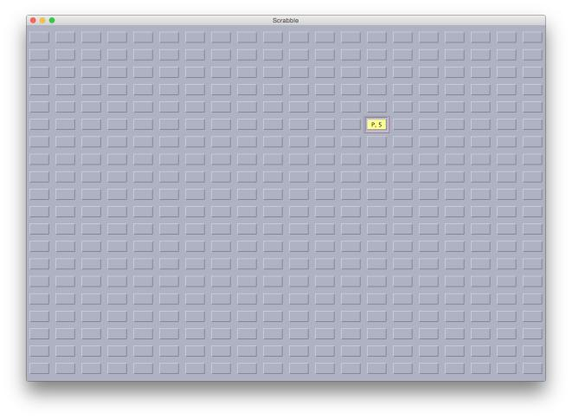

SCRABBLE PROGRAM USER MANUAL 5

PASSING A TURN

After finishing placing the tiles, you need to pass a turn to another player. Clicking the PASS button on the option window will easily do the job.

When you pass your turn, a pop-up message will show up to remind you that you have passed your turn.
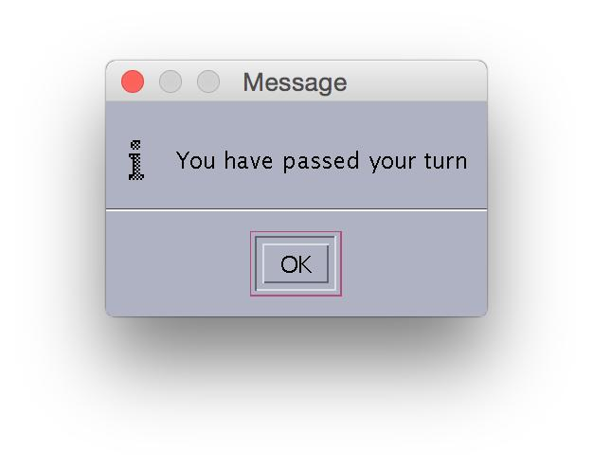

SCRABBLE PROGRAM USER MANUAL | 6

HOW TO SAVE AND LOAD THE GAME

SAVING THE GAME

Saving the game can be easily done by clicking the Save button on the option window.

Clicking the Save button will show a window like below:
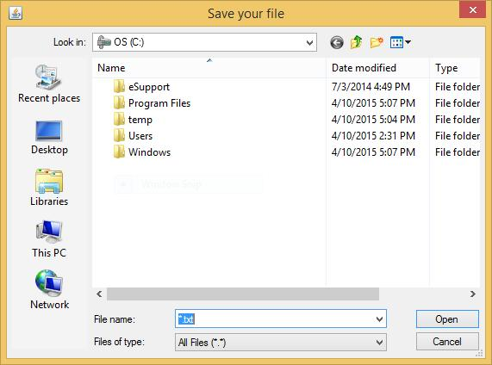

After choosing the file name and where to save the file, please click the save button.
SCRABBLE PROGRAM USER MANUAL | 7

LOADING THE GAME

When you click the Open button, a window that resembles what you saw when you saved. You should choose a save file to load and choose the Open button on the window that popped up.

SCRABBLE PROGRAM USER MANUAL | 8

ENDING THE GAME

The game will end in one of two ways. If all players pass their turn in a row without placing any tiles on the board, the program will terminate and print the name of the winner in the console. In addition, the program will also terminate and display the winner’s name if both a player’s tile rack is empty and the inventory when a player attempts to fill his or her tile rack.

SCRABBLE PROGRAM USER MANUAL 9

