Lab 1: SSH Brute-Force Analysis of mailsv secure.log
Prepared 20 October 2026 | Platform: Splunk Enterprise 10.6.1.1 | Index: lab1 | Host: mailsv
Prepared by: [Deepak Sharma]

Read this first (60 seconds)
In one line: people around the world kept guessing passwords on one server, and none of them got in.
What we checked | Result | What it means
Wrong-password attempts | 8,154 | Someone was guessing passwords, a lot
Different attacking computers | 181 | Many sources, so not one single hacker
Busiest attacker | 87.194.216.51 (218 tries) | Even the worst was only 2.7% of the total
Successful logins | 380 | All from 3 company-internal computers
Attackers who got in | 0 | No break-in found

How we found out, in 3 steps:
- Loaded the log into Splunk and counted the failed and successful logins.
- Pulled the computer address (IP) out of every failed login to see who was attacking.
- Checked whether any attacking address ever logged in successfully. None did.
What to do: turn off direct root login over SSH, use keys instead of passwords, and limit who can reach the server (firewall, VPN or fail2ban).
Usernames guessed: common defaults such as root, administrator, operator and admin. No single name dominates (root is only 4.2% of attempts).
Where to look in the rest: section 4 has the results, section 5 lists the mistakes we fixed, section 7 has the full recommendations, and Appendix A has searches you can copy and paste.

1. Executive summary
- The log holds 8,534 password events: 8,154 failed and 380 accepted (Figures 4 and 9).
- 181 distinct source IPs produced failed logins (Figure 7). The ten busiest sources account for 1,401 failures (17.2%), led by 87.194.216.51 with 218 attempts. The activity is spread across many addresses, which is typical of automated brute-forcing.
- All 380 successful logins came from three internal 10.x addresses. Only those three IPs both failed and succeeded, and their failure rate (about 10%) looks like ordinary mistyped passwords (Figure 10).
- No external IP achieved a successful login, so there is no evidence of compromise in this dataset.
- The most-guessed usernames are common defaults (root, administrator, operator, admin), and no name dominates: root is only 4.2% of attempts (Figure 8).

2. Scope and dataset
Item | Detail
Source file | D:\SPLUNK PROJECT\practical 1\mailsv\secure.log
Origin | Splunk tutorial data (tutorialdata.zip), mailsv host; see References
Log type | Linux sshd authentication events
Event dates | 9 to 16 October 2026 (8 days of activity). Splunk re-dates this file to the previous seven days when it is generated, so these are not real attack dates
Questions | Who is attacking, which accounts are targeted, did anyone get in?

3. Methodology

3.1 Ingestion (Figures 1 to 3)
Step | Setting | Result
Add Data, Files and Directories | File above, Continuously Monitor | File selected
Set Source Type | linux_secure | One event per line, timestamps parsed
Input Settings | Host: constant value mailsv; Index: lab1 | Data isolated in a dedicated index
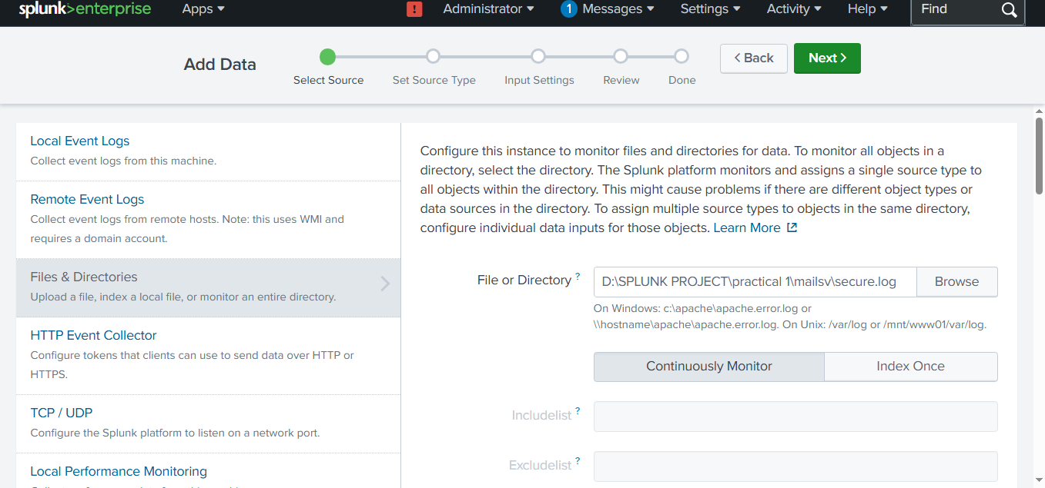
Figure 1: Add Data, Select Source (secure.log chosen, Continuously Monitor)
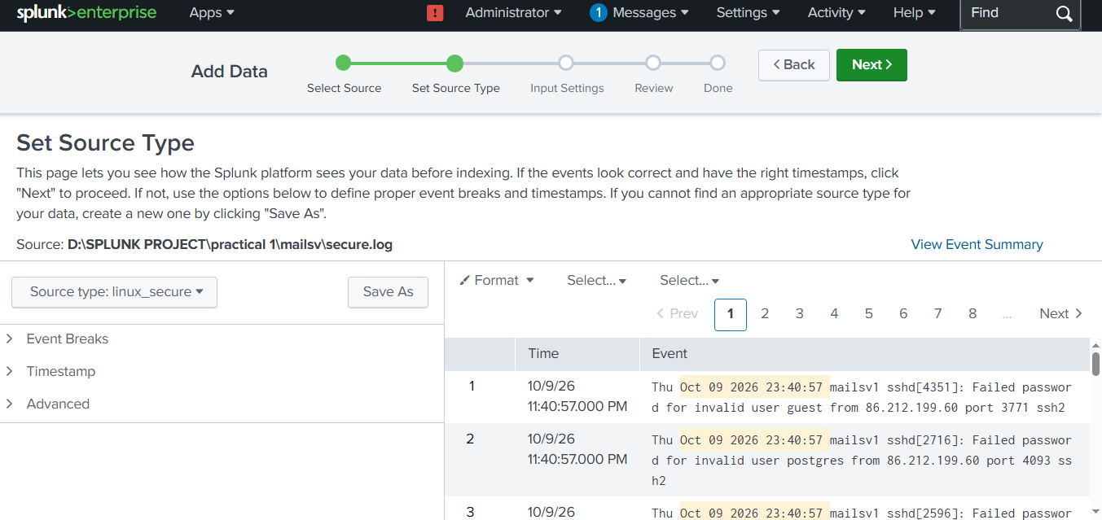
Figure 2: Set Source Type (linux_secure, one event per line)
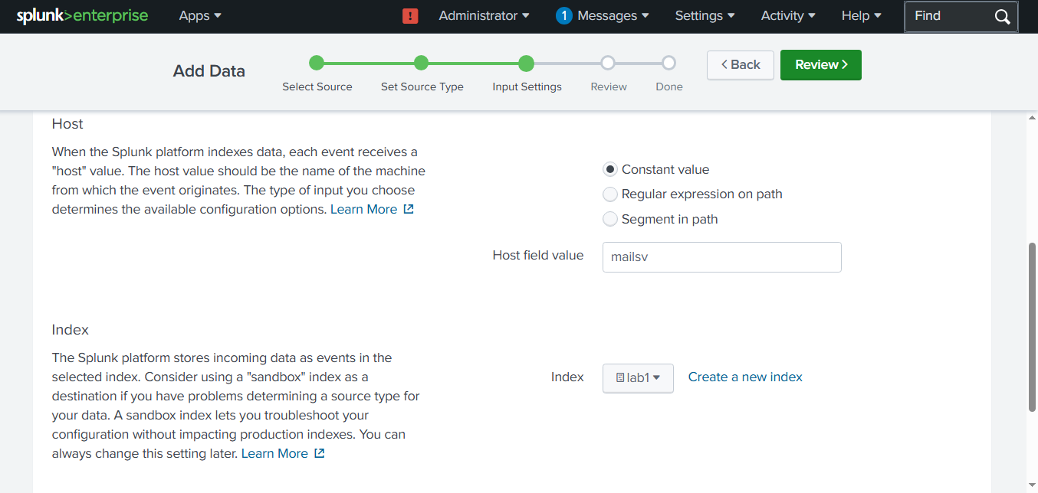
Figure 3: Input Settings (host mailsv, index lab1)

3.2 Analysis workflow
- Count events and confirm the totals reconcile.
- Extract fields with rex (src_ip, user).
- Validate each extraction by comparing the extracted count with the total.
- Aggregate with stats and top.
- Cross-check failures against successes for each IP.

4. Findings

4.1 Event volume
There are 8,154 failed password events (Figure 4) and 380 accepted ones (Figure 9). Together they equal the 8,534 events returned for the combined search (Figure 10), so no events were lost during ingestion.
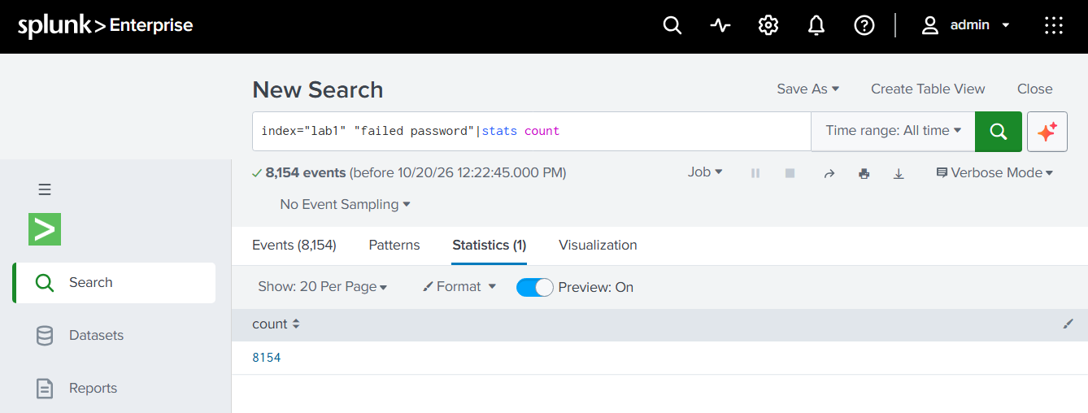
Figure 4: Failed password count (8,154)
Events span 9 to 16 October 2026. The six full days each hold roughly 1,100 to 1,400 password events, and the first and last days are partial (414 and 846). The activity was sustained across the week and not a single burst (Figure 11).
Date (2026) | Password events
9 October (partial) | 414
10 October | 1,137
11 October | 1,179
12 October | 1,149
13 October | 1,289
14 October | 1,128
15 October | 1,392
16 October (partial) | 846
Total | 8,534
Figure 11: Password events per day (from the timechart search, shown as a table)

4.2 Attacking sources (Figures 6 and 7)
Rank | Source IP | Failed attempts | Share of failures
1 | 87.194.216.51 | 218 | 2.7%
2 | 211.166.11.101 | 189 | 2.3%
3 | 194.215.205.19 | 186 | 2.3%
4 | 109.169.32.135 | 150 | 1.8%
5 | 128.241.220.82 | 135 | 1.7%
6 | 188.138.40.166 | 108 | 1.3%
7 | 170.192.178.10 | 107 | 1.3%
8 | 86.212.199.60 | 104 | 1.3%
9 | 216.221.226.11 | 103 | 1.3%
10 | 187.231.45.62 | 101 | 1.2%
 | Top 10 total | 1,401 | 17.2%

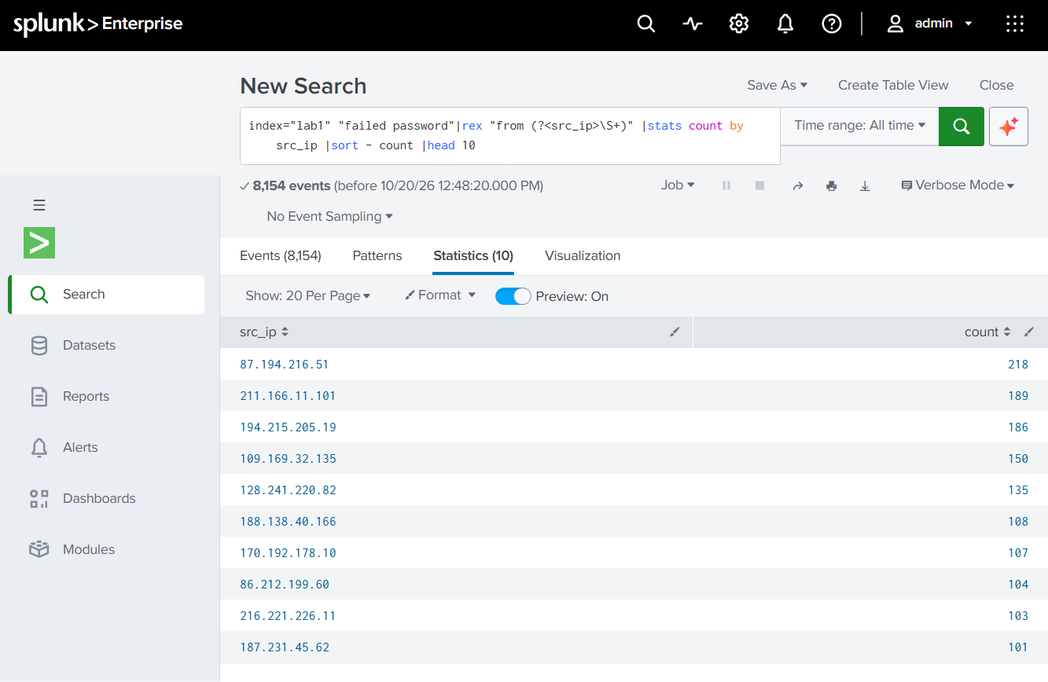
Figure 6: Top 10 attacking IPs with counts
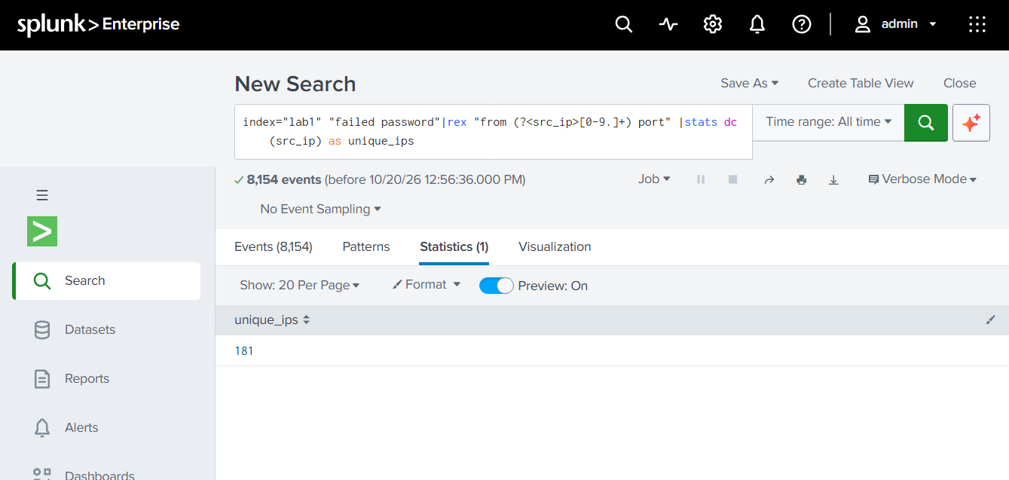
Figure 7: Unique attacking IPs (181)
With 181 unique IPs, the average is about 45 failures per source. No single address dominates: the top 10 explain only 17.2% of failures, and a long tail of other sources makes up the rest. That points to a distributed, automated campaign and not one persistent attacker. Raw events for 86.212.199.60 (rank 8) show it trying the accounts guest and postgres within the same second (Figure 2), a typical dictionary-attack signature.

4.3 Targeted usernames (Figure 8)
User | Attempts | Share of all failures
root | 346 | 4.24%
administrator | 272 | 3.34%
operator | 215 | 2.64%
admin | 212 | 2.60%
mail | 194 | 2.38%
email | 183 | 2.24%
mailman | 167 | 2.05%
irc | 161 | 1.97%
games | 155 | 1.90%
system | 152 | 1.86%
Top 10 total | 2,057 | 25.2%
Figure 8: Top 10 targeted usernames (corrected search, all 8,154 failures, shown as a table)
The most-guessed names are common defaults and administrator-style accounts (root, administrator, operator, admin), plus service names such as mail, email, mailman, irc, games and system. No name dominates: the top 10 make up 25.2% of failures and root alone is 4.2%. That is typical of dictionary-style guessing across many usernames.
Method note. An earlier version of this search skipped attempts against non-existent usernames and covered only about 2,282 events. The corrected pattern covers all 8,154 failures (346 is 4.24% of 8,154).

4.4 Successful logins (Figure 9)
There are 380 accepted-password events. Across all 380, exactly three users appear, each from one internal address. Every source address begins with 10., which is a private range, so none of these logins came from the attacking IPs in section 4.2.
User | Source IP | Logins
djohnson | 10.3.10.46 | 237
nsharpe | 10.2.10.163 | 104
myuan | 10.1.10.172 | 39
Total |  | 380
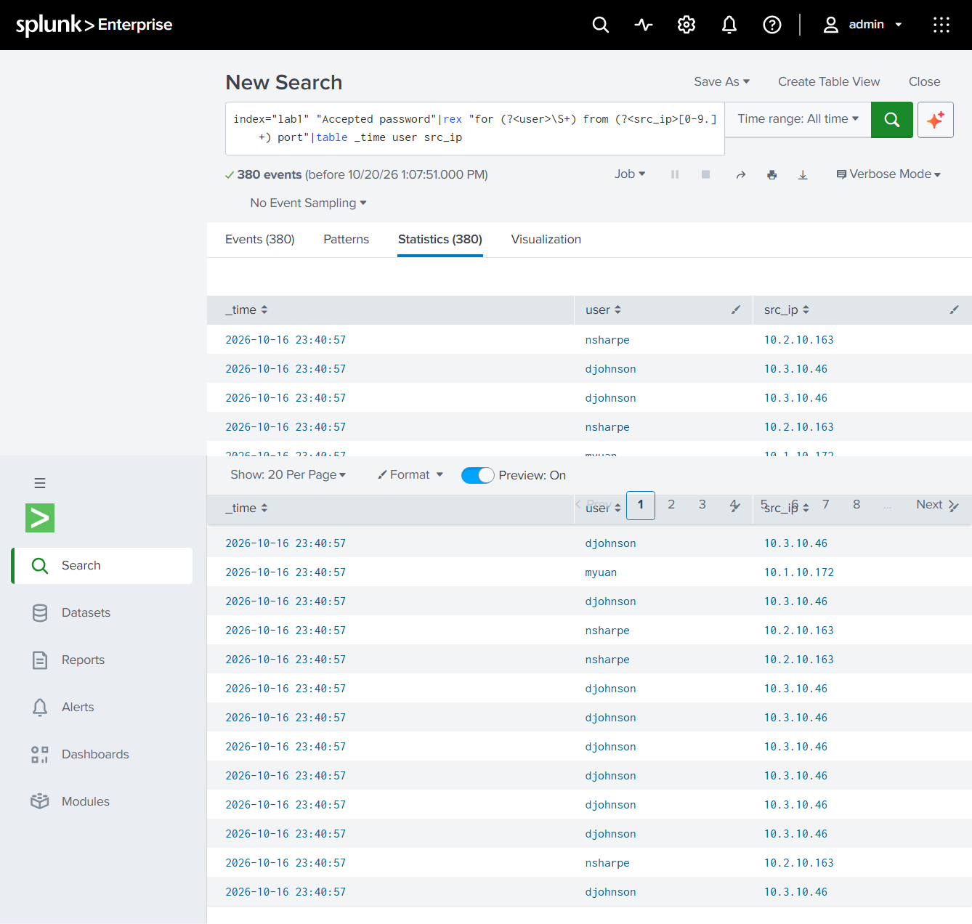
Figure 9: Accepted password events (380)

4.5 Failed-then-succeeded overlap (Figure 10)
Source IP | Failed | Succeeded | Failure rate
10.1.10.172 | 4 | 39 | 9.3%
10.2.10.163 | 12 | 104 | 10.3%
10.3.10.46 | 27 | 237 | 10.2%
Total | 43 | 380

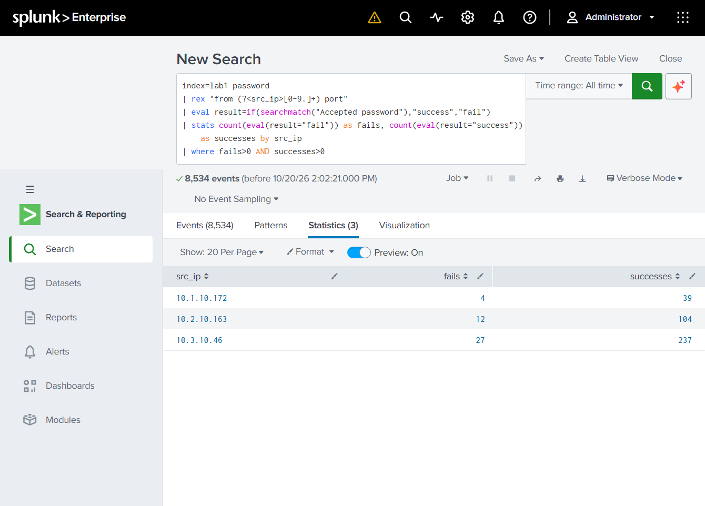
Figure 10: Overlap search (3 internal IPs, 8,534 events searched)
The successes sum to 380, which equals the total number of accepted-password events. Every successful login therefore belongs to one of these three internal addresses, and no external IP has any success. The roughly 10% failure rate is consistent with users mistyping a password before getting in.

5. Data quality issues and troubleshooting
# | Symptom | Cause | Fix
1 | No fields extracted on upload | Source type left as default | Select linux_secure
2 | IP regex extracted 894 of 8,154 events (11%), Figure 5 | Third octet written as a single digit | Use [0-9.]+ or \S+ (Figure 6)
3 | Zero results from a rex search | Backslash missing, so S+ matched the letter S | Write \S+
4 | Zero events when combining two phrases | Lowercase "or" is treated as a search word | Use uppercase OR
5 | Regex compile errors | Misplaced colon, missing closing parenthesis | Named capture is (?<name>pattern)
6 | stats command error | Aggregation missing "as name", or "by" field missing | Each aggregation needs its own "as"; "by" goes once at the end
7 | Username table undercounts | No space after "invalid user" | Fixed with the corrected pattern in Appendix A; the table now covers all 8,154 failures
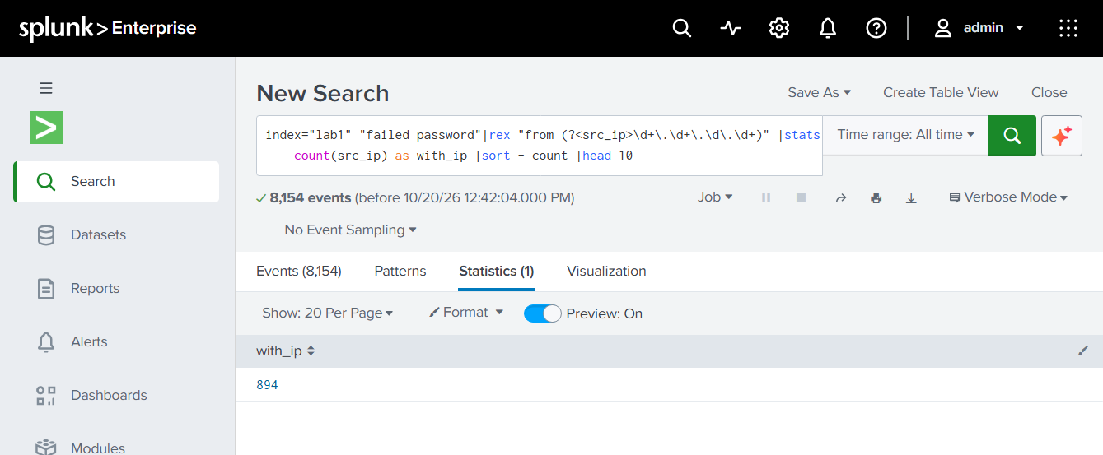
Figure 5: Faulty IP pattern matched only 894 of 8,154 events
Key lesson: after every extraction, compare the extracted count with the total count. That check exposed problem 2 immediately.

6. Assessment
- Activity observed: large-scale external SSH credential guessing against default accounts. Confirmed.
- Compromise: none observed. All successful logins are internal and consistent with normal use.
- Exposure: SSH on this host accepts attempts from the internet, including against root and service accounts. Assessed risk of compromise: low. Assessed exposure risk: medium.

7. Recommendations
Hardening
- Disable direct root login over SSH and use key-based authentication.
- Restrict SSH to internal ranges or a VPN, or rate-limit it with a tool such as fail2ban.
- Review the top 10 sources against threat intelligence before blocking them.
Detection
- Alert when one source exceeds a failure threshold in a short window.
- Alert on any successful login from an address that previously failed from outside the internal range.
- Watch internal accounts with repeated failures for password-guessing or compromised-credential activity.
Lab improvements
- Save validated extractions as a saved search or field extraction.
- Use Index Once for static lab files, since Continuously Monitor was selected in Figure 1.
- Add IP geolocation in the next iteration.

8. Limitations
- The data is Splunk training data (Buttercup Games tutorial), so findings illustrate the method and do not describe a real incident, and event dates are shifted to the download date.
- Source IPs were not enriched with geolocation or reputation data.
- Each internal IP maps to one username, but internal addresses could be shared machines or gateways, so reading the 10% failure rate as typing mistakes is an inference.

Appendix A: Search reference
Total failures:
index=lab1 "Failed password" | stats count

Extraction validation (both numbers should be 8154):
index=lab1 "Failed password"
| rex "from (?<src_ip>[0-9.]+) port"
| stats count(src_ip) as with_ip, count as total

Top 10 sources:
index=lab1 "Failed password"
| rex "from (?<src_ip>[0-9.]+) port"
| stats count by src_ip
| sort -count
| head 10

Unique source count:
index=lab1 "Failed password"
| rex "from (?<src_ip>[0-9.]+) port"
| stats dc(src_ip) as unique_ips

Targeted usernames (corrected, includes invalid users):
index=lab1 "Failed password"
| rex "for (?:invalid user )?(?<user>\S+) from"
| top limit=10 user

Events per day, split by result:
index=lab1 password
| eval result=if(searchmatch("Accepted password"),"success","fail")
| timechart span=1d count by result

Successful logins by user and IP:
index=lab1 "Accepted password"
| rex "for (?<user>\S+) from (?<src_ip>[0-9.]+) port"
| stats count by user, src_ip

Failed-then-succeeded overlap:
index=lab1 password
| rex "from (?<src_ip>[0-9.]+) port"
| eval result=if(searchmatch("Accepted password"),"success","fail")
| stats count(eval(result="fail")) as fails, count(eval(result="success")) as successes by src_ip
| where fails>0 AND successes>0

Appendix B: Evidence index
Figure | Content
1 | Add Data, Select Source: secure.log chosen, Continuously Monitor
2 | Set Source Type: linux_secure, one event per line, sample failed-password events
3 | Input Settings: host mailsv, index lab1
4 | Failed password count: 8,154
5 | Faulty IP regex: 894 matches out of 8,154
6 | Top 10 attacking IPs with counts
7 | Unique attacking IPs: 181
8 | Top 10 targeted usernames, corrected search (shown as a table)
9 | Accepted password events: 380
10 | Overlap table: 3 internal IPs, 8,534 events searched
11 | Password events per day (shown as a table)

References
- Splunk, What is in the tutorial data?, Splunk Enterprise Search Tutorial 9.2 (page last updated 4 July 2025, accessed 20 October 2026). Describes tutorialdata.zip, including the mail server secure.log used in this lab, and states that the file is refreshed daily with events timestamped for the previous seven days.

