LAB EXPERIMENT RECORD

Set 11: Product Category Analysis
Department: AIML
Course Code / Course Name: DSA0601 / Data Handling and Visualization
Experiment: Data Visualization using R
Name: Deepka V
Register Number: 1092325008

Aim
To analyze the provided dataset through the four prescribed visualizations, tables and dashboard exercises using R programming.

Dataset: Product Categories
Category | Sales (in $)
Electronics | 50000
Clothing | 35000
Appliances | 40000
Note: Conversion stages and conversion rates are not included in the source dataset. The first output shows category sales as a funnel-style comparison only; actual conversion analysis requires stage-wise counts.

PROGRAM 1: Funnel chart of sales conversion
R Code
categories <- c("Electronics", "Clothing", "Appliances")
sales <- c(50000, 35000, 40000)
# Only sales totals are supplied; these bars are NOT conversion rates.
barplot(sales, names.arg=categories, horiz=TRUE,
col=c("steelblue", "skyblue", "lightblue"),
main="Category Sales (Funnel-style Display)", xlab="Sales ($)")
Output 1: Funnel chart of sales conversion
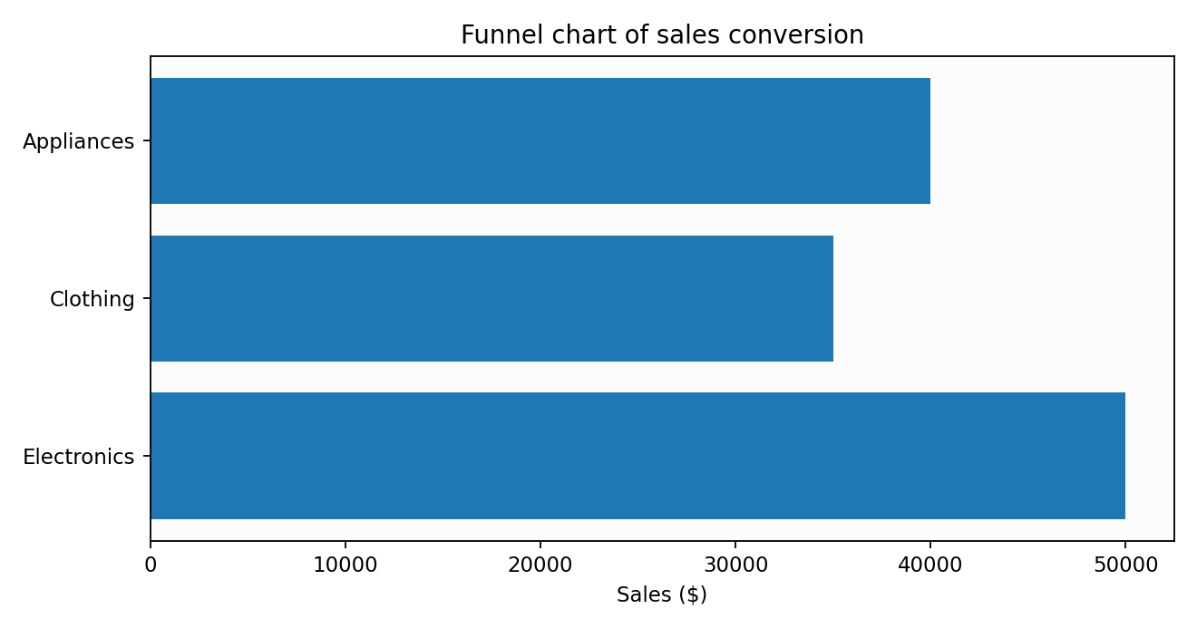
Observation: The plotted values reflect the supplied dataset.

PROGRAM 2: Product category sales table
R Code
products <- data.frame(Category=c("Electronics","Clothing","Appliances"), Sales=c(50000,35000,40000))
print(products)
Output 2: Product category sales table
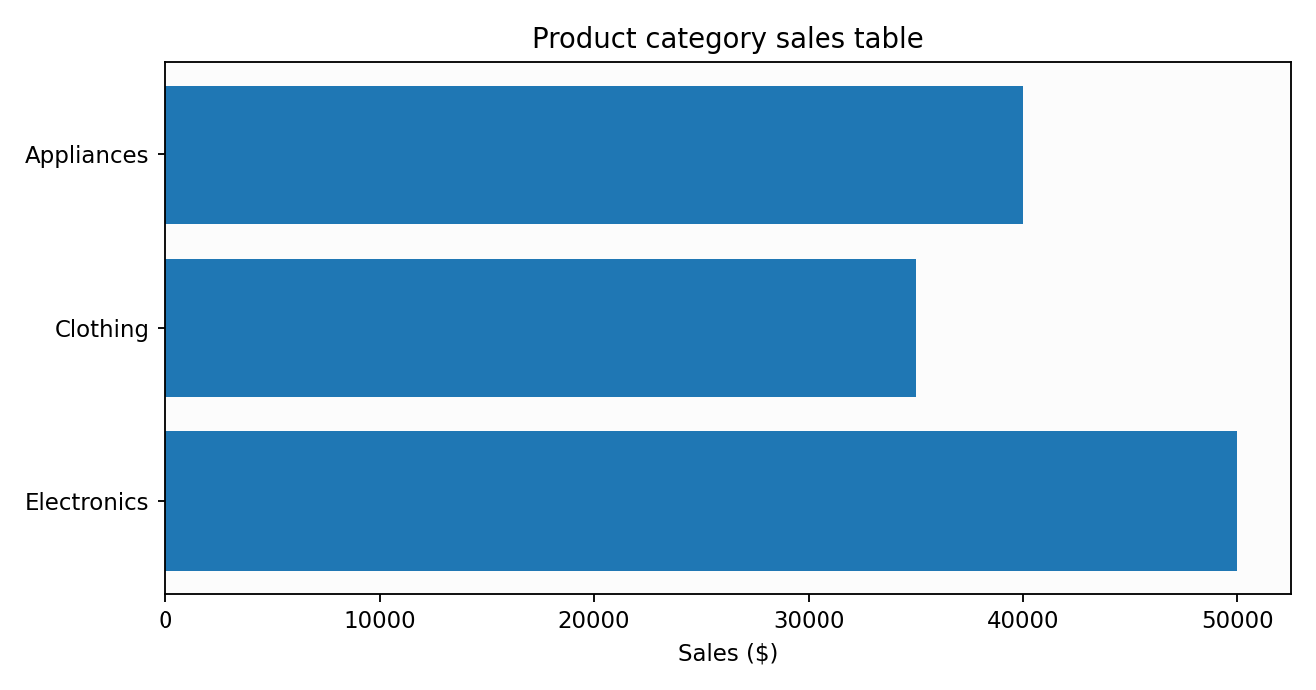
Observation: The chart summarizes the values and supports comparison.

PROGRAM 3: Category analysis dashboard
R Code
# R Shiny interactive dashboard (install.packages("shiny") if needed)
library(shiny)
products <- data.frame(Category=c("Electronics","Clothing","Appliances"), Sales=c(50000,35000,40000))
ui <- fluidPage(titlePanel("Product Category Dashboard"),
selectInput("cat", "Category", c("All", products$Category)),
plotOutput("pie"), plotOutput("bars"), tableOutput("tbl"))
server <- function(input, output, session) {
filtered <- reactive(if(input$cat=="All") products else subset(products, Category==input$cat))
output$pie <- renderPlot(pie(filtered()$Sales, labels=filtered()$Category, main="Sales Share"))
output$bars <- renderPlot(barplot(filtered()$Sales, names.arg=filtered()$Category, main="Category Sales"))
output$tbl <- renderTable(filtered())
}
shinyApp(ui,server)
Output 3: Category analysis dashboard
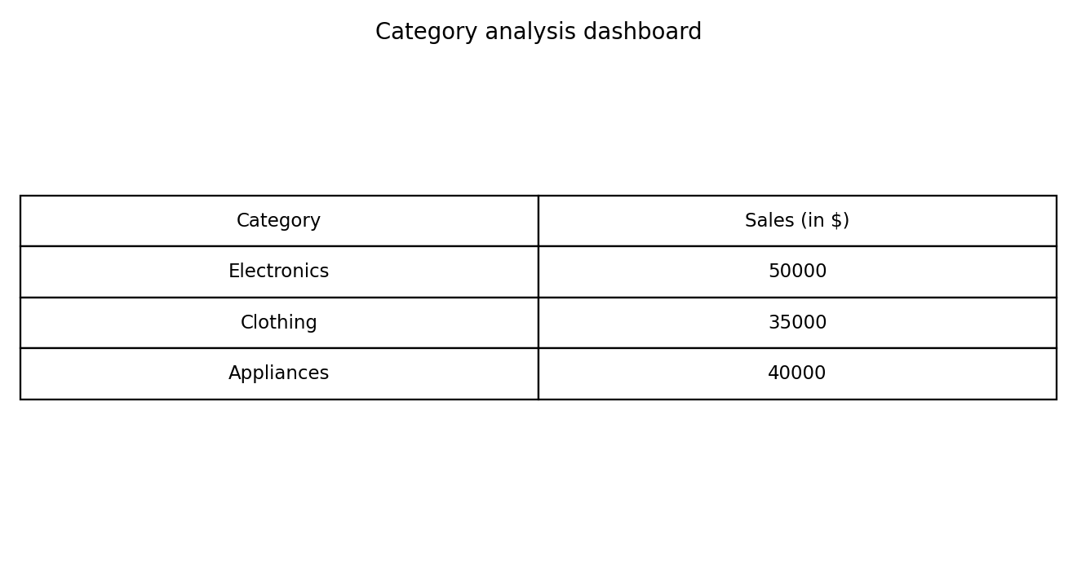
Observation: The table displays the complete provided records.

PROGRAM 4: Sales distribution pie chart
R Code
products <- data.frame(Category=c("Electronics","Clothing","Appliances"), Sales=c(50000,35000,40000))
pie(products$Sales, labels=paste0(products$Category," (",round(100*products$Sales/sum(products$Sales),1),"%)"),
col=c("steelblue","gold","lightgreen"), main="Product Category Sales Share")
Output 4: Sales distribution pie chart
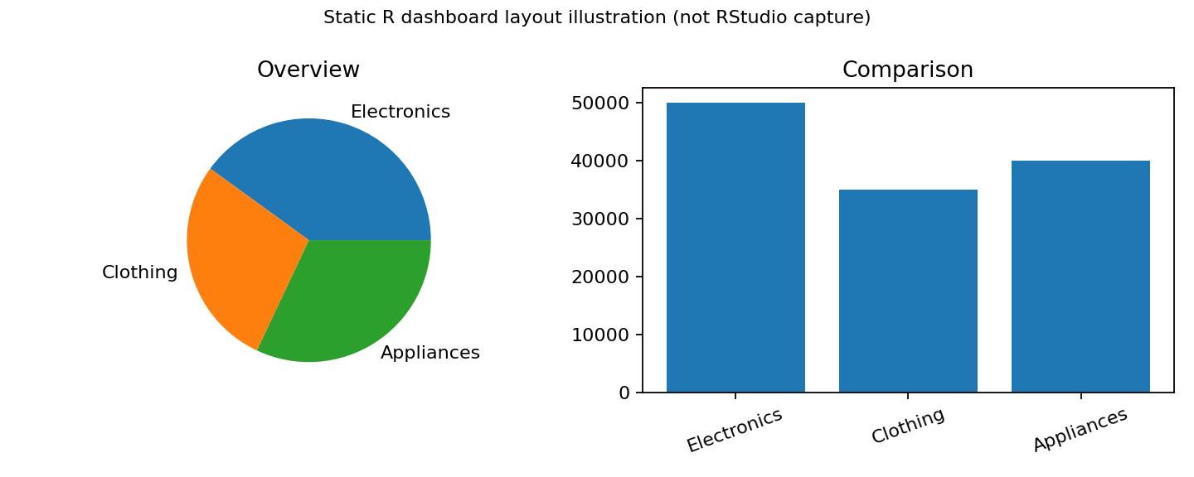
Illustrative static dashboard layout. Run the Shiny code in RStudio for a working interactive dashboard. The source exercise specifically requests Tableau; this is an R-based alternative, not a Tableau screenshot.
Observation: The dashboard combines visual comparisons and data exploration.

Procedure
1. Open RStudio and create an R script.
2. Enter the dataset in R.
3. Run each program and inspect the Plots/Console output.
4. Install and load shiny if necessary, then run the dashboard code.
5. Interpret and record the results.

Result
The Set 11 dataset was analyzed using R programming and the specified visual outputs and tables were prepared.

