LAB EXPERIMENT RECORD

Set 12: Website Traffic
Department: AIML
Course Code / Course Name: DSA0601 / Data Handling and Visualization
Experiment: Data Visualization using R
Name: Deepka V
Register Number: 1092325008

Aim
To analyze the provided dataset through the four prescribed visualizations, tables and dashboard exercises using R programming.

Dataset: Website Traffic
Date | Page Views | Click-through Rate (%)
2023-01-01 | 1500 | 2.3
2023-01-02 | 1600 | 2.7
2023-01-03 | 1400 | 2.0

PROGRAM 1: Daily page views line chart
R Code
traffic <- data.frame(Date=as.Date(c("2023-01-01","2023-01-02","2023-01-03")), PageViews=c(1500,1600,1400), CTR=c(2.3,2.7,2.0))
plot(traffic$Date, traffic$PageViews, type="o", pch=19,
xlab="Date", ylab="Page Views", main="Daily Page Views")
Output 1: Daily page views line chart
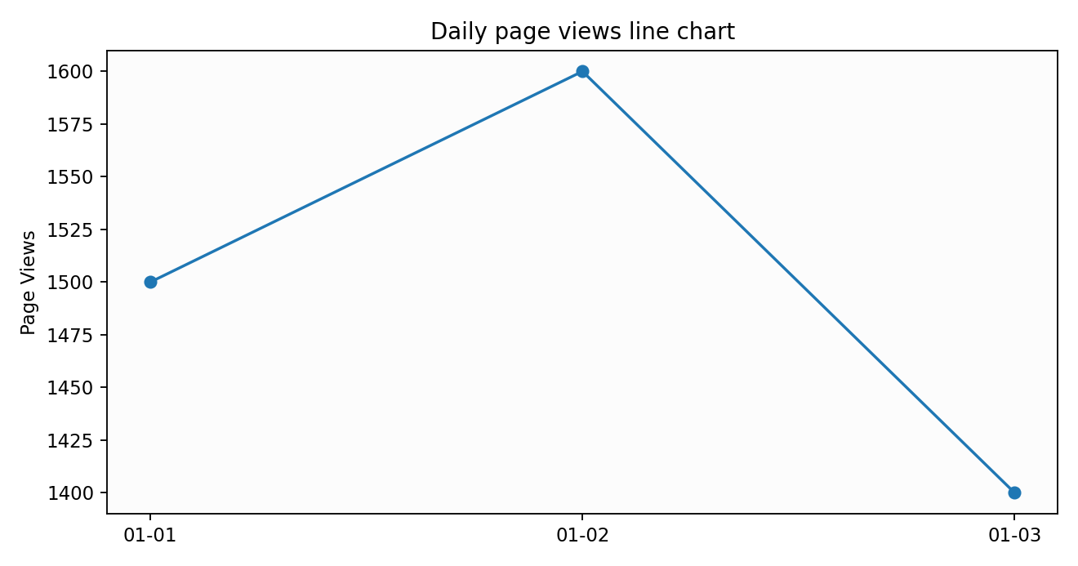
Observation: The plotted values reflect the supplied dataset.

PROGRAM 2: Highest click-through rates bar chart
R Code
traffic <- data.frame(Date=c("Jan 01","Jan 02","Jan 03"), CTR=c(2.3,2.7,2.0))
top_n <- head(traffic[order(-traffic$CTR),],3)
barplot(top_n$CTR, names.arg=top_n$Date, col="steelblue",
xlab="Date", ylab="Click-through Rate (%)", main="Top CTR Days")
Output 2: Highest click-through rates bar chart
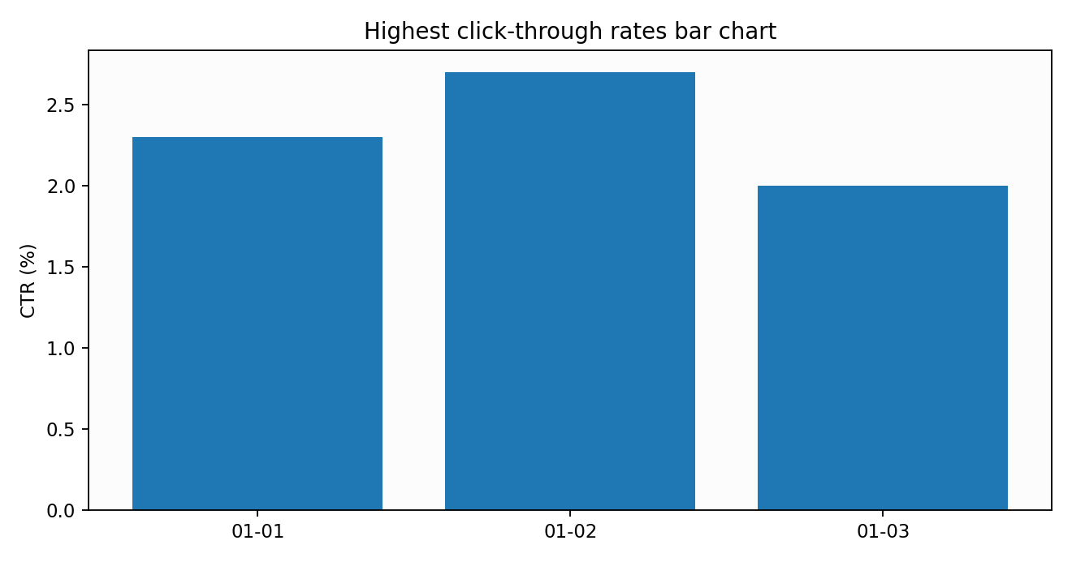
Observation: The chart summarizes the values and supports comparison.

PROGRAM 3: Website traffic table
R Code
traffic <- data.frame(Date=as.Date(c("2023-01-01","2023-01-02","2023-01-03")), PageViews=c(1500,1600,1400), CTR_Percent=c(2.3,2.7,2.0))
print(traffic)
Output 3: Website traffic table
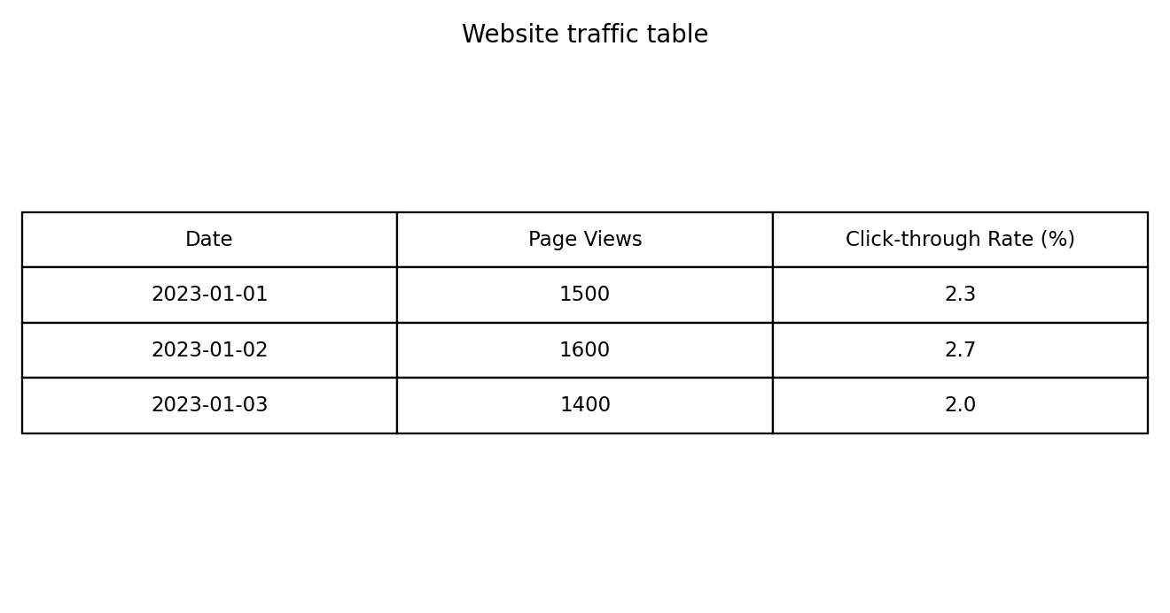
Observation: The table displays the complete provided records.

PROGRAM 4: Website traffic dashboard
R Code
library(shiny)
traffic <- data.frame(Date=as.Date(c("2023-01-01","2023-01-02","2023-01-03")), PageViews=c(1500,1600,1400), CTR=c(2.3,2.7,2.0))
ui <- fluidPage(titlePanel("Website Traffic Dashboard"),
dateRangeInput("dates","Dates",start=min(traffic$Date),end=max(traffic$Date)),
plotOutput("trend"),plotOutput("ctr"),tableOutput("tbl"))
server <- function(input,output,session){
d <- reactive(subset(traffic,Date>=input$dates[1] & Date<=input$dates[2]))
output$trend <- renderPlot(plot(d()$Date,d()$PageViews,type="o",xlab="Date",ylab="Views"))
output$ctr <- renderPlot(barplot(d()$CTR,names.arg=as.character(d()$Date),las=2,ylab="CTR (%)"))
output$tbl <- renderTable(d())
}
shinyApp(ui,server)
Output 4: Website traffic dashboard
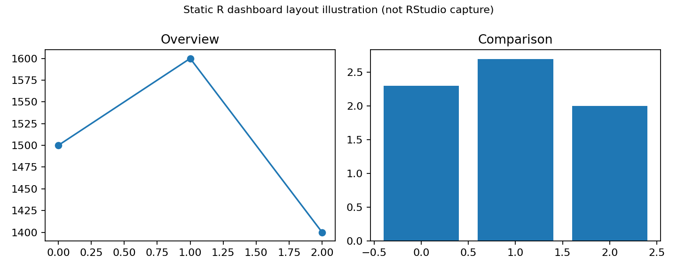
Illustrative static dashboard layout. Run the Shiny code in RStudio for a working interactive dashboard. The source exercise specifically requests Tableau; this is an R-based alternative, not a Tableau screenshot.
Observation: The dashboard combines visual comparisons and data exploration.

Procedure
1. Open RStudio and create an R script.
2. Enter the dataset in R.
3. Run each program and inspect the Plots/Console output.
4. Install and load shiny if necessary, then run the dashboard code.
5. Interpret and record the results.

Result
The Set 12 dataset was analyzed using R programming and the specified visual outputs and tables were prepared.

