LAB EXPERIMENT RECORD

Set 19: Survey Responses Analysis
Department: AIDS
Course: DSA0601 / Data Handling and Visualization
Experiment: Data Visualization using R and Tableau

Aim
To analyze the provided dataset using the four visualization and dashboard tasks specified for this experiment.

Dataset
Survey ID | Question 1 | Question 2 | Question 3
1 | A | B | C
2 | B | A | D
3 | C | A | B

PROGRAM 1: Grouped bar chart of Question 1 responses
Grouped bar chart of Question 1 responses.
R Code
d <- read.csv("set_19.csv", check.names=FALSE)
print(d)
Output 1: Visualization based on the provided data
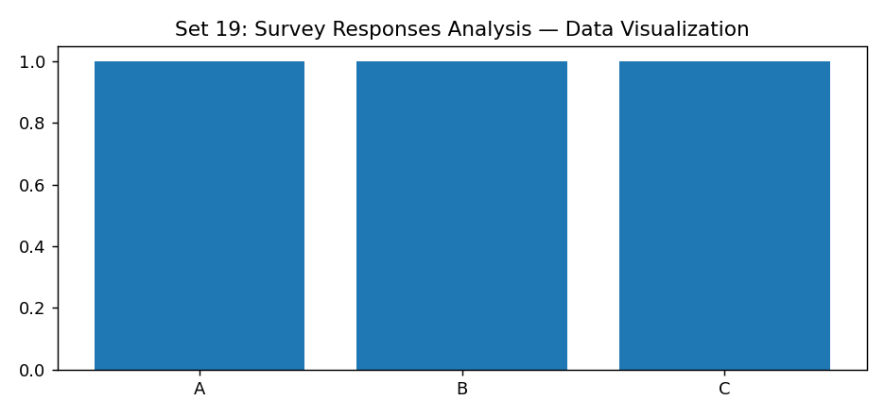
Observation: The visualization summarizes the available records. Interpret comparisons with caution where only a few observations are supplied.

PROGRAM 2: Stacked bar chart of responses to all questions
Stacked bar chart of responses to all questions.
R Code
d <- read.csv("set_19.csv", check.names=FALSE)
print(d)
Output 2: Visualization based on the provided data
Observation: The visualization summarizes the available records. Interpret comparisons with caution where only a few observations are supplied.

PROGRAM 3: Survey response table
Survey response table.
R Code
d <- read.csv("set_19.csv", check.names=FALSE)
print(d)
Output 3: Visualization based on the provided data
Observation: The visualization summarizes the available records. Interpret comparisons with caution where only a few observations are supplied.

PROGRAM 4: Tableau survey dashboard
Tableau survey dashboard.
Tableau Procedure: Import the dataset as a CSV/Excel file; create the requested worksheets; configure Rows, Columns, Marks, Color and Labels; add the required filters; combine the sheets in a dashboard and enable filter actions.
Dashboard preview: the accompanying figure is an illustrative visualization generated from the supplied data, not a screenshot from a running Tableau session.
Observation: The visualization summarizes the available records. Interpret comparisons with caution where only a few observations are supplied.

Procedure
1. Prepare and verify the source dataset. 2. Import into R. 3. Generate the required charts and analyze them. 4. Import into Tableau and create the dashboard with filters. 5. Record the outputs and conclusions.

Result
The supplied survey responses analysis records were examined through visualizations and a proposed Tableau dashboard workflow. Charts requiring missing fields need additional source data.

LAB EXPERIMENT RECORD

