LAB EXPERIMENT RECORD

Set 20: Stock Analysis
Department: AIDS
Course: DSA0601 / Data Handling and Visualization
Experiment: Data Visualization using R and Tableau

Aim
To analyze the provided dataset using the four visualization and dashboard tasks specified for this experiment.

Dataset
Date | Stock A | Stock B | Stock C
2023-01-01 | 100 |  | 120
2023-01-02 | 105 | 152 | 118
2023-01-03 | 110 | 148 | 122

PROGRAM 1: Line chart of three stock prices
Line chart of three stock prices.
R Code
# Load the provided data from a CSV export
d <- read.csv("set_20.csv", check.names=FALSE)
barplot(d[["Stock C"]], names.arg=d[[1]],
main="Line chart of three stock prices", xlab="Records", ylab="Stock C", col="steelblue")
Output 1: Visualization based on the provided data
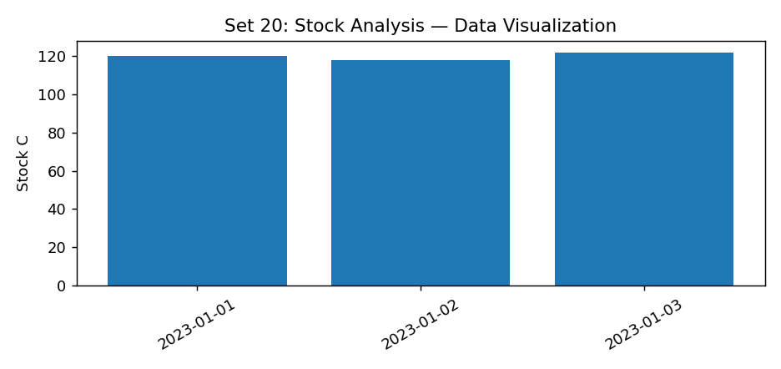
Observation: The visualization summarizes the available records. Interpret comparisons with caution where only a few observations are supplied.
Data limitation: The first-day Stock B value is not legible in the supplied source; it is left blank.

PROGRAM 2: Bar chart of Stock A daily percentage change
Bar chart of Stock A daily percentage change.
R Code
# Load the provided data from a CSV export
d <- read.csv("set_20.csv", check.names=FALSE)
barplot(d[["Stock C"]], names.arg=d[[1]],
main="Bar chart of Stock A daily percentage change", xlab="Records", ylab="Stock C", col="steelblue")
Output 2: Visualization based on the provided data
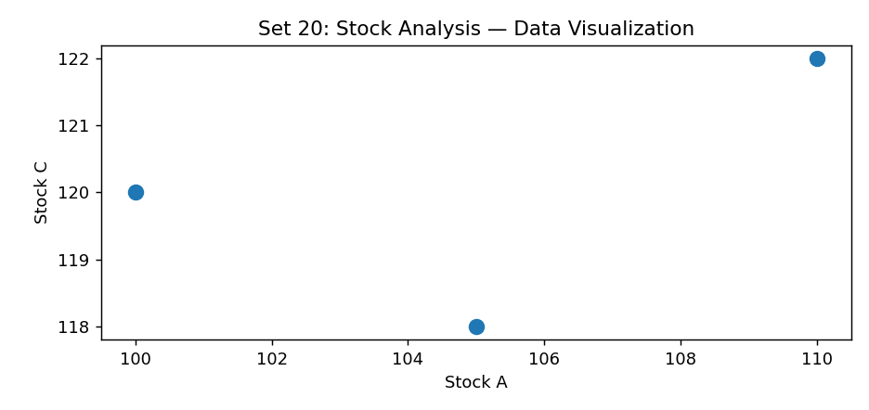
Observation: The visualization summarizes the available records. Interpret comparisons with caution where only a few observations are supplied.
Data limitation: The first-day Stock B value is not legible in the supplied source; it is left blank.

PROGRAM 3: Stock prices table
Stock prices table.
R Code
d <- read.csv("set_20.csv", check.names=FALSE)
print(d)
Output 3: Visualization based on the provided data
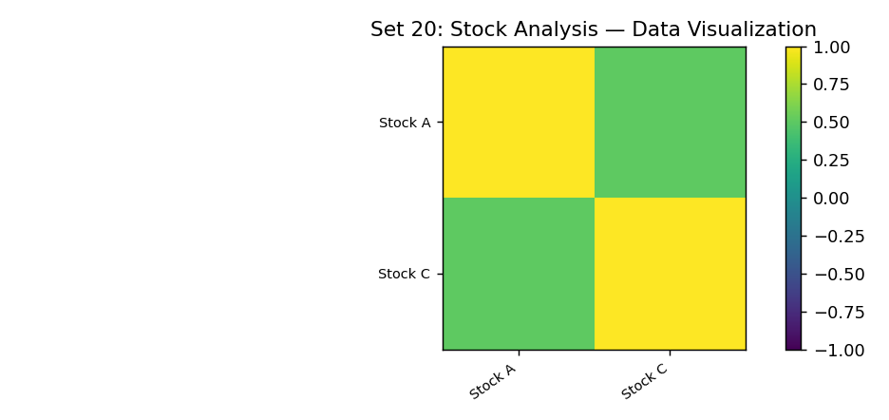
Observation: The visualization summarizes the available records. Interpret comparisons with caution where only a few observations are supplied.
Data limitation: The first-day Stock B value is not legible in the supplied source; it is left blank.

PROGRAM 4: Tableau stock dashboard
Tableau stock dashboard.
Tableau Procedure: Import the dataset as a CSV/Excel file; create the requested worksheets; configure Rows, Columns, Marks, Color and Labels; add the required filters; combine the sheets in a dashboard and enable filter actions.
Dashboard preview: the accompanying figure is an illustrative visualization generated from the supplied data, not a screenshot from a running Tableau session.
Observation: The visualization summarizes the available records. Interpret comparisons with caution where only a few observations are supplied.
Data limitation: The first-day Stock B value is not legible in the supplied source; it is left blank.

Procedure
1. Prepare and verify the source dataset. 2. Import into R. 3. Generate the required charts and analyze them. 4. Import into Tableau and create the dashboard with filters. 5. Record the outputs and conclusions.

Result
The supplied stock analysis records were examined through visualizations and a proposed Tableau dashboard workflow. Charts requiring missing fields need additional source data.

LAB EXPERIMENT RECORD

