LAB EXPERIMENT RECORD

Set 21: Energy Consumption Analysis
Department: AIDS
Course: DSA0601 / Data Handling and Visualization
Experiment: Data Visualization using R and Tableau

Aim
To analyze the provided dataset using the four visualization and dashboard tasks specified for this experiment.

Dataset
Region | Month | Temperature | Units_Consumed | Cost | Renewable_Usage | Sector | Peak_Hours
North | Jan | 15 | 320 | 2100 | 22 | Residential | 4
South | Jan | 24 | 540 | 3600 | 18 | Commercial | 6
West | Feb | 20 | 880 | 5900 | 12 | Industrial | 8
East | Feb | 18 | 350 | 2300 | 25 | Residential | 5
North | Mar | 28 | 610 | 4100 | 20 | Commercial | 7
South | Mar | 30 | 920 | 6200 | 15 | Industrial | 9

PROGRAM 1: Histogram and density of energy units
Histogram and density of energy units.
R Code
# Load the provided data from a CSV export
d <- read.csv("set_21.csv", check.names=FALSE)
barplot(d[["Peak_Hours"]], names.arg=d[[1]],
main="Histogram and density of energy units", xlab="Records", ylab="Peak_Hours", col="steelblue")
Output 1: Visualization based on the provided data
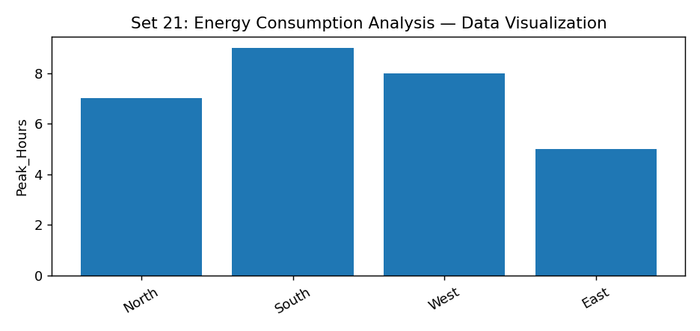
Observation: The visualization summarizes the available records. Interpret comparisons with caution where only a few observations are supplied.

PROGRAM 2: Bubble chart of temperature vs units, sized by peak hours
Bubble chart of temperature vs units, sized by peak hours.
R Code
# Load the provided data from a CSV export
d <- read.csv("set_21.csv", check.names=FALSE)
barplot(d[["Peak_Hours"]], names.arg=d[[1]],
main="Bubble chart of temperature vs units, sized by peak hours", xlab="Records", ylab="Peak_Hours", col="steelblue")
Output 2: Visualization based on the provided data
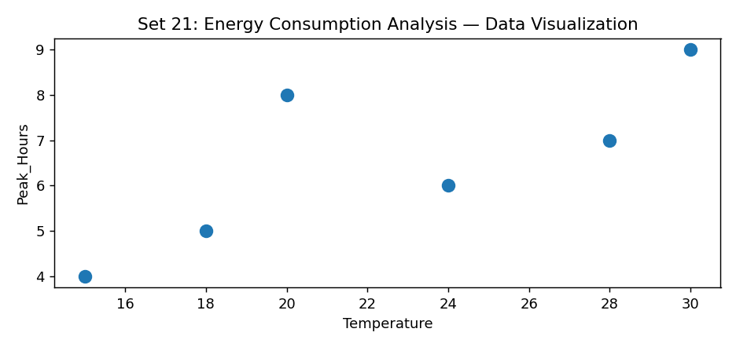
Observation: The visualization summarizes the available records. Interpret comparisons with caution where only a few observations are supplied.

PROGRAM 3: Average renewable usage by sector bar chart
Average renewable usage by sector bar chart.
R Code
# Load the provided data from a CSV export
d <- read.csv("set_21.csv", check.names=FALSE)
barplot(d[["Peak_Hours"]], names.arg=d[[1]],
main="Average renewable usage by sector bar chart", xlab="Records", ylab="Peak_Hours", col="steelblue")
Output 3: Visualization based on the provided data
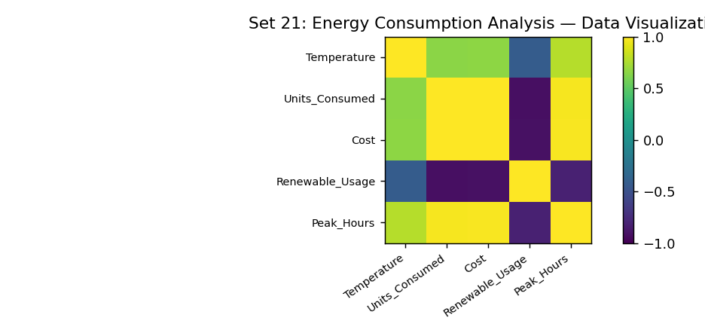
Observation: The visualization summarizes the available records. Interpret comparisons with caution where only a few observations are supplied.

PROGRAM 4: Tableau monthly energy and sector-region heatmap dashboard
Tableau monthly energy and sector-region heatmap dashboard.
Tableau Procedure: Import the dataset as a CSV/Excel file; create the requested worksheets; configure Rows, Columns, Marks, Color and Labels; add the required filters; combine the sheets in a dashboard and enable filter actions.
Dashboard preview: the accompanying figure is an illustrative visualization generated from the supplied data, not a screenshot from a running Tableau session.
Observation: The visualization summarizes the available records. Interpret comparisons with caution where only a few observations are supplied.

Procedure
1. Prepare and verify the source dataset. 2. Import into R. 3. Generate the required charts and analyze them. 4. Import into Tableau and create the dashboard with filters. 5. Record the outputs and conclusions.

Result
The supplied energy consumption analysis records were examined through visualizations and a proposed Tableau dashboard workflow. Charts requiring missing fields need additional source data.

LAB EXPERIMENT RECORD

