LAB EXPERIMENT RECORD

Set 22: Time Series Analysis
Department: AIDS
Course: DSA0601 / Data Handling and Visualization
Experiment: Data Visualization using R and Tableau

Aim
To analyze the provided dataset using the four visualization and dashboard tasks specified for this experiment.

Dataset
Month | Sales ($)
January | 15000
February | 18000
March | 22000
April | 20000
May | 23000

PROGRAM 1: R time-series line chart of sales
R time-series line chart of sales.
R Code
# Load the provided data from a CSV export
d <- read.csv("set_22.csv", check.names=FALSE)
barplot(d[["Sales ($)"]], names.arg=d[[1]],
main="R time-series line chart of sales", xlab="Records", ylab="Sales ($)", col="steelblue")
Output 1: Visualization based on the provided data
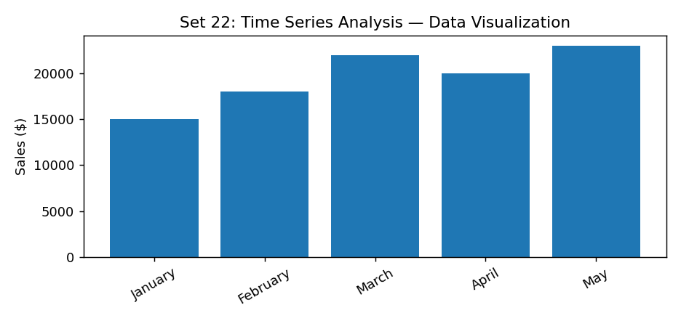
Observation: The visualization summarizes the available records. Interpret comparisons with caution where only a few observations are supplied.

PROGRAM 2: Scatter plot of advertising budget vs sales
Scatter plot of advertising budget vs sales.
R Code
# Load the provided data from a CSV export
d <- read.csv("set_22.csv", check.names=FALSE)
barplot(d[["Sales ($)"]], names.arg=d[[1]],
main="Scatter plot of advertising budget vs sales", xlab="Records", ylab="Sales ($)", col="steelblue")
Output 2: Visualization based on the provided data
Observation: The visualization summarizes the available records. Interpret comparisons with caution where only a few observations are supplied.
Data limitation: The source does not provide all fields needed for this requested chart. Additional authentic data is required; no values have been invented.

PROGRAM 3: Tableau sales line and product pie dashboard
Tableau sales line and product pie dashboard.
Tableau Procedure: Import the dataset as a CSV/Excel file; create the requested worksheets; configure Rows, Columns, Marks, Color and Labels; add the required filters; combine the sheets in a dashboard and enable filter actions.
Dashboard preview: the accompanying figure is an illustrative visualization generated from the supplied data, not a screenshot from a running Tableau session.
Output 3: Visualization based on the provided data
Observation: The visualization summarizes the available records. Interpret comparisons with caution where only a few observations are supplied.
Data limitation: The source does not provide all fields needed for this requested chart. Additional authentic data is required; no values have been invented.

PROGRAM 4: R autocorrelation plot for seasonality
R autocorrelation plot for seasonality.
Tableau Procedure: Import the dataset as a CSV/Excel file; create the requested worksheets; configure Rows, Columns, Marks, Color and Labels; add the required filters; combine the sheets in a dashboard and enable filter actions.
Dashboard preview: the accompanying figure is an illustrative visualization generated from the supplied data, not a screenshot from a running Tableau session.
Observation: The visualization summarizes the available records. Interpret comparisons with caution where only a few observations are supplied.
Data limitation: The source does not provide all fields needed for this requested chart. Additional authentic data is required; no values have been invented.

Procedure
1. Prepare and verify the source dataset. 2. Import into R. 3. Generate the required charts and analyze them. 4. Import into Tableau and create the dashboard with filters. 5. Record the outputs and conclusions.

Result
The supplied time series analysis records were examined through visualizations and a proposed Tableau dashboard workflow. Charts requiring missing fields need additional source data.

LAB EXPERIMENT RECORD

