LAB EXPERIMENT RECORD

Set 23: Employee Performance Analysis
Department: AIDS
Course: DSA0601 / Data Handling and Visualization
Experiment: Data Visualization using R and Tableau

Aim
To analyze the provided dataset using the four visualization and dashboard tasks specified for this experiment.

Dataset
Employee ID | Department | Years of Service | Performance Score
1 | Sales | 5 | 85
2 | HR | 3 | 92
3 | Marketing | 7 | 78
4 | Sales | 4 | 90
5 | HR | 2 | 76

PROGRAM 1: R bar chart of department distribution
R bar chart of department distribution.
R Code
# Load the provided data from a CSV export
d <- read.csv("set_23.csv", check.names=FALSE)
barplot(d[["Performance Score"]], names.arg=d[[1]],
main="R bar chart of department distribution", xlab="Records", ylab="Performance Score", col="steelblue")
Output 1: Visualization based on the provided data
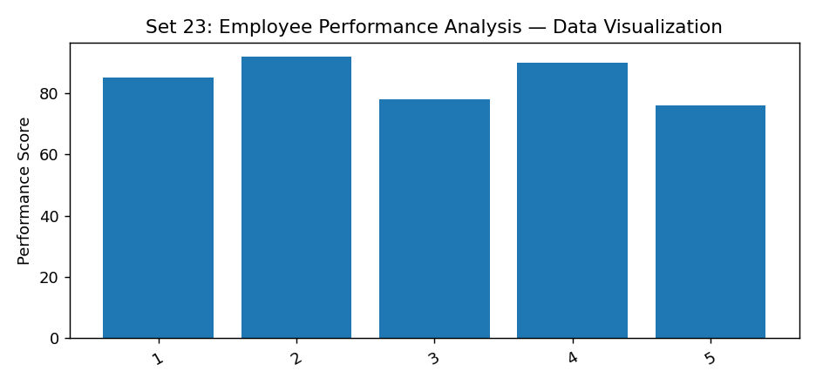
Observation: The visualization summarizes the available records. Interpret comparisons with caution where only a few observations are supplied.

PROGRAM 2: R line chart of employee performance
R line chart of employee performance.
R Code
# Load the provided data from a CSV export
d <- read.csv("set_23.csv", check.names=FALSE)
barplot(d[["Performance Score"]], names.arg=d[[1]],
main="R line chart of employee performance", xlab="Records", ylab="Performance Score", col="steelblue")
Output 2: Visualization based on the provided data
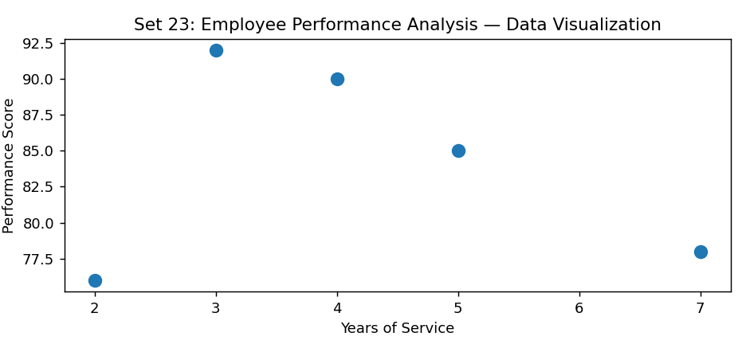
Observation: The visualization summarizes the available records. Interpret comparisons with caution where only a few observations are supplied.

PROGRAM 3: Tableau department and years-service dashboard
Tableau department and years-service dashboard.
Tableau Procedure: Import the dataset as a CSV/Excel file; create the requested worksheets; configure Rows, Columns, Marks, Color and Labels; add the required filters; combine the sheets in a dashboard and enable filter actions.
Dashboard preview: the accompanying figure is an illustrative visualization generated from the supplied data, not a screenshot from a running Tableau session.
Output 3: Visualization based on the provided data
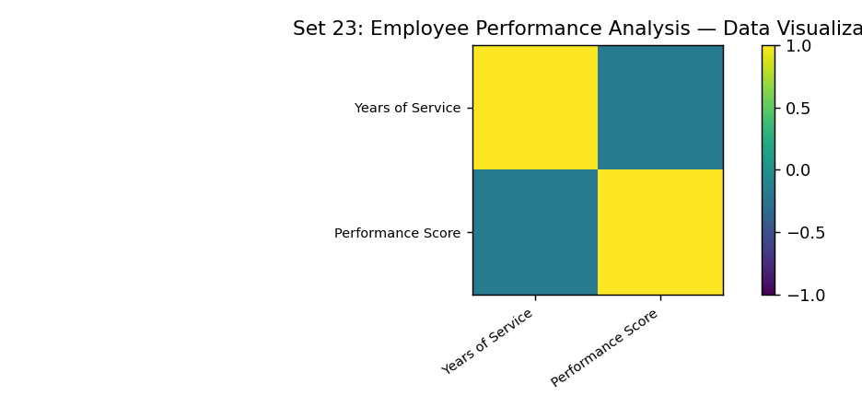
Observation: The visualization summarizes the available records. Interpret comparisons with caution where only a few observations are supplied.

PROGRAM 4: R employee data table
R employee data table.
Tableau Procedure: Import the dataset as a CSV/Excel file; create the requested worksheets; configure Rows, Columns, Marks, Color and Labels; add the required filters; combine the sheets in a dashboard and enable filter actions.
Dashboard preview: the accompanying figure is an illustrative visualization generated from the supplied data, not a screenshot from a running Tableau session.
Observation: The visualization summarizes the available records. Interpret comparisons with caution where only a few observations are supplied.

Procedure
1. Prepare and verify the source dataset. 2. Import into R. 3. Generate the required charts and analyze them. 4. Import into Tableau and create the dashboard with filters. 5. Record the outputs and conclusions.

Result
The supplied employee performance analysis records were examined through visualizations and a proposed Tableau dashboard workflow. Charts requiring missing fields need additional source data.

LAB EXPERIMENT RECORD

