LAB EXPERIMENT RECORD

Set 24: Product Inventory Management
Department: AIDS
Course: DSA0601 / Data Handling and Visualization
Experiment: Data Visualization using R and Tableau

Aim
To analyze the provided dataset using the four visualization and dashboard tasks specified for this experiment.

Dataset
Product ID | Product Name | Quantity Available
1 | Product A | 250
2 | Product B | 175
3 | Product C | 300
4 | Product D | 200
5 | Product E | 220

PROGRAM 1: R bar chart of inventory quantity
R bar chart of inventory quantity.
R Code
# Load the provided data from a CSV export
d <- read.csv("set_24.csv", check.names=FALSE)
barplot(d[["Quantity Available"]], names.arg=d[[1]],
main="R bar chart of inventory quantity", xlab="Records", ylab="Quantity Available", col="steelblue")
Output 1: Visualization based on the provided data
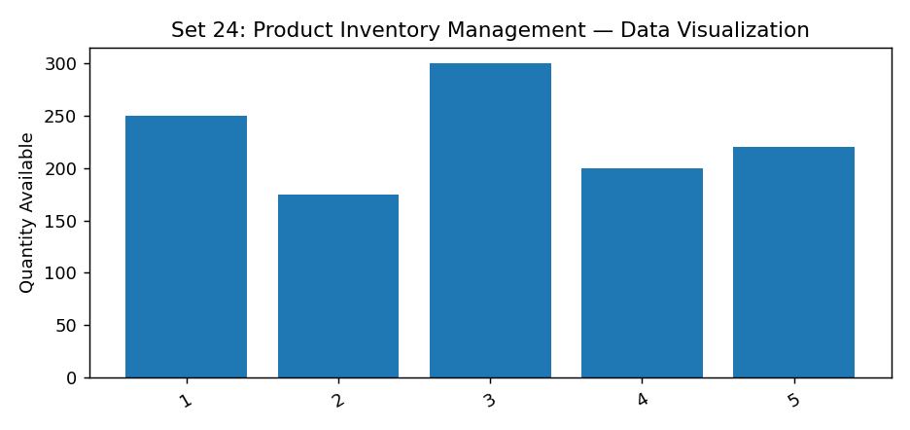
Observation: The visualization summarizes the available records. Interpret comparisons with caution where only a few observations are supplied.

PROGRAM 2: R stacked bar chart by product category
R stacked bar chart by product category.
R Code
# Load the provided data from a CSV export
d <- read.csv("set_24.csv", check.names=FALSE)
barplot(d[["Quantity Available"]], names.arg=d[[1]],
main="R stacked bar chart by product category", xlab="Records", ylab="Quantity Available", col="steelblue")
Output 2: Visualization based on the provided data
Observation: The visualization summarizes the available records. Interpret comparisons with caution where only a few observations are supplied.
Data limitation: The source does not provide all fields needed for this requested chart. Additional authentic data is required; no values have been invented.

PROGRAM 3: Tableau inventory dashboard
Tableau inventory dashboard.
Tableau Procedure: Import the dataset as a CSV/Excel file; create the requested worksheets; configure Rows, Columns, Marks, Color and Labels; add the required filters; combine the sheets in a dashboard and enable filter actions.
Dashboard preview: the accompanying figure is an illustrative visualization generated from the supplied data, not a screenshot from a running Tableau session.
Output 3: Visualization based on the provided data
Observation: The visualization summarizes the available records. Interpret comparisons with caution where only a few observations are supplied.

PROGRAM 4: R price vs quantity scatter plot
R price vs quantity scatter plot.
Tableau Procedure: Import the dataset as a CSV/Excel file; create the requested worksheets; configure Rows, Columns, Marks, Color and Labels; add the required filters; combine the sheets in a dashboard and enable filter actions.
Dashboard preview: the accompanying figure is an illustrative visualization generated from the supplied data, not a screenshot from a running Tableau session.
Observation: The visualization summarizes the available records. Interpret comparisons with caution where only a few observations are supplied.
Data limitation: The source does not provide all fields needed for this requested chart. Additional authentic data is required; no values have been invented.

Procedure
1. Prepare and verify the source dataset. 2. Import into R. 3. Generate the required charts and analyze them. 4. Import into Tableau and create the dashboard with filters. 5. Record the outputs and conclusions.

Result
The supplied product inventory management records were examined through visualizations and a proposed Tableau dashboard workflow. Charts requiring missing fields need additional source data.

LAB EXPERIMENT RECORD

