LAB EXPERIMENT RECORD

Set 25: Website Traffic Analysis
Department: AIDS
Course: DSA0601 / Data Handling and Visualization
Experiment: Data Visualization using R and Tableau

Aim
To analyze the provided dataset using the four visualization and dashboard tasks specified for this experiment.

Dataset
Date | Page Views | Click-through Rate (%)
2023-01-01 | 1500 | 2.3
2023-01-02 | 1600 | 2.7
2023-01-03 | 1400 | 2.0
2023-01-04 | 1650 | 2.4
2023-01-05 | 1800 | 2.6

PROGRAM 1: Tableau page-view line chart
Tableau page-view line chart.
Tableau Procedure: Import the dataset as a CSV/Excel file; create the requested worksheets; configure Rows, Columns, Marks, Color and Labels; add the required filters; combine the sheets in a dashboard and enable filter actions.
Dashboard preview: the accompanying figure is an illustrative visualization generated from the supplied data, not a screenshot from a running Tableau session.
Output 1: Visualization based on the provided data
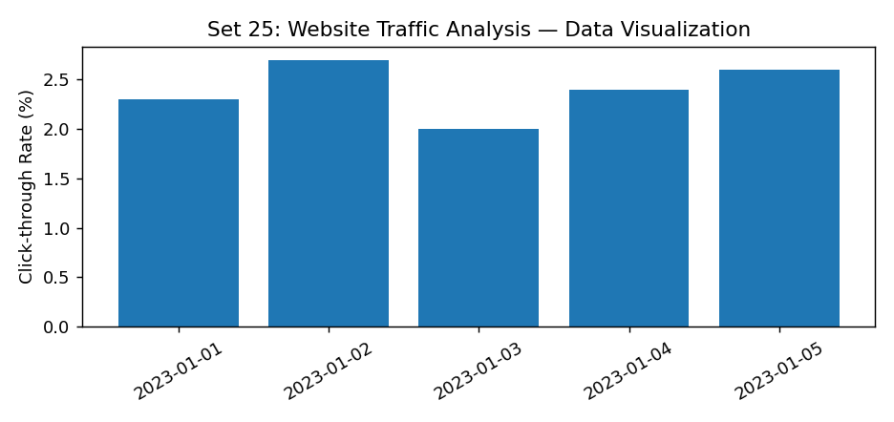
Observation: The visualization summarizes the available records. Interpret comparisons with caution where only a few observations are supplied.

PROGRAM 2: R top click-through-rate days bar chart
R top click-through-rate days bar chart.
R Code
# Load the provided data from a CSV export
d <- read.csv("set_25.csv", check.names=FALSE)
barplot(d[["Click-through Rate (%)"]], names.arg=d[[1]],
main="R top click-through-rate days bar chart", xlab="Records", ylab="Click-through Rate (%)", col="steelblue")
Output 2: Visualization based on the provided data
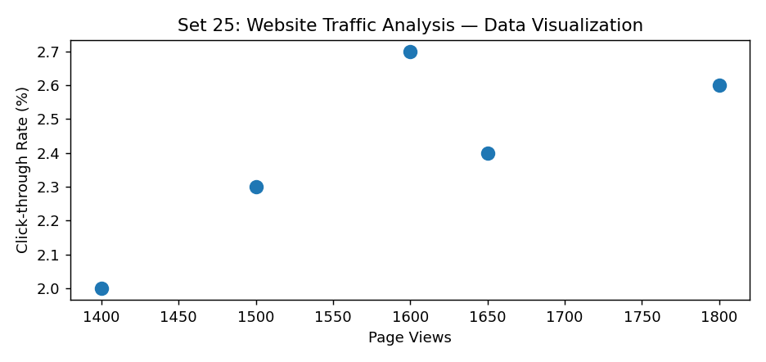
Observation: The visualization summarizes the available records. Interpret comparisons with caution where only a few observations are supplied.

PROGRAM 3: R stacked area chart of likes, shares, comments
R stacked area chart of likes, shares, comments.
R Code
# Load the provided data from a CSV export
d <- read.csv("set_25.csv", check.names=FALSE)
barplot(d[["Click-through Rate (%)"]], names.arg=d[[1]],
main="R stacked area chart of likes, shares, comments", xlab="Records", ylab="Click-through Rate (%)", col="steelblue")
Output 3: Visualization based on the provided data
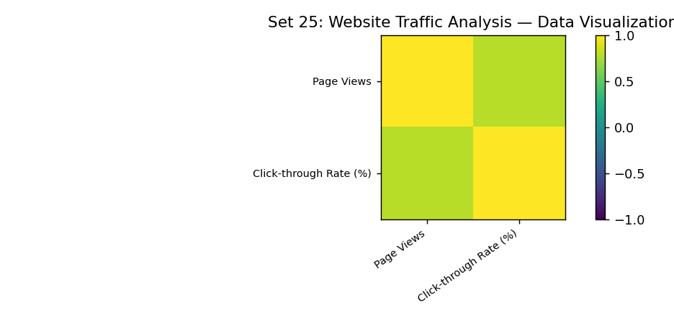
Observation: The visualization summarizes the available records. Interpret comparisons with caution where only a few observations are supplied.
Data limitation: The source does not provide all fields needed for this requested chart. Additional authentic data is required; no values have been invented.

PROGRAM 4: Tableau traffic-source map and bar dashboard
Tableau traffic-source map and bar dashboard.
Tableau Procedure: Import the dataset as a CSV/Excel file; create the requested worksheets; configure Rows, Columns, Marks, Color and Labels; add the required filters; combine the sheets in a dashboard and enable filter actions.
Dashboard preview: the accompanying figure is an illustrative visualization generated from the supplied data, not a screenshot from a running Tableau session.
Observation: The visualization summarizes the available records. Interpret comparisons with caution where only a few observations are supplied.
Data limitation: The source does not provide all fields needed for this requested chart. Additional authentic data is required; no values have been invented.

Procedure
1. Prepare and verify the source dataset. 2. Import into R. 3. Generate the required charts and analyze them. 4. Import into Tableau and create the dashboard with filters. 5. Record the outputs and conclusions.

Result
The supplied website traffic analysis records were examined through visualizations and a proposed Tableau dashboard workflow. Charts requiring missing fields need additional source data.

LAB EXPERIMENT RECORD

