LAB EXPERIMENT RECORD

Set 26: Student Performance Analysis
Department: AIDS
Course: DSA0601 / Data Handling and Visualization
Experiment: Data Visualization using R and Tableau

Aim
To analyze the provided dataset using the four visualization and dashboard tasks specified for this experiment.

Dataset
Student_ID | Gender | Study_Hours | Attendance | Math_Score | Science_Score | Exam_Date
S01 | Male | 2 | 78 | 62 | 65 | 2025-01-10
S02 | Female | 3.5 | 90 | 80 | 85 | 2025-01-10
S03 | Male | 1.5 | 70 | 55 | 58 | 2025-02-12
S04 | Female | 4 | 95 | 90 | 92 | 2025-02-12
S05 | Male | 2.8 | 85 | 72 | 74 | 2025-03-15
S06 | Female | 3 | 92 | 82 | 86 | 2025-03-15

PROGRAM 1: R histogram of Math scores and Science boxplot by gender
R histogram of Math scores and Science boxplot by gender.
R Code
# Load the provided data from a CSV export
d <- read.csv("set_26.csv", check.names=FALSE)
barplot(d[["Science_Score"]], names.arg=d[[1]],
main="R histogram of Math scores and Science boxplot by gender", xlab="Records", ylab="Science_Score", col="steelblue")
Output 1: Visualization based on the provided data
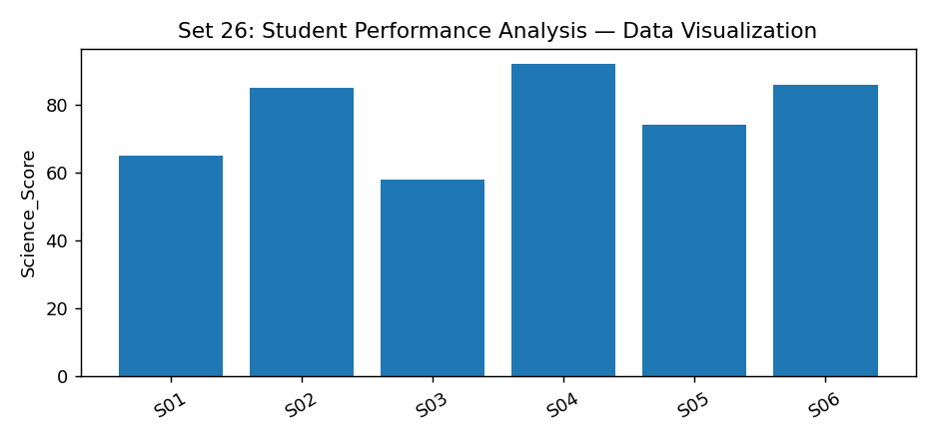
Observation: The visualization summarizes the available records. Interpret comparisons with caution where only a few observations are supplied.

PROGRAM 2: R study hours vs Math scatter with gender and regression
R study hours vs Math scatter with gender and regression.
R Code
d <- read.csv("set_26.csv", check.names=FALSE)
plot(d[["Study_Hours"]], d[["Science_Score"]], pch=19, col="steelblue",
xlab="Study_Hours", ylab="Science_Score", main="R study hours vs Math scatter with gender and regression")
Output 2: Visualization based on the provided data
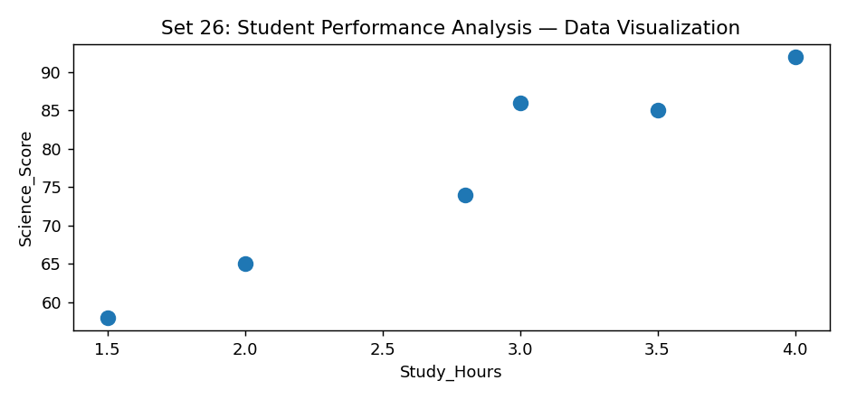
Observation: The visualization summarizes the available records. Interpret comparisons with caution where only a few observations are supplied.

PROGRAM 3: R monthly Math mean with moving average
R monthly Math mean with moving average.
R Code
# Load the provided data from a CSV export
d <- read.csv("set_26.csv", check.names=FALSE)
barplot(d[["Science_Score"]], names.arg=d[[1]],
main="R monthly Math mean with moving average", xlab="Records", ylab="Science_Score", col="steelblue")
Output 3: Visualization based on the provided data
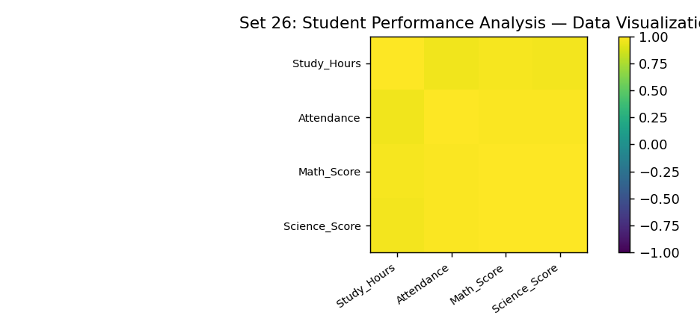
Observation: The visualization summarizes the available records. Interpret comparisons with caution where only a few observations are supplied.

PROGRAM 4: Tableau gender and date-filtered score dashboard
Tableau gender and date-filtered score dashboard.
Tableau Procedure: Import the dataset as a CSV/Excel file; create the requested worksheets; configure Rows, Columns, Marks, Color and Labels; add the required filters; combine the sheets in a dashboard and enable filter actions.
Dashboard preview: the accompanying figure is an illustrative visualization generated from the supplied data, not a screenshot from a running Tableau session.
Observation: The visualization summarizes the available records. Interpret comparisons with caution where only a few observations are supplied.

Procedure
1. Prepare and verify the source dataset. 2. Import into R. 3. Generate the required charts and analyze them. 4. Import into Tableau and create the dashboard with filters. 5. Record the outputs and conclusions.

Result
The supplied student performance analysis records were examined through visualizations and a proposed Tableau dashboard workflow. Charts requiring missing fields need additional source data.

LAB EXPERIMENT RECORD

