LAB EXPERIMENT RECORD

Set 27: Patient Health Risk Analysis
Department: AIDS
Course: DSA0601 / Data Handling and Visualization
Experiment: Data Visualization using R and Tableau

Aim
To analyze the provided dataset using the four visualization and dashboard tasks specified for this experiment.

Dataset
Patient_ID | Age | BMI | BP | Cholesterol
P1 | 25 | 22 | 120 | 180
P2 | 40 | 28 | 135 | 210
P3 | 55 | 30 | 145 | 240
P4 | 35 | 26 | 130 | 200
P5 | 60 | 32 | 150 | 260

PROGRAM 1: R scatterplot matrix of health indicators
R scatterplot matrix of health indicators.
R Code
d <- read.csv("set_27.csv", check.names=FALSE)
plot(d[["Age"]], d[["Cholesterol"]], pch=19, col="steelblue",
xlab="Age", ylab="Cholesterol", main="R scatterplot matrix of health indicators")
Output 1: Visualization based on the provided data
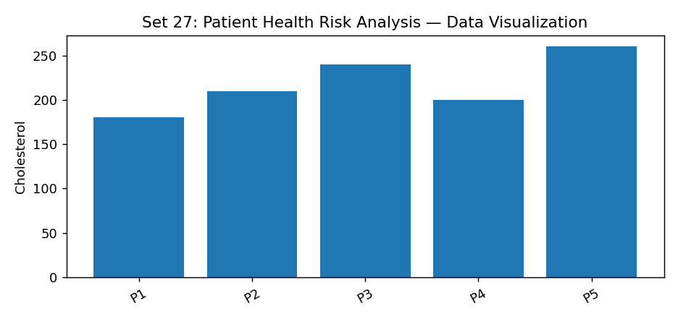
Observation: The visualization summarizes the available records. Interpret comparisons with caution where only a few observations are supplied.

PROGRAM 2: R Q-Q plot and ECDF of cholesterol
R Q-Q plot and ECDF of cholesterol.
R Code
# Load the provided data from a CSV export
d <- read.csv("set_27.csv", check.names=FALSE)
barplot(d[["Cholesterol"]], names.arg=d[[1]],
main="R Q-Q plot and ECDF of cholesterol", xlab="Records", ylab="Cholesterol", col="steelblue")
Output 2: Visualization based on the provided data
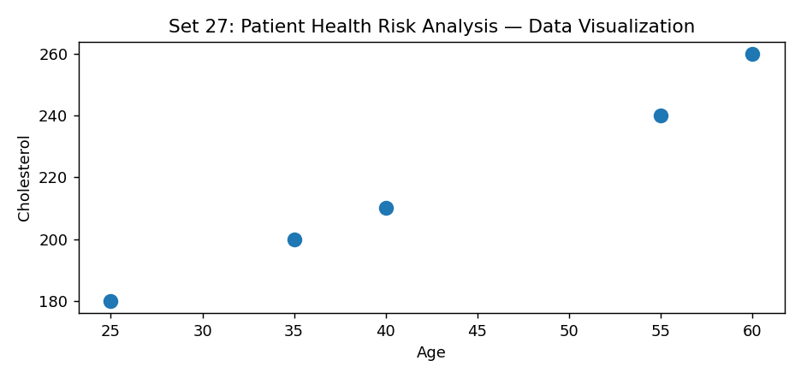
Observation: The visualization summarizes the available records. Interpret comparisons with caution where only a few observations are supplied.

PROGRAM 3: R average health indicators bar chart
R average health indicators bar chart.
R Code
# Load the provided data from a CSV export
d <- read.csv("set_27.csv", check.names=FALSE)
barplot(d[["Cholesterol"]], names.arg=d[[1]],
main="R average health indicators bar chart", xlab="Records", ylab="Cholesterol", col="steelblue")
Output 3: Visualization based on the provided data
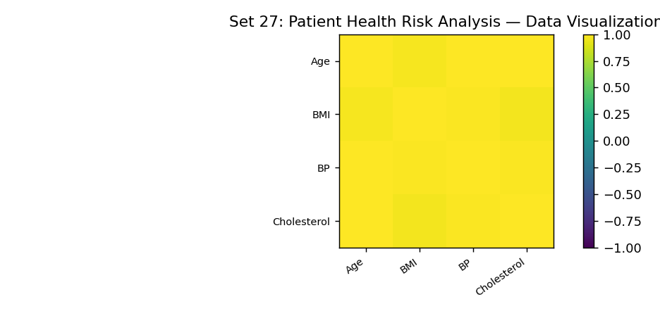
Observation: The visualization summarizes the available records. Interpret comparisons with caution where only a few observations are supplied.

PROGRAM 4: Tableau risk heatmap with age filter
Tableau risk heatmap with age filter.
Tableau Procedure: Import the dataset as a CSV/Excel file; create the requested worksheets; configure Rows, Columns, Marks, Color and Labels; add the required filters; combine the sheets in a dashboard and enable filter actions.
Dashboard preview: the accompanying figure is an illustrative visualization generated from the supplied data, not a screenshot from a running Tableau session.
Observation: The visualization summarizes the available records. Interpret comparisons with caution where only a few observations are supplied.

Procedure
1. Prepare and verify the source dataset. 2. Import into R. 3. Generate the required charts and analyze them. 4. Import into Tableau and create the dashboard with filters. 5. Record the outputs and conclusions.

Result
The supplied patient health risk analysis records were examined through visualizations and a proposed Tableau dashboard workflow. Charts requiring missing fields need additional source data.

LAB EXPERIMENT RECORD

