LAB EXPERIMENT RECORD

Set 28: Vehicle Performance Analysis
Department: AIDS
Course: DSA0601 / Data Handling and Visualization
Experiment: Data Visualization using R and Tableau

Aim
To analyze the provided dataset using the four visualization and dashboard tasks specified for this experiment.

Dataset
Vehicle_ID | Engine_Size | Horsepower | Fuel_Efficiency | Top_Speed | Safety_Rating
V1 | 1.5 | 110 | 18 | 180 | 4
V2 | 2 | 150 | 15 | 200 | 5
V3 | 3 | 250 | 12 | 250 | 5
V4 | 2.5 | 200 | 14 | 220 | 4
V5 | 1.8 | 130 | 17 | 190 | 3

PROGRAM 1: R violin plot of fuel efficiency by safety rating
R violin plot of fuel efficiency by safety rating.
R Code
# Load the provided data from a CSV export
d <- read.csv("set_28.csv", check.names=FALSE)
barplot(d[["Safety_Rating"]], names.arg=d[[1]],
main="R violin plot of fuel efficiency by safety rating", xlab="Records", ylab="Safety_Rating", col="steelblue")
Output 1: Visualization based on the provided data
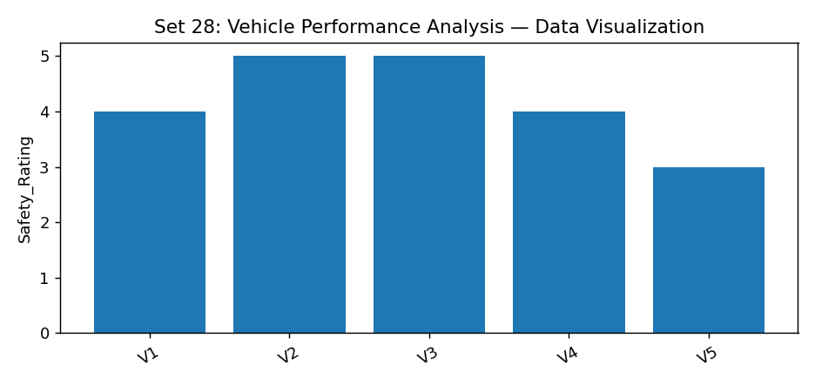
Observation: The visualization summarizes the available records. Interpret comparisons with caution where only a few observations are supplied.

PROGRAM 2: R horsepower vs top speed scatter colored by engine size
R horsepower vs top speed scatter colored by engine size.
R Code
d <- read.csv("set_28.csv", check.names=FALSE)
plot(d[["Engine_Size"]], d[["Safety_Rating"]], pch=19, col="steelblue",
xlab="Engine_Size", ylab="Safety_Rating", main="R horsepower vs top speed scatter colored by engine size")
Output 2: Visualization based on the provided data
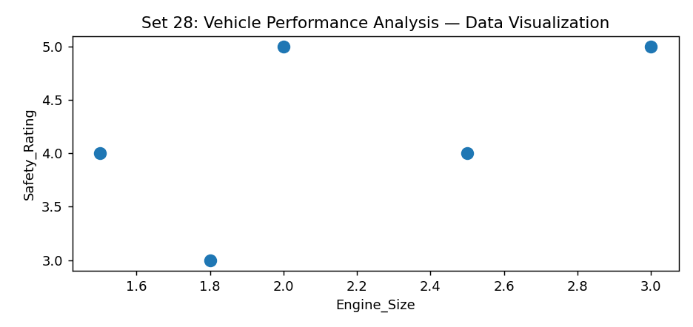
Observation: The visualization summarizes the available records. Interpret comparisons with caution where only a few observations are supplied.

PROGRAM 3: R numeric correlation heatmap
R numeric correlation heatmap.
R Code
# Load the provided data from a CSV export
d <- read.csv("set_28.csv", check.names=FALSE)
barplot(d[["Safety_Rating"]], names.arg=d[[1]],
main="R numeric correlation heatmap", xlab="Records", ylab="Safety_Rating", col="steelblue")
Output 3: Visualization based on the provided data
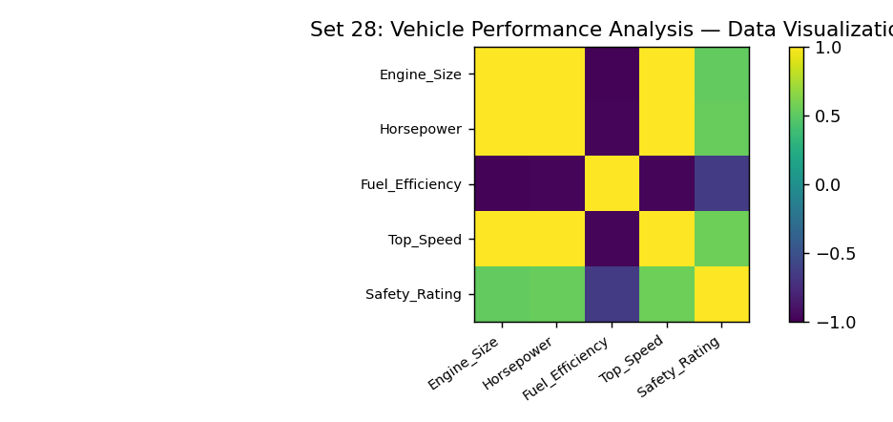
Observation: The visualization summarizes the available records. Interpret comparisons with caution where only a few observations are supplied.

PROGRAM 4: Tableau vehicle performance dashboard
Tableau vehicle performance dashboard.
Tableau Procedure: Import the dataset as a CSV/Excel file; create the requested worksheets; configure Rows, Columns, Marks, Color and Labels; add the required filters; combine the sheets in a dashboard and enable filter actions.
Dashboard preview: the accompanying figure is an illustrative visualization generated from the supplied data, not a screenshot from a running Tableau session.
Observation: The visualization summarizes the available records. Interpret comparisons with caution where only a few observations are supplied.

Procedure
1. Prepare and verify the source dataset. 2. Import into R. 3. Generate the required charts and analyze them. 4. Import into Tableau and create the dashboard with filters. 5. Record the outputs and conclusions.

Result
The supplied vehicle performance analysis records were examined through visualizations and a proposed Tableau dashboard workflow. Charts requiring missing fields need additional source data.

LAB EXPERIMENT RECORD

