LAB EXPERIMENT RECORD

Set 29: Student Academic Performance
Department: AIDS
Course: DSA0601 / Data Handling and Visualization
Experiment: Data Visualization using R and Tableau

Aim
To analyze the provided dataset using the four visualization and dashboard tasks specified for this experiment.

Dataset
Student_ID | Age | Study_Hours | Attendance | Test_Score | Participation_Score
S1 | 19 | 12 | 90 | 85 | 8
S2 | 21 | 8 | 70 | 70 | 7
S3 | 20 | 15 | 95 | 92 | 9
S4 | 22 | 10 | 85 | 80 | 8
S5 | 23 | 7 | 60 | 65 | 6

PROGRAM 1: R stacked area chart of test and participation scores
R stacked area chart of test and participation scores.
R Code
# Load the provided data from a CSV export
d <- read.csv("set_29.csv", check.names=FALSE)
barplot(d[["Participation_Score"]], names.arg=d[[1]],
main="R stacked area chart of test and participation scores", xlab="Records", ylab="Participation_Score", col="steelblue")
Output 1: Visualization based on the provided data
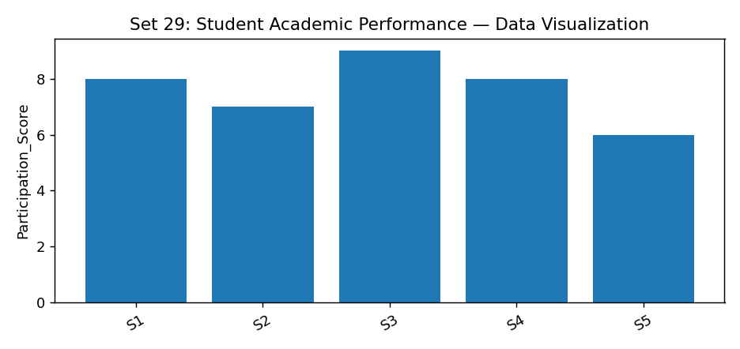
Observation: The visualization summarizes the available records. Interpret comparisons with caution where only a few observations are supplied.

PROGRAM 2: R study hours boxplot by attendance quartile
R study hours boxplot by attendance quartile.
R Code
# Load the provided data from a CSV export
d <- read.csv("set_29.csv", check.names=FALSE)
barplot(d[["Participation_Score"]], names.arg=d[[1]],
main="R study hours boxplot by attendance quartile", xlab="Records", ylab="Participation_Score", col="steelblue")
Output 2: Visualization based on the provided data
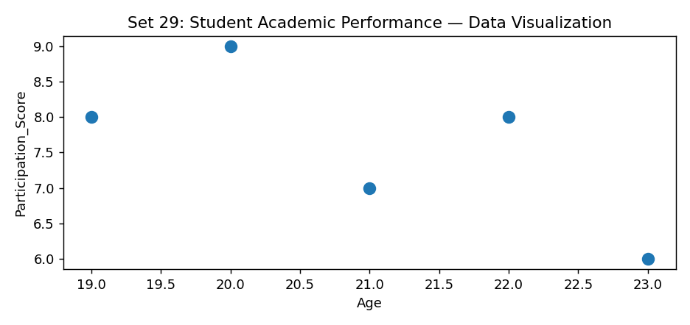
Observation: The visualization summarizes the available records. Interpret comparisons with caution where only a few observations are supplied.

PROGRAM 3: R density plot of test scores
R density plot of test scores.
R Code
# Load the provided data from a CSV export
d <- read.csv("set_29.csv", check.names=FALSE)
barplot(d[["Participation_Score"]], names.arg=d[[1]],
main="R density plot of test scores", xlab="Records", ylab="Participation_Score", col="steelblue")
Output 3: Visualization based on the provided data
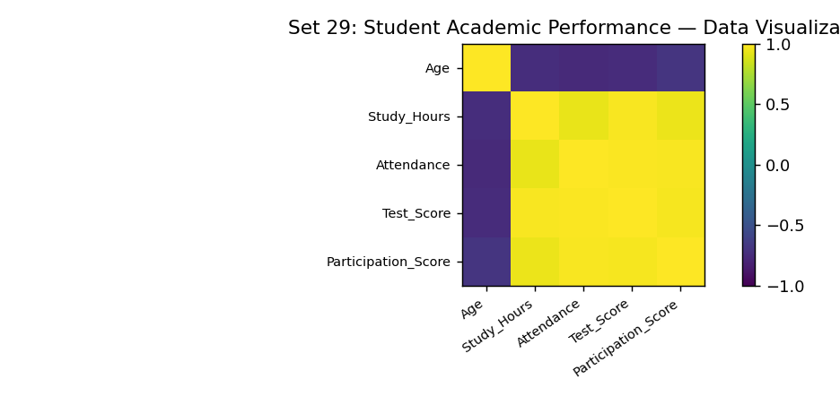
Observation: The visualization summarizes the available records. Interpret comparisons with caution where only a few observations are supplied.

PROGRAM 4: Tableau study hours vs test score scatter dashboard
Tableau study hours vs test score scatter dashboard.
Tableau Procedure: Import the dataset as a CSV/Excel file; create the requested worksheets; configure Rows, Columns, Marks, Color and Labels; add the required filters; combine the sheets in a dashboard and enable filter actions.
Dashboard preview: the accompanying figure is an illustrative visualization generated from the supplied data, not a screenshot from a running Tableau session.
Observation: The visualization summarizes the available records. Interpret comparisons with caution where only a few observations are supplied.

Procedure
1. Prepare and verify the source dataset. 2. Import into R. 3. Generate the required charts and analyze them. 4. Import into Tableau and create the dashboard with filters. 5. Record the outputs and conclusions.

Result
The supplied student academic performance records were examined through visualizations and a proposed Tableau dashboard workflow. Charts requiring missing fields need additional source data.

LAB EXPERIMENT RECORD

