LAB EXPERIMENT RECORD

Set 30: Mobile App Usage Analysis
Department: AIDS
Course: DSA0601 / Data Handling and Visualization
Experiment: Data Visualization using R and Tableau

Aim
To analyze the provided dataset using the four visualization and dashboard tasks specified for this experiment.

Dataset
User_ID | Gender | Age | Screen_Time | App_Usage_Count | Data_Used | Satisfaction | Usage_Date
U01 | Male | 20 | 4.5 | 18 | 2.4 | 3 | 2025-01-08
U02 | Female | 22 | 6 | 25 | 3.8 | 5 | 2025-01-08
U03 | Male | 19 | 3.2 | 12 | 1.6 | 3 | 2025-02-11
U04 | Female | 21 | 7.1 | 30 | 4.5 | 5 | 2025-02-11
U05 | Male | 23 | 2.8 | 10 | 1.2 | 2 | 2025-03-14
U06 | Female | 20 | 5.4 | 22 | 3.1 | 4 | 2025-03-14

PROGRAM 1: R histogram and density of screen time
R histogram and density of screen time.
R Code
# Load the provided data from a CSV export
d <- read.csv("set_30.csv", check.names=FALSE)
barplot(d[["Satisfaction"]], names.arg=d[[1]],
main="R histogram and density of screen time", xlab="Records", ylab="Satisfaction", col="steelblue")
Output 1: Visualization based on the provided data
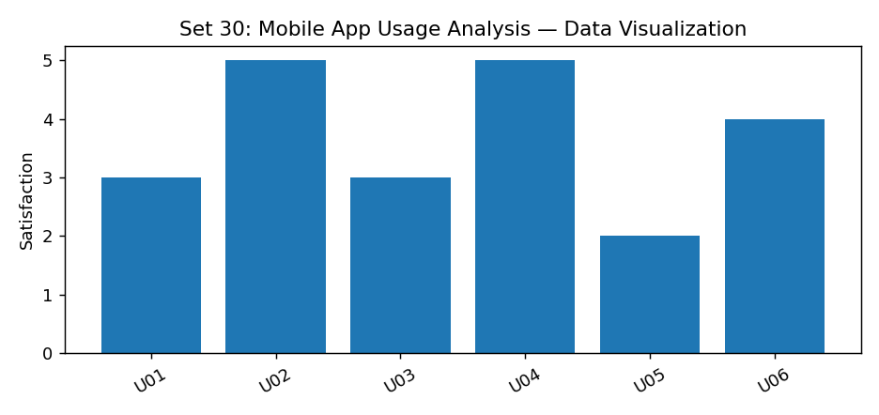
Observation: The visualization summarizes the available records. Interpret comparisons with caution where only a few observations are supplied.

PROGRAM 2: R data used vs screen time scatter and correlation
R data used vs screen time scatter and correlation.
R Code
d <- read.csv("set_30.csv", check.names=FALSE)
plot(d[["Age"]], d[["Satisfaction"]], pch=19, col="steelblue",
xlab="Age", ylab="Satisfaction", main="R data used vs screen time scatter and correlation")
Output 2: Visualization based on the provided data
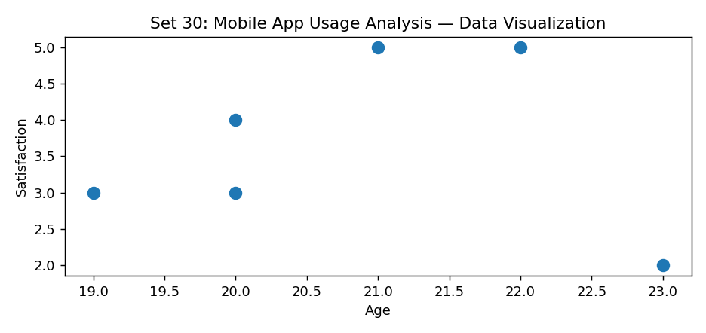
Observation: The visualization summarizes the available records. Interpret comparisons with caution where only a few observations are supplied.

PROGRAM 3: R average satisfaction by gender bar chart
R average satisfaction by gender bar chart.
R Code
# Load the provided data from a CSV export
d <- read.csv("set_30.csv", check.names=FALSE)
barplot(d[["Satisfaction"]], names.arg=d[[1]],
main="R average satisfaction by gender bar chart", xlab="Records", ylab="Satisfaction", col="steelblue")
Output 3: Visualization based on the provided data
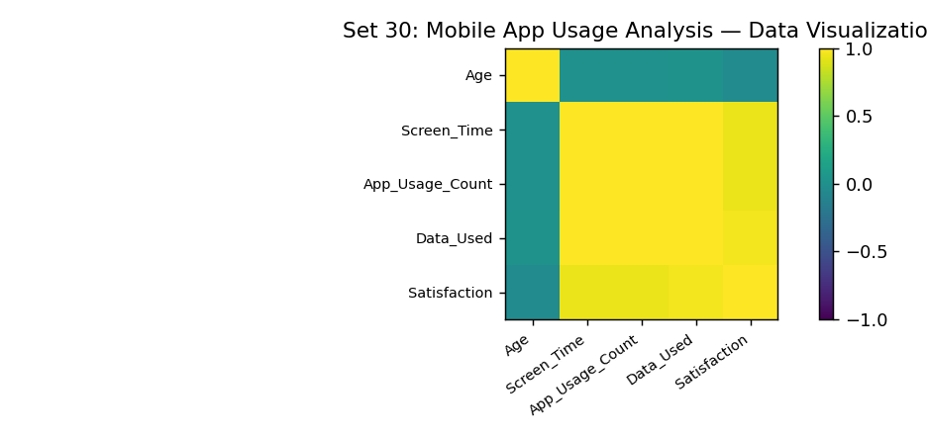
Observation: The visualization summarizes the available records. Interpret comparisons with caution where only a few observations are supplied.

PROGRAM 4: Tableau bubble and trend dashboard
Tableau bubble and trend dashboard.
Tableau Procedure: Import the dataset as a CSV/Excel file; create the requested worksheets; configure Rows, Columns, Marks, Color and Labels; add the required filters; combine the sheets in a dashboard and enable filter actions.
Dashboard preview: the accompanying figure is an illustrative visualization generated from the supplied data, not a screenshot from a running Tableau session.
Observation: The visualization summarizes the available records. Interpret comparisons with caution where only a few observations are supplied.

Procedure
1. Prepare and verify the source dataset. 2. Import into R. 3. Generate the required charts and analyze them. 4. Import into Tableau and create the dashboard with filters. 5. Record the outputs and conclusions.

Result
The supplied mobile app usage analysis records were examined through visualizations and a proposed Tableau dashboard workflow. Charts requiring missing fields need additional source data.

