SET 16
Customer Demographics Analysis
Course: DSA06 – Data Handling and Visualization

Dataset
Customer Demographics — values transcribed from the supplied experiment sheet.
Customer ID | Age | Gender | Income
1 | 28 | Female | 50000
2 | 35 | Male | 60000
3 | 42 | Female | 75000

Question 1
Create a bar chart to visualize the distribution of customer ages. Label the axes and title the chart.

Answer / Interpretation
The bar chart compares the ages of the three customers. Customer 3 is the oldest at 42 years, Customer 1 is the youngest at 28 years, and Customer 2 is 35 years old.

Complete R Program
data <- data.frame(
Customer_ID = c(1, 2, 3),
Age = c(28, 35, 42),
Gender = c("Female", "Male", "Female"),
Income = c(50000, 60000, 75000)
)
barplot(data$Age, names.arg=data$Customer_ID, xlab="Customer ID", ylab="Age (years)", main="Customer Ages", col="skyblue")

Output Image
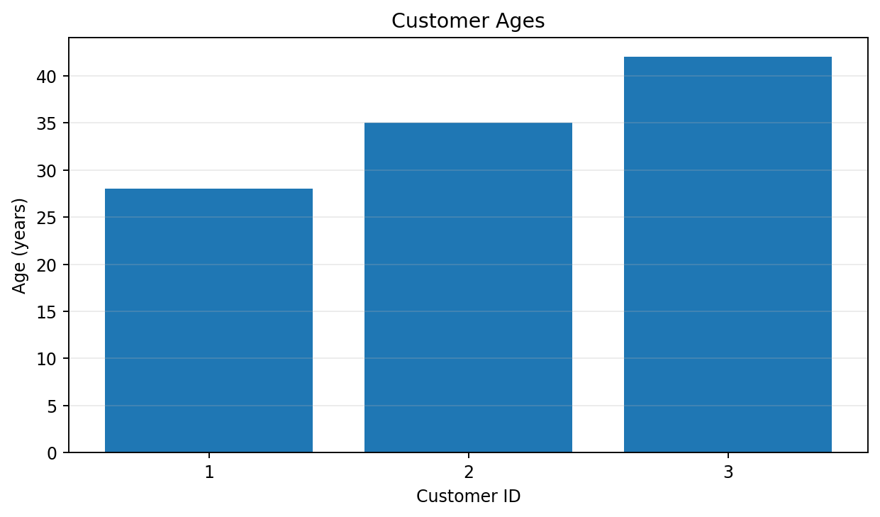
Output for Question 1

Question 2
Generate a pie chart to represent the distribution of customers by gender.

Answer / Interpretation
There are two female customers (66.7%) and one male customer (33.3%). The dataset therefore contains twice as many female customers as male customers.

Complete R Program
gender_count <- table(data$Gender)
pie(gender_count, labels=paste(names(gender_count), gender_count), main="Customers by Gender", col=c("lightpink","skyblue"))

Output Image
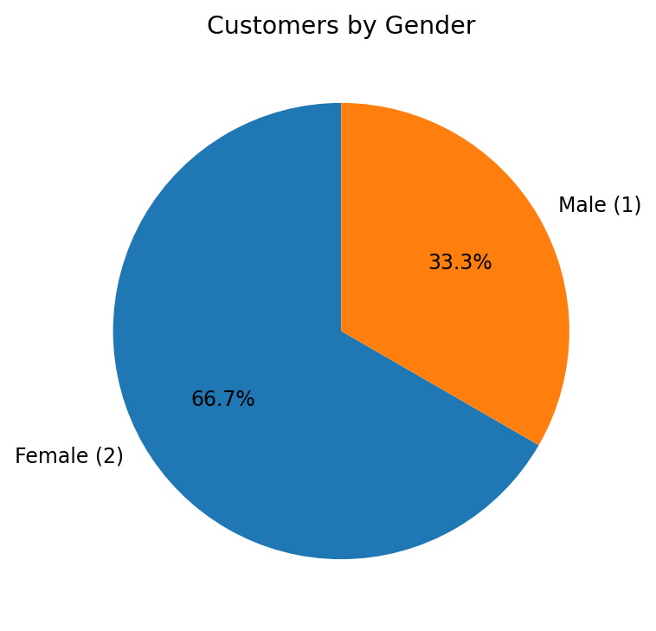
Output for Question 2

Question 3
Build a table to show the demographic information for each customer. Label the table elements.

Answer / Interpretation
The table lists each customer's ID, age, gender, and income. Customer 3 has the highest income ($75,000), followed by Customer 2 ($60,000) and Customer 1 ($50,000).

Complete R Program
print(data)
# Optional formatted table:
# install.packages("knitr")
# knitr::kable(data, caption="Customer Demographics")

Output Image
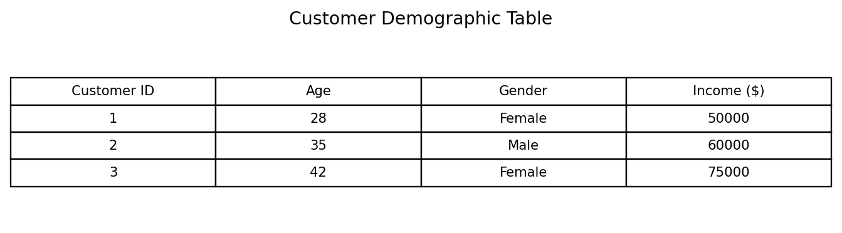
Output for Question 3

Question 4
Develop a Tableau dashboard combining the bar chart, pie chart, and the table for interactive exploration of customer demographics.

Answer / Interpretation
In Tableau, place the Age bar chart, Gender pie chart, and customer demographic table on one dashboard. Add a Customer ID or Gender filter if desired. The R code below also creates a combined static dashboard preview because Tableau itself cannot be generated from R.

Complete R Program
data <- data.frame(
Customer_ID = c(1, 2, 3),
Age = c(28, 35, 42),
Gender = c("Female", "Male", "Female"),
Income = c(50000, 60000, 75000)
)
barplot(data$Age, names.arg=data$Customer_ID, xlab="Customer ID", ylab="Age (years)", main="Customer Ages", col="skyblue")
# Gender pie chart
gender_count <- table(data$Gender)
pie(gender_count, labels=paste(names(gender_count), gender_count), main="Customers by Gender", col=c("lightpink","skyblue"))
# For an actual interactive dashboard, assemble these views in Tableau.

Output Image
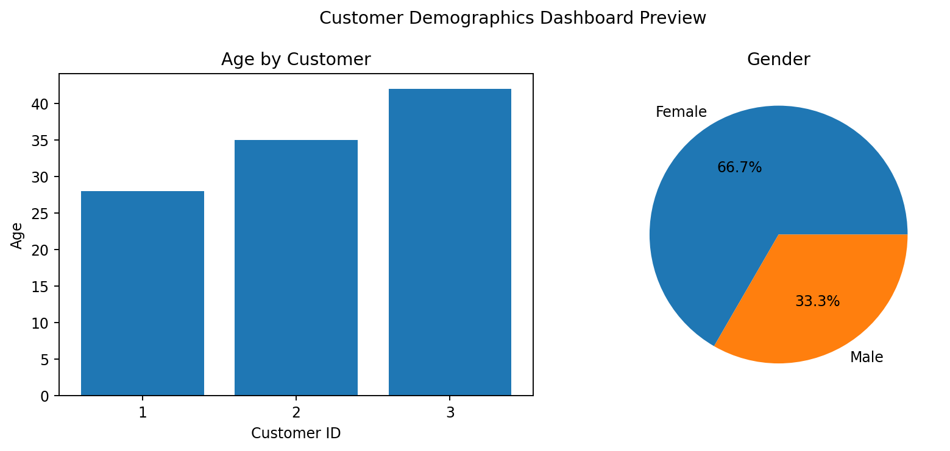
Output for Question 4

Notes
The output images are rendered chart/table previews based on the supplied data, not screenshots captured from RStudio. Run the included R code in R/RStudio to generate native R output. Tableau questions are preserved and include guidance; the combined image is a static dashboard preview, not an interactive Tableau workbook.

