SET 17
Employee Performance Analysis
Course: DSA06 – Data Handling and Visualization

Dataset
Employee Performance — values transcribed from the supplied experiment sheet.
Employee ID | Department | Years of Service | Performance Score
1 | Sales | 5 | 85
2 | HR | 3 | 92
3 | Marketing | 7 | 78

Question 1
Create a line chart to visualize the performance trend of employees over time. Label the axes and title the chart.

Answer / Interpretation
The line chart shows performance scores of 85, 92, and 78 for Employees 1, 2, and 3. The score rises from Employee 1 to Employee 2, then falls for Employee 3. The source data gives years of service but no dates, so employee order is used as the x-axis rather than claiming a chronological trend.

Complete R Program
data <- data.frame(
Employee_ID = c(1, 2, 3),
Department = c("Sales", "HR", "Marketing"),
Years_of_Service = c(5, 3, 7),
Performance_Score = c(85, 92, 78)
)
plot(data$Employee_ID, data$Performance_Score, type="b", pch=19, xlab="Employee ID (given order)", ylab="Performance Score", main="Employee Performance Scores")

Output Image
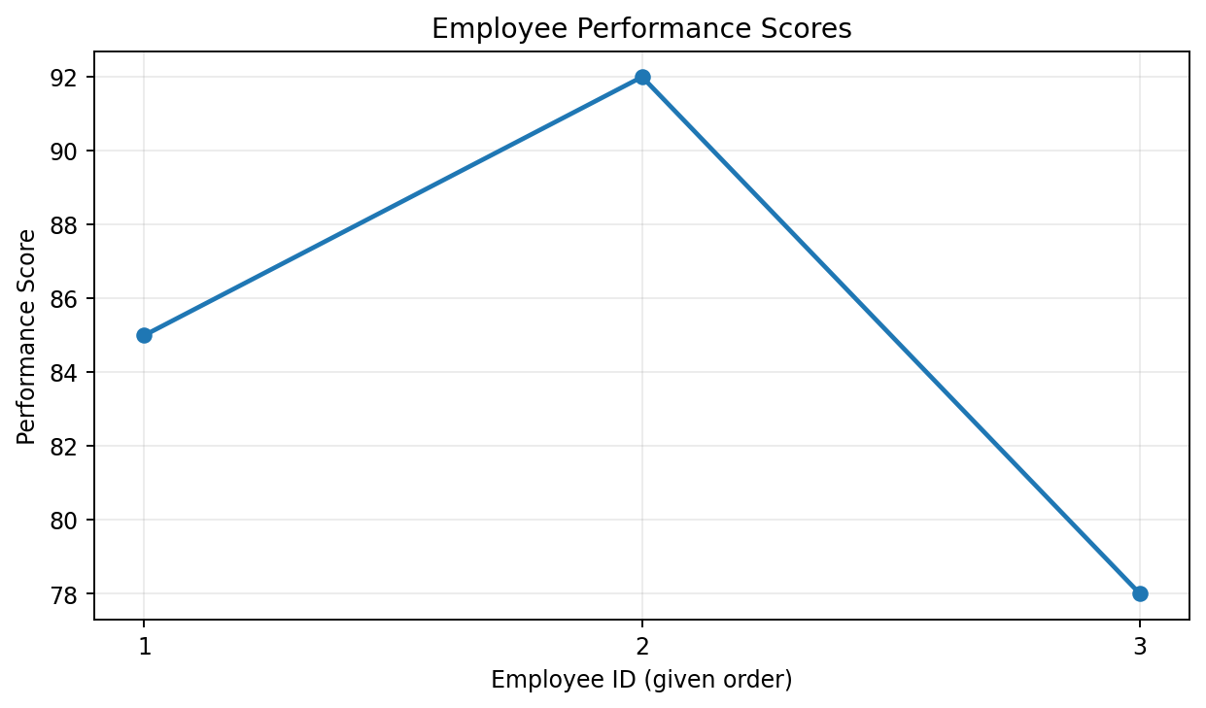
Output for Question 1

Question 2
Generate a bar chart showing the distribution of employees across different departments. Label the chart elements.

Answer / Interpretation
There is one employee each in Sales, HR, and Marketing. The dataset has an equal count across the three departments.

Complete R Program
dept_count <- table(data$Department)
barplot(dept_count, xlab="Department", ylab="Number of Employees", main="Employees by Department", col="lightgreen")

Output Image
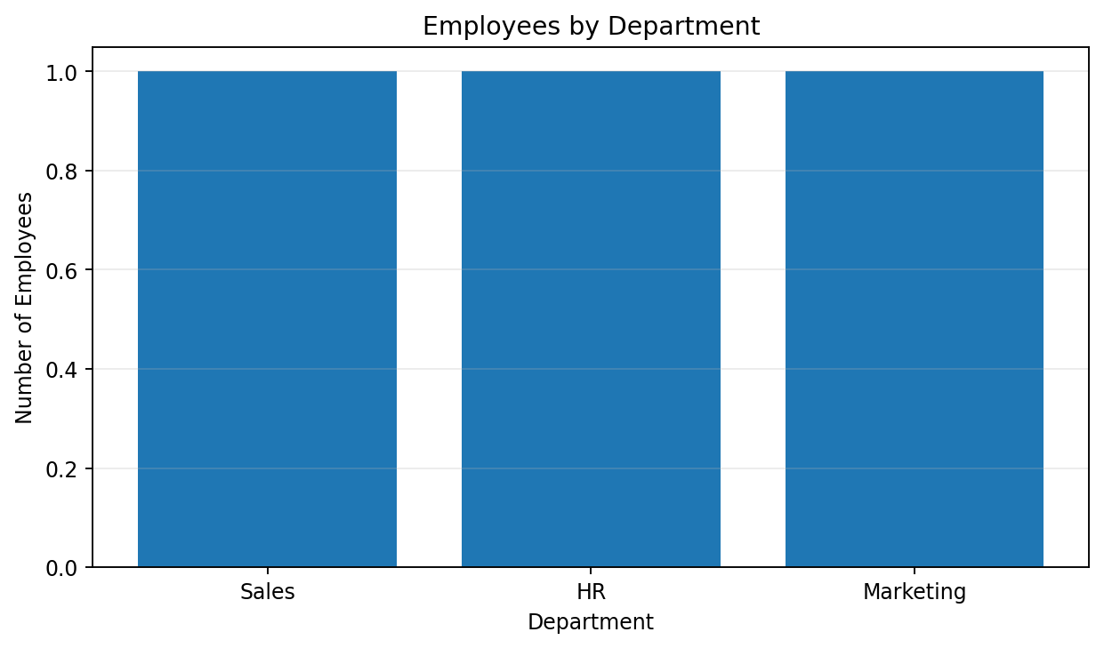
Output for Question 2

Question 3
Build a table to display the performance data for each employee. Label the table elements.

Answer / Interpretation
The table shows department, years of service, and performance score. Employee 2 (HR) has the highest score (92), while Employee 3 (Marketing) has the lowest score (78).

Complete R Program
print(data)
# Optional formatted table:
# install.packages("knitr")
# knitr::kable(data, caption="Employee Performance")

Output Image
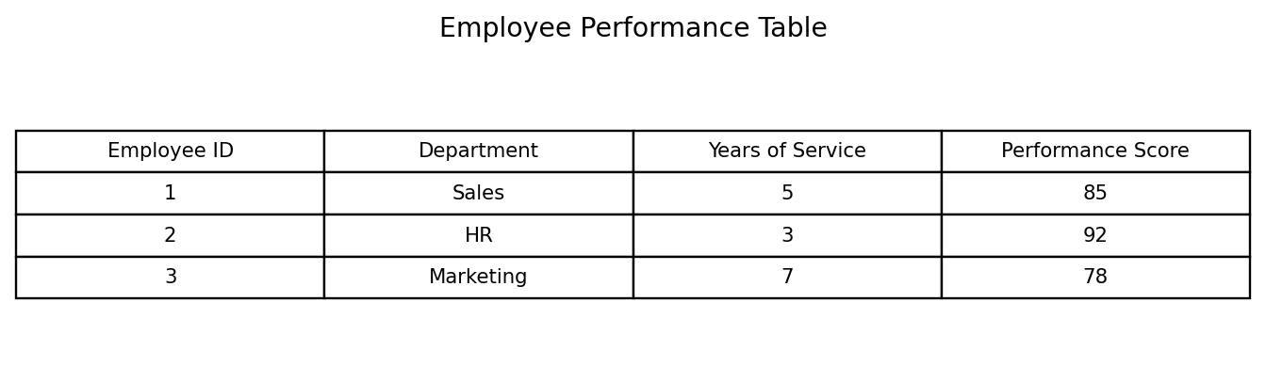
Output for Question 3

Question 4
Develop a Tableau dashboard combining the bar chart, line chart, and the table for interactive exploration of employee performance data.

Answer / Interpretation
In Tableau, place the employee performance line chart, department count bar chart, and data table on a single dashboard. Add Department as a filter. The R code below also creates a combined static dashboard preview; actual interactivity must be configured in Tableau.

Complete R Program
data <- data.frame(
Employee_ID = c(1, 2, 3),
Department = c("Sales", "HR", "Marketing"),
Years_of_Service = c(5, 3, 7),
Performance_Score = c(85, 92, 78)
)
plot(data$Employee_ID, data$Performance_Score, type="b", pch=19, xlab="Employee ID (given order)", ylab="Performance Score", main="Employee Performance Scores")
# Department bar chart
dept_count <- table(data$Department)
barplot(dept_count, xlab="Department", ylab="Number of Employees", main="Employees by Department", col="lightgreen")
# Assemble both views and the table in Tableau for interactivity.

Output Image
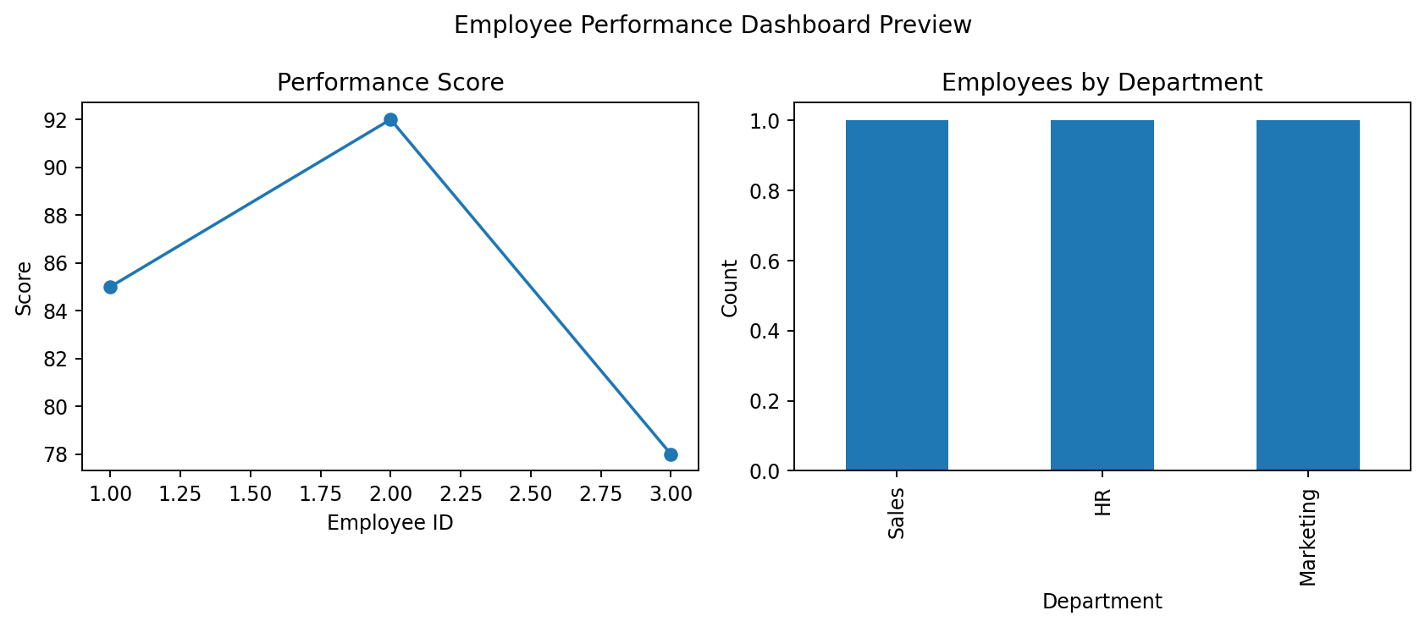
Output for Question 4

Notes
The output images are rendered chart/table previews based on the supplied data, not screenshots captured from RStudio. Run the included R code in R/RStudio to generate native R output. Tableau questions are preserved and include guidance; the combined image is a static dashboard preview, not an interactive Tableau workbook.

