SET 18
Product Inventory Management
Course: DSA06 – Data Handling and Visualization

Dataset
Product Inventory — values transcribed from the supplied experiment sheet.
Product ID | Product Name | Quantity Available
1 | Product A | 250
2 | Product B | 175
3 | Product C | 300
4 | Product D | 200
5 | Product E | 220

Question 1
Create a bar chart to visualize the quantity of each product in the inventory. Label the axes and title the chart.

Answer / Interpretation
Product C has the largest available quantity (300), while Product B has the smallest (175). The quantities for Products A, D, and E are 250, 200, and 220 respectively.

Complete R Program
data <- data.frame(
Product_ID = c(1, 2, 3, 4, 5),
Product_Name = c("Product A", "Product B", "Product C", "Product D", "Product E"),
Quantity_Available = c(250, 175, 300, 200, 220)
)
barplot(data$Quantity_Available, names.arg=data$Product_Name, xlab="Product", ylab="Quantity Available", main="Product Inventory Quantity", col="tan")

Output Image
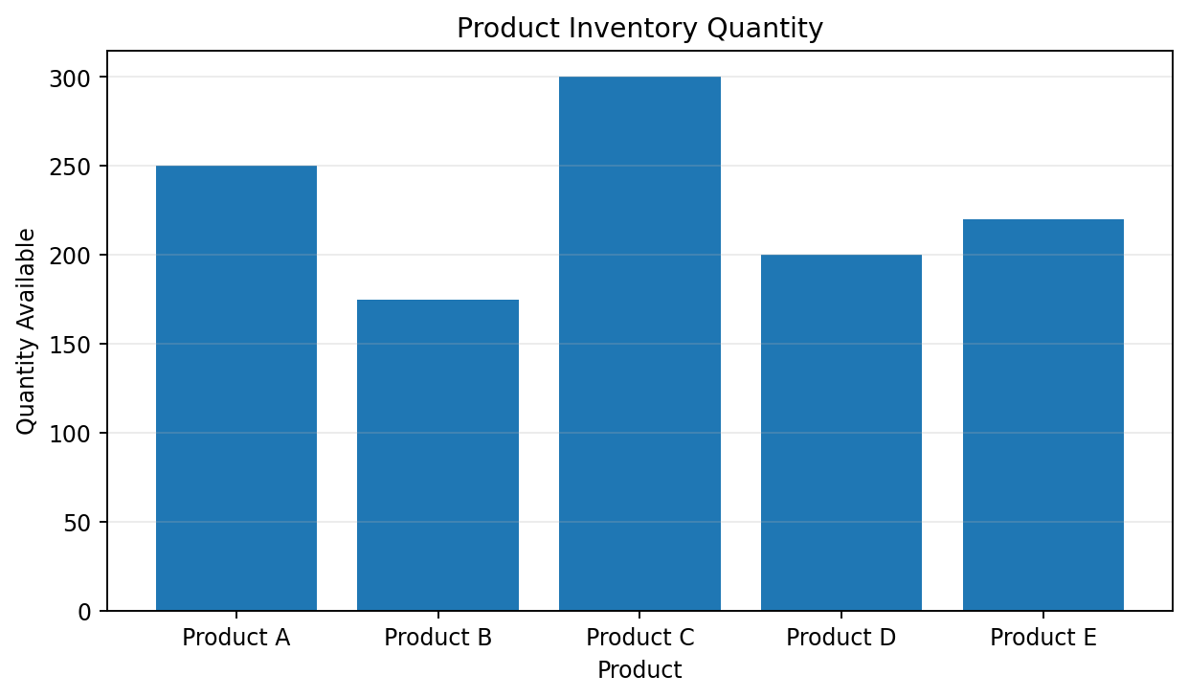
Output for Question 1

Question 2
Generate a stacked bar chart to show the quantity of each product within different product categories.

Answer / Interpretation
The provided dataset does not include a Product Category column. To demonstrate the stacked-bar format, the example code uses explicitly labelled illustrative categories (Category 1 and Category 2). Replace these assignments with the real product categories when available.

Complete R Program
# The supplied dataset has no Product_Category column.
# These example category assignments are illustrative only.
data$Category_1 <- c(250, 0, 300, 0, 220)
data$Category_2 <- c(0, 175, 0, 200, 0)
barplot(rbind(data$Category_1, data$Category_2), names.arg=data$Product_Name, beside=FALSE, col=c("skyblue","orange"), xlab="Product", ylab="Quantity", main="Inventory by Illustrative Category")
legend("topright", legend=c("Category 1 (illustrative)","Category 2 (illustrative)"), fill=c("skyblue","orange"), cex=0.7)

Output Image
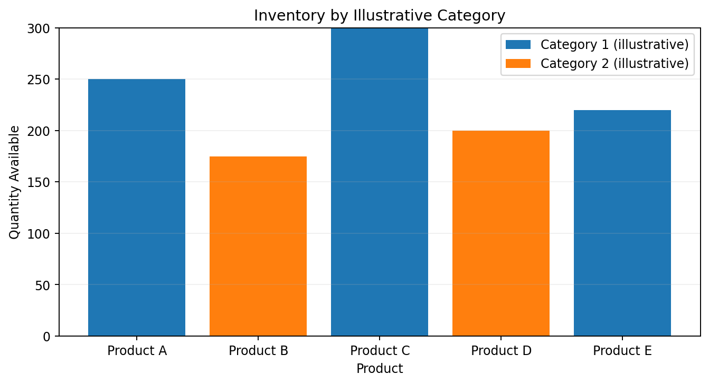
Output for Question 2

Question 3
Build a table to show the inventory data for each product. Label the table elements.

Answer / Interpretation
The table lists each product and its available quantity. Total inventory is 1,145 units (250 + 175 + 300 + 200 + 220). Product C contributes the most units.

Complete R Program
print(data)
cat("Total inventory =", sum(data$Quantity_Available), "units\n")

Output Image
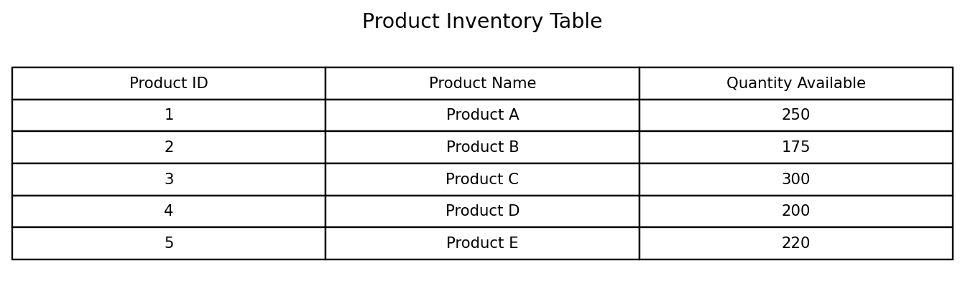
Output for Question 3

Question 4
Develop a Tableau dashboard combining the bar chart and stacked bar chart to allow users to interact with inventory data.

Answer / Interpretation
In Tableau, place the quantity bar chart and category-stacked bar chart on a single dashboard and add Product Name and Category filters. A static combined preview is included below; real interactivity is created inside Tableau.

Complete R Program
data <- data.frame(
Product_ID = c(1, 2, 3, 4, 5),
Product_Name = c("Product A", "Product B", "Product C", "Product D", "Product E"),
Quantity_Available = c(250, 175, 300, 200, 220)
)
barplot(data$Quantity_Available, names.arg=data$Product_Name, xlab="Product", ylab="Quantity Available", main="Product Inventory Quantity", col="tan")
# Stacked bar example (category values are illustrative)
# The supplied dataset has no Product_Category column.
# These example category assignments are illustrative only.
data$Category_1 <- c(250, 0, 300, 0, 220)
data$Category_2 <- c(0, 175, 0, 200, 0)
barplot(rbind(data$Category_1, data$Category_2), names.arg=data$Product_Name, beside=FALSE, col=c("skyblue","orange"), xlab="Product", ylab="Quantity", main="Inventory by Illustrative Category")
legend("topright", legend=c("Category 1 (illustrative)","Category 2 (illustrative)"), fill=c("skyblue","orange"), cex=0.7)
# Create an interactive dashboard by placing both worksheets on a Tableau dashboard.

Output Image
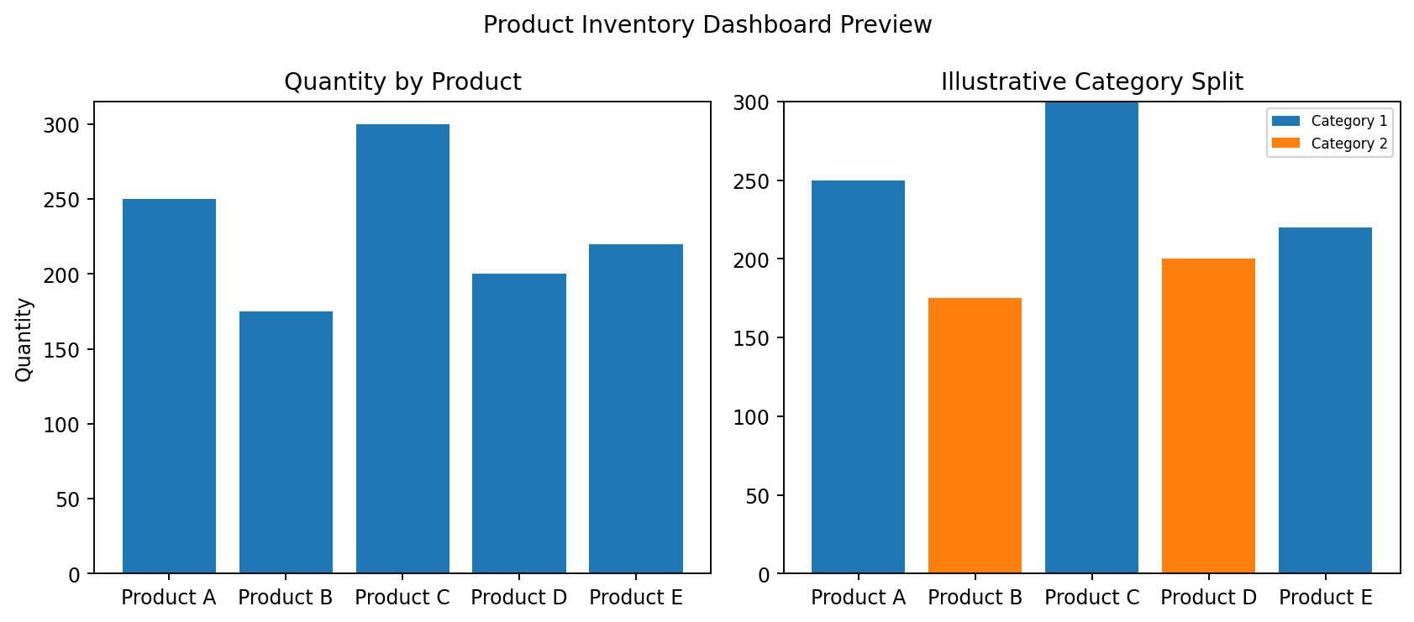
Output for Question 4

Notes
The output images are rendered chart/table previews based on the supplied data, not screenshots captured from RStudio. Run the included R code in R/RStudio to generate native R output. Tableau questions are preserved and include guidance; the combined image is a static dashboard preview, not an interactive Tableau workbook.

