LAB EXPERIMENT RECORD

Set 13: Geographic Data
Department: AIML
Course Code / Course Name: DSA0601 / Data Handling and Visualization
Experiment: Data Visualization using R
Name: Deepka V
Register Number: 192325008

Aim
To analyze the provided dataset through the four prescribed visualizations, tables and dashboard exercises using R programming.

Dataset: Geographic Data
City | Population | Avg. Temperature | Elevation
City A | 500000 | 75 | 1000
City B | 700000 | 68 | 800
City C | 600000 | 80 | 1200
Note: The source uses anonymous City A/B/C names and provides no geographic coordinates. A true map cannot be generated without latitude/longitude; an attribute chart is used instead.

PROGRAM 1: Geographic city map
R Code
cities <- data.frame(City=c("City A","City B","City C"), Population=c(500000,700000,600000), Temperature=c(75,68,80), Elevation=c(1000,800,1200))
# No latitude/longitude is supplied: a true geographic map cannot be produced.
plot(cities$Temperature,cities$Elevation,pch=19,col="steelblue",
xlab="Average Temperature",ylab="Elevation",main="City Attributes (Not Geographic Coordinates)")
text(cities$Temperature,cities$Elevation,labels=cities$City,pos=3)
Output 1: Geographic city map
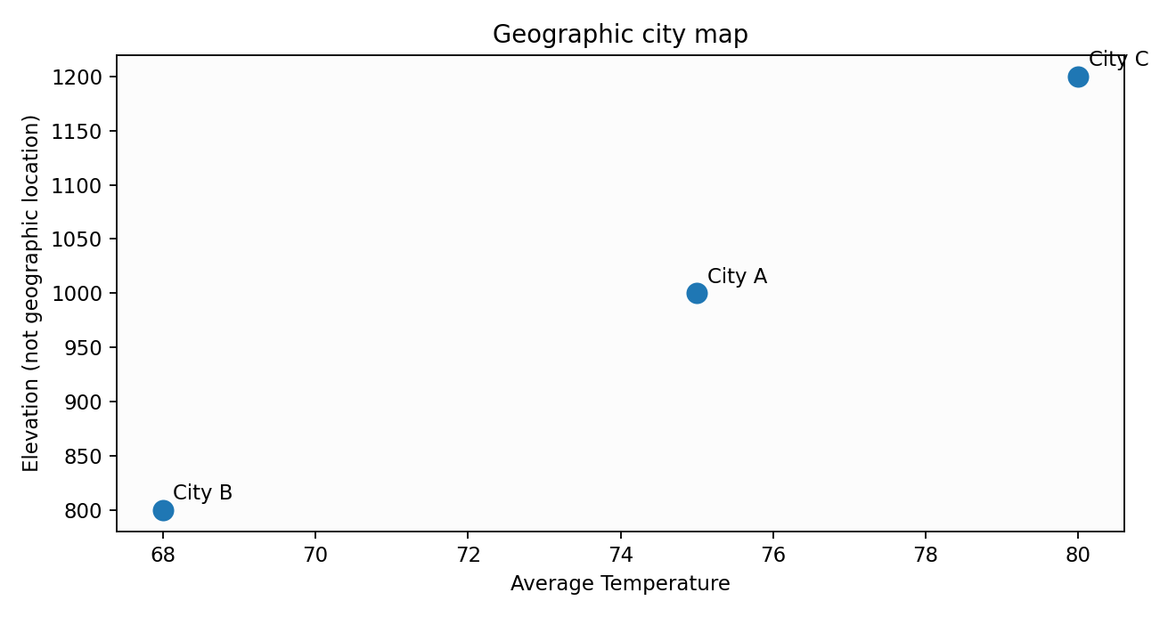
Observation: The plotted values reflect the supplied dataset.

PROGRAM 2: Temperature vs population scatter plot
R Code
cities <- data.frame(City=c("City A","City B","City C"), Population=c(500000,700000,600000), Temperature=c(75,68,80))
plot(cities$Temperature,cities$Population,pch=19,col="darkblue",
xlab="Average Temperature",ylab="Population",main="Temperature vs Population")
text(cities$Temperature,cities$Population,labels=cities$City,pos=3)
Output 2: Temperature vs population scatter plot
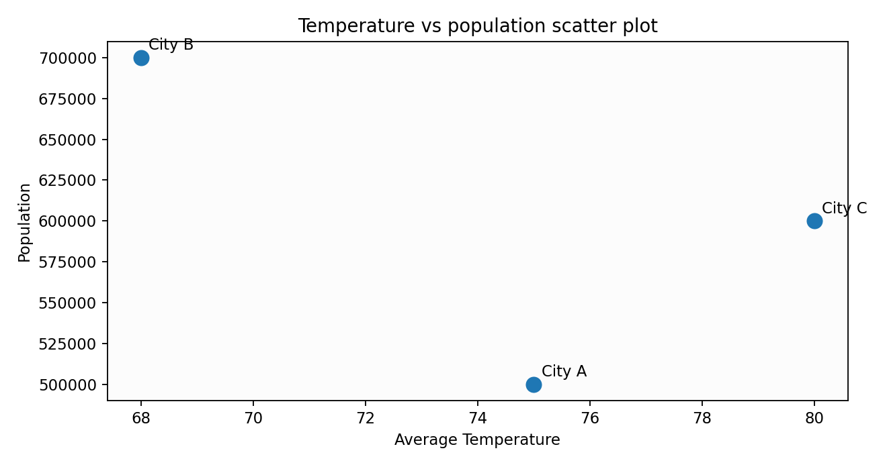
Observation: The chart summarizes the values and supports comparison.

PROGRAM 3: Geographic data table
R Code
cities <- data.frame(City=c("City A","City B","City C"),Population=c(500000,700000,600000),Avg_Temperature=c(75,68,80),Elevation=c(1000,800,1200))
print(cities)
Output 3: Geographic data table
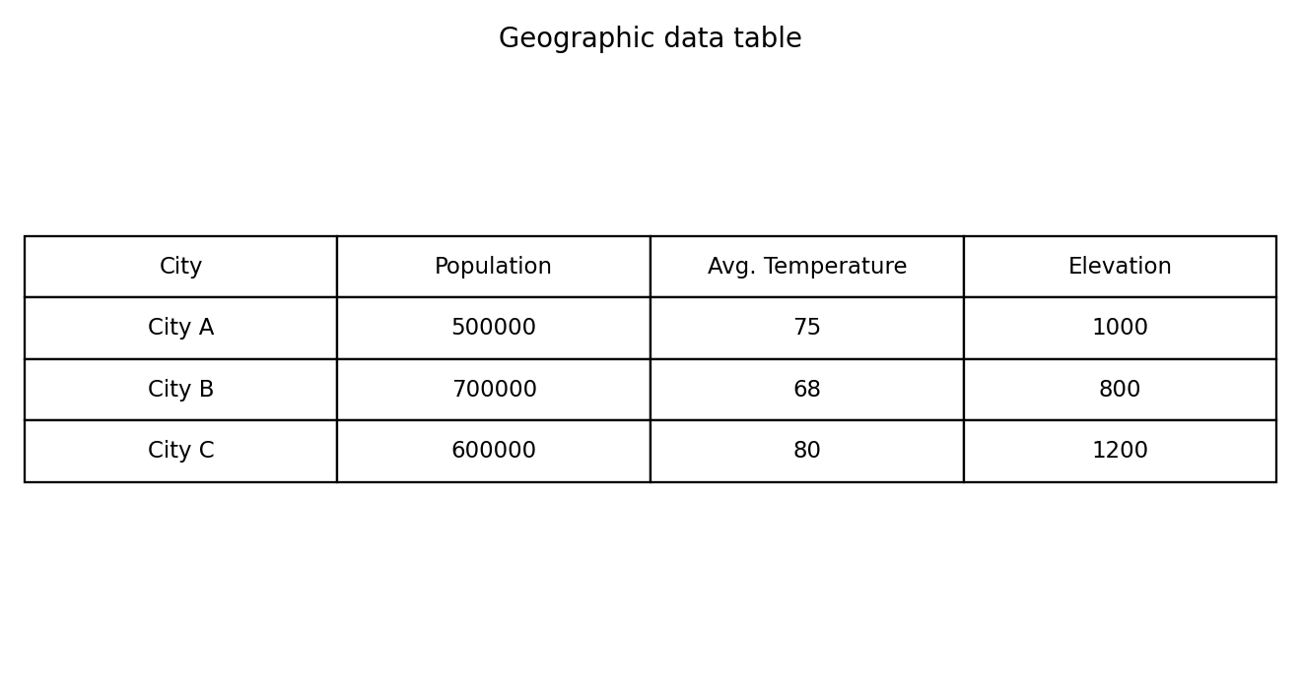
Observation: The table displays the complete provided records.

PROGRAM 4: Geographic analysis dashboard
R Code
library(shiny)
cities <- data.frame(City=c("City A","City B","City C"),Population=c(500000,700000,600000),Temperature=c(75,68,80),Elevation=c(1000,800,1200))
ui <- fluidPage(titlePanel("Geographic Data Dashboard"),
selectInput("city","City",c("All",cities$City)),plotOutput("attributes"),plotOutput("scatter"),tableOutput("tbl"))
server <- function(input,output,session){
d <- reactive(if(input$city=="All") cities else subset(cities,City==input$city))
output$attributes <- renderPlot(barplot(d()$Elevation,names.arg=d()$City,main="Elevation by City"))
output$scatter <- renderPlot(plot(d()$Temperature,d()$Population,pch=19,xlab="Temperature",ylab="Population"))
output$tbl <- renderTable(d())
}
shinyApp(ui,server)
# A true map requires real latitude/longitude for each city.
Output 4: Geographic analysis dashboard
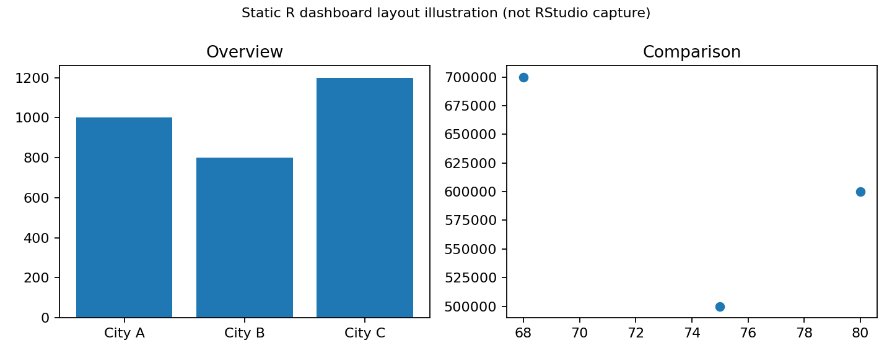
Illustrative static dashboard layout. Run the Shiny code in RStudio for a working interactive dashboard. The source exercise specifically requests Tableau; this is an R-based alternative, not a Tableau screenshot.
Observation: The dashboard combines visual comparisons and data exploration.

Procedure
1. Open RStudio and create an R script.
2. Enter the dataset in R.
3. Run each program and inspect the Plots/Console output.
4. Install and load shiny if necessary, then run the dashboard code.
5. Interpret and record the results.

Result
The Set 13 dataset was analyzed using R programming and the specified visual outputs and tables were prepared.

