SET 4: Product Inventory Management
Dataset: Product Inventory
Data note: The source gives quantities but not product categories or prices. Q2/Q3 use clearly marked illustrative category/price values.

Question 1
Create a bar chart to visualize the quantity of each product in the inventory. Label the axes and title the chart.
R Programming Code
product <- c("Product A","Product B","Product C","Product D","Product E")
qty <- c(250,175,300,200,220)
barplot(qty, names.arg=product, xlab="Product", ylab="Quantity", main="Inventory Quantity")
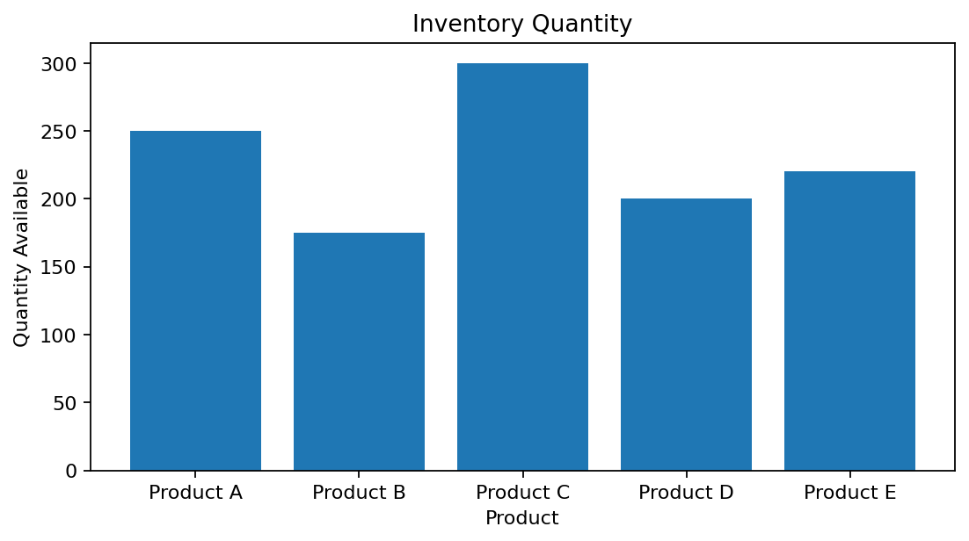
R output preview
Answer / Interpretation: Product C has the largest inventory quantity (300), while Product B has the smallest (175).

Question 2
Generate a stacked bar chart to show the quantity of each product within different product categories.
R Programming Code
product <- c("Product A","Product B","Product C","Product D","Product E")
qty <- c(250,175,300,200,220)
category <- c("Category 1","Category 1","Category 2","Category 2","Category 3") # illustrative
tab <- tapply(qty, category, sum)
barplot(tab, col=1:length(tab), ylab="Quantity", main="Inventory by Category")
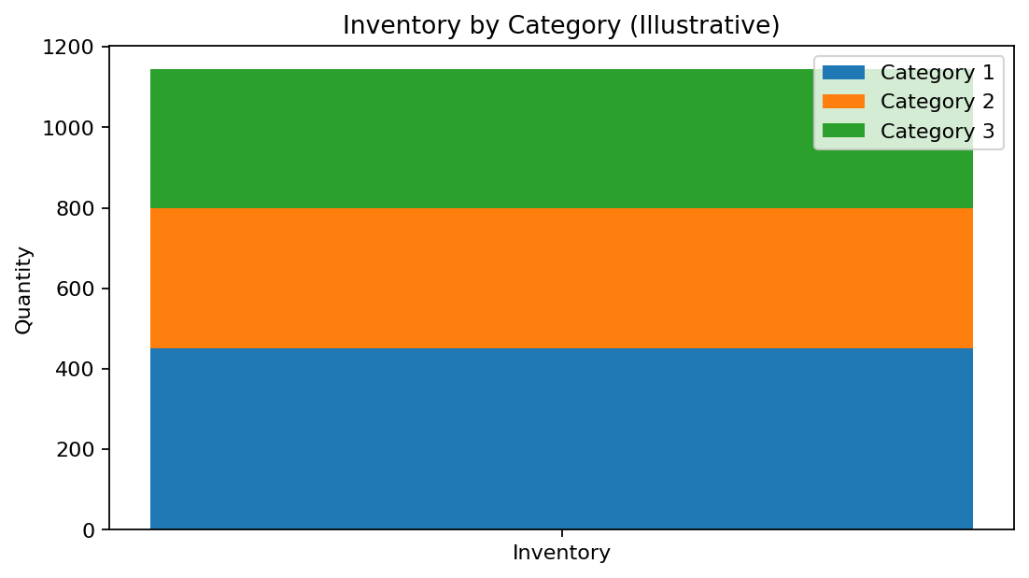
R output preview
Answer / Interpretation: The category totals demonstrate how products can be grouped in a stacked view. Category assignments were not supplied in the source.

Question 3
Build a scatter plot to explore the relationship between product price and quantity available. Explain the findings.
R Programming Code
price <- c(20,15,18,25,22) # illustrative
qty <- c(250,175,300,200,220)
plot(price, qty, pch=19, xlab="Price ($)", ylab="Quantity", main="Price vs Quantity")
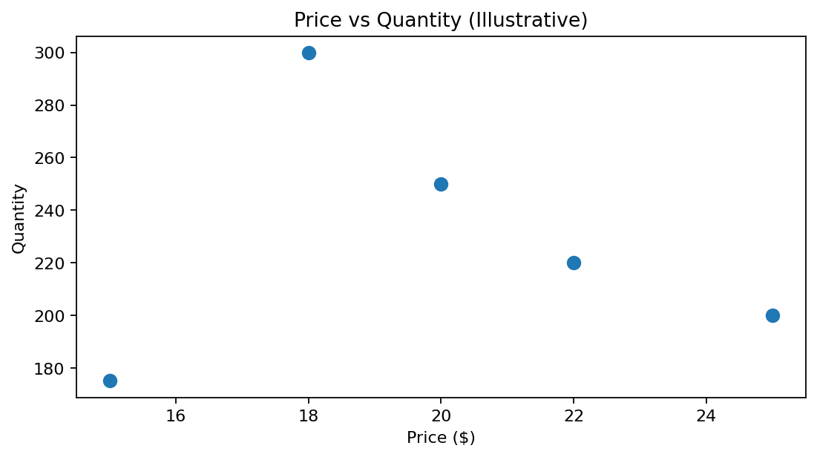
R output preview
Answer / Interpretation: The illustrative values do not show a strong simple relationship. Actual product prices were not included in the supplied dataset.

Question 4
Develop a Tableau dashboard with the bar chart and stacked bar chart to allow users to interact with the data.
R Programming Code
library(shiny)
# Place the inventory bar plot and category plot in separate Shiny outputs.
# Add selectInput() controls if interactive filtering is required.
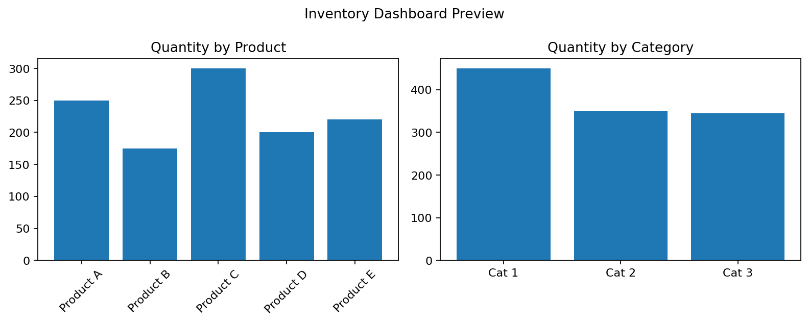
R output preview
Answer / Interpretation: The dashboard preview combines product-level inventory and category-level totals. A Shiny implementation can provide interactive filtering.

