SET 8: Employee Performance Analysis
Dataset: Employee Performance

Question 1
Create a line chart to visualize the performance trend of employees over time. Label the axes and title the chart.
R Programming Code
years <- c(5,3,7)
score <- c(85,92,78)
ord <- order(years)
plot(years[ord], score[ord], type="o", xlab="Years of Service", ylab="Performance Score", main="Employee Performance Trend")
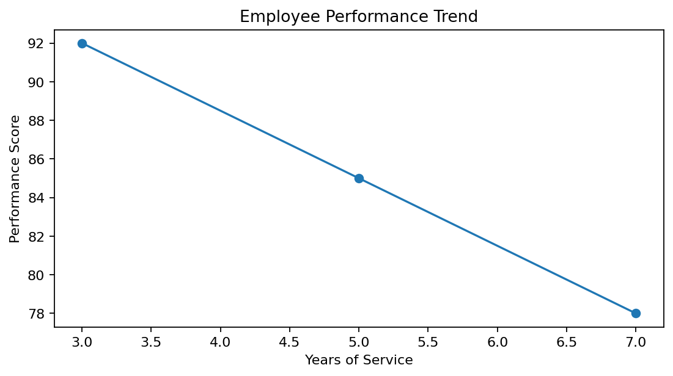
R output preview
Answer / Interpretation: Performance score varies across employees; the highest score belongs to the 3-year employee, while the 7-year employee has the lowest score.

Question 2
Generate a bar chart showing the distribution of employees across different departments. Label the chart elements.
R Programming Code
department <- c("Sales","HR","Marketing")
barplot(rep(1,3), names.arg=department, xlab="Department", ylab="Employees", main="Employees by Department")
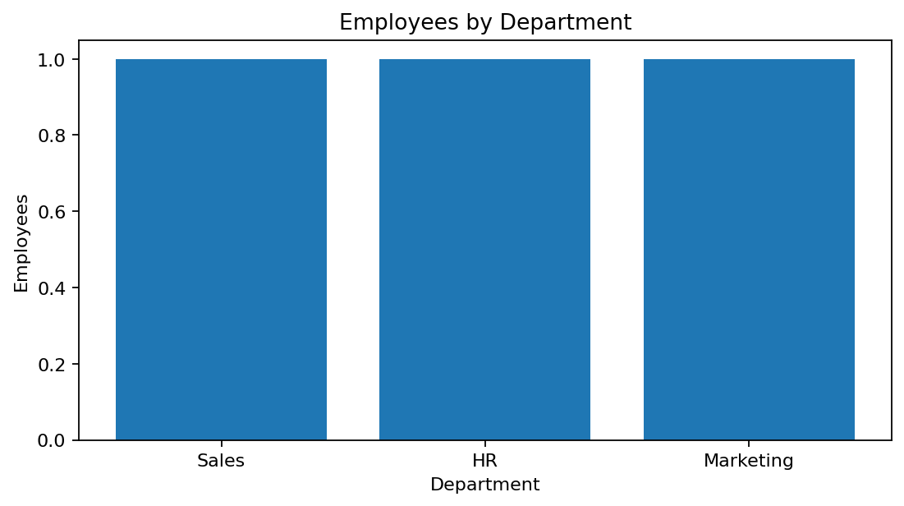
R output preview
Answer / Interpretation: Each listed department has one employee in the supplied dataset.

Question 3
Build a table to display the performance data for each employee. Label the table elements.
R Programming Code
employee <- data.frame(Employee_ID=1:3, Department=c("Sales","HR","Marketing"), Years=c(5,3,7), Score=c(85,92,78))
print(employee)
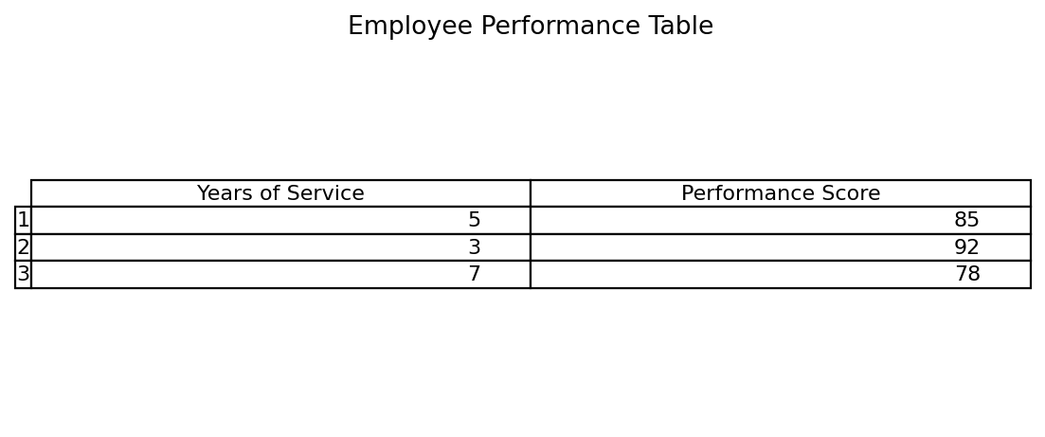
R output preview
Answer / Interpretation: The table provides the complete employee-level performance information.

Question 4
Develop a Tableau dashboard combining the line chart, bar chart, and the table for interactive exploration of employee performance data.
R Programming Code
library(shiny)
# Combine line chart, department bar chart and performance table as Shiny outputs.
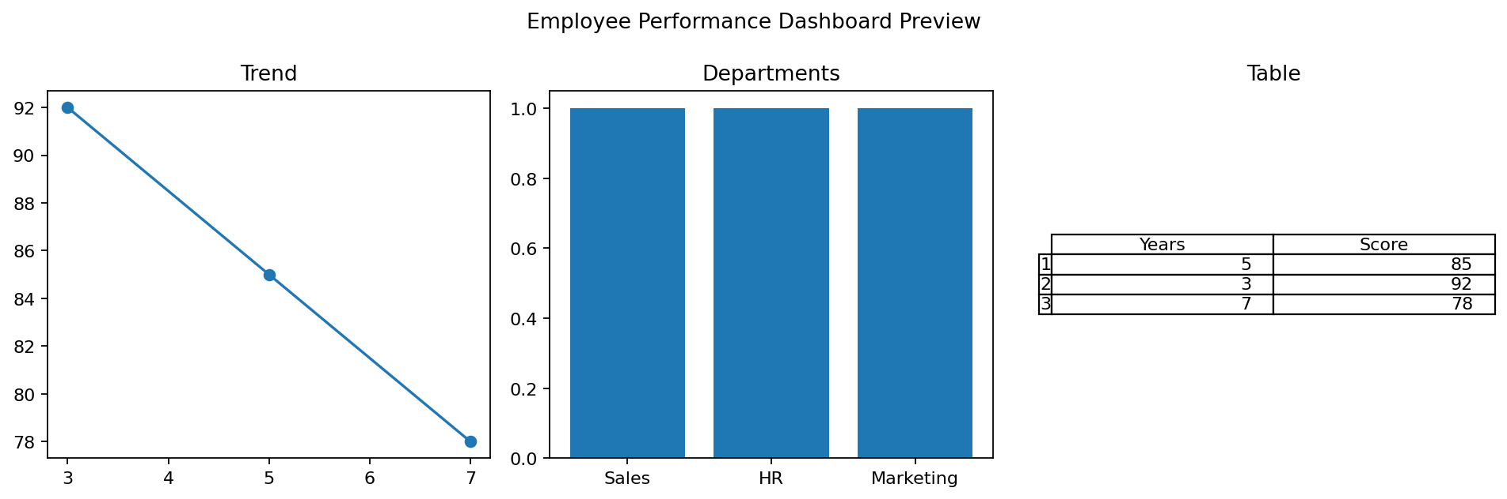
R output preview
Answer / Interpretation: The dashboard gives a compact view of trend, department distribution and employee details.

