SET 10: Survey Responses Analysis
Dataset: Survey Responses

Question 1
Create a grouped bar chart to visualize the distribution of answers for Question 1. Label the chart elements.
R Programming Code
q1 <- c("A","B","C")
barplot(table(q1), xlab="Question 1 Answer", ylab="Count", main="Question 1 Response Distribution")
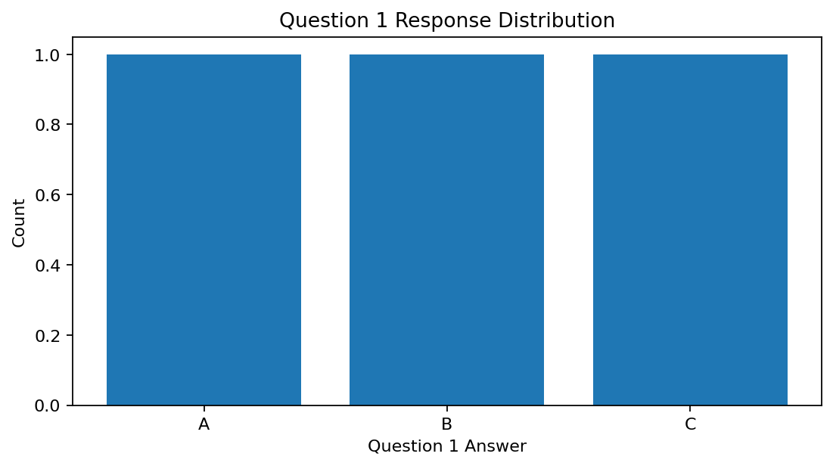
R output preview
Answer / Interpretation: Question 1 has one response each for A, B and C, so the distribution is evenly split.

Question 2
Generate a stacked bar chart to represent the overall distribution of responses for all three questions.
R Programming Code
responses <- data.frame(Q1=c("A","B","C"), Q2=c("B","A","A"), Q3=c("C","D","B"))
tab <- table(stack(responses))
barplot(tab, beside=FALSE, legend.text=TRUE, xlab="Question", ylab="Responses", main="Overall Response Distribution")
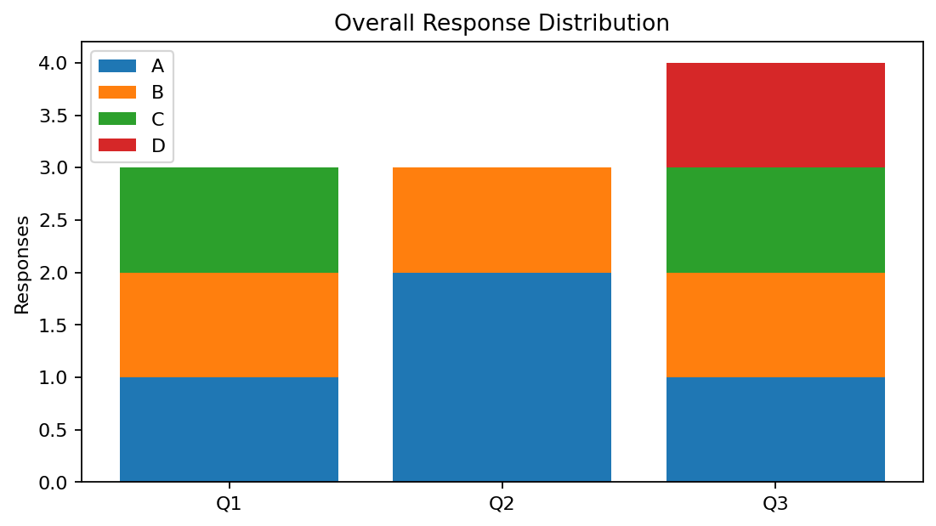
R output preview
Answer / Interpretation: The stacked chart shows how answer choices are distributed across the three survey questions. Question 2 has the most A responses, while Question 3 includes D.

Question 3
Build a table to show the survey response data for each survey. Label the table elements.
R Programming Code
survey <- data.frame(Survey_ID=1:3, Question_1=c("A","B","C"), Question_2=c("B","A","A"), Question_3=c("C","D","B"))
print(survey)
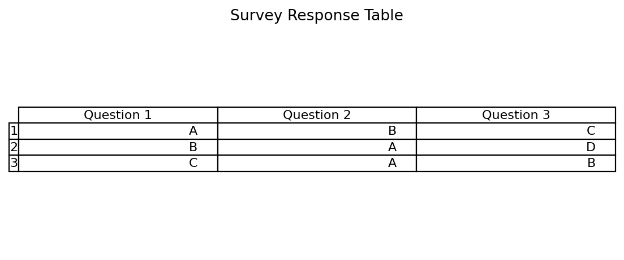
R output preview
Answer / Interpretation: The table presents every respondent’s answer to all three questions.

Question 4
Develop a Tableau dashboard combining the grouped bar chart, stacked bar chart, and the table for interactive exploration of survey responses.
R Programming Code
library(shiny)
# Combine the Question 1 chart, overall stacked chart and response table.
# Use renderPlot() and renderTable() in the server function.
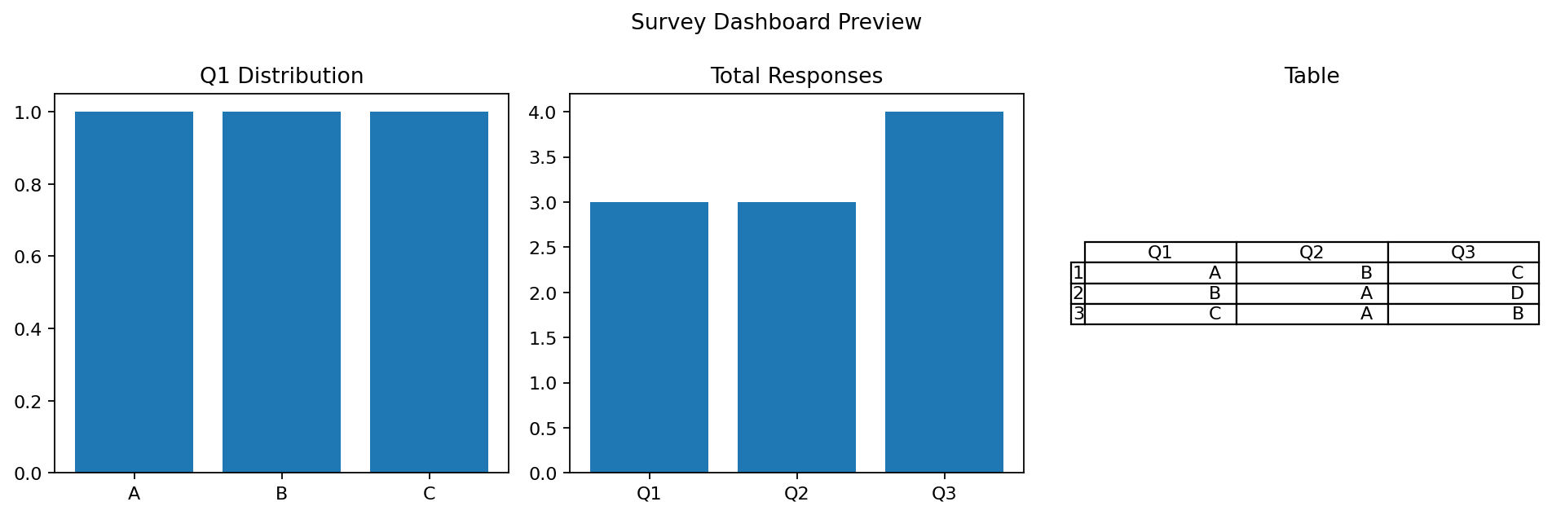
R output preview
Answer / Interpretation: The dashboard combines response distribution charts with the exact survey table, making comparison easier.

