LAB EXPERIMENT RECORD

Set 14: Survey Results
Department: AIML
Course Code / Course Name: DSA0601 / Data Handling and Visualization
Experiment: Data Visualization using R
Name: Deepka V
Register Number: 1092325008

Aim
To analyze the provided dataset through the four prescribed visualizations, tables and dashboard exercises using R programming.

Dataset: Survey Results
Respondent | Question 1 | Question 2 | Question 3
1 | A | B | C
2 | B | A | D
3 | C | A | B

PROGRAM 1: Question 1 stacked bar chart
R Code
survey <- data.frame(Respondent=1:3,Q1=c("A","B","C"),Q2=c("B","A","A"),Q3=c("C","D","B"))
counts <- table(factor(survey$Q1,levels=c("A","B","C","D")))
barplot(matrix(counts,nrow=4),col=c("steelblue","orange","green","pink"),
legend.text=c("A","B","C","D"),xlab="Question 1",ylab="Count",main="Q1 Response Distribution")
Output 1: Question 1 stacked bar chart
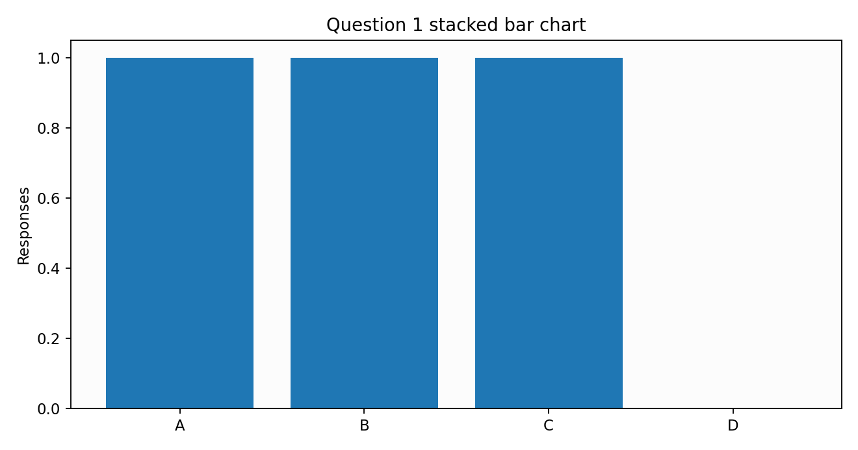
Observation: The plotted values reflect the supplied dataset.

PROGRAM 2: Response pattern radar chart
R Code
survey <- data.frame(Q1=c("A","B","C"),Q2=c("B","A","A"),Q3=c("C","D","B"))
# Radar axes represent counts of each response across the three questions.
answers <- c("A","B","C","D")
counts <- sapply(survey,function(x) as.numeric(table(factor(x,levels=answers))))
angles <- seq(0,2*pi,length.out=5)
plot(NA,xlim=c(-2,2),ylim=c(-2,2),asp=1,axes=FALSE,xlab="",ylab="",main="Survey Response Radar")
for(i in 1:3){r <- c(counts[,i],counts[1,i]); lines(r*cos(angles),r*sin(angles),type="o",col=i,lwd=2)}
text(1.8*cos(angles[1:4]),1.8*sin(angles[1:4]),answers)
legend("topright",legend=names(survey),col=1:3,lty=1,bty="n")
Output 2: Response pattern radar chart
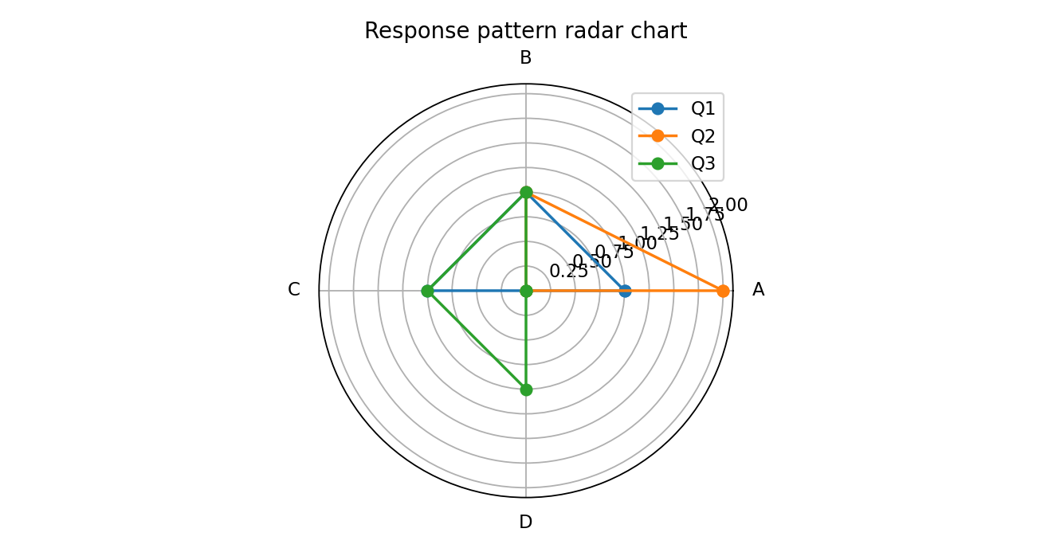
Observation: The chart summarizes the values and supports comparison.

PROGRAM 3: Survey response table
R Code
survey <- data.frame(Respondent=1:3,Question_1=c("A","B","C"),Question_2=c("B","A","A"),Question_3=c("C","D","B"))
print(survey)
Output 3: Survey response table
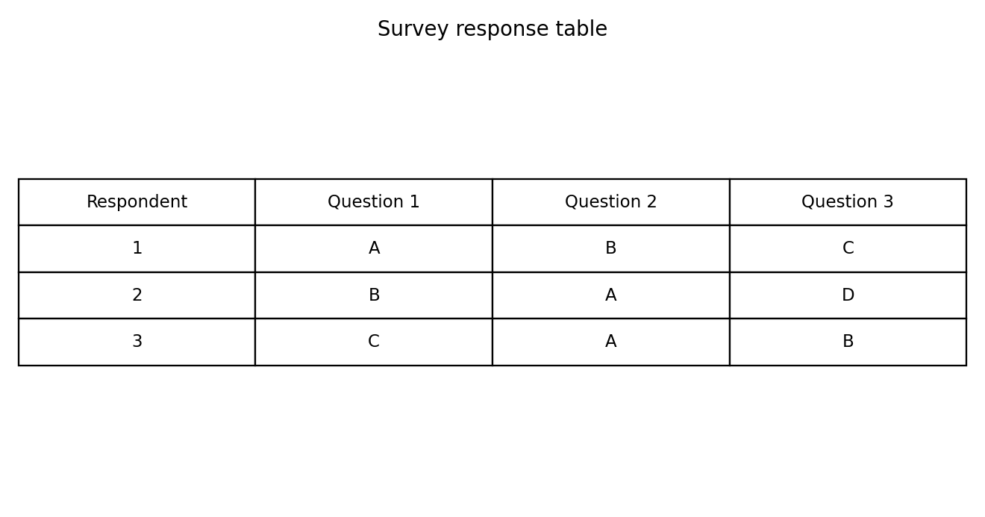
Observation: The table displays the complete provided records.

PROGRAM 4: Survey results dashboard
R Code
library(shiny)
survey <- data.frame(Respondent=1:3,Q1=c("A","B","C"),Q2=c("B","A","A"),Q3=c("C","D","B"))
ui <- fluidPage(titlePanel("Survey Results Dashboard"),selectInput("question","Question",c("Q1","Q2","Q3")),plotOutput("bars"),plotOutput("radar"),tableOutput("tbl"))
server <- function(input,output,session){
output$bars <- renderPlot(barplot(table(survey[[input$question]]),main=paste(input$question,"Responses")))
output$radar <- renderPlot({counts <- sapply(survey[-1],function(x)as.numeric(table(factor(x,levels=c("A","B","C","D"))))); matplot(t(counts),type="b",lty=1,main="Response Profiles",xlab="Answer index",ylab="Count")})
output$tbl <- renderTable(survey)
}
shinyApp(ui,server)
Output 4: Survey results dashboard
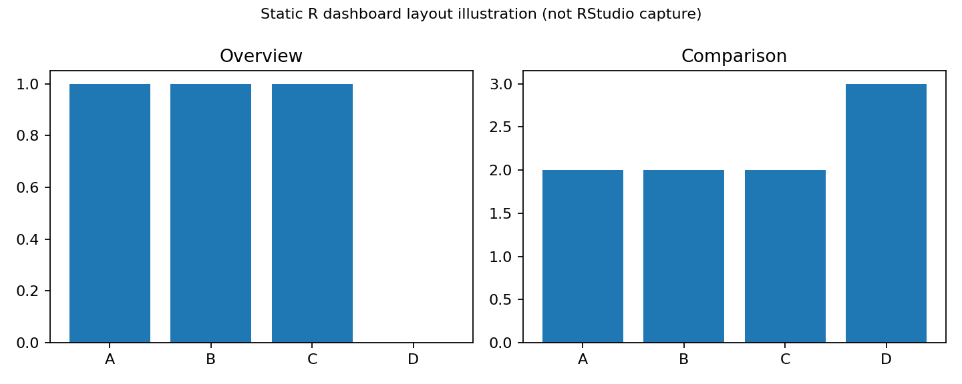
Illustrative static dashboard layout. Run the Shiny code in RStudio for a working interactive dashboard. The source exercise specifically requests Tableau; this is an R-based alternative, not a Tableau screenshot.
Observation: The dashboard combines visual comparisons and data exploration.

Procedure
1. Open RStudio and create an R script.
2. Enter the dataset in R.
3. Run each program and inspect the Plots/Console output.
4. Install and load shiny if necessary, then run the dashboard code.
5. Interpret and record the results.

Result
The Set 14 dataset was analyzed using R programming and the specified visual outputs and tables were prepared.

