LAB EXPERIMENT RECORD

Set 15: Product Sales Analysis
Department: AIML
Course Code / Course Name: DSA0601 / Data Handling and Visualization
Experiment: Data Visualization using R
Name: Deepka V
Register Number: 1092325008

Aim
To analyze the provided dataset through the four prescribed visualizations, tables and dashboard exercises using R programming.

Dataset: Product Sales Analysis
Product ID | Product Name | January Sales | February Sales | March Sales
1 | Product A | 2000 | 2200 | 2400
2 | Product B | 1500 | 1800 | 1600
3 | Product C | 1200 | 1400 | 1100

PROGRAM 1: Grouped product sales bar chart
R Code
sales <- matrix(c(2000,1500,1200,2200,1800,1400,2400,1600,1100),nrow=3,dimnames=list(c("Product A","Product B","Product C"),c("Jan","Feb","Mar")))
barplot(sales,beside=TRUE,col=c("steelblue","orange","green"),legend.text=rownames(sales),xlab="Month",ylab="Sales ($)",main="First Quarter Product Sales")
Output 1: Grouped product sales bar chart
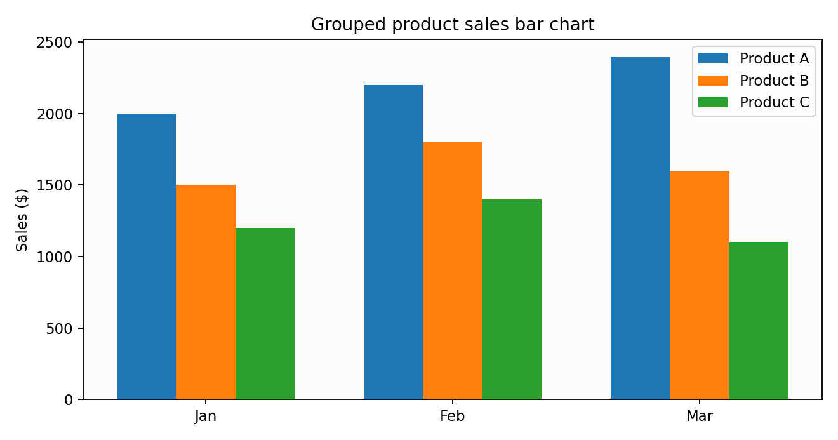
Observation: The plotted values reflect the supplied dataset.

PROGRAM 2: Quarterly stacked area chart
R Code
sales <- matrix(c(2000,1500,1200,2200,1800,1400,2400,1600,1100),nrow=3)
matplot(t(apply(sales,2,cumsum)),type="l",lty=1,col=1:3,xlab="Month",ylab="Cumulative Sales",main="Stacked Sales Boundaries")
# For a filled stacked area chart:
polygon(c(1:3,3:1),c(rep(0,3),rev(sales[1,])),col="lightblue")
# Recommended: ggplot2::geom_area() for polished stacked areas.
Output 2: Quarterly stacked area chart
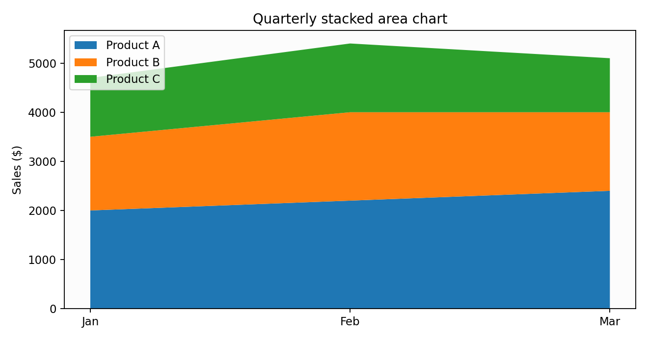
Observation: The chart summarizes the values and supports comparison.

PROGRAM 3: Monthly product sales table
R Code
sales <- data.frame(Product_ID=1:3,Product_Name=c("Product A","Product B","Product C"),January=c(2000,1500,1200),February=c(2200,1800,1400),March=c(2400,1600,1100))
print(sales)
Output 3: Monthly product sales table
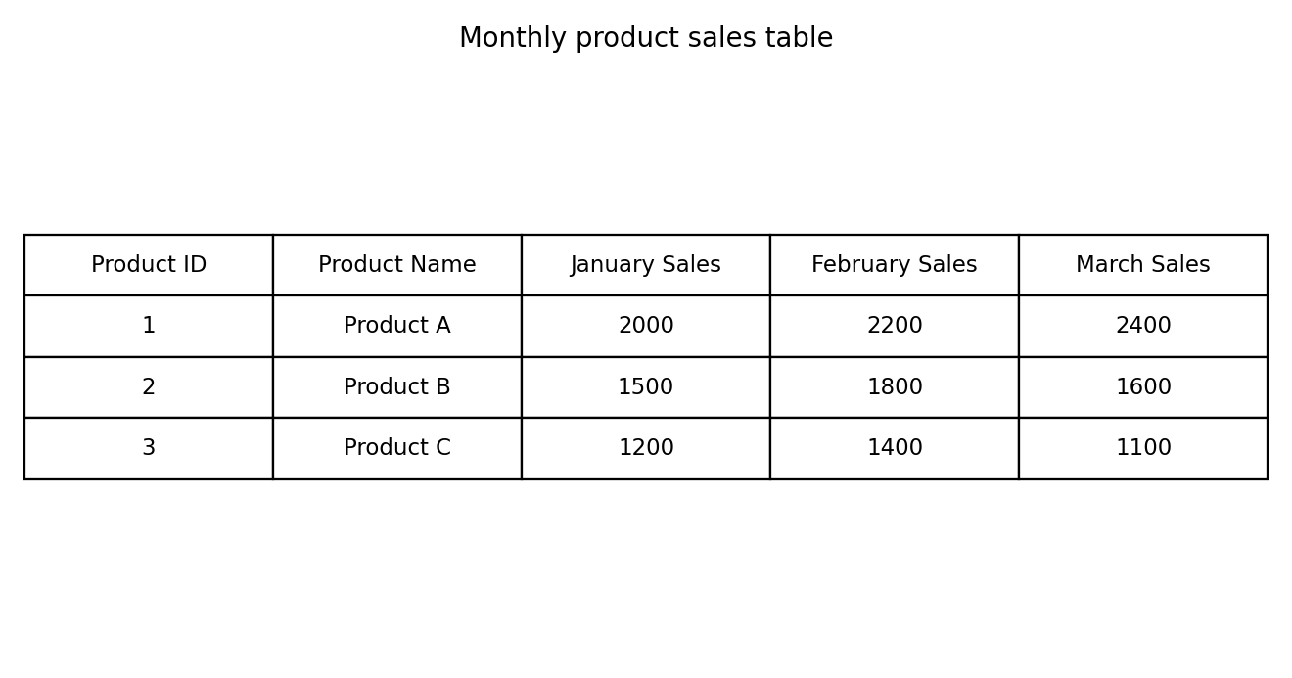
Observation: The table displays the complete provided records.

PROGRAM 4: Product sales dashboard
R Code
library(shiny)
sales <- data.frame(Product=c("Product A","Product B","Product C"),Jan=c(2000,1500,1200),Feb=c(2200,1800,1400),Mar=c(2400,1600,1100))
ui <- fluidPage(titlePanel("Product Sales Dashboard"),selectInput("product","Product",c("All",sales$Product)),plotOutput("grouped"),plotOutput("area"),tableOutput("tbl"))
server <- function(input,output,session){
d <- reactive(if(input$product=="All") sales else subset(sales,Product==input$product))
output$grouped <- renderPlot(barplot(as.matrix(d()[-1]),beside=TRUE,legend.text=d()$Product,main="Monthly Sales"))
output$area <- renderPlot({m <- as.matrix(d()[-1]); matplot(t(m),type="l",lty=1,xlab="Month",ylab="Sales",main="Sales Trends")})
output$tbl <- renderTable(d())
}
shinyApp(ui,server)
Output 4: Product sales dashboard
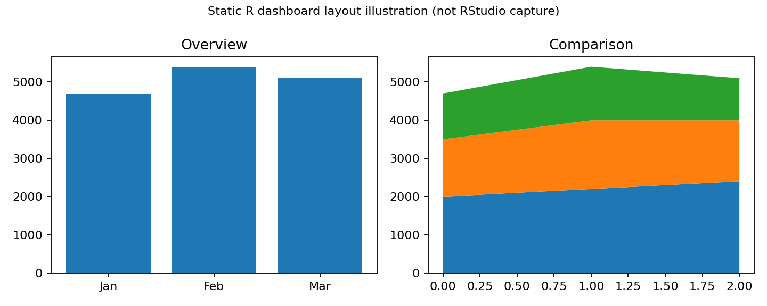
Illustrative static dashboard layout. Run the Shiny code in RStudio for a working interactive dashboard. The source exercise specifically requests Tableau; this is an R-based alternative, not a Tableau screenshot.
Observation: The dashboard combines visual comparisons and data exploration.

Procedure
1. Open RStudio and create an R script.
2. Enter the dataset in R.
3. Run each program and inspect the Plots/Console output.
4. Install and load shiny if necessary, then run the dashboard code.
5. Interpret and record the results.

Result
The Set 15 dataset was analyzed using R programming and the specified visual outputs and tables were prepared.

