SET 5: Website Analytics
Dataset: Website Traffic
Data note: The source provides date, page views and click-through rate, but not likes/shares/comments. Q3 uses clearly marked illustrative interaction values.

Question 1
Create a line chart to visualize the trend in daily page views over time. Label the axes and title the chart.
R Programming Code
date <- as.Date(c("2023-01-01","2023-01-02","2023-01-03","2023-01-04","2023-01-05"))
views <- c(1500,1600,1400,1650,1800)
plot(date, views, type="o", xlab="Date", ylab="Page Views", main="Daily Page Views")
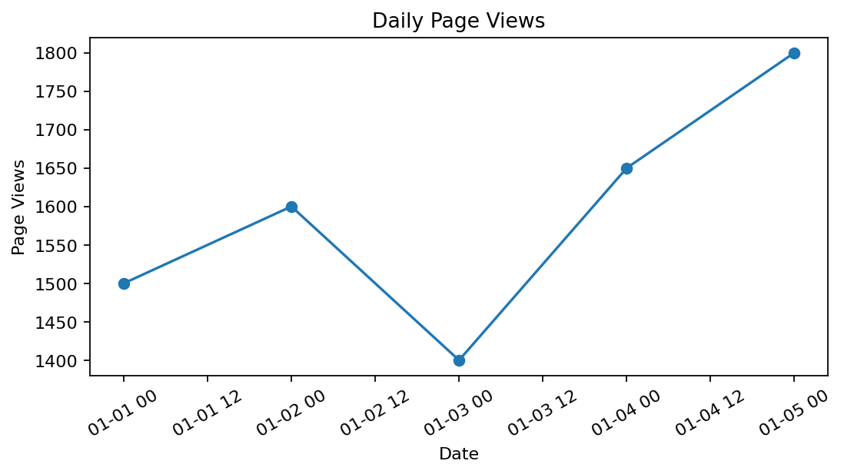
R output preview
Answer / Interpretation: Page views fluctuate but finish at the highest level on January 5, suggesting an overall upward movement after the January 3 dip.

Question 2
Generate a bar chart showing the top N days with the highest click-through rates. Label the chart elements.
R Programming Code
date <- as.Date(c("2023-01-01","2023-01-02","2023-01-03","2023-01-04","2023-01-05"))
ctr <- c(2.3,2.7,2.0,2.4,2.6)
ord <- order(ctr, decreasing=TRUE)
barplot(ctr[ord], names.arg=format(date[ord]), xlab="Date", ylab="CTR (%)", main="Top Days by CTR")
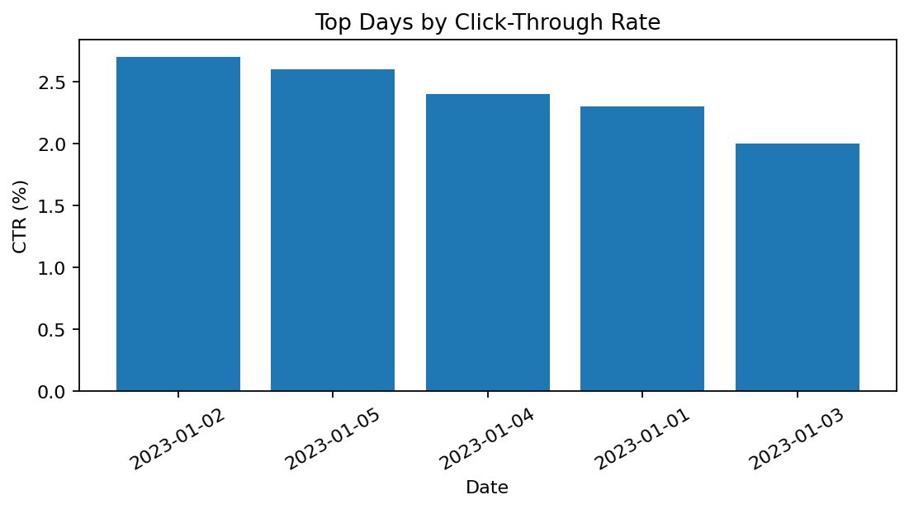
R output preview
Answer / Interpretation: January 2 has the highest CTR (2.7%), followed by January 5 (2.6%).

Question 3
Develop a stacked area chart to display the distribution of user interactions (likes, shares, comments) on a website.
R Programming Code
date <- as.Date(c("2023-01-01","2023-01-02","2023-01-03","2023-01-04","2023-01-05"))
likes <- c(300,320,280,350,390)
shares <- c(90,100,80,110,120)
comments <- c(40,45,35,50,55) # illustrative
matplot(date, cbind(likes,shares,comments), type="l", lty=1, xlab="Date", ylab="Interactions", main="User Interactions")
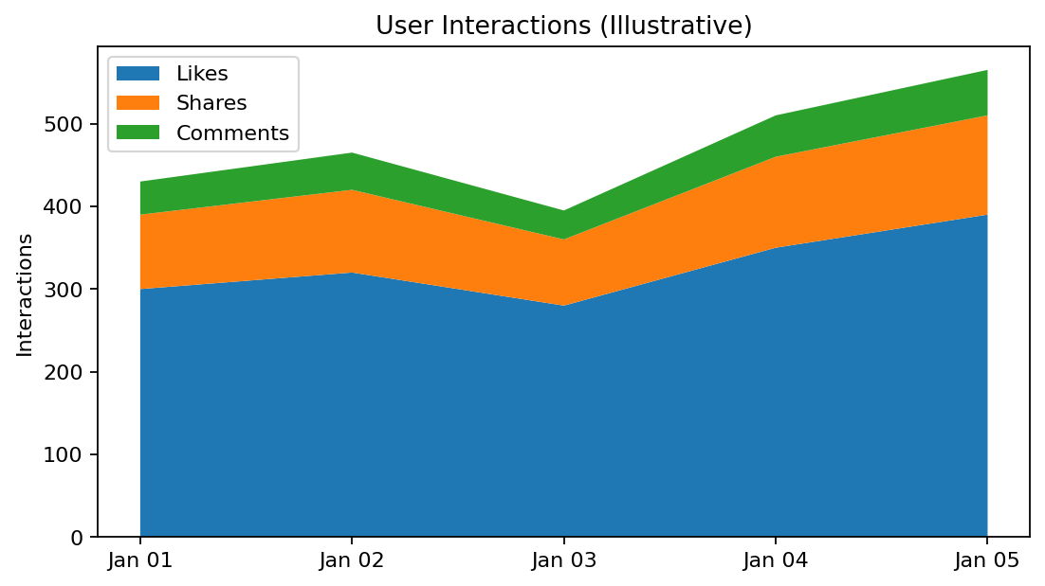
R output preview
Answer / Interpretation: Likes are the largest interaction type in the illustrative data, followed by shares and comments. These interaction values were not supplied in the source.

Question 4
Build a Tableau dashboard with the line chart and bar chart for interactive exploration of website traffic data.
R Programming Code
library(shiny)
# Create two plotOutput() panels for page views and CTR.
# Add date or metric inputs if interactive filtering is required.
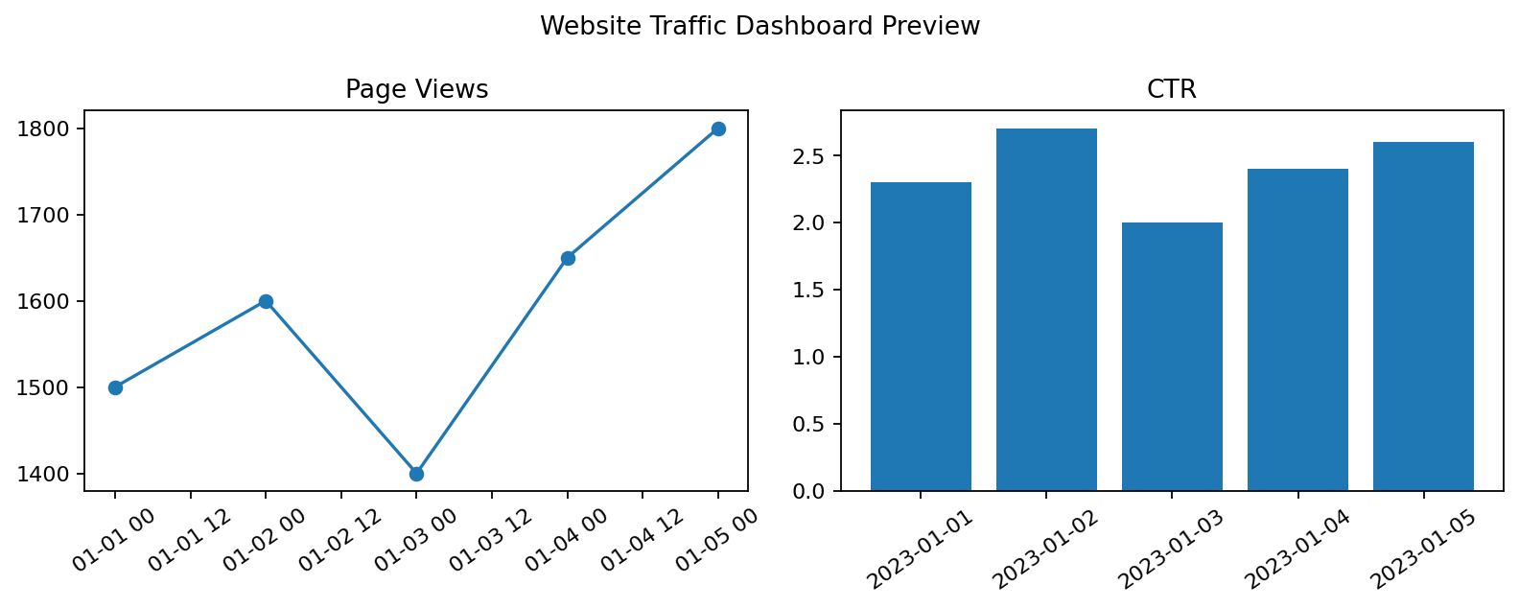
R output preview
Answer / Interpretation: The dashboard combines traffic volume and engagement rate. A Shiny version can provide interactive controls; the image is a static preview.

