SET 6: Product Sales Analysis
Dataset: Monthly Product Sales

Question 1
Create a grouped bar chart to visualize the sales of each product for the first quarter. Label the chart elements.
R Programming Code
product <- c("Product A","Product B","Product C")
jan <- c(2000,1500,1200); feb <- c(2200,1800,1400); mar <- c(2400,1600,1100)
barplot(rbind(jan,feb,mar), beside=TRUE, names.arg=product, legend.text=c("January","February","March"), xlab="Product", ylab="Sales", main="Q1 Product Sales")
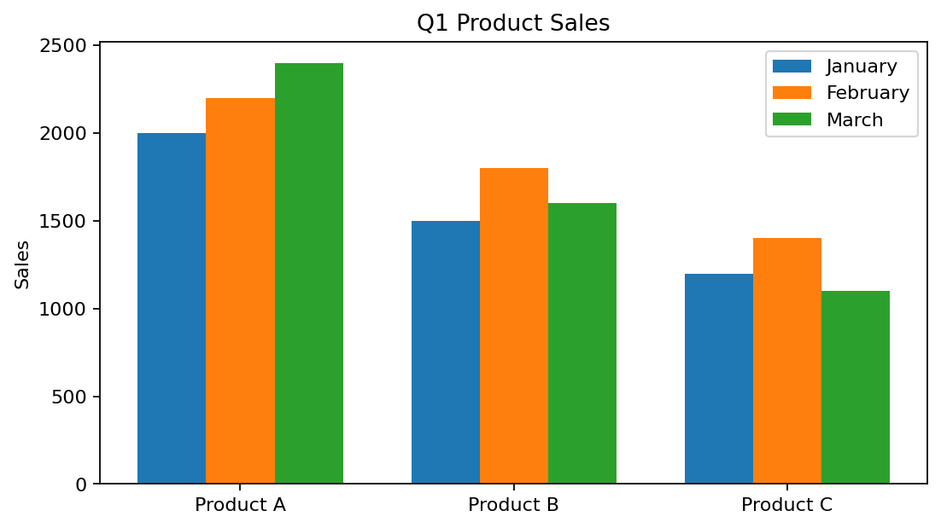
R output preview
Answer / Interpretation: Product A has the highest sales in all three months. Product C decreases from February to March.

Question 2
Generate a stacked area chart to represent the overall sales trend for all products over the three months.
R Programming Code
sales <- rbind(c(2000,2200,2400), c(1500,1800,1600), c(1200,1400,1100))
matplot(1:3, t(sales), type="l", lty=1, xlab="Month", ylab="Sales", main="Product Sales Trend")
# For a true stacked area, use polygon() or an area-chart package.
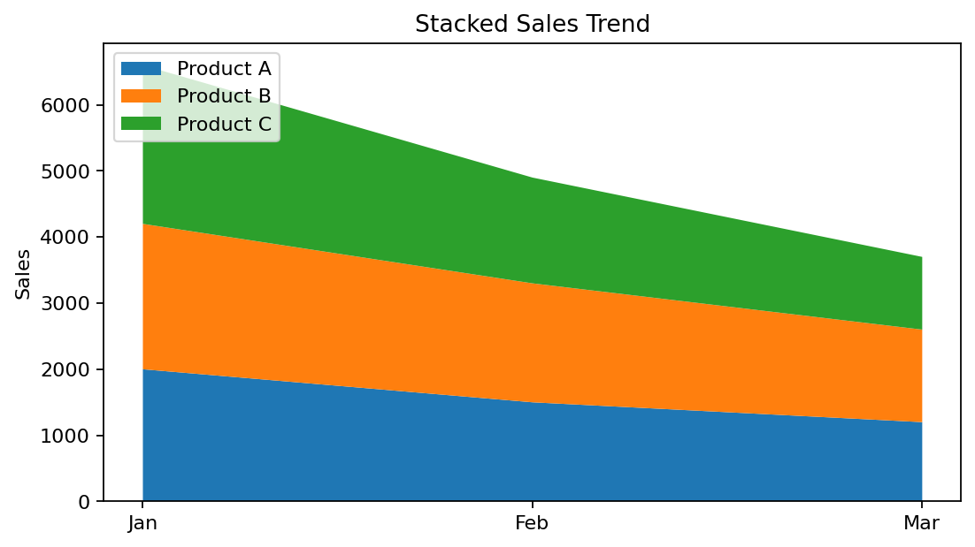
R output preview
Answer / Interpretation: Total sales increase from January to February and again slightly to March because Product A grows strongly, even though Products B and C fall in March.

Question 3
Build a table to show the monthly sales data for each product. Label the table elements.
R Programming Code
product <- c("Product A","Product B","Product C")
sales <- data.frame(Product=product, January=c(2000,1500,1200), February=c(2200,1800,1400), March=c(2400,1600,1100))
print(sales)
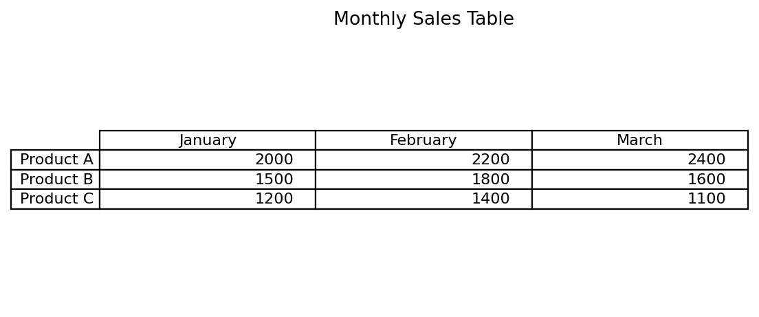
R output preview
Answer / Interpretation: The table clearly presents each product’s sales for January, February and March.

Question 4
Develop a Tableau dashboard combining the grouped bar chart, stacked area chart, and the table for interactive exploration of sales data.
R Programming Code
library(shiny)
# Build three output areas: grouped bar chart, area chart, and data table.
# In Shiny, renderPlot() handles charts and renderTable() handles the table.
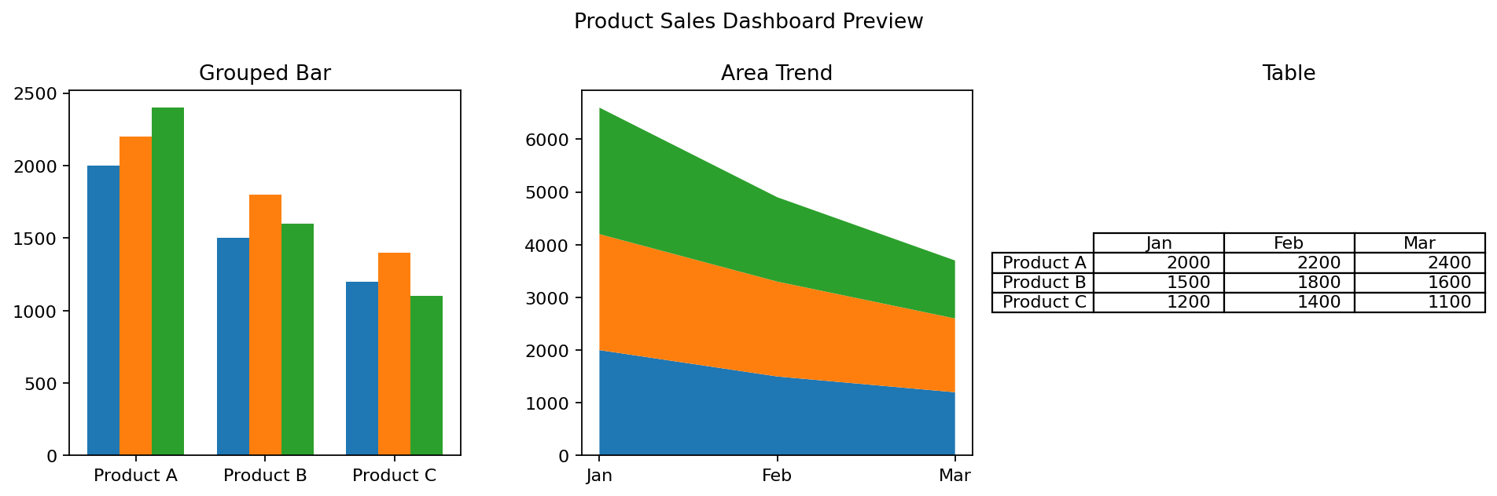
R output preview
Answer / Interpretation: The dashboard combines comparison, trend and exact-value views in one place.

