SET 1: Monthly Sales Data
Dataset: Monthly Sales
Data note: The source gives monthly sales, but does not provide product-level sales or advertising-budget values. For Q2/Q3, small illustrative values are explicitly supplied so the R programs can demonstrate the requested charts.

Question 1
Create a line chart to visualize the monthly sales. Label the axes and title the chart.
R Programming Code
month <- c("January","February","March","April","May")
sales <- c(15000,18000,22000,20000,23000)
plot(sales, type="o", xaxt="n", xlab="Month", ylab="Sales ($)", main="Monthly Sales")
axis(1, at=1:5, labels=month)
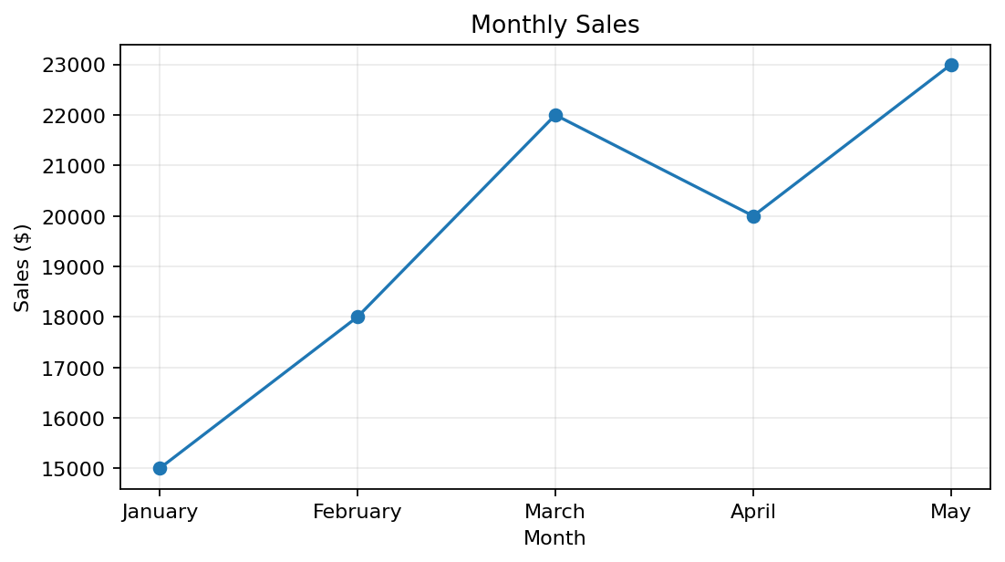
R output preview
Answer / Interpretation: Sales rise from January to March, dip slightly in April, and reach the highest value in May.

Question 2
Generate a bar chart to display the top-selling products for the year. Label the chart elements.
R Programming Code
product <- c("Product A","Product B","Product C","Product D")
sales <- c(30000,26000,22000,18000) # illustrative because product data is not in source
barplot(sales, names.arg=product, xlab="Product", ylab="Sales ($)", main="Top-Selling Products")
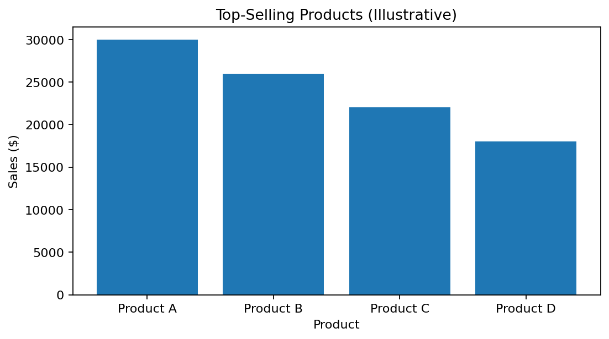
R output preview
Answer / Interpretation: Product A has the highest illustrative annual sales, followed by B, C and D. The product values are demonstration values, not values from the supplied list.

Question 3
Develop a scatter plot to explore the relationship between advertising budget and monthly sales. Explain the insights drawn from the scatter plot.
R Programming Code
ad_budget <- c(5000,6500,8000,7500,9000) # illustrative
sales <- c(15000,18000,22000,20000,23000)
plot(ad_budget, sales, pch=19, xlab="Advertising Budget ($)", ylab="Monthly Sales ($)", main="Advertising vs Sales")
abline(lm(sales ~ ad_budget), lty=2)
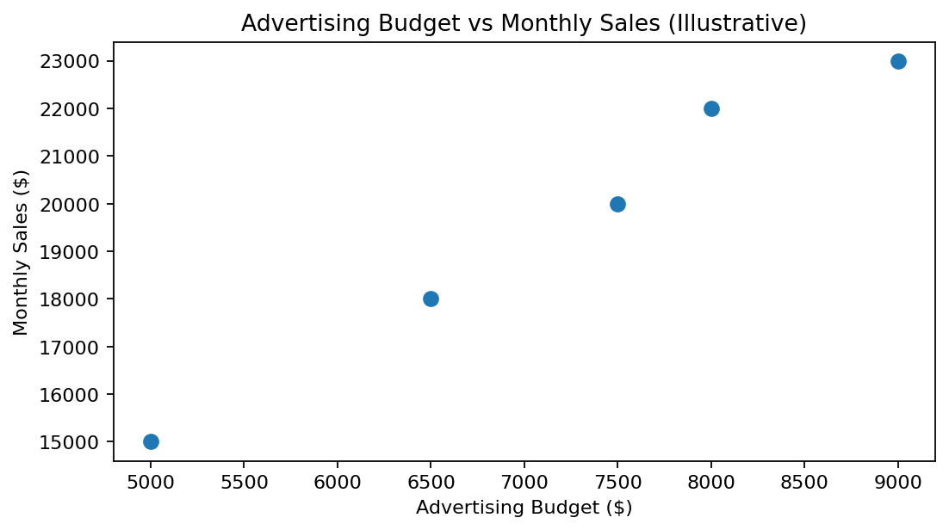
R output preview
Answer / Interpretation: The illustrative points show a positive relationship: higher advertising budgets generally correspond to higher sales. The advertising values were not supplied in the source.

Question 4
Build an interactive dashboard combining the line chart and bar chart to allow users to explore sales data interactively.
R Programming Code
library(shiny)
library(ggplot2)
# Use the two plots above as outputs in a Shiny dashboard.
# ui <- fluidPage(plotOutput("sales_line"), plotOutput("product_bar"))
# server <- function(input, output) { ... }
# shinyApp(ui, server)
# For a simple static preview, par(mfrow=c(1,2)) can place both charts together.
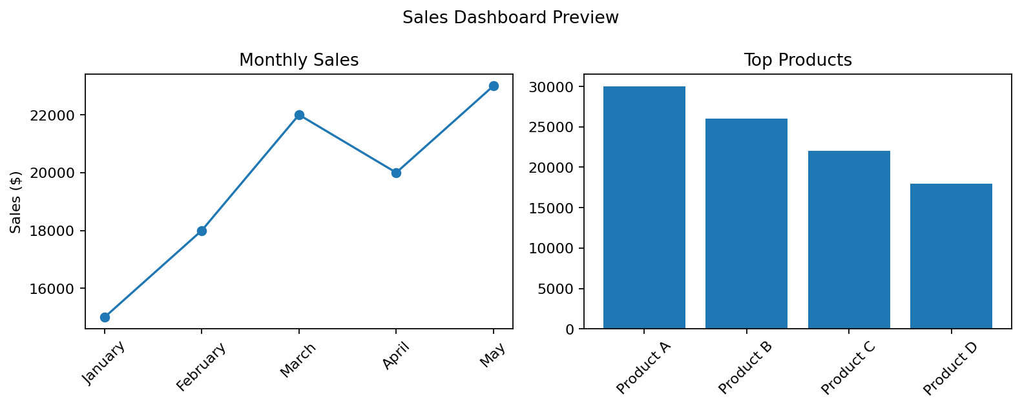
R output preview
Answer / Interpretation: The dashboard combines the monthly trend and product comparison. A Shiny app would make the charts interactive; the image here is a static preview.

