SET 2: Customer Feedback Analysis
Dataset: Customer Satisfaction
Data note: The source provides age and satisfaction score, but no open-ended feedback text. Q4 therefore uses clearly marked illustrative feedback text.

Question 1
Create a histogram to represent the distribution of customer ages. Label the axes and title the chart.
R Programming Code
age <- c(25,30,35,28,40)
hist(age, breaks=5, col="lightblue", xlab="Age", ylab="Customers", main="Customer Age Distribution")
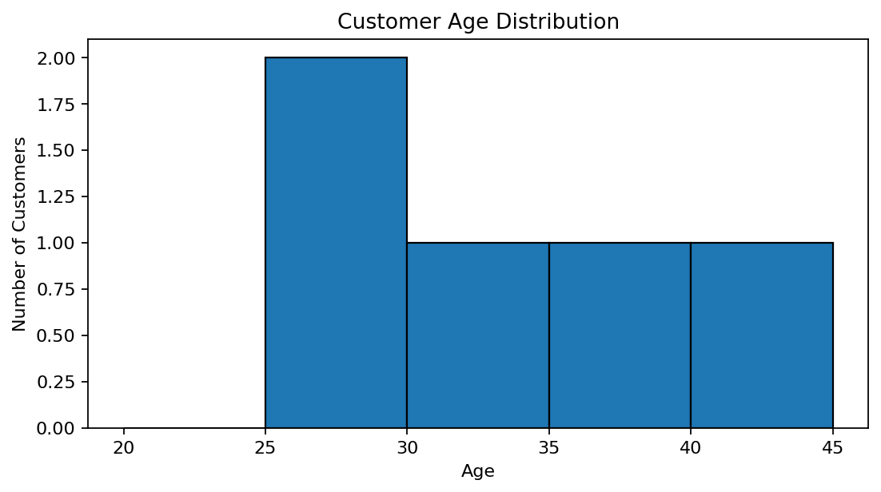
R output preview
Answer / Interpretation: The customers range from 25 to 40 years old, with most observations in the middle age ranges.

Question 2
Generate a pie chart to display the overall distribution of customer satisfaction scores. Include labels.
R Programming Code
score <- c(4,5,3,4,5)
counts <- table(score)
pie(counts, labels=paste(names(counts), "Score"), main="Satisfaction Score Distribution")
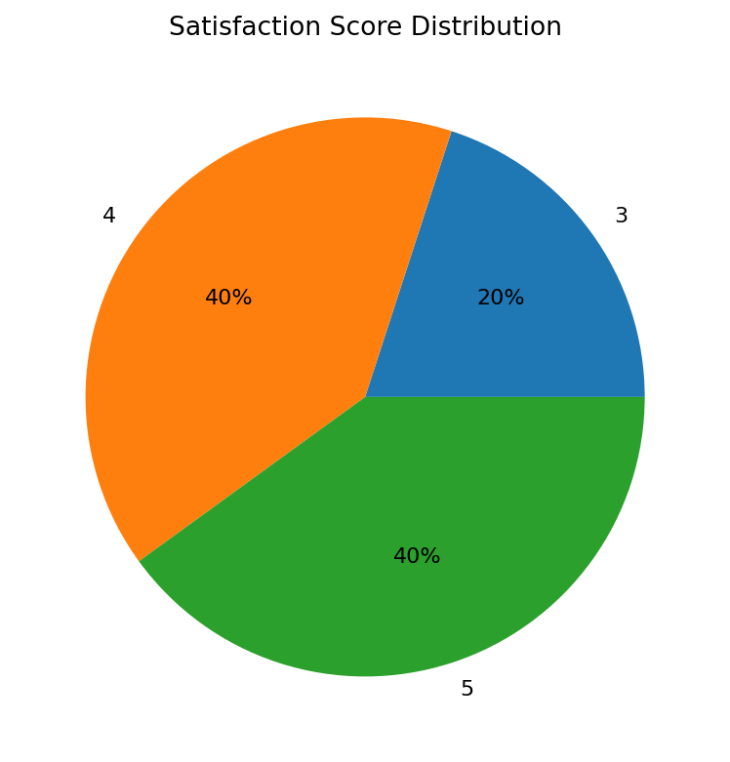
R output preview
Answer / Interpretation: Scores 4 and 5 are the most common, indicating generally positive satisfaction in the supplied data.

Question 3
Build a stacked bar chart to visualize the distribution of customer satisfaction scores by age group.
R Programming Code
age <- c(25,30,35,28,40)
score <- c(4,5,3,4,5)
age_group <- cut(age, breaks=c(17,29,39,49), labels=c("18-29","30-39","40-49"))
tab <- table(age_group, score)
barplot(tab, beside=FALSE, legend.text=TRUE, xlab="Age Group", ylab="Customers", main="Satisfaction by Age Group")
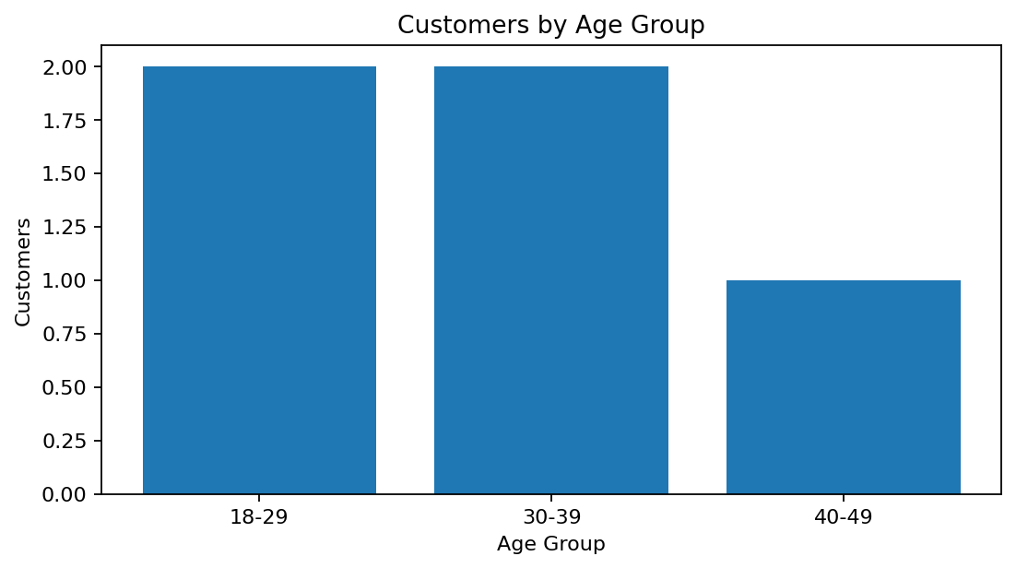
R output preview
Answer / Interpretation: The chart groups customers by age range and stacks satisfaction scores within each group. With only five observations, conclusions should be treated as descriptive.

Question 4
Develop a word cloud from open-ended customer feedback to identify prevalent customer sentiments.
R Programming Code
feedback <- c("great service", "very helpful", "average", "excellent support", "good experience", "fast response") # illustrative
library(wordcloud)
wordcloud(words=unlist(strsplit(paste(feedback, collapse=" "), " ")), min.freq=1, random.order=FALSE)
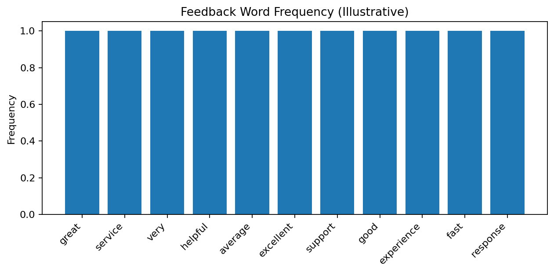
R output preview
Answer / Interpretation: Positive words such as great, helpful, excellent and good dominate the illustrative feedback. The original source did not include feedback text.

