SET 3: Employee Performance Evaluation
Dataset: Employee Performance

Question 1
Create a line chart to visualize the performance trend of employees over time. Include a legend and labels.
R Programming Code
years <- c(5,3,7,4,2)
score <- c(85,92,78,90,76)
ord <- order(years)
plot(years[ord], score[ord], type="o", xlab="Years of Service", ylab="Performance Score", main="Performance Trend")
legend("topright", legend="Employees", lty=1)
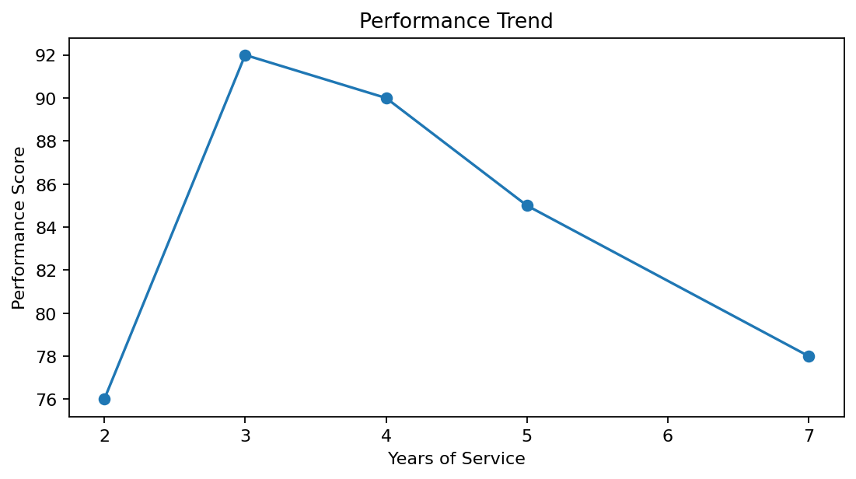
R output preview
Answer / Interpretation: Performance is not strictly increasing with years of service in this small dataset; the 7-year employee has a lower score than several employees with fewer years.

Question 2
Generate a bar chart showing the distribution of employees across different departments. Label the chart elements.
R Programming Code
department <- c("Sales","HR","Marketing","Sales","HR")
barplot(table(department), xlab="Department", ylab="Number of Employees", main="Employees by Department")
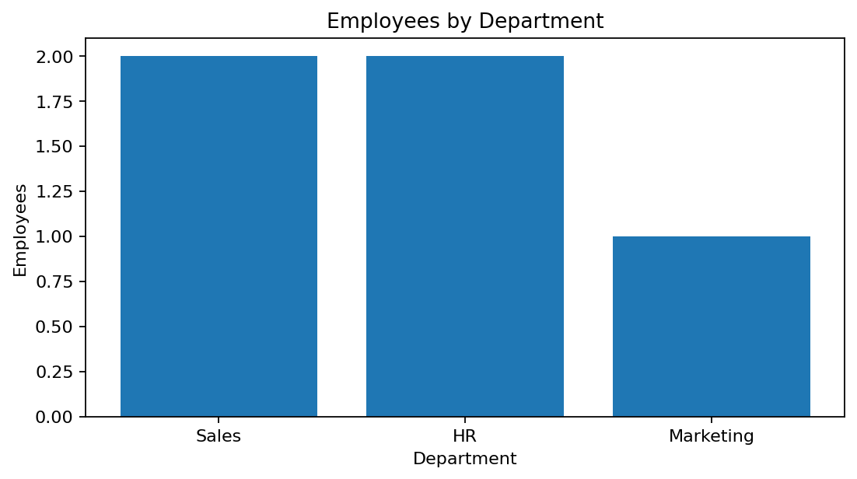
R output preview
Answer / Interpretation: Sales and HR each have two employees, while Marketing has one.

Question 3
Build a scatter plot to analyze the correlation between years of service and performance scores. Explain any insights.
R Programming Code
years <- c(5,3,7,4,2)
score <- c(85,92,78,90,76)
plot(years, score, pch=19, xlab="Years of Service", ylab="Performance Score", main="Service vs Performance")
cor(years, score)
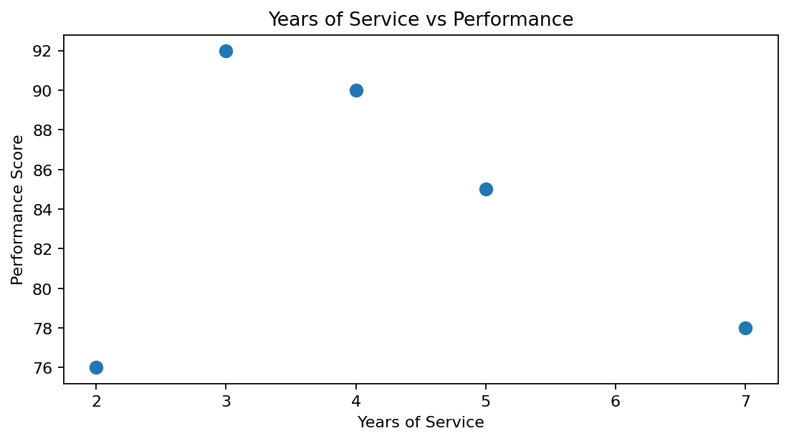
R output preview
Answer / Interpretation: The points suggest a weak-to-moderate negative relationship in this small sample: more years of service do not automatically mean a higher performance score.

Question 4
Develop a Tableau dashboard with the line chart and bar chart for interactive exploration.
R Programming Code
library(shiny)
# Combine the performance line plot and department bar plot as two Shiny outputs.
# Use plotOutput() for each chart and server renderPlot() to draw them.
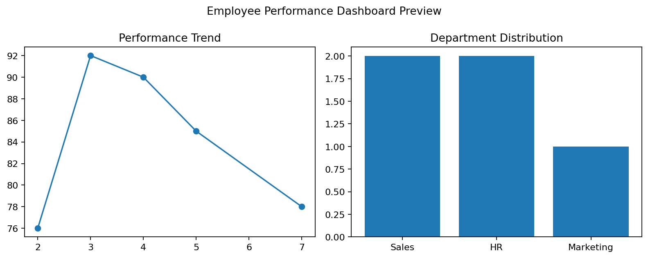
R output preview
Answer / Interpretation: The combined dashboard makes it easier to compare performance trends with department distribution. The supplied question names Tableau, while this submission demonstrates the equivalent R-side visualization.

