SET 7: Customer Demographics Analysis
Dataset: Customer Demographics

Question 1
Create a bar chart to visualize the distribution of customer ages. Label the axes and title the chart.
R Programming Code
id <- c(1,2,3)
age <- c(28,35,42)
barplot(age, names.arg=id, xlab="Customer ID", ylab="Age", main="Customer Age Distribution")
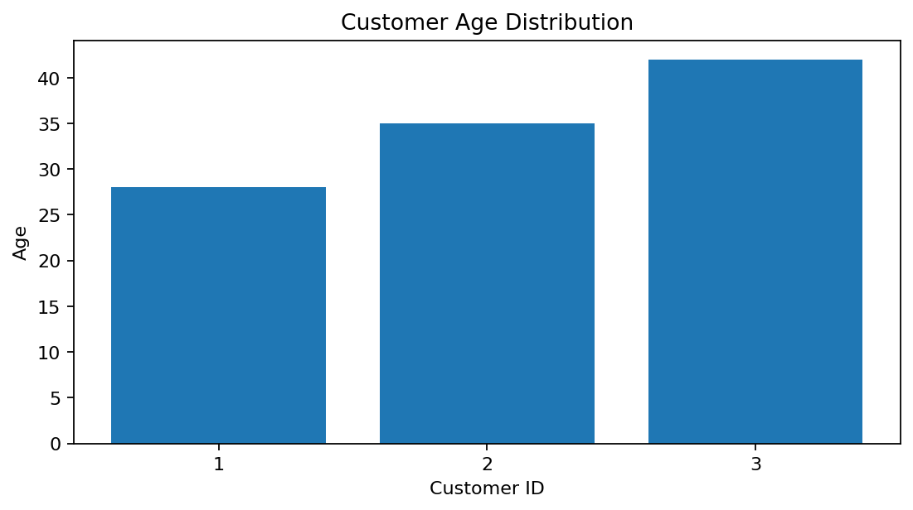
R output preview
Answer / Interpretation: The three customers are aged 28, 35 and 42, showing a spread across the adult age range.

Question 2
Generate a pie chart to represent the distribution of customers by gender.
R Programming Code
gender <- c("Female","Male","Female")
pie(table(gender), main="Customers by Gender")
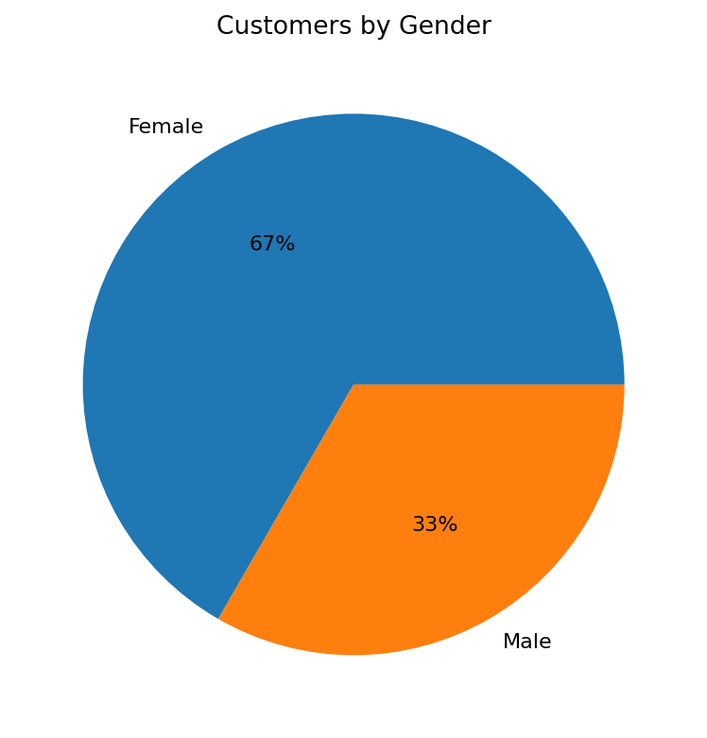
R output preview
Answer / Interpretation: Females make up two-thirds of the supplied customers and males one-third.

Question 3
Build a table to show the demographic information for each customer. Label the table elements.
R Programming Code
customer <- data.frame(Customer_ID=1:3, Age=c(28,35,42), Gender=c("Female","Male","Female"), Income=c(50000,60000,75000))
print(customer)
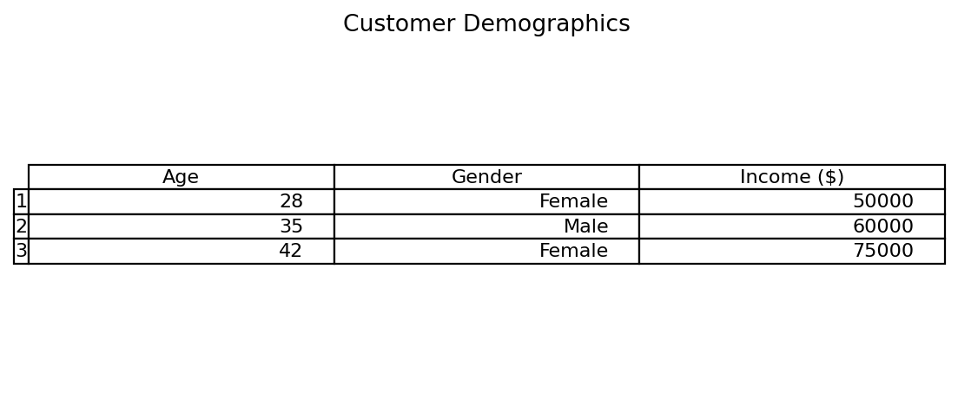
R output preview
Answer / Interpretation: The table displays customer ID, age, gender and income together for easy comparison.

Question 4
Develop a Tableau dashboard combining the bar chart, pie chart, and the table for interactive exploration of customer demographics.
R Programming Code
library(shiny)
# Use plotOutput() for the age bar chart and gender pie chart.
# Use tableOutput() for the demographic table.
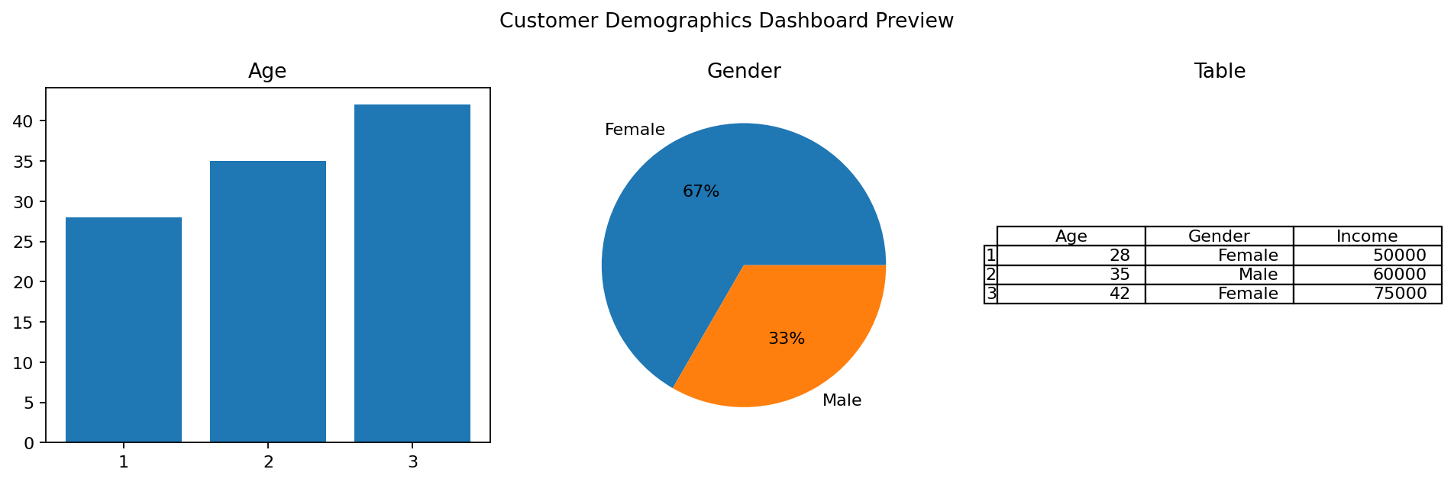
R output preview
Answer / Interpretation: The combined dashboard lets a user compare age, gender distribution and exact demographic values.

