SET 9: Online Learning Activity
Dataset: Online_Learning_Activity.csv
Data note: The source text contains six records, but the extracted formatting is fragmented. The code below uses the visible values for six students as reconstructed from the supplied list.

Question 1
Import the dataset in R. Plot a histogram for Quiz_Score. Draw a boxplot of Quiz_Score by Course. Add title and labels. Interpret student performance.
R Programming Code
data <- data.frame(Student_ID=c("L01","L02","L03","L04","L05","L06"), Gender=c("Male","Female","Male","Female","Male","Female"), Age=c(20,22,19,21,23,20), Course=c("R","R","SQL","R","R","SQL"), Study_Time=c(3.5,4.2,2.0,5.0,2.5,4.0), Videos_Watched=c(12,15,8,18,9,14), Quiz_Score=c(78,85,65,92,70,88))
hist(data$Quiz_Score, xlab="Quiz Score", main="Quiz Score Distribution")
boxplot(Quiz_Score ~ Course, data=data, xlab="Course", ylab="Quiz Score", main="Quiz Score by Course")
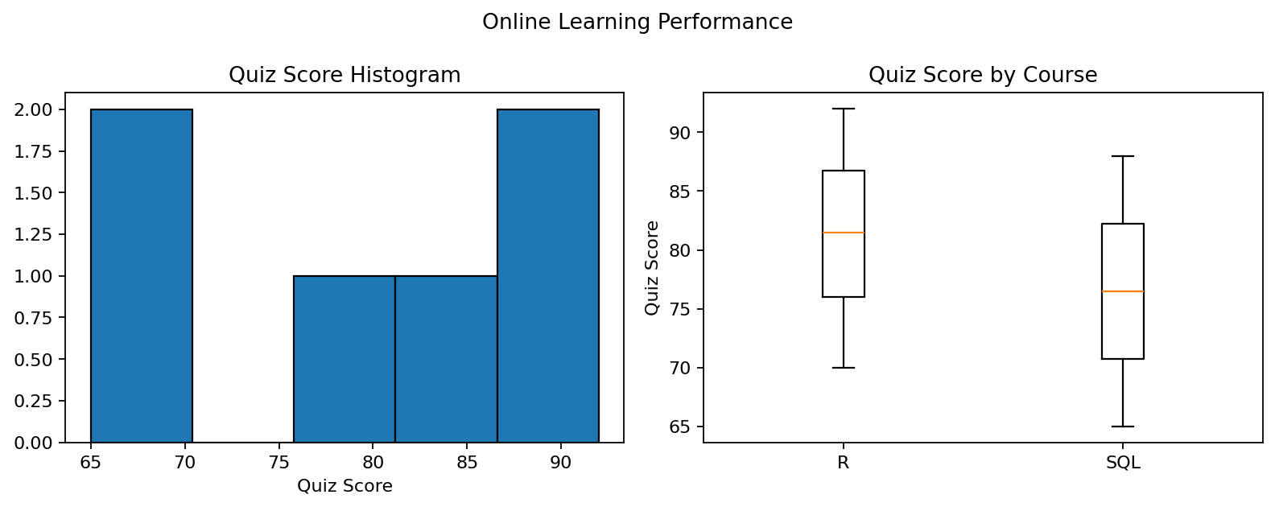
R output preview
Answer / Interpretation: Quiz scores range from 65 to 92. The R-course scores are generally higher in this small sample, although the sample is too small for a strong general conclusion.

Question 2
Create a scatter plot using R programming between Study_Time and Quiz_Score. Represent Videos_Watched using bubble size. Apply transparency. Explain the learning pattern.
R Programming Code
plot(data$Study_Time, data$Quiz_Score, cex=data$Videos_Watched/4, pch=19, col=rgb(0,0,1,0.45), xlab="Study Time (hrs)", ylab="Quiz Score", main="Study Time vs Quiz Score")
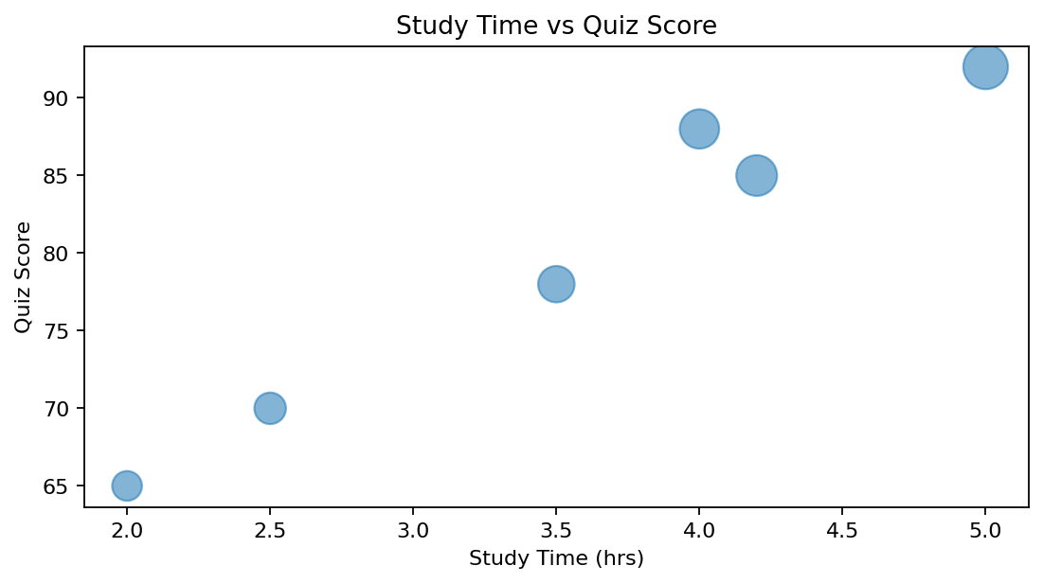
R output preview
Answer / Interpretation: The points suggest that more study time is generally associated with higher quiz scores. Larger bubbles indicate more videos watched.

Question 3
Using R programming, convert Login_Date into Date format. Calculate average quiz score per month. Plot a line chart. Apply moving average smoothing. Identify the trend.
R Programming Code
data$Login_Date <- as.Date(c("2025-01-05","2025-01-05","2025-02-08","2025-02-08","2025-03-12","2025-03-12"))
data$Month <- format(data$Login_Date, "%Y-%m")
monthly <- aggregate(Quiz_Score ~ Month, data=data, FUN=mean)
plot(monthly$Month, monthly$Quiz_Score, type="o", xlab="Month", ylab="Average Quiz Score", main="Monthly Quiz Trend")
monthly$Moving_Avg <- stats::filter(monthly$Quiz_Score, rep(1/2,2), sides=1)
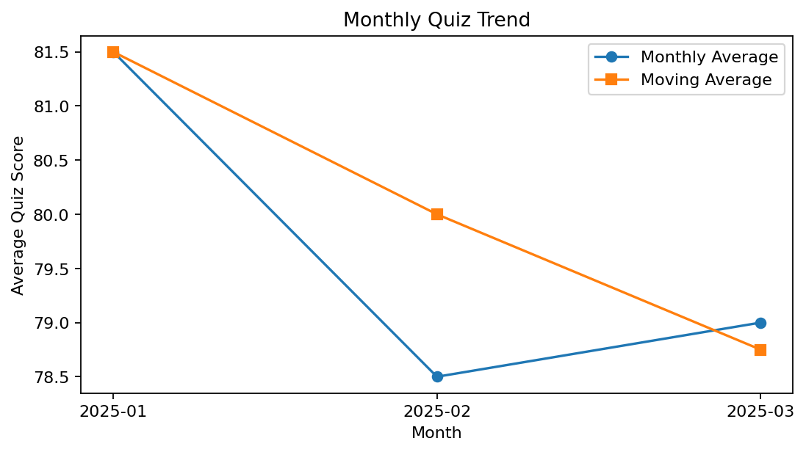
R output preview
Answer / Interpretation: The monthly average rises from January to February and remains high in March. The moving average smooths short-term changes.

Question 4
Import Online_Learning_Activity.csv into Tableau. Create a bar chart showing average quiz score by Course. Create a scatter plot (Study Time vs Quiz Score). Add filter for Gender and Course. Design a mini interactive dashboard.
R Programming Code
library(shiny)
# Use selectInput("gender") and selectInput("course") for filters.
# renderPlot() can draw the average-score bar chart and the study-time scatter plot.
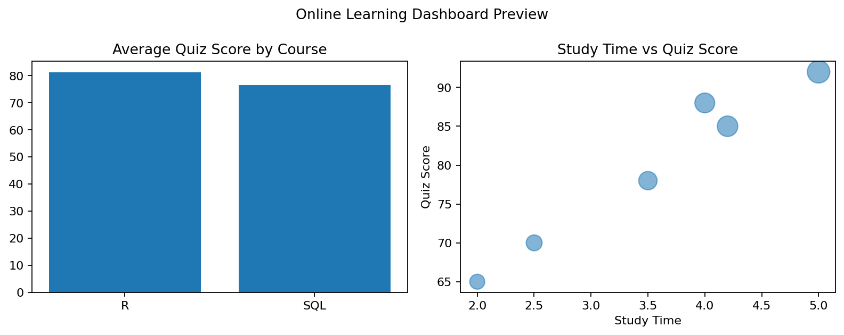
R output preview
Answer / Interpretation: The dashboard compares course performance and the relationship between study time and quiz score, with gender/course filters in the interactive version.

