,

Term 2 - Optimization Assignment
Submission By – Deep Kamal Singh (12020053)

Indian School of Business
AMPBA Batch 15
Subject Professor - Vishwakant Malladi
email: vishwakant_malladi@isb.edu

Table of Contents
Assignment Instructions 2
Deliverables 2
General Instructions 2
Assignment Questions 3
1. LP Modelling 3
1.1. Restaurant Staffing 3
1.2. Managing a port folio 3
1.3. Riskless profit ( Does arbitrage exist?) 4
2. Interpreting the Sensitivity report 5
3. Modelling Business Logic 6
Solutions 7
1. LP Modelling 7
1.1. Restaurant Staffing 7
1.2. Managing a portfolio 8
1.3. Riskless profit ( Does arbitrage exist?) 9
1.3.1. Answer 9
1.3.2. Answer 10
1.3.3. Answer 10
2. Interpreting the Sensitivity report 11
2.1. Answer 12
2.2. Answer 12
2.3. Answer 12
2.4. Answer 13
2.5. Answer 13
2.6. Answer 13
2.7. Answer 13
2.8. Answer 13
2.9. Answer 14
2.10. Answer 14
2.11. Answer 14
3. Modelling Business Logic 15
3.1. Answer 15
3.2. Answer 16
3.3. Answer 17
References 18

Assignment Instructions

This deliverable has a 30% weightage in the Consolidated Total score.

Deliverables

Submit your answers in a PDF file. Attach a copy of the excel sheet used for building models. The deadline for Submission of Assignment is 17th April.

General Instructions

- This is an individual assignment.
- Do NOT submit .zip files otherwise, the submission will not be considered.
- Please include your name and PGID in the submission.
- Penalty will be applied for Late Submissions according to Late Submission Policy.
- The honor code for this submission is 3N-b.

Assignment Questions

LP Modelling

Restaurant Staffing

Consider a restaurant that is open 7 days a week. Based on past experience, the number of workers needed on a particular day is given as follows:

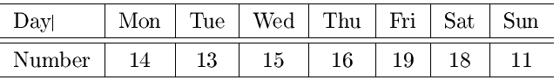

Every worker works five consecutive days and then takes off two days, repeating this pattern indefinitely.
Our goal is to minimize the number of workers that staff the restaurant. Define your variables, constraints, and objective function clearly. Develop a Solver model and solve for the optimal staffing plan.

Managing a port folio

We are going to manage an investment portfolio over a 6-year time horizon. We begin with $1,000,000, and at various times we can invest in one or more of the following:

- Savings account X, annual yield 5%,
- Security Y , 2-year maturity, total yield 12% if bought now, 11% thereafter,
- Security Z, 3-year maturity, total yield 18%, and
- Security W, 4-year maturity, total yield 24%.

To keep things simple we will assume that each security can be bought in any denomination. We can make savings deposits or withdrawals anytime.
We can buy Security Y any year but year 3.
We can buy Security Z any time after the first year.
Security W, now available, is a one-time opportunity.

Write down a LP model to maximize the final investment yield. Assume all investments must mature on or before year 6 and you cannot sell securities in between. Define your decision variables and constraints clearly.

Riskless profit ( Does arbitrage exist?)

A European call option is a contract with the following conditions: At a prescribed time in the future, known as the expiration date, the holder of the option has the right, but not the obligation to purchase a prescribed asset, known as the underlying asset/security, for a prescribed amount, known as the strike price or exercise price.
For example, suppose an investor purchases a call option on stock XYZ with a $50 strike price. At expiration, say a month from the time of purchase, the spot price of stock XYZ is $75. In this case, the owner of the call option has the right to purchase the stock at $50 and exercises the option, making $25, or ($75 - $50), per share. However, in this scenario, if the spot price of stock XYZ is $30 at expiration, it does not make sense to exercise the option to purchase the stock at $50 when the same stock could be purchased in the spot market for $30. In this case, the payoff is $0. Note the payoff and profit are different. To calculate the
profit from the option, the cost of the contract must be subtracted from the payoff. In this sense, the most an investor in the option can lose is the premium price paid for the option. In general, if S is the spot price of stock XYZ on the expiration date and K is the strike price of the European call option, then the call option
payoff = max {0,(S - K)} and the profit = payoff-option price.
Consider the following problem: You have $20,000 to invest. Stock XYZ sells at $20 per share today. A European call option to buy 100 shares of stock XYZ at $15 exactly six months from today sells for $1000.
You can also raise additional funds which can be immediately invested, if desired, by selling call options with the above characteristics. In addition, a 6-month riskless zero-coupon bond with $100 face value (the amount you will make at the end of 6 months) sells for $90. You have decided to limit the number of call options that you buy or sell to at most 50. You consider three scenarios for the price of stock XYZ six months from today: the price will be the same as today, the price will go up to $40, or drop to $12. Your best estimate is that each of these scenarios is equally likely.

- Formulate and solve (in Solver) a linear program to determine the portfolio of stocks, bonds, and options that maximizes expected profit.

- What happens to profitability if the price of XYZ goes to $40 per stock?

- Suppose you want a profit of at least $2000 in any of the three scenarios. Write and solve (in Solver) a linear program that will maximize your expected profit under this additional constraint.

- How does the solution compare to the earlier case described in (1).

- Riskless profit is defined as the largest possible profit that a portfolio is guaranteed to earn, no matter which scenario occurs. Formulate and solve (in Solver) the model to determine the portfolio that maximizes riskless profit for the above three scenarios?

Interpreting the Sensitivity report

Your friend's diet requires that all the food your friend eats come from one of the four “basic food groups” (chocolate cake, ice cream, soda, and cheesecake). At present, the following four foods are available for consumption: brownies, chocolate ice cream, cola, and pineapple cheesecake. Each brownie costs $50, each scoop of chocolate ice cream costs $20, each bottle of cola costs $30, and each piece of pineapple cheesecake costs $80. Each day, your friend must ingest at least 500 calories, 6 oz of chocolate, 10 oz of sugar, and 8 oz. of fat. The nutritional content per unit of each food is shown in Table (1) below. The variable names are indicated in parenthesis.

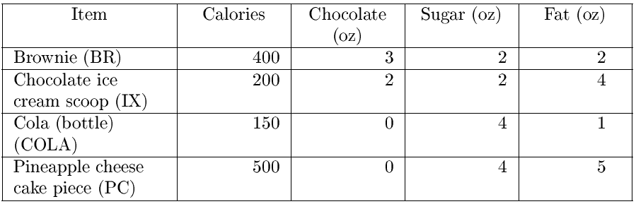
Table 1: Nutritional content per unit of food item.

After solving the LP formulation, the sensitivity report is given in Figure (2).

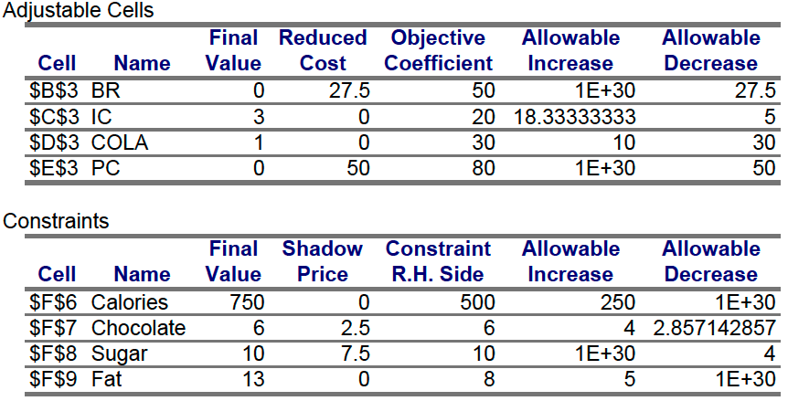
Figure 2: The sensitivity report.

Answer the following questions:
- Formulate (need not input into Solver) a linear programming model that can be used to satisfy my daily nutritional requirements at minimum cost. Use the same variable and constraint names as indicated the sensitivity report.
- If a brownie costs $30, what would be the new optimal solution to the problem? How much will our costs change?
- If a bottle of cola costs $35, what would be the new optimal solution to the problem?
- If a bottle of cola cost $45, would the new optimal solution be the same or different? Can you calculate
- the new optimal solution easily just from looking at the sensitivity reports? Why or why not?
- If at least 8 oz of chocolate were required, what would be the cost of the optimal diet?
- If at least 600 calories were required, what would be the cost of the optimal diet?
- If at least 9 oz of sugar were required, what would be the cost of the optimal diet?
- What would the price of pineapple cheesecake have to be before it would be optimal to eat some cheesecake?
- What would the cost of the optimal diet be if your friend had to eat at least one brownie?
- If 10 oz of fat were required, would the optimal solution to the problem change? Why or why not?
- Suppose your friend could also eat Cad bury chocolate eggs. Each egg costs $45 and contains 250 calories,5 oz of chocolate, 5 oz of sugar, and 2 oz of fat. Should you add Cad bury eggs to your friend's diet? Why or why not?

Modelling Business Logic

Model the following situations exactly using binary/integer variables and linear constraints:

- Suppose a consumer derives UA units of utility from product A and UB units from product B: Further suppose UA 6= UB and UA > 0 and UB > 0. Model the following consumer choice constraint using binary variables: If both products are shown (presented) to the consumer, the consumer will not choose the product with lower utility (notice that the consumer may choose none of the products.)

- A group of friends are browsing through the local video store, trying to decide which movies to rent. The friends, all ISB students, would like to plan their movie-watching schedule using integer programming. Write exactly one binary variable constraint to model the following statement: “If we rent both Bahubali II (B) and Dangal (D), then we can rent at most one of Drishyam (R), The Lunch Box (L), and Bhaag Milkha Bhaag (M).”

- 3. Suppose a broker must choose to invest in four investments 1, 2, 3, and 4. Let x1, x2, x3, and x4 denote the binary variables if she chooses the particular investment or not. Suppose she has the following constraints: If she invests in 3 or 4 or both then she must invest in exactly one of 1 or 2. Otherwise, if she invests in neither (of 3 or 4) then there are no constraints on investing in 1 or 2.

Solutions

LP Modelling

Restaurant Staffing

Staff requirement on Given days

 |  |  |  | Mon |  | Tue |  | Wed |  |  | Thu |  | Fri |  | Sat |  | Sun
 |  |  |  | 14 |  | 13 |  | 15 |  |  | 16 |  | 19 |  | 18 |  | 11
Let X1-X7 represent schedule of Employees starting their week on respective weekdays from Mon to Sun, Thus, the 7 schedules can be represented as:

 | X1 | X2 | X3 | X4 | X5 | X6 | X7 | Staff Needed
Mon | 1 | 0 | 0 | 1 | 1 | 1 | 1 | 14 | >= | 14
Tue | 1 | 1 | 0 | 0 | 1 | 1 | 1 | 13 | >= | 13
Wed | 1 | 1 | 1 | 0 | 0 | 1 | 1 | 15 | >= | 15
Thu | 1 | 1 | 1 | 1 | 0 | 0 | 1 | 16 | >= | 16
Fri | 1 | 1 | 1 | 1 | 1 | 0 | 0 | 19 | >= | 19
Sat | 0 | 1 | 1 | 1 | 1 | 1 | 0 | 18 | >= | 18
Sun | 0 | 0 | 1 | 1 | 1 | 1 | 1 | 15 | >= | 11

Our Objective function is to minimize X1+X2+X3+X4+X5+X6+X7

Constraints
( 1 ) -- X1 >= 0
( 2 ) -- X2 >= 0
( 3 ) -- X3 >= 0
( 4 ) -- X4 >= 0
( 5 ) -- X5 >= 0
( 6 ) -- X6 >= 0
( 7 ) -- X7 >= 0
( 8 ) -- 1.X1 + 0.X2 + 0.X3 + 1.X4 + 1.X5 + 1.X6 + 1.X7 >= 14
( 9 ) -- 1.X1 + 1.X2 + 0.X3 + 0.X4 + 1.X5 + 1.X6 + 1.X7 >= 13
( 10 ) -- 1.X1 + 1.X2 + 1.X3 + 0.X4 + 0.X5 + 1.X6 + 1.X7 >= 14
( 11 ) -- 1.X1 + 1.X2 + 1.X3 + 1.X4 + 0.X5 + 0.X6 + 1.X7 >= 16
( 12 ) -- 1.X1 + 1.X2 + 1.X3 + 1.X4 + 1.X5 + 0.X6 + 0.X7 >= 19
( 13 ) -- 0.X1 + 1.X2 + 1.X3 + 1.X4 + 1.X5 + 1.X6 + 0.X7 >= 18
( 14 ) -- 0.X1 + 0.X2 + 1.X3 + 1.X4 + 1.X5 + 1.X6 + 1.X7 >= 11

With these 14 constraints, we use excel solver to compute optimal value of Objective function

Schedule | Weekday | Employee Count | Solution to Problem 1.1  - Total 22 employees are sufficient to manage the schedule  - 4 employees will start their week on Monday, 3 on Tuesday,5 on Wednesday,4 on Thursday, 3 on Friday and Saturday  - No employee will be starting their week on Sunday
X1 | MONDAY | 4
X2 | TUESDAY | 3
X3 | WEDNESDAY | 5
X4 | THURSDAY | 4
X5 | FRIDAY | 3
X6 | SATURDAY | 3
X7 | SUNDAY | 0
Total |  | 22

Managing a portfolio

With the given investment options and their maturity terms, there are below feasible options for investing through year 1 to 6

Visualizing Investment Constraints
 | Year 1 | Year 2 | Year 3 | Year 4 | Year 5 | Year 6
 | |-------------------------------------------------6 Year----------------------------------------------------|
X | X1(5%) | X2(5%) | X3(5%) | X4(5%) | X5(5%) | X6 (5%)
Y | Y12 (12%) |  |  | Y45(11%)
Y |  | Y23(11%) |  |  | Y56(11%)
Z |  | Z234(18%)
Z |  |  | Z345 (18%)
Z |  |  |  |  | Z456 (18%)
W | W (24%)

Constraints
(1) | X1+Y12+W | = | $10,00,000.00
(2) | X2+Y23+Z234-1.05*X1 | = | $0.00
(3) | X3+Z345-1.05*X2-1.12*Y12 | = | $0.00
(4) | X4+Y45+Z456-1.05*X3-1.11*Y23 | = | $0.00
(5) | X5+Y56-1.05*X4 - 1.18*Z234 - 1.24*W | = | $0.00
(6) | X6-1.05*X5-1.11*Y45-1.18*Z345 | = | $0.00

With these constraints, we run excel solver to get values of decision variables

Decision Variables |  |  | Optimal Investment value of each decision variable  - In year 1, all investment should go to Y which gives 12% yield in 2 years  - After this we invest al amount in X on 3rd year  - When X matures on 4th year, we invest everything in Z, which matures after 3 years at the end of 6th Year  - We obtain 38.768% of gain over spread of 6 years.  - Since our initial investment is $100000, our maximized yield is  $$\$1,387,680-\$1,000,000 = \$387,680$$
X1 | = | $0.00
X2 | = | $0.00
X3 | = | $11,20,000.00
X4 | = | $0.00
X5 | = | $0.00
X6 | = | $0.00
Y12 | = | $10,00,000.00
Y23 | = | $0.00
Y45 | = | $0.00
Y56 | = | $0.00
Z234 | = | $0.00
Z345 | = | $0.00
Z456 | = | $11,76,000.00
W | = | $0.00

Objective function | Optimal Solution
max(1.05*X6+1.11*Y56+1.18*Z456) | $13,87,680.00

Riskless profit ( Does arbitrage exist?)

Answer

Fixed Amount to Invest | 20000

Investment Choices, Possibilities, Payoff and Profits
Name | Purchase | Strike Price | Spot Price | Payoff | Profit
C_Sell_20 | 1000 | 1500 | 2000 | -500 | 500
C_Sell_40 | 1000 | 1500 | 4000 | -2500 | -1500
C_Sell_12 | 1000 | 1500 | 1200 | 300 | 1000
C_Buy_20 | 1000 | 1500 | 2000 | 500 | -500
C_Buy_40 | 1000 | 1500 | 4000 | 2500 | 1500
C_Buy_12 | 1000 | 1500 | 1200 | -300 | -1000
Bond | 0 | 90 | 100 | 10 | 10
Stocks_20 | 0 | 20 | 20 | 0 | 0
Stocks_12 | 0 | 20 | 12 | -8 | -8
Stocks_40 | 0 | 20 | 40 | 20 | 20

Expected Profit for investments (Decision Variables)
 | Purchase Cost | Profit | Invested Units | We are considering expected value of investments for all maturity scenarios
C_Sell (Cs) | -1000 | 0 | 50
C_Buy (Cb) | 1000 | 0 | 0
Bond(B) | 90 | 10 | 0
Stocks(S) | 20 | 4 | 3500

Constraints
1000.Cb-1000.Cs+20.S+90.B | <= | 20000
C_Sell | <= | 50
C_Buy | <= | 50

Optimal Solution
$0.C_{Sell}+0.C_{Buy}+10.Bond+4.Stocks$ = | 14000

Evaluating the optimal solution when stock prices reach $\$40$ , the profit per Stocks will be $\$20$, however profit (actually loss) per Cs will be $-1500$, substituting in objective function

$–1500×50 + 3500×20 = -\$5000$

Investment will sustain a loss of $5000 when stock price go to $40 , there is a 1/3rd chance of losing $5000 dollar with optimal solution we obtained from LP modelling

Answer

As we need to ensure the minimum profit in any scenario remains $\$2000$, For this we can just add constraints for every possible stock value (i.e $12,$20,$40),
Such that
$Profit(S)+Profit(Cs)+Profit(Cb)+Profit(B) ≥ 2000$

There will be total 3 new constraints given by

Constraints for Profit >=2000
1000.Cb-1000.Cs+20.S+90.B | 0 | <= | 0
C_Sell | 0 | <= | 50
C_Buy | 0 | <= | 50
500Cs-500Cb+0S+10B | 18000 | >= | 2000
-1500Cs+1500Cb+20S+10B | 2000 | >= | 2000
1000Cs-1000Cb-8S+10B | 13600 | >= | 2000

1.3.2.a
Adding this constraint and using solver in excel we get – optimality value as 11200
Which is evidently $2,800 less than optimal value of $14,000,

Important to note that even though the optimal value is reduced by $2800, this investment plan guarantees minimum profit of $2000 irrespective of the stock prices after 6 months

Answer

We need to consider minimum profit from all the cases, and set our constraints just $≥$ the minimum profit

Constraints for Profit >=2000
1000.Cb-1000.Cs+20.S+90.B | 0 | <= | 0
C_Sell | 0 | <= | 50
C_Buy | 0 | <= | 50
500Cs-500Cb+0S+10B | 12727.275 | >= | 7272.73
-1500Cs+1500Cb+20S+10B | 7272.725 | >= | 7272.73
1000Cs-1000Cb-8S+10B | 7272.73 | >= | 7272.73

We find minimum riskless profit among all scenarios is 7272.73 , setting that as MINIMUM constraint value towards each scenario profit, we obtain

Expected overall profit : $ $9090.91$

Interpreting the Sensitivity report

Nutritional content per unit of each food

Item | Code | Calories | Chocolate | Sugar | Fat
Brownie | BR | 400 | 3 | 2 | 2
Chocolate ice cream scoop | IC | 200 | 2 | 2 | 4
Cola (bottle) | COLA | 150 | 0 | 4 | 1
Pineapple cheese cake piece | PC | 500 | 0 | 4 | 5

Sensitivity report

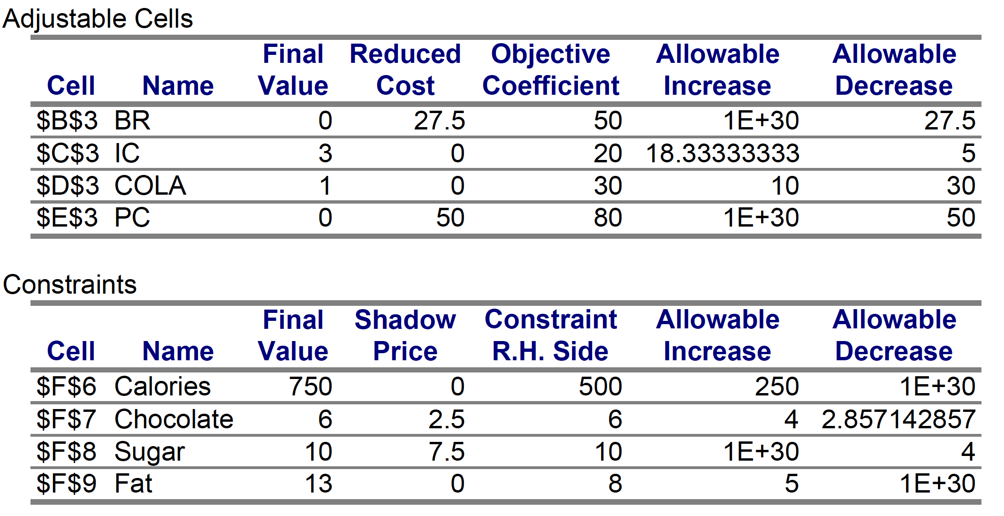

Answer

Code | Decision Variable Name | Cost
BR | Brownie Quantity | 50
IC | Chocolate Ice Cream Quantity | 20
COLA | Cola quantity | 30
PC | Pineapple Cheese cake quantity | 80

As per the information given in question and sensitivity report (object coeff), the objective function (O) will be formed as

O = Minimize(50xBR + 20xIC + 30xCOLA + 80xPC)

Constraints with output

 |  | O |  | Calories |  |  | Chocolate |  | Sugar | Fat
BR | 0 | 50 |  | 400 |  |  | 3 |  | 2 | 2
IC | 3 | 20 |  | 200 |  |  | 2 |  | 2 | 4
COLA | 1 | 30 |  | 150 |  |  | 0 |  | 4 | 1
PC | 0 | 80 |  | 500 |  |  | 0 |  | 4 | 5
Totals => |  | 90 |  | 750 |  |  | 6 |  | 10 | 13
Constraints
Total Calories |  |  | 750 |  | >= | 500
Total Chocolate |  |  | 6 |  | >= | 6
Total Sugar |  |  | 10 |  | >= | 10
Fat |  |  | 13 |  | >= | 8

Answer

We see in the sensitivity report that allowable decrease in the Brownie cost value is 27.5, this means that there will be no change in optimal solution when Brownie cost changes to 30,
As the current cost is 50 and reducing it to 30 is only decreasing it by 20, we can expect no change up to decrease by 27.5.

Further to this, in our optimal solution the Brownie is 0, thus there will be no change in cost as well.

Answer

We find in the sensitivity report that allowable increase for COLA is 10, this means that we can increase COLA cost by 10 without having any change in optimal solution, since current cost is 30, increase of 5 to $35 will make respective changes in the cost of Diet –
$$3 × 20 + 1 ×35 = 95$$

Answer

If we increase the COLA price to 45, it will be an increase of 15 from its current value of 30, since we know allowable increase is 10, this is going to change the optimal solution. Looking at the Sensitivity report we ascertain that coefficient of cola is 10, and it’s the max value ($40), this mean that when a bottle of cola will be costing $5 more than its present cost the current optimal solution will change

- Since chocolate ice-cream has reduced cost of 0 , thus it is most attractive option
- To satisfy Calory, chocolate, sugar and fat requirements, we need 5 scoops of Chocolate ice-cream,
  - That corresponds to cost of
$$5 × 20 = \$100$$

Answer

Since chocolate is a binding constraint with its constraint limit being equal to optimal value of 6, thus if at least 8 oz of chocolate were required – and allowable increase is 4, increasing by 2 will keep shadow price unaffected and thus increasing from 6 to 8 will for sure change our optimal solution,
The change can be calculated by “Shadow Price ” of the constraint

Change in optimality = (Shadow Price x Change in Value)

- 2 x 2.5 = 5

New cost of optimal diet = 90 + 5 = 95

Answer

Here as well with same calculation as above, since the allowed increase is 200 and we are increasing by 100 – in such cases the shadow price remains unchanged and can be used to calculate change in optimal value, but the constraint is a NON-binding constraint, thus there will be no change in optimal value.

Answer

As we know
Change in optimality = (Shadow Price x Change in Value)
This is valid in cases when increase or decrease is less than allowed value, given allowed decrease for Sugar is 4, reducing it to 8oz will only impact it by 1 unit and thus Shadow price will be valid, change in optimality will be
- 7.5 x -1 = -7.5
Thus cost of optimal diet will be 90 – 7.5 = 82.5

Answer
Reduced cost of decision variable is measure of its impact on optimal value,
Reduced cost for Pan Cheesecake(PC) is 50,
In the optimal solution the value of PC is 0,
Objective coefficient is 80
Thus the optimal solution to keep PC also in feasibility (eatable), the price has to be reduced by “Reduced Cost”:
New PC price feasibility is: 80 – 50 = 30

Answer

Reduced cost of decision variable is measure of its impact on optimal value,

Reduced cost for Brownie(BR) is 27.5,
Objective coefficient for BR is 80

Thus the optimal solution when friend eats at least 1 brownie will be

New BR price: 90+27.5 = 117.5

Answer

In current constraints, minimum Fat intake is set to 8, and in sensitivity report we see Allowed increase to 5, for Fat intake to be 10 , actual increase will be 10 – 8 = 2
Since the change is within allowable increase, the shadow price will be valid,
Further we see that shadow price is also 0 – this implies there will be no change in price

Answer

Here we are adding another decision variable called Cadbury Eggs,
Since $45 is price of egg, this to be taken as Objective Coefficient

Given that each Cadbury Egg contains

Calories | 250
Chocolate | 5
Sugar | 5
Fat | 2
To decide whether to add Cadbury Egg to friends diet, we must calculate its Margin Contribution to optimal value, if it is less than 0 then it will further add to minimize objective function, if it is more than 0 then it will increase objective function from its current optimal value,

To calculate margin contribution, we will look at specific shadow price of each constraints
Since shadow price of Calories and Fat is 0 , we will consider shadow price of Chocolate and Sugar only

Marginal Opp(Cadbury Egg) = Chocolate Content x Chocolate SP + Sugar Content x Sugar SP

- 250 x 2.5 + 5 x 7.5
- 12.5 + 37.5
- 50
Here we get Marginal Opp cost = 50 , whereas Objective Coefficient is 45,
Net Margin Contribution = 45 – 50 => -5 which is < 0

Thus we recommend to include Cadbury in the diet

Modelling Business Logic

Answer

Let $X_{A}$ and $X_{B}$be the choices to go with product A or B

Available choices for customer can be tabled as:

$$X_{A}$$ | $$X_{B}$$
0 | 0
0 | 1
1 | 0
1 | 1

Its given in the question that
- Customer derives UA units of utility from product A and UB units from product B
- UA $≠$UB
- UA > 0
- UB > 0

With given constraints we form constraint equation

$\left(X_{A}+X_{B}\right) ≤ 1$

Answer

- In the problem we have 5 binary variables, since each of them can be either 0 or 1 , the entire set of possibilities will be between $0 to 2^{\left(5-1\right)}$ i.e. 0 to 31,  - Representing them in table with their integer equivalent given  - Given constraints are applicable when group decides to rent both B & D together  - These conditions are covered where B and D both are 1  - In other cases however, there are no constraints so all other cases where both B and D are not 1 are under feasible conditions  - With simple binary equations we can form constraints like  - $16.B+8.D+4.R+2.L+1.M ≤ 28$  - $16.B+8.D+4.R+2.L+1.M ≠27$  - $16.B+8.D+4.R+2.L+1.M ≥ 0$  - However, requirement of question is to derive a single constraint, i.e. single equation, thus we formulate  $$3\left(B+D\right)+2\left(R+L+M\right)≤9$$ | Visualizing Movie rent options in Binary matrix
Feasible | B | D | R | L | M | INT**
TRUE | 0 | 0 | 0 | 0 | 0 | 0
TRUE | 0 | 0 | 0 | 0 | 1 | 1
TRUE | 0 | 0 | 0 | 1 | 0 | 2
TRUE | 0 | 0 | 0 | 1 | 1 | 3
TRUE | 0 | 0 | 1 | 0 | 0 | 4
TRUE | 0 | 0 | 1 | 0 | 1 | 5
TRUE | 0 | 0 | 1 | 1 | 0 | 6
TRUE | 0 | 0 | 1 | 1 | 1 | 7
TRUE | 0 | 1 | 0 | 0 | 0 | 8
TRUE | 0 | 1 | 0 | 0 | 1 | 9
TRUE | 0 | 1 | 0 | 1 | 0 | 10
TRUE | 0 | 1 | 0 | 1 | 1 | 11
TRUE | 0 | 1 | 1 | 0 | 0 | 12
TRUE | 0 | 1 | 1 | 0 | 1 | 13
TRUE | 0 | 1 | 1 | 1 | 0 | 14
TRUE | 0 | 1 | 1 | 1 | 1 | 15
TRUE | 1 | 0 | 0 | 0 | 0 | 16
TRUE | 1 | 0 | 0 | 0 | 1 | 17
TRUE | 1 | 0 | 0 | 1 | 0 | 18
TRUE | 1 | 0 | 0 | 1 | 1 | 19
TRUE | 1 | 0 | 1 | 0 | 0 | 20
TRUE | 1 | 0 | 1 | 0 | 1 | 21
TRUE | 1 | 0 | 1 | 1 | 0 | 22
TRUE | 1 | 0 | 1 | 1 | 1 | 23
TRUE | 1 | 1 | 0 | 0 | 0 | 24
TRUE | 1 | 1 | 0 | 0 | 1 | 25
TRUE | 1 | 1 | 0 | 1 | 0 | 26
FALSE | 1 | 1 | 0 | 1 | 1 | 27
TRUE | 1 | 1 | 1 | 0 | 0 | 28
FALSE | 1 | 1 | 1 | 0 | 1 | 29
FALSE | 1 | 1 | 1 | 1 | 0 | 30
FALSE | 1 | 1 | 1 | 1 | 1 | 31

Answer

In the problem we have 4 binary variables, since each of them can be either 0 or 1 , the entire set of possibilities will be between $0 to 2^{\left(4-1\right)}$ i.e. 0 to 15,

Representing them in table with their integer equivalent given

Feasible | X1 | X2 | X3 | X4 | INT*
TRUE | 0 | 0 | 0 | 0 | 0
FALSE | 0 | 0 | 0 | 1 | 1
FALSE | 0 | 0 | 1 | 0 | 2
FALSE | 0 | 0 | 1 | 1 | 3
TRUE | 0 | 1 | 0 | 0 | 4
TRUE | 0 | 1 | 0 | 1 | 5
TRUE | 0 | 1 | 1 | 0 | 6
TRUE | 0 | 1 | 1 | 1 | 7
TRUE | 1 | 0 | 0 | 0 | 8
TRUE | 1 | 0 | 0 | 1 | 9
TRUE | 1 | 0 | 1 | 0 | 10
TRUE | 1 | 0 | 1 | 1 | 11
TRUE | 1 | 1 | 0 | 0 | 12
FALSE | 1 | 1 | 0 | 1 | 13
FALSE | 1 | 1 | 1 | 0 | 14
FALSE | 1 | 1 | 1 | 1 | 15
**Integer value of binary bits are calculated by $\sum{2^{i-1}×x_{i}}$

Further based upon given constraints we highlight feasibility in Feasible column as TRUE in green and FALSE in RED,

We see that all combinations of X1,X2,X3,X4 values from 4 to 12 are feasible, and also Broker can decide not to invest in any of investments, formulating mathematical equations for Linear Programming, we get

CONSTRAINTS
8.X1+4.X2+2.X3+1.X4 >=4
8.X1+4.X2+2.X3+1.X4 <=12
X1+X2+X3+X4 = 0

References

