(For Private Circulation Only)

UNITED TECHNOLOGIES OF INDIA

Mr. Ram Kumar, a fresh graduate from Indian Institute of Management, Bangalore, had joined the corporate headquarters of United Technologies of India (UTI) a month ago. He was assigned to a group, which was re-examining the strategy to achieve the corporate mission in the wake of the new economic policy.

Ram was eager to start on his assignment. Towards that end, he decided to go through some of the literature on UTI that was given to him recently. Confident of his abilities in Quantitative Techniques, he whipped out his calculator and started punching in the numbers.

Ram became more and more puzzled. There appeared to be a many contradictions. Over the last twenty odd years, sales had increased 18 fold but Profit Before Tax (PBT) had increased only 10 fold. Other Incomes (OTINC.), as a percentage of PBT had increased from 6% to 65%. Personnel (EMPL) and Interest payment (INT) had both shot up. Ram wondered about the contribution of the different variables to Sales and PBT.

He felt that there were some reasons for concern. With his scientific background, he felt that any re-examination of corporate strategies must include analysis of past data. He decided to write a statistical report based on the available data.

Company Background

In the late sixties, the Indian government realized that the country lacked a sound manufacturing base in electronics. All vital components in Defense and Communication were being imported. The Indian government established UTI in 1971 to meet the national needs in every vital area of technology. Its customers were to include Defense, Department of Telecommunication, Department of Space and All India Radio.

To acquire a sound manufacturing base, the company, in its early years, tied up with internationally reputed companies under know-how/license agreements. This helped the company to assimilate production technologies quickly and be capable of manufacturing a variety of products of international quality standards. While acquiring a viable manufacturing base, it also established its commitment to R&D by locating a laboratory in South India and investing 7% of the annual turnover in research. As a result, 75% of its business comes from products of indigenous design.

In the first decade, the company saw a steady growth due to the license agreements. There was a small hiccup in one year because of conflict between management and labour. In the eighties, there was a small boom in the country. Demand in the defense sector and in consumer electronics picked up. The company seized the opportunity and expanded. The investments in R&D paid off.

UTI was touted as the flagship of the Public Sector Units (PSUs). Moreover, the Ministry kept pressuring the other PSUs to follow the lead set by UTI in innovation, quality and technology (Of course, there was little concern for profitability). But, in the recent times, UTI has come under pressure because of the new policies of the government. The ministry has been hinting about a cut in budgetary support and has been pushing the company to raise capital in the market.

Corporate Mission

Ever since its inception in 1971, UTI has been committed to meeting the national needs in every vital area of technology. And it strives to gain a reputation in Quality, Technology and Innovation.

Corporate Strategy

In the dynamic environment of the electronics industry, innovation is the keystone to a company’s success. To achieve the corporate mission, UTI has to have an excellent infrastructure in manufacturing. To bridge the technological gap, UTI has to adopt/develop superior technology using backward integration.

Current Affairs

At present, UTI has major plants in North and South of the country. It has an annual turnover of 7.2 billion Rupees in electronic components, defense equipment, turnkey projects and other products. Its customers include the Defense, Department of Space, All India Radio, Doordarshan, DOT and the Railways.
Appendix 1. United Technologies of India – Data for the past 20 Years

YEAR | SALES | MATERIAL | OTINC | PBT | EMPL | INT
1 | 3973.0 | 1742.0 | 37.0 | 662.0 | 13148.0 | 126.0
2 | 4871.0 | 2296.0 | 103.0 | 746.0 | 14871.0 | 208.0
3 | 4315.0 | 2356.0 | 126.0 | 482.0 | 15340.0 | 265.0
4 | 5567.0 | 2673.0 | 81.0 | 503.0 | 15642.0 | 410.0
5 | 6537.0 | 2796.0 | 164.0 | 690.0 | 15780.0 | 460.0
6 | 7460.0 | 3172.0 | 500.0 | 898.0 | 16298.0 | 336.0
7 | 7638.0 | 3503.0 | 469.0 | 1220.0 | 16644.0 | 202.0
8 | 8295.0 | 3824.0 | 475.0 | 851.0 | 17229.0 | 286.0
9 | 6891.0 | 3407.0 | 370.0 | 893.0 | 17351.0 | 416.0
10 | 12844.0 | 5123.0 | 382.0 | 2013.0 | 17306.0 | 526.0
11 | 14428.0 | 5733.0 | 684.0 | 2346.0 | 17952.0 | 513.0
12 | 15493.0 | 6100.0 | 535.0 | 2694.0 | 18207.0 | 713.0
13 | 18653.0 | 6600.0 | 414.0 | 2877.0 | 18453.0 | 877.0
14 | 21978.0 | 9030.0 | 383.0 | 2545.0 | 18903.0 | 1206.0
15 | 29562.0 | 15518.0 | 447.0 | 3032.0 | 18797.0 | 1697.0
16 | 37821.0 | 21380.0 | 1248.0 | 2969.0 | 19129.0 | 1861.0
17 | 49826.0 | 27510.0 | 972.0 | 2971.0 | 19280.0 | 2680.0
18 | 64521.0 | 36479.0 | 1385.0 | 4139.0 | 19394.0 | 2990.0
19 | 72392.0 | 35131.0 | 3937.0 | 5397.0 | 19357.0 | 3211.0
20 | 71678.0 | 33108.0 | 4398.0 | 6750.0 | 19080.0 | 4625.0

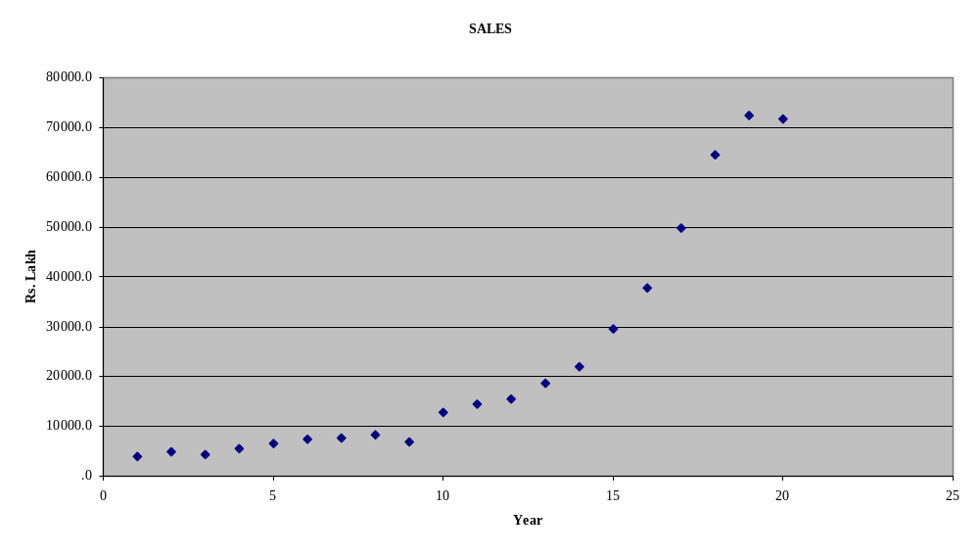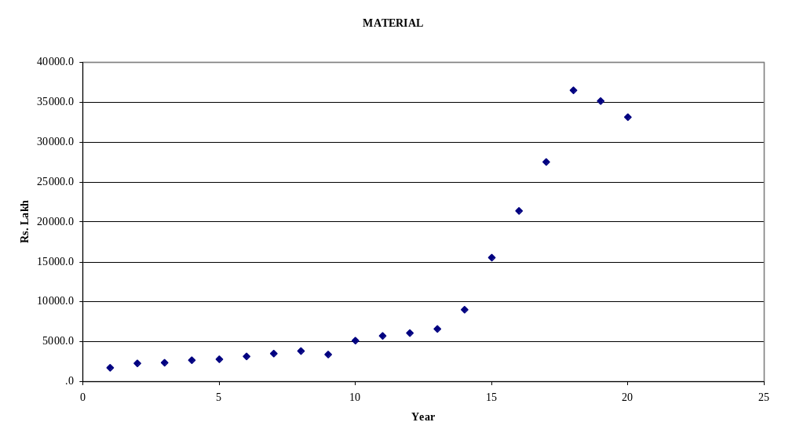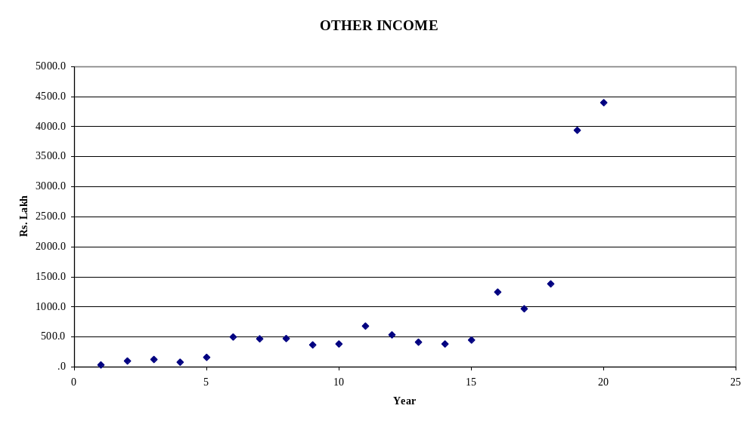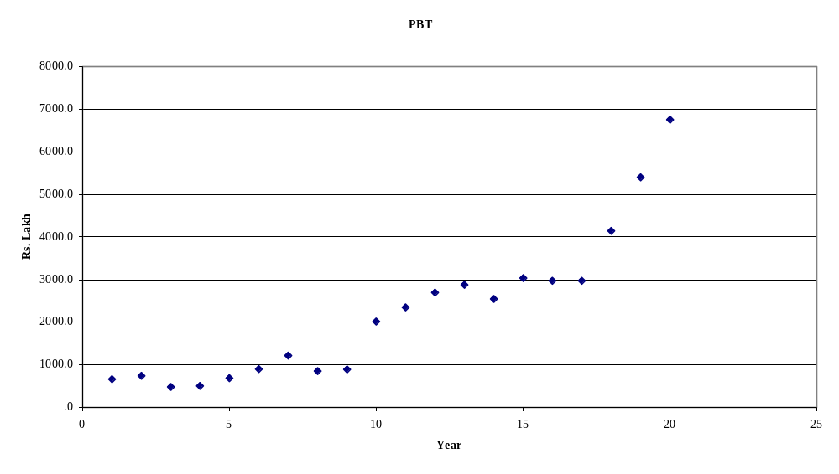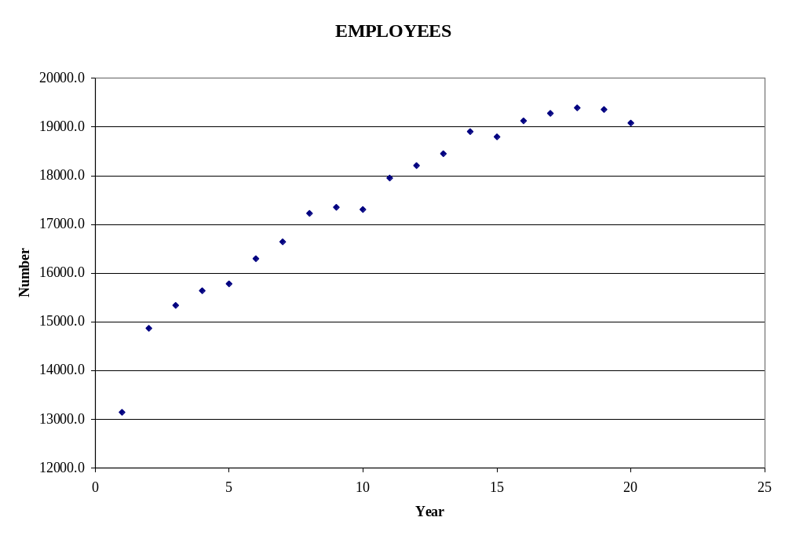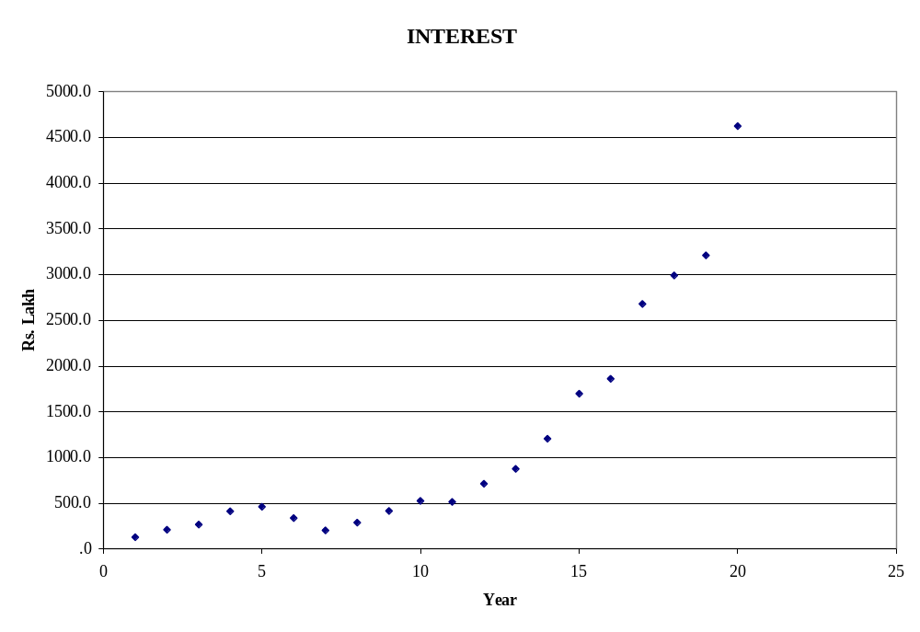

Developed by Professors V Nagadevara and S Rajagopalan, Indian Institute of Management Bangalore.

